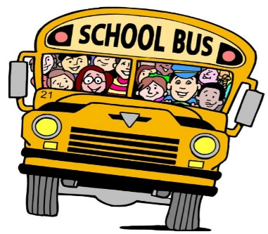
8-16-19
Fairlane’s Family Connection

Dear Families,
I want to welcome everyone back to school. We’ve had a great first two weeks. Everyone is getting back into the routine of things. I love seeing all the smiling faces.

Please make sure to get all the needed school forms filled out and sent back into your child’s teacher.

Thank you for all your help and patience with afternoon pick-ups. Remember our K students and parents are learning the routine. It will go quicker once everyone gets use to the routine. Also remember some days will still be slower once everyone learns the routine (Fridays & rainy days). Please continue to be patient on these days.

Our school collects box tops. Please clip, save, and send these into your child’s teacher. We use the money from these to buy things needed for our school.

Don’t forget to visit our school’s website for information and event dates. www.fairlaneelementaryschool.com

Just a few dates to let you know about.
Mon. Sept. 2 – Labor Day - No School
Tues. Sept. 10 – School Pictures
Wed. Sept. 18 – Parent/Teacher Conf. 12-6pm (NO SCHOOL for students)

Have a great weekend!
Mrs. Gunter, Principal
READ 20 min. a Day

