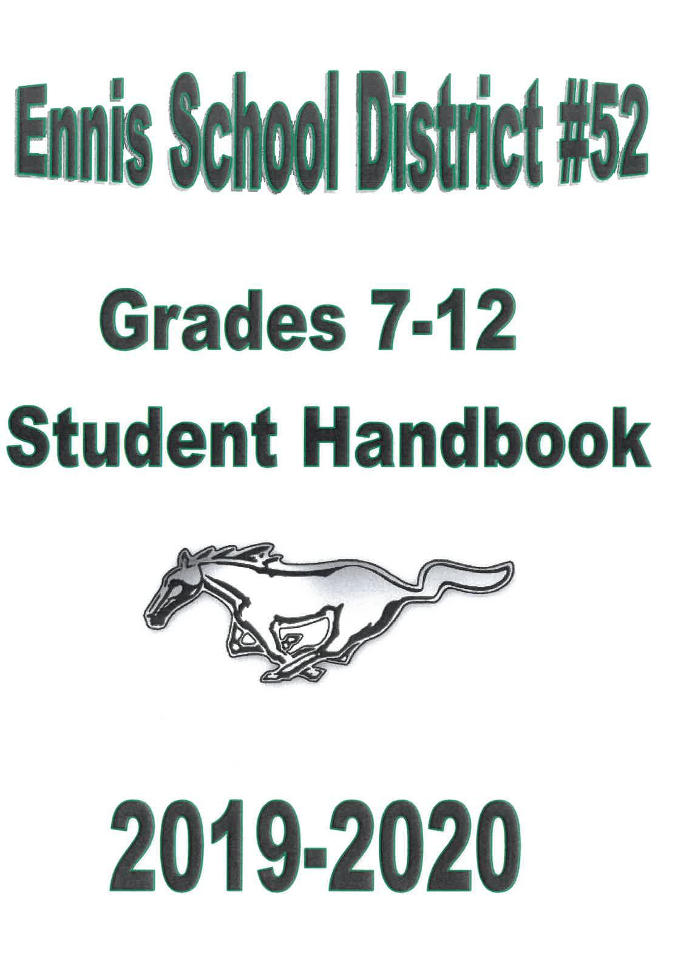

ENNIS SENIOR AND JUNIOR IDGH SCHOOLS STUDENT HANDBOOK

Brian Hilton
Principal - K-6

Mellissa Newman
Principal - 7-12

P.O. Box 517 Ennis 59729

Telephone: Elementary: 682-4237
JH/HS: 682-4258

**Changes have been made to the following areas:
Drug Testing Policy, Appearance and Dress Code, Assemblies, Attendance, Cell Phone, Chemical Dependency Policy, Discipline

1

Opening Statement

Welcome to the· Ennis Public Schools for the 2019-2020 school year. This
handbook is designed to give you the information you need to have a successful and enjoyable year as a student at Ennis Public Schools. Please take the time to read and review the information contained in this handbook. District-wide policies
referred to in this handbook may be found in the District Administration Office. The parent/student signature sheet must be signed and returned to the school office. Signature indicates that parents and students have read the handbook and acknowledge the contents.
The staff at Ennis Public Schools wants your experience at school to be a positive one. We hope to provide an environment that promotes optimal academic learning, as well as one that provides you with social and leadership opportunities that will foster success in your life. As a team, we will work together to develop your talents and strengths and provide you with opportunities to share these gifts with others.

ENNIS PUBLIC SCHOOLS STRATEGIC PLAN
OVERVIEW

The Ennis Public School District·#52 has created a new direction of the school district to strategically focus its resources on identified wants, preferences, and needs of its community. As part of this process, the District went through a strategic planning and thinking process that will lead to a stronger and more vital school district. This process involved various stakeholders in the community, such as students, staff, board members, parents, and members of the community and was facilitated by the Montana School Boards Association. On May 24, 2017, the Ennis Public Schools Board of Trustees formally adopted its new strategic plan.
The Ennis Public School District views the process of strategic planning as an ongoing process within the school system. This is not a "strategic planning project" that is completed. Adoption of a plan is an affirmation of the general intent and direction articulated by the Core Ideology, Envisioned Future and Goals and Strategic Objectives laid out in the plan. It 1s understood that progress toward achieving a plan strategic objective will be assessed at least annually, and the plan will be updated based on achievement and changes in the needs of the children served by the District.

CORE IDEOLOGY OF THE ENNIS PUBLIC SCHOOL DISTRICT
The core ideology section of the strategic plan describes a school district's consistent identity that transcends all changes related to is relevant environment. It consists of two elements - core purpose - the

2

school district's reason for being - and core values - essential and enduring principles that guide a school district.
The Core Purpose of Ennis Public Schools is to provide a safe, positive, and stimulating environment that challenges each student to reach his/her full potential in life.
Core Values of Ennis Public Schools:

Community - We value our community support of the District. Our community genuinely cares about kids and they are passionate about the education and success of our youth.
Integrity - We believe that in order to foster a culture of trust and transparency, we must act with integrity and accountability at all times.
Respect - We value having and showing respect in everything we do as a school and a community.
Pride - We take pride in working hard, in caring and looking out for one another, and inspiring our students to always do their very best. We take ownership of our challenges and we celebrate our successes.

For more information on the Ennis Public Schools Strategic Plan please contact a school administration or the Ennis School District Board of Trustees.

Board and Administration
Kris Inman, Chairman Karen Ketchu, Vice-Chairman
Andrew Henrich Halley Perry Jennifer Rohrback
Casey Klasna, Superintendent Brian Hilton, Elementary Principal Mellissa Newman, Principal 7-12 Ginger Martello, District Clerk Ross Lingle, Title IX Coordinator Administrative Support Staff D'awn Ledgerwood, K-6
Sally Lee, 7-12
Dana Pulliam - School Lunch

3

Contents

APPEARANCE AND DRESS CODE

ATTENDANCE
Attendance Regulations Unexcused Absences Tardies
Attendance Waiver AUTOMOBILES
BELL SCHEDULE BREAKFAST/LUNCH PROGRAM CARE OF SCHOOL PROPERTY
CELL PHONE AND OTHER ELECTRONIC EQUIPMENT
Activity Bus Trips Violation
CHEMICAL DEPENDENCY PREVENTION POLICY AND EXTRA CURRICULAR ACTIVITIES CODE
Policy
Dances and Parties

DIRECTORY INFORMATION
Notice of Rights Regarding Directory Information DISCIPLINARY ACTION
DISTRIBUTION AND POSTING OF INFORMATION

DRUG TESTING PROGRAM (DTP)
Extra-curricular and Co-curricular Activities Mandatory and Random Drug Testing Policy: Purpose
Scope
Procedures for Students:
Registration:
DTP Orientation:
Informed Consent for Testing:
Ennis School District #52 MHSA/JH Activities:
Ennis School District #52 Co-curricular Activities.

4

Ennis School District #52 Summer Activities: Selection for Testing:
Frequency of Drug Testing:
Withdrawal of Consent:
Voluntary or Opt-in Drug Testing Program

TESTING PROCEDURES
Sample Collection:
Drugs that may be tested for include, but are not limited to:

TEST RESULTS
Negative Test Results:
Positive Test Results:
Appeal:

POLICY VIOLATIONS:
Consequences
First Violation (in- and out-of-season) Self-Referral:
Second Violation On- and out-of-season)
Third Violation and subsequent violations (in- and out-of-season}

Financial Responsibility Incentive Program: Confidentiality:
EDUCATION OF HOMELESS CHILDREN

ELEMENTARY/MIDDLE SCHOOL PROMOTION AND RETENTION EMERGENCY DRILLS
EMERGENCY FORMS

EQUAL EDUCATIONAL OPPORTUNITY FEES, FINES AND CHARGES
FIELD TRIPS

FOOD AND BEVERAGE

GANGS AND GANG ACTIVITY GRADING SYSTEM
GRADUATION REQUIREMENTS AND CEREMONIES

5

Valedictorian and Salutatorian Requirements Requirements for Graduation (State and Local) Graduation Ceremonies
Early Graduation
College Preparatory Program GUIDANCE AND COUNSELING SERVICES
GUIDELINES FOR TELECOMMUNICATIONS NETWORK SYSTEM USE HALL PASSES
HARASSMENT. INTIMIDATION, HAZING AND BULLYING
Sexual Harassment Prohibited HONOR ROLL AND CLASS RANK
ILLNESS AND INJURY AT SCHOOL
Accident Prevention Accident Insurance
Emergency Medical Treatment and Information IMMUNIZATIONS
INAPPROPRIATE CONDUCT
Gun Free Schools
Possession of a Weapon in a School Building

INTERVIEWS WITH LAW ENFORCEMENT AND CHILD PROTECTIVE SERVICES LEAVING CAMPUS
LOCKERS

LUNCHTIME/CLOSED CAMPUS
MUSTANG EXTRA-CURRICULAR ACTIVITIES CODE CONTROLLED SUBSTANCES
Self-Referral:
NCAA Eligibility ONLINE COURSE POLICY ORGANIZATIONS
POWER SCHOOL
Power Announcement Notification System

6

PUBLICATIONS & WORK
School Sponsored Publications
Non-School Sponsored Publications Plagiarism & Cheating
RIGHTS AND RESPONSIBILITIES
SCHOLASTIC ELIGIBILITY FOR CO-CURRICULAR ACTIVITIES SCHOOL COOPERATION WITH LAW ENFORCEMENT SEARCH OF SCHOOL AND/OR STUDENT PROPERTY
Students and Their Personal Effects School Property
Seizure of Property
STUDENT/PARENT COMPLAINTS AND GRIEVANCE PROCEDURE
Filing a Complaint Investigation Decision and Appeal
TECHNOLOGY ACCEPTABLE USE
Student Internet Access
Security Guidelines for Network Use Ennis School District Shall: Penalties for Misuse
TITLE I

USE OF FACILITIES

USE OF VIDEO SURVEILLANCE CAMERAS

VANDALISM

VISITORS WORK STUDY

7

ACCESS TO STUDENT RECORDS
School student records are confidential, and information from them will not be released other than as provided by law. State and Federal laws grant students and parents certain rights, including the right to inspect, copy, and challenge school records.
The District will not release, disclose, or grant access to information found in any student record except under the conditions set forth in this handbook. The parents of a student under 18 years of age will be entitled to inspect and copy the information in the child's school records. Such requests will be made in writing and directed to the Principal. Access to the records will be granted within 15 days of receipt of such request. Where the parents are divorced or separated, both will be permitted to inspect and copy the student's school records, unless a court order indicates otherwise. When the student reaches 18 years of age, graduates from high school, marries, or enters military service, all rights and privileges accorded to the parent become exclusively those of the student, except as provided below.
Access will not be granted to the parent or the student to confidential letters and recommendations concerning admission to a post-secondary educational institution, applications for_ employment, or receipt of an honor or award, if the student has waived his or her right of access after being advised of his or her right to obtain the names of all persons making such confidential letters or statements.
Other individuals or entities may access student records as follows:
- The District may grant access to or release information from student records to employees or officials of the District or the Montana State Board of Education, provided a legitimate educational interest is shown, without parental consent or notification. Access in such cases will be limited to the satisfaction of that need.
- The District may grant access to or release information from student records without parental consent or notification to any person, for the purpose of research, statistical reporting, or planning, provided that no student or parent can be identified from the information released, and the person to whom the information is released signs an affidavit agreeing to comply with all applicable statutes and rules pertaining to school student records
- The District will grant access to or release information from a student's records pursuant to a court order, provided that the parent will be given prompt written notice, upon receipt of such order, of its terms, the nature and substance of the information proposed to be released, and an opportunity to inspect and copy such records and to challenge their contents.
- The District will grant access to or release information from any student record, as specifically required by federal or state statute. The parent will be given prompt written notice of its intended action, the nature and substance of the information proposed to be

8

released, and an opportunity to inspect and copy such records and to challenge their contents.
  - The District will grant access to or release information from student records to any person possessing a written, dated consent, signed by the parent or eligible student, with particularity as to whom the records may be released, the information or record to be released, and reason for the release. One copy of the consent form will be kept in the records, and 1 copy will be mailed to the parent or eligible student. The parent will be given prompt written notice of its intended action, the nature and substance of the information proposed to be released, and an opportunity to inspect and copy such records and to challenge their contents.
  - The District may release student records to the superintendent or an official with similar responsibilities in a school in which the student has enrolled or intends to enroll, upon written request from such official. The parent will be given prompt written notice of its intended action, the nature and substance of the information proposed to be released, and an opportunity to inspect and copy such records and to challenge their contents.
  - The District may release student records or information in connection with an emergency, without parental consent, if the knowledge of such information is necessary to protect the health or safety of the student or other persons. The Superintendent or Principal will make this decision, taking into consideration the nature of the emergency, the seriousness of the threat to the health and safety of the student or other persons, the need for such records to meet the emergency, and whether the persons to whom such records are released are in a position to deal with the emergency.
  - The District will notify the parents or eligible student, as soon as possible, of the information released, the date of the release, the person, agency, or organization to whom the release was made, and the purpose of the release.
  - The District may disclose, without parental consent, student records or information to the youth court and law enforcement authorities, pertaining to violations of the Montana Youth Court Act or criminal laws by the student.
  - The District will comply with an ex parte order requiring it to permit the U.S. Attorney General or designee to have access to a student's school records without notice to or consent of the student's parent.
The District charges a nominal fee for copying information in the student's records. No parent or student will be precluded from copying information because of financial hardship. A record of all releases of information from student records will be kept and maintained as part of such records.
This record will be maintained for the life of the student record and will be accessible only to the parent or eligible student, records custodian, or other person.

9

APPEARANCE AND DRESS CODE
There is a strong connection between academic performance, students' appearance, and students' conduct. Inappropriate student appearance may cause a material and substantial disruption to the school environment or present a threat to the health and safety of students, employees, and visitors to the school. Students are expected to adhere to reasonable levels of cleanliness and modesty. Students are expected to wear clothing that is appropriate for school and that does not disrupt the school or educational environment.
A student and their parent or legal guardian are responsible for a student's pattern of personal appearance. Personal appearance of a student shall be respected provided it does not interfere with the health and safety of the students or others and does not materially or substantially disrupt, interfere with, disturb, or detract for the learning process. To make this possible, the following regulations have been set:
- Head coverings that cover the entire head such as bandanas, hats, hoods, helmets, and scarves are not to be worn during school hours between 8:00 a.m. to 3:17p.m
- Clothing that is revealing of undergarments, including bras and underwear is not allowed.
- Tube tops, strapless shirts, spaghetti strap shirts, and halter tops are not allowed.
- Pajama pants and unreasonably sagging and/or baggy pants are not allowed.
- Tank tops with wide cut straps (at least 2 fingers wide) will be allowed if neat and cut in a modest fashion.
- Tights, spandex & yoga pants cannot be worn alone, they are permitted to be worn under clothing long enough to cover students front and backsides.
- No midriffs showing with any clothing.
- Skirts and shorts are allowed. Skirts and shorts must exceed the length of your fingertips when arms are positioned at the student's side.
- Gym clothes are to be worn in PE only, students that participate in PE need to have separate PE clothing. Gym clothes are not to be worn in the classroom.
- Muscle shirts and cutoff T-shirts are prohibited. Ribs and underwear must not be exposed.
- Students must wear shoes, sandals, sneakers, or other appropriate footwear at all times.
- Students' clothing cannot not be offensive to any student or staff member, excessive skin protruding from the clothing will not be allowed (ex. cleavage, gluteus, etc.).
- Dress shall not be sexually suggestive or advertise or promote items illegal for use by minors including, but not limited to, alcohol or tobacco, clothing displaying firearms or other weapons, and clothing displaying obscenity, profanity, and vulgarity, racial or sexual remarks, making reference to prohibited conduct or similar displays.
The building Principal and the Title IX coordinator will make the final determination of the appropriateness of the students' appearance. Students who are inappropriately dressed will be

10

required to change their clothing or leave the school. If a student repeatedly violates the Ennis School Dress Code they will be subject to further discipline including, but not limited to, detention and suspension.

ASSEMBLIES
School assemblies are a privilege to attend. Continuation of assemblies is contingent upon the ability of students to conduct themselves properly at all times. During an assembly students shall:
  - Remain quiet and attentive;
  - Be courteous;
  - Remain in their places until they have been dismissed;
  - Refrain from talking or other disruptive acts that would be perceived as discourteous.

ATTENDANCE
(Refer to Board Policy 3122)
To reach the goal of maximum educational benefits for each child requires a regular continuity of instruction, classroom participation, learning experiences, and study. Regular interaction of students with one another in the classroom and their participation in instructional activities under the tutelage of competent teachers are vital to the entire process of education. This established principle of education underlies the given purpose the requirement of compulsory schooling in every state in the nation. The good things schools have to offer can only be presented to students in attendance.
A student's regular school attendance also reflects dependability and is a significant component on a student's permanent record. Future employers are as much concerned about punctuality and dependability as they are about academic record. School success, scholarship, and job opportunity are greatly affected by a good attendance record. In addition, Montana State Law requires attendance for students between the ages of 7 and 16, and the District employees must monitor and report on the regular attendance of its students. Those students who voluntarily attend school after the age of 16 are subject to the same rules and regulations as those students between the ages of 7 and 16.

Attendance Regulations
- A student will be allowed 10 absences per class, per semester. Parents may excuse an absence by phone (682-4258), fax (682-7751) or by written notes. Students have two days to clear absences. Absences not cleared in this time span will be unexcused

11

absences. No late documentation will be accepted. Please see Ms. Newman if circumstances make obtaining a parental note impossible within the two days.
If a parent does not contact the school to report the student absence, the school will attempt to contact the parent by the end of the school day to determine whether the parent is aware of the student's absence from school.
- An excused absence is any absence approved by the parent. The ONLY absences that WILL NOT be used in calculating the attendance record are:
  - School related activities - athletic events, band performances, field trips, and any other activities approved by the administration.
Administrative approval is contingent upon students currently passing all classes at the time of event;
  - Bereavement in the immediate family (grandmother, grandfather, father, mother, sister, brother). Any extended bereavement may be reviewed by the Administration;
  - Students grades 11-12: two (2) days (per school year) of visitation to institutes of higher learning as verified by institutional admissions' office;
  - Absences due to a family emergency or extenuating circumstances. These absences must be either pre-approved or brought to the administration's attention within two days of the student's return and will be reviewed by the administration for approval.
  - Students who participate in sports or activities that are not sponsored by Ennis Schools will be allowed to miss school to participate in these activities under the following conditions:
    - Parent and student must receive prior approval from the principal to miss school days for the extra-curricular activity in question.
    - Parent and/or student must provide verification of competition/participation through a copy of their registration to compete/participate.
    - Up to 5 days a semester may be designated as an "outside activity absence" and will not count towards the 10 day absence limit. Absences for an "outside activity absence" exceeding 5 days in a semester will be counted towards the 1O day absence limit;
  - Suspension in and out of school and subpoenas to appear in court or court-ordered, out of district placements for special services; and
  - Illness, hospitalization or medical appointments verified by a doctor's statement who has physically (in person) examined the student.
- Absences which will be counted in the ten (10) day limit will include such areas as: family trips, illness not verified by a doctor's note within two days, illness called in by parent, work days, vacations, visiting friends or relatives, watching tournaments when not an actual participant or not on the pep bus, non-medical appointments, skiing, hunting, attending concerts, shopping, or any others not mentioned which are unacceptable to the administration. If a student is not in class for the first 10 minutes of that period, they will be counted absent.

12

- After five absences, a letter will be sent, indicating the severity of the situation and explaining in detail the alternatives for non-compliance.
- After eight absences, a letter shall be sent to the student's home requesting a conference with the parent to discuss the student's attendance record.
- Any student absent, excused or unexcused, for more than ten (10) days per semester in any class will lose two (2) percentage points from their semester grade for each subsequent absence in that class. This attendance is counted on a period by period basis.
- Any student absent, excused or unexcused, for more than fifteen (15) days per semester in any class will earn no credit for that class for that semester. This attendance is counted on a period by period basis. *Please refer to #3 to verify which absences, excused or unexcused, will be counted in the ten (10) day limit.*
- Appeals of this attendance policy may be made to the attendance committee by filling out an attendance waiver (contact the building principal for a waiver). An attendance waiver does not guarantee the student will regain the points or credit lost, it only brings the case before the attendance committee to make a recommendation upon hearing the appeal. The appeal must be made within ten (10) school days of notification of loss of points and/or credit.
- If the Committee does not reinstate the percentage points or credit, the student/parent may appeal the decision to the Superintendent or if not resolved can appeal the Board of Trustees.
- If a student has had intermittent or extended illnesses not verified by a medical provider (in person) please be in communication with the building principal. Each situation will be evaluated by the administrator on a case by case basis.
- Students have the number of days absent plus one additional day to makeup assigned work for days absent (# of days absent+ 1 day=# of make-up days). This policy only applies to students who are absent for reasons other than school activity or field trip absences. Students absent on the due date of a pre-announced assignment/test are expected to turn in the assignment or complete the test the first day back in school.

Unexcused Absences
An unexcused absence is any absence that is not approved by the parent. These absences are not acceptable and missed work may not be made up for credit. Unexcused absences shall be counted toward the ten day rule. Building administrators may determine the appropriate discipline, up to and including a recommendation for expulsion, for students who absences are unexcused.

13

Tardies
Late arrivals to school will generally not be excused. After the ten (10) minute mark, a student is considered absent. A student is tardy if he or she is not in the assigned classroom when the bell
rings. Students tardy for first (1st) and fifth (5th) sixth (6th) periods on Friday must check in at the
) ,
office.
Teachers will mark students tardy and will keep accurate records. Detention will be assigned by the classroom teacher and be served at the convenience of the school staff for excessive tardies as follow.
- 3 tardies (per class per semester)= 30 minutes of detention (May use study table)
- 6 tardies (per class per semester)= 1 hour of detention
- 9 tardies (per class per semester) = Office referral and assigned 1 day of ISS and/or Saturday school.
- Students who have accumulated more than 9 tardies (per class per semester) will be subject to further disciplinary action, loss of certain privileges, etc. deemed appropriate by the building principal.

Attendance Waiver - Medical/Other

Any student absent for more than ten (10) days per semester in any class will lose two (2) percentage points from their semester grade for each subsequent absence in that class. Any student absent for more than fifteen (15) days per semester in any class will earn no credit for that class for that semester. This attendance is counted on a period by period basis. Appeals of this attendance policy may be made to the attendance committee by filling out an attendance waiver (contact the building principal for a waiver). An attendance waiver does not guarantee the student will regain the points or credit lost, it only brings the case before the attendance committee to make a recommendation upon hearing the appeal. The appeal must be made within ten (10) school davs of notification of loss of points and/or credit.

Medical:
A medical exemption may be granted by the committee for days missed beyond the 10th in any semester. There are two categories that cover medical exemptions: extended illness and chronic/mental condition.
- Extended illness is considered to be any illness that requires a student to miss 5 or more days for the same illness. In the case of extended illness, a physician's verification will be required.
- A chronic condition is one that causes periodic absence because of physical or mental incapacitation. A chronic condition requires verification from a physician.

14

Other:
Exemptions may be granted by the attendance committee for days missed beyond the 10th absence in cases that are beyond the student's control. The committee will review each case on an individual basis taking into consideration the following: family emergency, notification to school, unavoidable circumstances, etc. Please be specific.
Student Name: _ Date:---------
Dates Missed:

Reason for absences:

Student Signature Parent/Guardian Signature

Updated 6/19

AUTOMOBILES
  - Student parking is permitted:
    - In the school parking lot only.
    - No parking on the north, south or east sides of the school or on Ballard Ln.
    - Parking violations can result in loss of school parking privileges.
    - Motorcycles may be parked in the designated area next to the alley.
    - Bicycles are to be parked in the bike racks near the main entrance.

15

BELL SCHEDULE
Subject to Revision.

Mon-Tues-Wed-Thurs  1st Bell 7:55 | Friday  1st Bell | 7:55 | Pre-Vacation  1st Bell | Days  7:55
Period 1 8:00 - 8:55 | Period 1 | 8:00 - 8:45 | Period 1 | 8:00 - 8:31
Period2 8:58 - 9:53 | Period2 | 8:48 - 9:33 | Period 2 | 8:34 - 9:05
Period 3 9:56- 10:51 | Period 3 | 9:36 - 10:21 | Period 3 | 9:08 - 9:39
Period 4 10:54-11:49 | Period4 | 10:24 - 11:09 | Period4 | 9:42 - 10:13
Lunch 11:49 -12:21 | Period 5 | 11:12 - 11:57 | Period 5 | 11:12- 10:47
Period 5 12:26- 1:21 | Lunch | 11:57 -12:27 | Period 6 | 10:50 - 11:21
Period 6 1:24 - 2:19 | Period 6 | 12:30 -1:15 | Period 7 | 11:24- 11:55
Period 7 2:22 - 3:17 | Period 7 | 1:18-2:03

BREAKFAST/LUNCH PROGRAM
The District participates in the National School Lunch and Breakfast Program and offers students balanced breakfasts and lunches. Free and reduced price breakfasts and lunches are available based on financial need. The information about a student's participation is kept confidential. Contact Dana in the HS office to apply.
Breakfast and hot lunch is served in the lunchroom located in the elementary building. The cost for breakfast is $1.50, the cost for lunch is $1.95 for K-5 & $2.45 for 6-12. Extra milks are $.30. All second meals will be charged $1.00. Under our computerized system you may send money for your entire family in one check. Adult guest breakfast is $1.65, lunch is $3.20.

CARE OF SCHOOL PROPERTY
Students are expected to take care of school property including desks, chairs, books, lockers and school equipment. Vandalism is not tolerated. Students found to have destroyed or otherwise harmed school property may be required to reimburse the school district. In certain circumstances, students may be reported to law enforcement officials.

CELL PHONE AND OTHER ELECTRONIC EQUIPMENT
Students are permitted to bring cell phones and other electronic devices to school. These devices may only be used by grades 9-12 at the school before the instructional day, during noon, and after the instructional day. Grades 7-8 will not be allowed cell phone usage anytime during the

16

day at school. Cell phones will not be allowed in the school cafeteria during lunch. During the instructional day, these devices need to be turned off and not be seen during school instructional hours (8:00 - 3:17). Students are prohibited from using a cell phone, electronic device, etc. in a locker room or a bathroom for any reason. Inappropriate use of such device will result in strict consequences including, but not limited to, detention and suspension. Once a student has been in violation, they will lose their privileges for the remainder of the school year. If students make the choice to continue to violate any of this policy, the entire privilege will be revoked for the entire 9-12 student body. Students should have no expectation of privacy in communications when using school owned equipment (iPads, Chromebooks, computers etc). If parent(s) need to make emergency contact with their child(ren), they need to contact the school secretary. Principals may grant permission for individual students to use and/or possess these devices if, in the sole discretion of the Principal, such use is necessary for the safety and/or welfare of the student. Internet access from outside sources allowing 3G or 4G access is not permitted on school grounds in order to promote safe, filtered internet access.

Activity Bus Trips
Students are permitted to bring cell phones and other electronic devices on school transportation such as but not limited to iPads, Tablets, digital cameras, iPods, MP3 players, pagers, etc.

Cell Phone Violation
Disciplinary action may be taken against any student in violation of the code above. Disciplinary action may range from conferring with a student to expulsion from school. Continued infractions will have a cumulative effect in terms of disciplinary action.
- 1st Offense - Reported to the Principal and phone locked in the vault. Student can retrieve after school day.
- 2nd Offense - Reported to the Principal, parent called, phone locked in the vault and parent must retrieve the phone.
- 3rd Offense - Same as 2nd offense plus one (1) hour of detention served at the convenience of school staff.
- Multiple violations will be addressed by the building Principal and appropriate consequences will be applied.
- Inappropriate use of cell phones or other personal electronic devices will be subject to additional disciplinary action deemed appropriate by the Principal.
- Each cell phone violation will count as ten (10) points on the student's disciplinary record.

17

CHEMICAL DEPENDENCY PREVENTION POLICY AND EXTRA CURRICULAR ACTIVITIES CODE
One of the primary goals of the Ennis School District is the well-being of students. Students have a right to attend school in a safe environment conducive to learning. The use of illegal drugs/alcohol and other intoxicants is not permitted and is incompatible with effective learning and development.
Chemical dependency is an illness and the use of drugs/alcohol can be an inherent trigger to the progressive disease, especially in our youth. The school should not be solely responsible for the solution of chemical dependency, but it is a significant place in dealing with the problem. Any program that has a rigorous prevention, identification and response format to chemical use problems will be of benefit to the individual(s) involved and to our entire community. This process is policy and is mandatory for the student's attending the Ennis School. Violations of this policy are cumulative for each individual school year.

Policy
- No student shall possess, use, sell, buy, distribute, give away, or be under the influence of any "controlled substance" drug(s), or tobacco (possession of related paraphernalia included) in any school building, or on any school grounds (parking lot included), under the supervision, jurisdiction/control of the school, or place that the student is under school supervision, any school sponsored/supervised activity off school premises.
- Saleable Possession-First Offense: Administration will notify the police. A conference will be held with parent or legal guardian. The student will be recommended for expulsion if the police determine the amount in possession is a saleable amount.
- Personal Possession-First Offense: Administration will notify the police. A conference will be held with parent or legal guardian. The student will receive a 2 (two) Day In-School-Suspension and attend and complete an approved program (i.e. Insight Class or Tobacco Education Class). The administrator will refer the student to the School Counselor/SAP Coordinator for assessment and placement. Student's readmission will be contingent upon agreeing to attendance and completion of an approved program (i.e. Insight Class or Tobacco Education Class). The student will also schedule an assessment that is to be completed before the completion of the approved program. The student will also be assessed fifty (50) points toward their discipline record.
- Personal Possession-Second Offense: Administration will notify police. A conference
will be held with parent or legal guardian. The student will be referred to the Assessment

18

Team, which make a determination on the course of action to be taken. The student will also be assessed fifty (50) points toward their discipline record.
- Suspicion of Use/Suspicious Behaviors: A student who indicates; by actions/mannerisms of having consumed any "controlled substance" prior to or during the school day or at any school activity, or exhibits suspicious behavior, or mimic behaviors consistent with the use of "controlled substance" can come under the Personal Possession referral process. Parents will be notified.
- Students do not necessarily need to violate policy to be referred into the Student Assistance Program for assessment/assistance/placement/intervention. Our philosophy emphasizes a rigorous prevention, identification and response format. We have a program to serve all our students that might need an "understanding ear", support, education and direction. Therefore, referrals can be based on behaviors observed that are beyond the expected behavioral norms, not necessarily in violation of policy.
- For identified Special Education Students: The administration will notify the police. A conference will be held with parent or legal guardian. A meeting will be called with the appropriate people prior to any disciplinary sanctions to determine the consequences and intervention program to be followed for violating this policy.
- Students participating in extra-curricular activities are also subjected to the rules, regulations and punishments associated with the Mustangs Extra Curricular Activities Code.

Dances and Parties
Dances, parties and other recreational activities are held in connection with the school for the enjoyment and benefit of the school body. In order that they may be enjoyed, these activities should be well planned and follow a pattern that is consistent with any cooperative effort to provide wholesome recreation. To make this possible, the following regulations have been set:
- All requests for dances and parties shall be filed on a dance request form in the Principal's office at least two weeks in advance of the date desired. The purpose of this request is not to hinder parties, but to make sure that the date and facilities will be reserved for the occasion.
- Behavior at all school functions should be such as to reflect credit upon yourself, your parents, your school and your community.
- Regular hours for High School are from 8:00 or 9:00 p.m. until 12:00 a.m., and regular hours for Middle School will range from 6:30pm-9:30p.m. Dances for Middle School may conclude 15 minutes early for students to call parents and assist with cleanup. Parents are expected to be there at the end of the dance to pick up their child.
- During dances, the doors will be closed to entry one hour after the dance has started. Once you leave a dance you will not be allowed to return.

19

- No one will be allowed to enter or remain who shows signs of intoxication. In the case of such an instance, authorities and parents will be notified and the student will be detained. Disciplinary action will follow Ennis School’s 7-12 Student Handbook policy.
- Students creating serious discipline problems at a dance will be restricted from attending the next dance, plus whatever additional punishment is appropriate.
- Students who attend from other schools outside the district must be pre-approved by the principal at least one week prior to the dance.

DIRECTORY INFORMATION

Notice of Rights Regarding Directory Information
The Family Educational Rights and Privacy Act (FERPA), a Federal law, requires that the Ennis School District, with certain exceptions, obtain your written consent prior to the disclosure of personally identifiable information from your child's education records. However, the District may disclose appropriately designated "directory information" without written consent, unless you have advised the District to the contrary in accordance with District procedures. The primary purpose of directory information is to allow the District to include this type of information from your child's education records in certain school publications. Directory information, which is information that is generally not considered harmful or an invasion of privacy if released, can also be disclosed to outside organizations without a parent's prior written consent. Outside organizations include, but are not limited to, companies that manufacture class rings or publish yearbooks. In addition, two federal laws require local educational agencies (LEAs) receiving assistance under the Elementary and Secondary Education Act of 1965 (ESEA) to provide military recruiters, upon request, with three directory information categories - names, addresses and telephone listings - unless parents have advised the LEA that they do not want their student's information disclosed without their prior written consent.
If you do not want the District to disclose directory information from your child's education records without your prior written consent, you must notify the District in writing by SEPTEMBER 6, 2019. The District has designated the following information as directory information:
Student's name Address Telephone listing Date of birth
Dates of attendance Grade level
Participation in officially recognized activities and sports

20

Weight and height of members of athletic teams Photograph
Honors and awards received

DISCIPLINARY ACTION
The Board of Trustees, administration, and staff believe that students need an environment that is safe and positive for learning. To establish and maintain such a climate, the administration and staff approach student discipline as a means to encourage positive student behavior and growth. Disciplinary measures help students understand and change unacceptable conduct. Disciplinary action ranges from conferring with a teacher to expulsion from school as set forth in School Policy No. 3310. Continued infractions will result in increasingly serious disciplinary measures, and serious violations will result in more immediate and severe discipline. In addition to the information contained in School Policies Nos. 3300 and 3310, please be aware of the following:

Detention
Before a detention is ordered, an Administrator will meet with the student to explain the charges of misconduct, and the student will be given the opportunity to respond to the charges. Notice of the reason for and the length of the detention will be mailed to the parents. The student will be allowed to call or text a responsible adult prior to serving after school detention so that arrangements may be made for necessary transportation. Students may be placed in supervised, before school, lunch time, and/or after-school detention by the teacher or the Administration for an amount of time deemed appropriate for the infraction. Detention time will be strictly monitored. Detention is not designed to be enjoyable. No food or drink will be allowed in the detention area. Students will arrive at the detention destination on time, prepared to be quiet, and with homework or an appropriate book to read. Computers will not be allowed during the detention period. Students are expected to make up any school work missed. If detention rules are violated or a student fails to serve a detention on the date assigned, the result will be double time. Failure to serve double time will result in suspension. If a student fails to improve their behavior and makes the choice to continue being a distraction to the learning environment, the student may be subject to harsher disciplinary action, including but not limited to out of school suspension or expulsion.

Suspension
Suspension is the exclusion of a student from class, school, and/or school activities for a period of time up to ten (10) school days (a partial day counts as one school day). Upon a finding by the Administrator that the return to school would be detrimental to the health, welfare, or safety

21

of others or would be disruptive of the educational process, the student may be suspended for one
- Additional period not to exceed ten (10) school days. The student must be granted an informal hearing (notice and the opportunity to be heard) with the Administrator before imposition of the additional suspension.

Before any suspension is ordered, the Administrator will meet with a student to explain the charges of misconduct and any supporting evidence, and the student will be given the opportunity to respond to the charges. This rudimentary due process is not required and the student may be immediately suspended when the student's presence poses a continuing danger to persons or property or an ongoing threat of disruption to the educational process. In such cases, the notice of charges and opportunity to respond shall follow as soon as practicable.

An Administrator shall report any suspension to a student's parent/legal guardian/caretaker relative by phone call as soon as possible. In addition, the Administrator shall provide a written notice of the suspension which contains a statement of the reasons for the suspension (including any school rule which was violated) and a notice of the right to a review of the suspension. A copy shall be provided to the Superintendent. Upon request of the parent/guardian/caretaker
relative for a review, the Superintendent shall convene a meeting with them to review the
suspension as soon as practicable. The Superintendent shall decide whether the suspension is appropriate. The decision of the Superintendent is final and cannot be appealed to the Board.

Suspension is classified as "in school" suspension (ISS) or "out of school" suspension (OSS), depending on the severity of the offense and/or the number of prior offenses. ISS will be for the duration of the instructional day, will be served in a location determined by an Administrator, and supervised directly by administrative staff. Students serving ISS will not be able to eat breakfast or lunch with their peers; they will not be allowed to interact with their peers. Students may be allowed to ask a teacher a question that directly relates to the class. Students in ISS will be expected to work from start to finish. ISS is not designed to be enjoyable. If a student fails to meet the ISS expectations, the student could be subject to harsher disciplinary action, including but not limited to out of school suspension or expulsion.

Students on suspension have the right to make up any work missed. Students on Out Of School Suspension may make up any work missed at 50% credit.

Expulsion
Only the Board may expel a student from school. Expulsion is any removal of a student from school for more than twenty (20) school days without the provision of educational services.

22

After the administration has investigated the alleged misconduct and made the decision to recommend an expulsion of the student to the Board, the Superintendent or Board Chair shall send written notice by hand or by registered or certified mail at least five (5) school days before the date of the scheduled Board hearing to the student and the parent/guardian/caretaker relative of the following:

  - the recommendation to expel;
  - the specific charges against the student;
  - what rule, policy, regulation, or law was broken;
  - the nature of the evidence supporting the charges;
  - the date, time and place where the hearing will be held;
  - the procedures that will be followed by the Board;
  - a reminder of the rights the student and parents have, including the right to counsel, the right to cross examine witnesses, and the right to present witnesses and other evidence.·

The hearing will be conducted in closed session unless the student's privacy right is waived. The parent/guardian/caretaker relative (or the adult student) may submit a request showing good cause to reschedule the hearing to the Superintendent at least two (2) school days before the scheduled date of the hearing. The Superintendent shall determine if the request shows good cause, and, if it does, will work with the Board Chair and the family to reschedule the meeting.

If the student will have an attorney present at the hearing, the attorney must provide the Superintendent notice of representation at least 48 hours before the hearing.

The Board will not be bound by formal rules of evidence in conducting the hearing.

Section 504/lndividuals with Disabilities in Education Act
The District will comply with the provisions of the Individuals with Disabilities in Education Act and/or Section 504 of the Rehabilitation Act when disciplining students who are protected by those laws.

DISPENSING MEDICATION
A student who must take prescription medicine during the school day must bring a written request from his or her parent, and the medicine in its original, properly labeled container, to the Principal or office personnel. The Principal or designee will either give the medicine at the proper times or give the student permission to take the medication as directed.
[For further information, see policy 3416]

23

DISTRIBUTION AND POSTING OF INFORMATION
The District allows distribution of materials of parent and student organizations sponsored by the District or other governmental agencies. The District also may allow distribution of materials that provide information valued or needed by the District. The Superintendent must approve all materials before they may be distributed by any student or organization. To facilitate the distribution of materials with information about student activities, each school may maintain a centrally located bulletin board for the posting of materials, and/or maintain a table available to students for placing approved materials.

DRUG TESTING PROGRAM (DTP}

Extra-curricular and Co-curricular Activities Mandatory and Random Drug Testing Policy:
The Ennis School District has adopted this policy to enhance and convey our strong commitment to the health, safety, and well-being of our students. Results of studies throughout the United States indicate that education alone, as a preventive measure, is not effective in combating substance abuse. Our commitment to maintaining the Ennis School District as a safe and secure educational environment requires a clear policy and supportive programs relating to detection, treatment, and prevention of substance abuse by students involved in extra-curricular and/or co-curricular activities.

Purpose
The purpose of this program is to educate and help direct students away from drug and alcohol abuse and toward healthy and drug-free participation. Students involved m extra-curricular/co-curricular activities need to be exemplary in the eyes of the community and other students. Activity Students carry a responsibility to themselves and their Parents, School and fellow students to set the highest possible examples of conduct, sportsmanship, and training, which requires abstaining from the use of illegal or performance-enhancing drugs and alcohol. Participation in extra-curricular/co-curricular activities is not an absolute right. Rather, it is a privilege offered to all students who are eligible. Thus, Activity Students voluntarily subject themselves to a higher degree of accountability and regulation than commonly imposed on students. The Ennis School District believes accountability is a powerful tool to help students avoid using illegal drugs and that early detection and intervention can save lives.

24

Scope
This policy applies to all District Students, in grades 6-12, who wish to participate or are participating in any extra-curricular/co-curricular activities, practices and/or contests under the control and jurisdiction of the Ennis Public School District and/or Montana High School Association (MHSA), including those activities listed in the current Student Handbook and any other school-sponsored activity not listed. A participant in the aforementioned activities shall be designated as an "Activity Student" in a "Required Testing Activity (RTA)".
This policy outlines the procedures for mandatory and random drug testing of all Activity Students in RTAs in Ennis Public Schools. The building Principals and the Superintendent and/or Designees (the Administration) shall be responsible for implementation and oversight of the Drug Testing Program and shall adopt procedures and regulations to further implement this policy consistent with its purpose and intent.

Procedures for Students:
This policy is adopted as of April 11, 2018. This policy will go into effect at the beginning of the 2018-2019 school year. All Activity Students, in and out of season, shall sign the Drug Testing Consent Form prior to the first day of fall practices. All Activity Students will be subject to drug testing beginning the 2018-2019 school year.

Registration:
At registration in August, all students shall indicate their extra-curricular and/or co-curricular activity plans for the school year. This annual registration process will identify students who are required to sign the Student Drug Testing Consent Form and help generate the list of current and prospective Activity Students by Season (Fall, Winter, Spring). Each Activity Student shall be given a copy of the Consent Form and the DTP. It is imperative that these documents be read and understood by the student/Parent. To assist in this process of understanding, each student will be required to attend the Drug Testing Program Orientation; and Parents/Guardians shall be encouraged to attend.

DTP Orientation:
Prior to the commencement of drug testing each year, or at other times throughout the year as designated by the Administration, an orientation session will be held for all students to educate them regarding the Consent Form and the Drug Testing Program, including drug-testing procedures; the sample collection process; privacy arrangements; violation consequences; and intervention, treatment and counseling resources. Any additional administrative rules and

25

procedures relevant to the DTP, including those of the Superintendent and the testing company and/or professional laboratory, will be provided to each participant.

Informed Consent for Testing:
It is MANDATORY that the Student Drug Testing Consent Form (3351F) be signed and dated by the activity student and by the parent/guardian prior to the start of their activity season. Students expressing interest in participating in an RTA after the fall season are still required to sign 335 lF prior to the start of their activity season. Failure to comply will result in non-participation. Transfer students shall complete the Consent Form prior to the start of their activity season.
A student who is uncertain of their participation and decides to participate in required testing activities after the sign-up deadline shall return a properly signed Consent Form and may be subject to a mandatory entry drug test, at the district's expense, prior to practice or participation in any RTA for the remainder of the school year. A subsequent late sign-up may subject the Activity Student to mandatory entry testing, at student/Parent expense, for each RTA for the duration of their junior high or high school career.

Upon signing the Consent Form, the Activity Student agrees to participate in the mandatory/random Drug Testing Program at Ennis Public Schools, makes the commitment to adhere to the rules that govern the program and enters the appropriate testing consent pool.
The following participants will make up the testing consent pools for specific seasons:

Ennis School District #52 MHSA/JH Activities:
Fall: HS/IB Football, HS/JH Volleyball, HS/JH Cross Country, HS Band/Choir, JH Basketball Winter: HS Boys Basketball, HS Girls Basketball, HS Speech and Drama, HS Band/Choir, JH Basketball
Spring: HS/JH Track and Field, HS Softball, HS Golf, HS Band/Choir

Ennis School District #52 Co-curricular Activities:
BPA, Skills USA, FCCLA, School Play, Close-Up, World Strides

Ennis School District #52 Summer Activities:
Traffic Education, National FCCLA, National Skills USA

Note: Once an Activity Student is in a testing consent pool, they will remain in the pool for the duration of the activity season and the school calendar days, including all preseason and postseason practices, camps, and competitions associated with or sponsored by Ennis Public Schools and/or the MHSA; unless otherwise noted herein.

26

Selection for Testing:
The consent requires that the Activity Student provide a urine and/or saliva and/or breath sample:
- when the Activity Student is chosen by random selection to provide a sample;
- when mandatory entry, follow-up or re-entry tests are incurred;
- if there is reasonable suspicion to test for illegal drug use;
- upon Parent/Guardian request to test his/her student.

Frequency of Drug Testing:
The following provisions apply to frequency of testing:
- Random Testing:
  - All Activity Students are subject to random drug testing on a periodic basis, with the likelihood of a participant being randomly-selected multiple times. Testing will occur throughout the school calendar days and may occur at any time during the school day or a scheduled activity time, Monday through Saturday. No student shall be given advance notice or early warning of the testing. This variable schedule will keep students conscious of the possibility of being tested at any time.
  - Up to twenty percent (20%) of all Activity Students may be subject to random testing at the beginning of each required testing activity or specific season(Fall, Winter, Spring), any time prior to or from the first day of practice/class to the day preceding the first inter-scholastic contest/event.
  - Up to twenty percent (20%) of all Activity Students, regardless of in- or out-of-season status, may be tested on a periodic basis.
  - Testing may be done on up to one hundred percent (100%) of participants in any one RTA or specific season randomly-selected from the list of all required testing activities or specific seasons.
  - Percentage of students selected and the number of times drawn per periodic basis will be at the discretion of the Administration and/or Board of Trustees.
  - If a participant is randomly-selected and tests negative, the student will return to the assigned testing pool and be subject to re-selection at the next testing date. If a participant is randomly-selected and tests positive, the student will incur violation consequences including removal from the random pool and subjection to mandatory testing.

Note: If a randomly-selected student is absent from school on the day of the drug test, the student will remain eligible for required testing activity participation. Testing vacancies on random selection lists will be filled by an

27

alternate participant randomly-selected by the testing company or District Designee.
- Mandatory Entry, Follow-up and Re-entry Drug Testing:
  - Drug testing may be done on all participants of all RTAs.
  - Late Consent sign-up or a Withdrawal of Consent will subject the student to mandatory entry testing.
  - Students who test positive or are deemed to have a positive test under the DTP are subject to violation consequences listed herein, including mandatory entry, follow-up, or re-entry tests.

Withdrawal of Consent:
An Activity Student whose season is over or who quits an RTA prior to testing selection can be removed from the Drug Testing Program by student/parent signed consent delivered to the Administration; however, the student will be ineligible to participate in required testing activities for the remainder of the school calendar days. Should the student wish to resume participating in RTAs during the school year, the student/Parent shall rescind the withdrawal of consent; and the student shall submit to a mandatory entry drug test, at student/parent expense, prior to activity participation. Activity Students will be re-enrolled in the DTP at their previous level of violation, if any. A Withdrawal of Consent cannot be used by a participant as a way to refuse testing after selection or avoid violation consequences incurred.

Reasonable Suspicion Testing:
The procedures in this policy are not intended to restrict the authority of the District to directly apply Policy 3352, "Reasonable Suspicion of Illegal Drug, Alcohol, and Tobacco/Nicotine Use and Possession", and require a student to submit to a drug test when the Administration has a "reasonable suspicion" the student has violated the law or school rules regarding illegal drugs, Alcohol, and Tobacco/Nicotine. A student using, under the influence of, in possession of, selling or distributing illegal drugs, alcohol, or tobacco/nicotine on school property or at school-sponsored/related events is in violation (i.e., discovered without the use of a random, mandatory entry, follow-up or re-entry drug test under the rule of the DTP) of the Student Code of Conduct and shall be subject to procedures, discipline and consequences under the Student Code of Conduct, associated District policies (e.g., Policy 3231, 3310, 3351, 3352) and Montana Law. In the context of performance-enhancing drugs, reasonable suspicion specifically includes unusual increases in size, weight or other athletic abilities.

28

Voluntary or Opt-in Drug Testing Program
The District shall make available to student/parent a voluntary, opt-in to the DTP for students enrolled in grades 6-12 who do not participate in required testing activities in Ennis Public Schools. Opt-in students will be considered DTP participants and shall be subject to every regulation and procedure of the DTP.

TESTING PROCEDURES

Sample Collection:
The District shall have the discretion to choose one of the following methods to test for the presence of illegal drugs: fresh urine, saliva, breath, or other District approved laboratory sample. All aspects of the DTP, including the taking of urine, saliva, and/or breath samples, will be conducted so as to safeguard the personal and privacy rights of the student to the maximum degree possible. The test specimen shall be obtained in a manner designed to minimize intrusiveness of the procedure.
Any drug test will be administered by or at the direction of an independent drug testing company and/or a SAMHSA certified laboratory contracted by the Ennis Public School District. To help eliminate invalid tests or outside influences, a strict "chain of custody" procedure will be used by the designated personnel of the District and/or the testing company to monitor the identity and integrity of the sample throughout the collection, transportation, and testing process. The professional laboratory shall be required to use scientifically validated toxicological testing methods, have detailed written specifications to assure the chain of custody of the specimens, and have proper laboratory control and scientific testing.
Before the drug test, students shall fill out, sign and date any form that may be required by the District and/or the testing company. Upon being selected for a urinalysis, saliva, breath or other test approved under District policy, a student will be required to provide an acceptable sample, according to the quality control standards and policy of the laboratory conducting tests on those samples. Participants will be tested at Ennis Public Schools unless otherwise determined by the Administration.
The District shall not accept for any part of its DTP, including for purposes of an appeal of a confirmed positive test, any test results submitted by a student/Parent from drug tests not performed by the District and/or the District's contracted testing company and/or laboratory as part of the District's Drug Testing Program.

29

Drugs that may be tested for include, but are not limited to:
- Alcohol
- Methadone
- Barbituates
- Tricyclic Antidepressants
- Oxycodone
- Steroids
- Tobacco
- Marijuana
- Cocaine
- Amphetamines - Methamphetamines (Ecstasy, Crystal Meth)
- Opiates - Morphine and Codeine
- Benzodiazepines (Xanax, Valium)
- Phencyclidine (PCP)

Note: The Administration, in consultation with the testing company and other relevant professionals, shall determine which drugs shall be screened; but in no event shall that determination be made after selection (excluding reasonable suspicion) of students for testing. Student samples will not be screened for the presence of any substances other than an illegal drug or for the existence of any physical condition other than drug use.

TEST RESULTS

Negative Test Results:
As soon as practical, students and their parents will receive verbal and written notice when the student's test result is negative.

Positive Test Results:
If the initial drug test (urinalysis) is positive, the test result will then be subject to confirmation by a second and different test of the same sample. A specimen shall not be reported a "confirmed positive" by a professional laboratory unless the second test is a positive reading for the presence of an illegal or performance-enhancing drug or the metabolites thereof.
Medical Review Officer: The District and/or testing company will utilize an MRO to review and certify all laboratory-reported "confirmed positive" tests and notify the student/Parent and the Administration of the certified results. The Medical Review Officer is a licensed physician who has additional training in the area of drug testing and substance abuse. Specifically, the

30

MRO has detailed knowledge in how drug testing is done, how testing is affected by food and medications, and how various methods are used to adulterate specimens to give false negative results. The MRO serves a decisive role in determining whether the use of a substance identified by the sample analysis is from illicit use or a legitimate medical use and will provide the District with a certified opinion as to the result. Before any sample result is verified "confirmed positive" by the MRO, every reasonable attempt will be made by the MRO to contact the student/Parent and discuss whether or not there is a legitimate medical explanation for the positive lab result; including recent or current medical treatments or use of prescription or over-the-counter drugs. If the Medical Review Officer requests written verification, such as a copy of the prescription or physician's order, the student and Parent/Guardian shall have seventy-two (72) hours to comply by submitting the required information to the MRO's office via fax or certified mail. The MRO will make the final determination as to the status of the particular sample and report certified results to the Parent/Student and the Administration. Any information obtained through testing that is unrelated to the use of a controlled substance or alcohol must be held in strict confidentiality by the Medical Review Officer and may not be released to the District.

Appeal:
A student who has been determined by the Administration to be in violation of this policy shall have the right to appeal the decision, in writing, to the Superintendent or his/her designee(s). Such written request for a review must be submitted to the Superintendent within three (3) calendar days of notice of the violations or any further right_ to appeal is waived. A Student requesting a review will remain ineligible to participate in any RTAs until the review is completed. The Superintendent shall then determine whether the original finding was justified. The Superintendent will rely solely upon the opinion of the MRO to determine whether or not a "confirmed positive" test was the result of the consumption of an illegal drug. No further review of the Superintendent's decision will be provided and his/her decision shall be conclusive in all respects. Any necessary interpretation or application of this policy shall be in the sole and exclusive judgment and discretion of the Superintendent, which shall be final and non-appealable. DTP consequences will not be deferred pending the completion of the appeal process. If the conclusion of the appeal is not in the student's favor, the number of days the student was prohibited from participation during the appeal process will be deducted from the total days of suspension the student must serve for the DTP violation. If the conclusion of the appeal is in the student's favor, the student may be allowed to return to participation in all RTAs.

31

POLICY VIOLATIONS:
The following actions of the Activity Student constitute DTP violations and are deemed a positive test:
- Failure to report to collection site after notification;
- Refusal to be tested or submit a sample when selected;
- Failure to produce a sample without a valid medical reason (validity determined by the MRO);
- Quitting an RTA upon test selection; or filing a Withdrawal of Consent upon test selection;
- Refusal to submit to a re-test when requested following an inconclusive, adulterated or suspect result;
- Tampering with the sample for testing or attempting to subvert the collection/identification process;
- Aiding and/or abetting another participant in violating this policy;
- Confirmed positive test results for banned substances.

Consequences
There will be no academic sanction for violation of this policy, except to the extent that if a violation of this policy would also constitute a violation of the District's discipline policy and Student Code of Conduct. Any sanction imposed herein is additional, separate, and distinct from other sanctions, which may be imposed for violating rules outlined in the Student Handbook. DTP violations are cumulative throughout the student's attendance in junior high or high school. Consequences and violations will not carry over from Junior High to High School.
Any student who tests positive or is deemed to have a positive test under this program shall be subject to the following procedures and consequences:
- A Medical Review Officer (MRO), provided by the Testing Company/Professional Laboratory, will certify the "confirmed positive" test result and make every reasonable attempt to contact the student/Parent.
- The Administration shall notify the student, Parent/Guardian and the School Counselor of the DTP violation and the consequences incurred. The Coach/Sponsor shall be informed of the student's eligibility status. The date of notification is the commencement of consequences.

32

First Violation (in- and out-of-season)

Self-Referral:
The purpose of self-referral is to encourage a student participant to seek help. Self-referral constitutes notification of the Administration or School Staff within 24 hours of the violation or the next regularly scheduled school day following the violation. The voluntary admission may not be used by the student if the violation is already known to the school authorities or if there have been prior violations of the DTP. Self-referrals are considered a positive test and may be used only as a first violation and only one time by a student while enrolled in either grades 6-8 or in grades 9-12. In the event a student self-refers a first violation, he/she will be suspended from the current and/or the next activity for two (2) performance/competitive weeks, to begin with the nearest scheduled · performance/competition week. Student shall participate in scheduled meetings and practices. The student must complete first violation consequences 4 and 5; however, the student may participate in RTAs after the suspension provided that he/she is attending the District's chemical/drug awareness program and continues to complete all sessions, while meeting with the School Counselor on a regularly scheduled basis.

If a student fails to self-refer and is subsequently found to be in first violation of this program:
  - Suspension from activities for a three (3) week period starting the date of notification. Student shall participate in scheduled meetings and practices (Coach/Sponsor discretion).
  - Student must complete a chemical/drug awareness program approved by the Administration and meet with the school counselor on a regularly scheduled basis. A minimum of 8 hours of drug education/counseling shall be completed within the three week suspension time period. Once the drug awareness program is completed, an administrator will sign off to verify completion of the program. Failure to complete the 8 hours of drug education/counseling within the three week time period, the student will be suspended an additional two (2) weeks.
  - Upon commencement of suspension, student will be subject to follow-up drug tests at the next three (3) scheduled test dates, which may and can carry over into the next school year and activity season.
  - Student must submit to a re-entry drug test and receive a negative result before the Administration will reinstate the student to any activity.

Second Violation (in- and out-of-season)
- Suspension from activities for a twelve (12) week period starting the date of notification. Student shall participate in scheduled meetings and practices (Coach/Sponsor discretion).

33

- Student must obtain a chemical dependency assessment from a certified counselor and follow the counselor's recommendation. Student must meet with the School Counselor on a regularly scheduled basis.
- Student will complete an additional twelve (12) hours of drug education/counseling or a similar non-school program recommended by the chemical dependency counselor and approved by the Administration.
- Upon commencement of suspension, student will be subject to follow-up drug tests at the next six (6) scheduled test dates, which may and can carry over into the next school year and activity season.
- Student must submit to a re-entry drug test and receive a negative result before the Administration will reinstate the student to any activity.

Third Violation and subsequent violations (in- and out-of-season)
- Complete suspension from all extra-curricular and/or co-curricular activities including all meetings, practices, performances, and inter-scholastic competition for one (1) calendar year. Referral for professional help. Student must complete an extensive drug and chemical awareness program provided by or recommended by a substance abuse professional (SAPS).
- Upon commencement of suspension, student will be subject to follow-up drug tests at the next twelve (12) scheduled test dates.

NOTE:
A student who is suspended from RTAs pursuant to this policy or who is ineligible to participate in such activities because of DTP noncompliance shall not be permitted to engage in or enjoy the benefits of any game, competition, travel, award, banquet, reward, practice, tryout or other activity or event related to the team or other organizational activity, except for practice at the in-town customary site if permitted by the coach or sponsor of such team or activity. A suspended student will not dress down or reside sideline with the team. In addition, where the only opportunity to try out for a team/activity occurs during the period of suspension, the student may be allowed to try out for such RTA if the student otherwise qualifies to try out for such team/activity, but the student's selection for such team/activity shall be subject to the student fulfilling and completing the suspension and being in good standing under this policy prior to otherwise participating in such RTA.
  - All consequences are consecutive in nature and may carry over into the student's next school year and next activity and/or activities, which shall be defined as that activity and/or those activities the student participated in during the current or preceding school year and activity seasons.

34

    - Regardless of in-season or off-season status, Activity Students will begin the appropriate sequence of assessment, counseling, chemical awareness program and treatment consequences on the date of the violation notification.
- If an Activity Student receives violation notification at a time during the school calendar days when the student is not participating, the suspension from performances and competition shall not begin until the student would otherwise begin participation or otherwise be eligible or able to participate in RTAs; notwithstanding whether non-participation at the time of violation notification is because:
  - The required testing activities in which the student participates are not scheduled;
  - The student is ineligible for academic reasons; or
  - The student has health-related reasons or any other verified reasons for non­ participation.
- Suspension is inclusive of all extra-curricular and/or co-curricular activities, performances and competitions that fall within the student's suspension parameters.
- During a scheduled school vacation period, the vacation days do not count toward the number of days a student is suspended from attendance to and participation in any and all RTAs and school-sponsored social activities.
- Absences from practice for attendance to drug education/treatment/counseling programs will be considered excused.
- Should the student/Parent not agree to or complete the violation consequences, the sanctions listed in this policy for the next level of violation shall be imposed. A student who has no intention of completing consequences incurred for violation of the DTP shall not be eligible to participate in any activities covered under this policy including all meetings, practices, performances and competitions for the duration of their junior high and high school activity careers. Additionally, such student shall not be considered for any activity honors or awards given by the school including the participation in any "all- star" games held after the end of the season.
- If the participant is enrolled in a class that involves co-curricular activities, he or she will continue to attend the class, but cannot participate in any activities outside the regularly scheduled class time or take part in any class, club or field trips. If participation in outside activities is required for the class or affects the student grade, the student may be required to satisfy participation requirements in alternative ways (e.g., community service, detention).
- Cooperation with counseling must be documented weekly until such time as the student is successfully discharged by the school counselor and/or the certified chemical dependency counselor. Any approved, non-school counseling must be completed outside the regular school day.
- Documentation of completion of assessment, counseling, education, and treatment programs and a negative drug test result must be received by the Administration prior to

35

the student being released from suspension and deemed eligible to participate. A student who receives an MIP or DUI is subject to Montana State Statutes regarding chemical awareness programs that may differ from what is approved by the Administration.

Financial Responsibility
- Under this policy, the District will pay for all random drug tests and all initial reasonable suspicion, initial follow-up and initial re-entry drug tests.
- The District will pay for the second test of the same sample conducted to confirm an initial positive test. Student/Parent will pay for requested tests of a "confirmed positive" sample.
- Mandatory entry and re-entry drug tests incurred from late Consent sign-up are the financial responsibility of the district.
- Mandatory entry and re-entry drug tests incurred from Withdrawal of Consent, and other DTP violations are the financial responsibility of the Student/Parent/Guardian.
- Counseling, assessment and treatment by non-school agencies are the financial
responsibility of the Student/Parent/Guardian.
- If a student/Parent is unable to pay for drug testing, the cost may be paid out of District funds. Criteria for eligibility for financial assistance will be the same as for the Free and Reduced Lunch Program.

Incentive Program:
An incentive program will be established and administered for those students who are positive role models by testing drug-free (e.g., gift cards from local businesses and sponsors).

Confidentiality:
All records pertaining to students in the Drug Testing Program .shall be held in strict confidence and be kept separate from the student academic records. These records will be kept in locked files and accessible only to the Administration and Designees. None of this information shall be kept on any school computer.
Test results will be disclosed only to those who have a legitimate need to know and will not be divulged to any law enforcement authorities, other agencies or individuals except when required by law. Records pertaining to a particular student will be destroyed within one year of his/her class graduation at Ennis Public Schools.

36

Statistical Reporting:

The District will receive a quarterly report from the testing company showing the number of tests performed, the rate of positive and negative results, and the substances found in the positive student samples. The quarterly report will not include the individual results of an identifiable student. The testing company may not release any statistics on the rate of positive drug tests to any person, organization, news publication, or media without express written consent of the Board of Trustees.

Severability: If any portion of this policy is deemed to be contrary to the law of the state of Montana or the United States by judicial decision or an act of Congress, then only such portion or provision directly deemed to be unconstitutional shall be stricken, and the remainder of the policy shall remain in full force and effect; insofar as may be practicable.

Definitions
"Activity Student or Participant: means a member of any junior high or high school extra-curricular and/or co-curricular organization, whether or not he or she participates in interscholastic competition. Opt-in students included.
"Required Testing Activities or RTAs": As used in this policy, this term means any
School sponsored activity which is an extra-curricular or co-curricular activity, including all meetings, practices, performances, and competitions. These types of activities are defined as: "Co-curricular Activities" are those activities that a student participates in outside of the classroom as a result of being enrolled in a school-offered class. This includes any class, club or field trip.
"Extra-curricular Activities" are those school-sponsored activities that take place outside the regular course of study in school, including, but not limited to, those activities that are sanctioned or governed by the MHSA.
"Activity Season" is the time period for those activities for which the MHSA establishes a
starting and ending date, including MHSA sanctioned preseason activities and post-season competitions. For those activities that are not defined by MHSA starting and ending dates, the time period for starting and ending dates will be the established time schedule, including preseason and post-season practices, competitions, and camps: July 1st - June 30th .
"School Year, Calendar Days and Days": School year and Calendar days are all consecutive days between the first and last day of the scheduled school year, beginning on the first day that activities begin in August until the last day of the academic year or activity schedule, whichever

37

is later. Calendar days do not include all of summer vacation; therefore, consequences may extend from one school year into the next school year. School days are instructional days and any portion of an instructional day. Thus, for example, if students are released at noon on a particular day, that portion of the day is considered one school day for purposes of calculating days of suspension.
"Random Selection" means a mechanism for selecting activity students for drug testing that:
- Results in an equal probability that any activity student from a group of activity students subject to the selection mechanism will be selected, and
- Does not give the School District discretion to waive the selection of any activity student selected under the mechanism.
"Illegal drugs" means any substance that an individual may not legally sell, possess, use, distribute or purchase under either Federal or Montana law. "Illegal drugs" includes, but is not limited to, all prescription drugs obtained without authorization, and all prescribed and over-the-counter drugs being used for an abusive purpose. "Illegal drugs" include alcohol and tobacco/nicotine.
"Positive" when referring to a drug test administered under this policy means a toxicological test result which is considered to demonstrate the presence of illegal or performance-enhancing drugs or the metabolites thereof using the standards customarily established by the testing laboratory administering the drug use test. A positive test does not necessarily mean the subject was "under the influence" of drugs at the time of the test. Rather, the test detects and measures use of a particular drug within previous days.
"Performance-Enhancing Drugs" includes anabolic steroids and any other natural or synthetic substance used to increase muscle mass, strength, endurance, speed, or other athletic ability. This term does not include dietary or nutritional supplements such as vitamins, minerals, and proteins that can be lawfully purchased.

EDUCATION OF HOMELESS CHILDREN
Every child of a homeless individual and every homeless child are entitled to equal access to the same free, appropriate public education as provided to other students. In addition, homeless students will have access to services comparable to those offered to other students. The District must assign and admit a child who is homeless to a District school regardless of residence and irrespective of whether the homeless child is able to produce records normally required for enrollment. The District may not require an out of District attendance agreement and tuition for a homeless child.
The Superintendent will review and revise rules or procedures that may be barriers to enrollment of homeless children and youths. In reviewing and revising such procedures, the Superintendent

38

will consider issues of transportation, immunization, residence, birth certificates, school records, and other documentation.
The Superintendent will ensure the enrollment and attendance of homeless children and youths not currently attending school. The Superintendent will appoint a liaison for homeless children. A "homeless individual" is defined as provided in the McKinney Homeless Assistance Act.
Anyone having a concern or complaint regarding placement or education of a homeless child will first present it orally and informally to the District homeless liaison. Thereafter, a written complaint must be filed in accordance with the District Uniform Complaint Procedure.
(See Ennis School Board Policy 3125 and 3125F)

JUNIOR HIGH SCHOOL PROMOTION AND RETENTION
The decision to promote a student to the next grade level shall be based on successful completion of the curriculum, attendance, performance based on standardized testing, or other testing. A student shall not be promoted based upon age or any other social reason not related to academic performance.

Throughout the Junior high school years, a well-balanced educational program including mathematics, language arts, science, social studies, career and technical education, fine arts or exploratory classes, health, and physical education is emphasized. The importance of all coursework cannot be underestimated for students to be ready for high school. Students who successfully complete all junior high school coursework are prepared for the rigors of high school and the Montana Smarter Balanced Assessment. Ennis Junior High School has adopted promotion standards and regulations to ensure students are academically prepared.

Yearly standards for promotion through Junior High School and into High School:
Students enrolled in Grade 7 during the 2019-20 school year must earn a total of 5 ½ credits for the year to be promoted to Grade 8. These credits must include 1 credit in Math, 1 credit in English, 1 credit in Science, and 1 credit in History.
Students enrolled in Grade 8 during the 2019-20 school year must earn a total of 6 credits for the year to be promoted to high school. These credits must include 1 credit in Math, 1 credit in English, 1 credit in Science, and 1 credit in History.
A Special Education or 504 student's promotion is determined by his or her Individualized Education Program (IEP) or a 504 plan.

Academic Probation:
A student will be on Academic Probation if they fail a quarter of a core class; Math, English, Science, and History. A student will be placed in a Title I Reading class to help with reading,

39

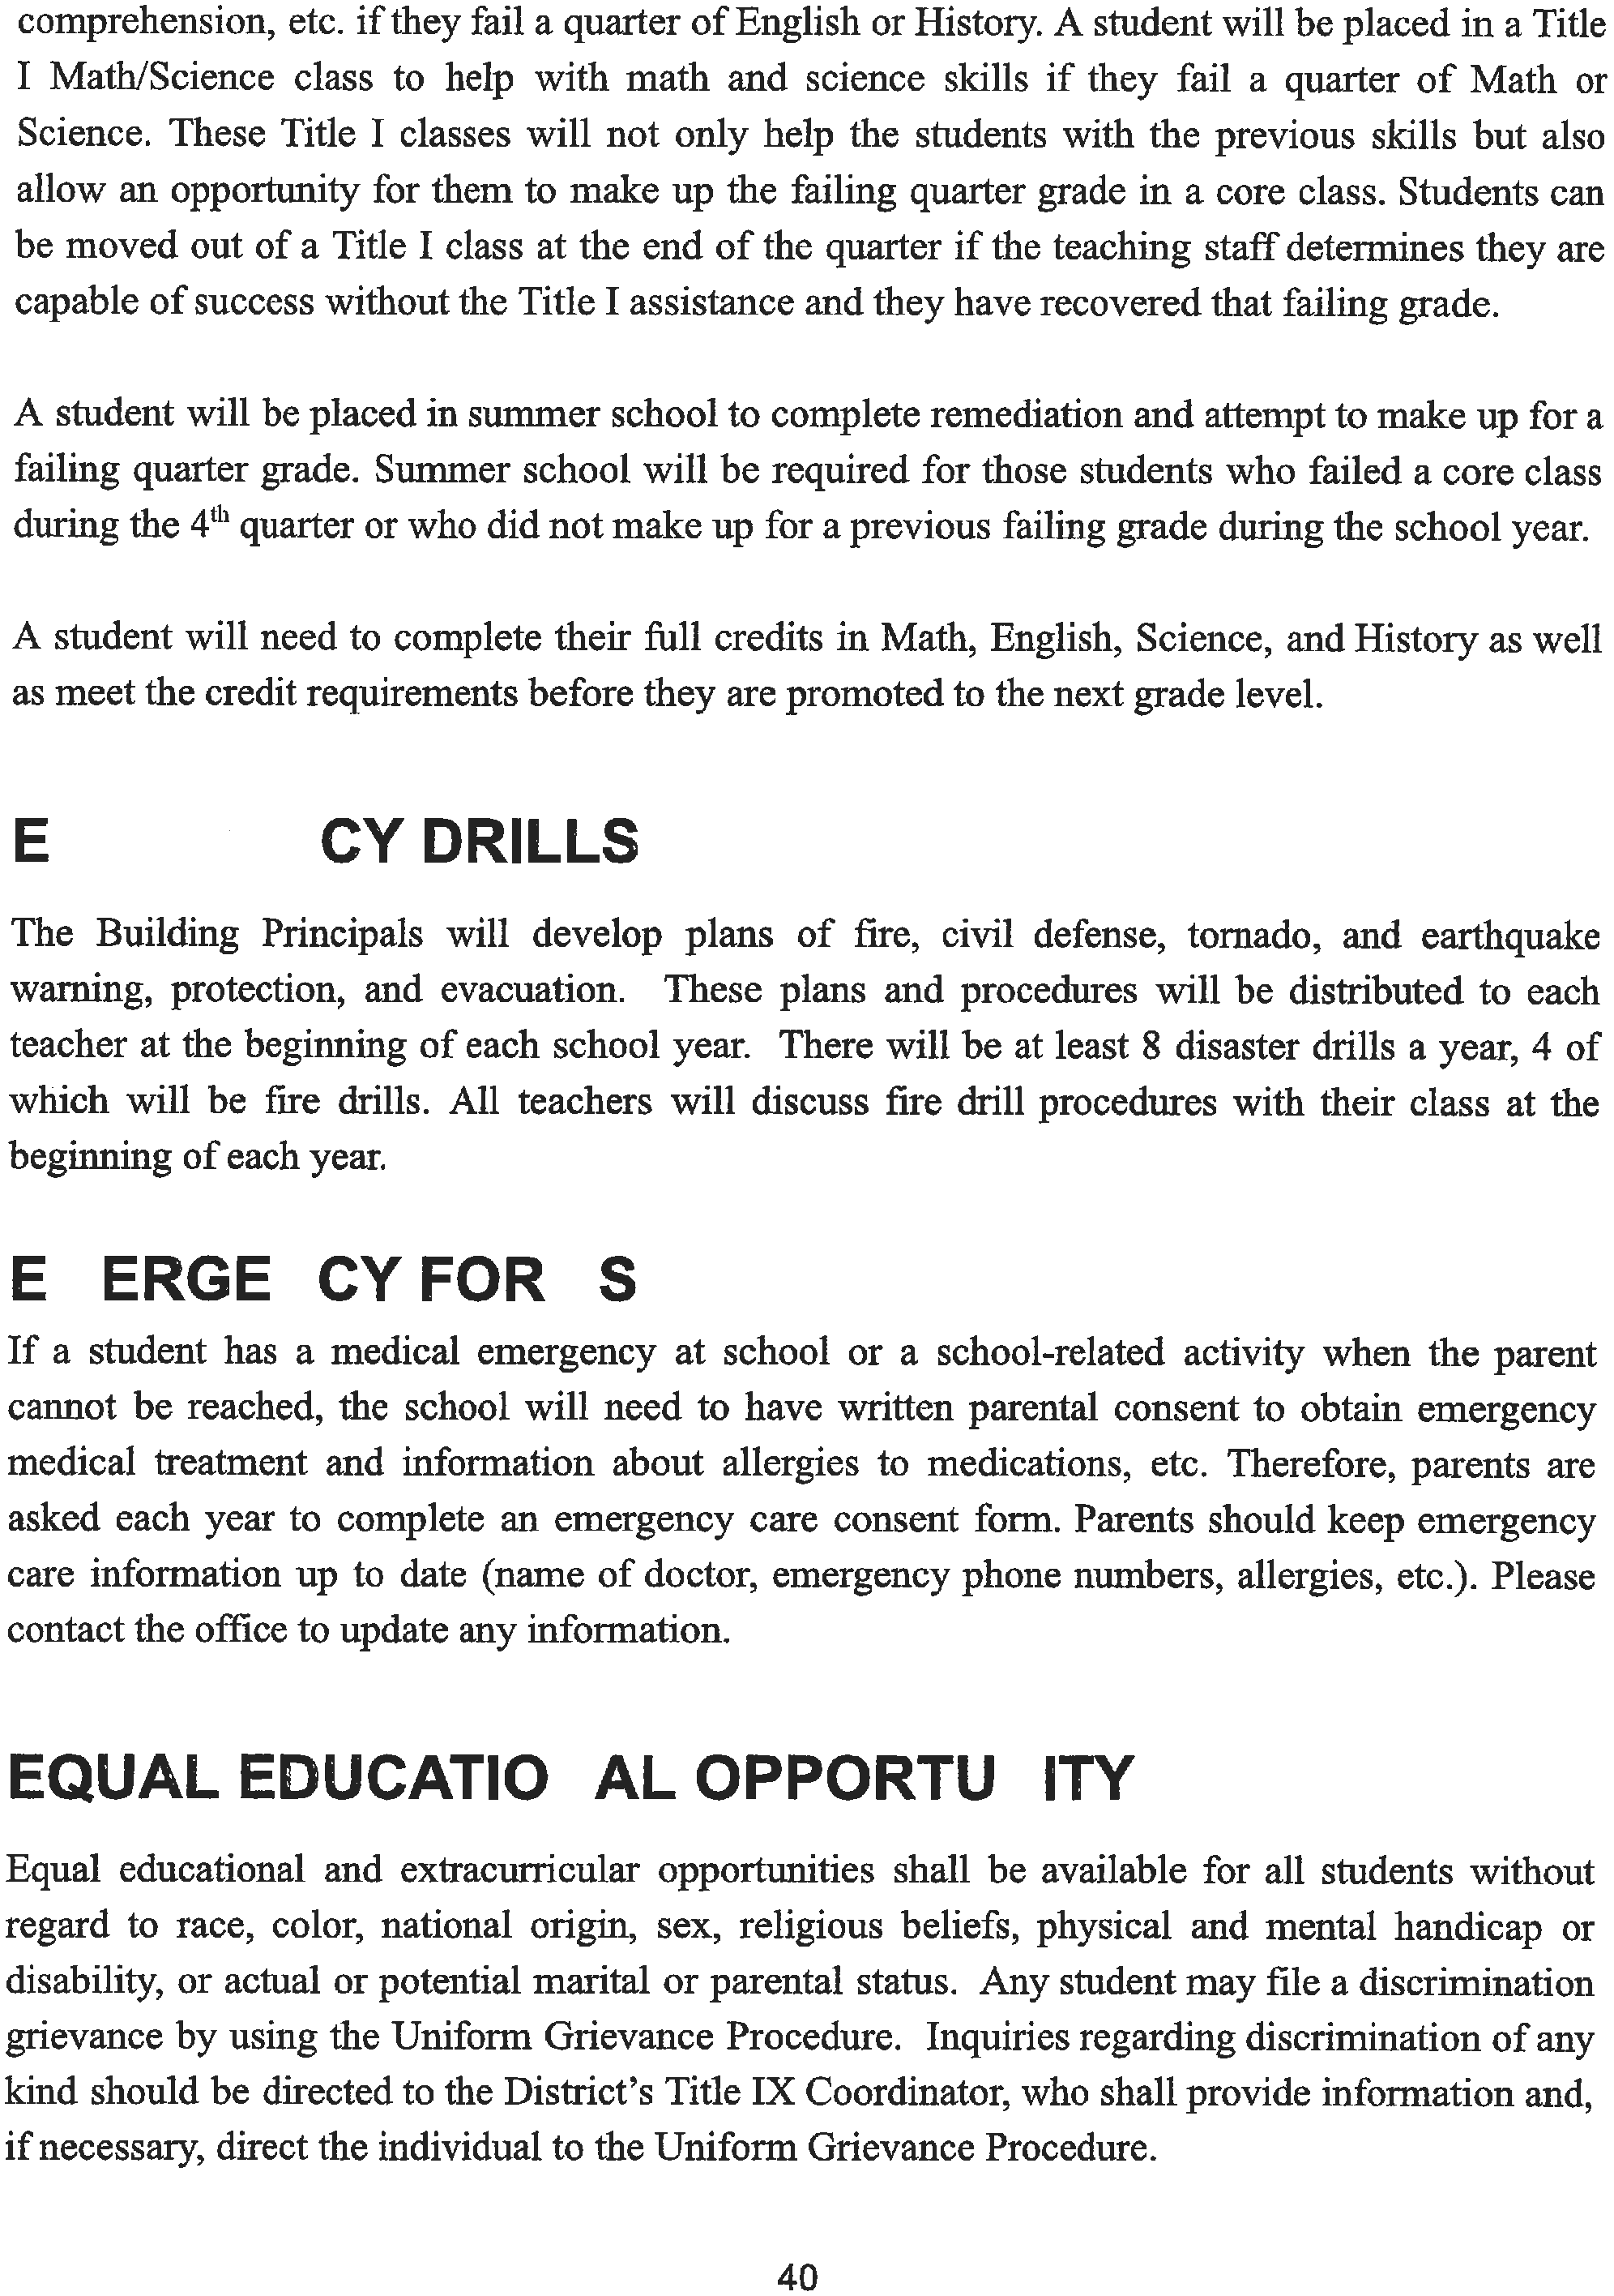

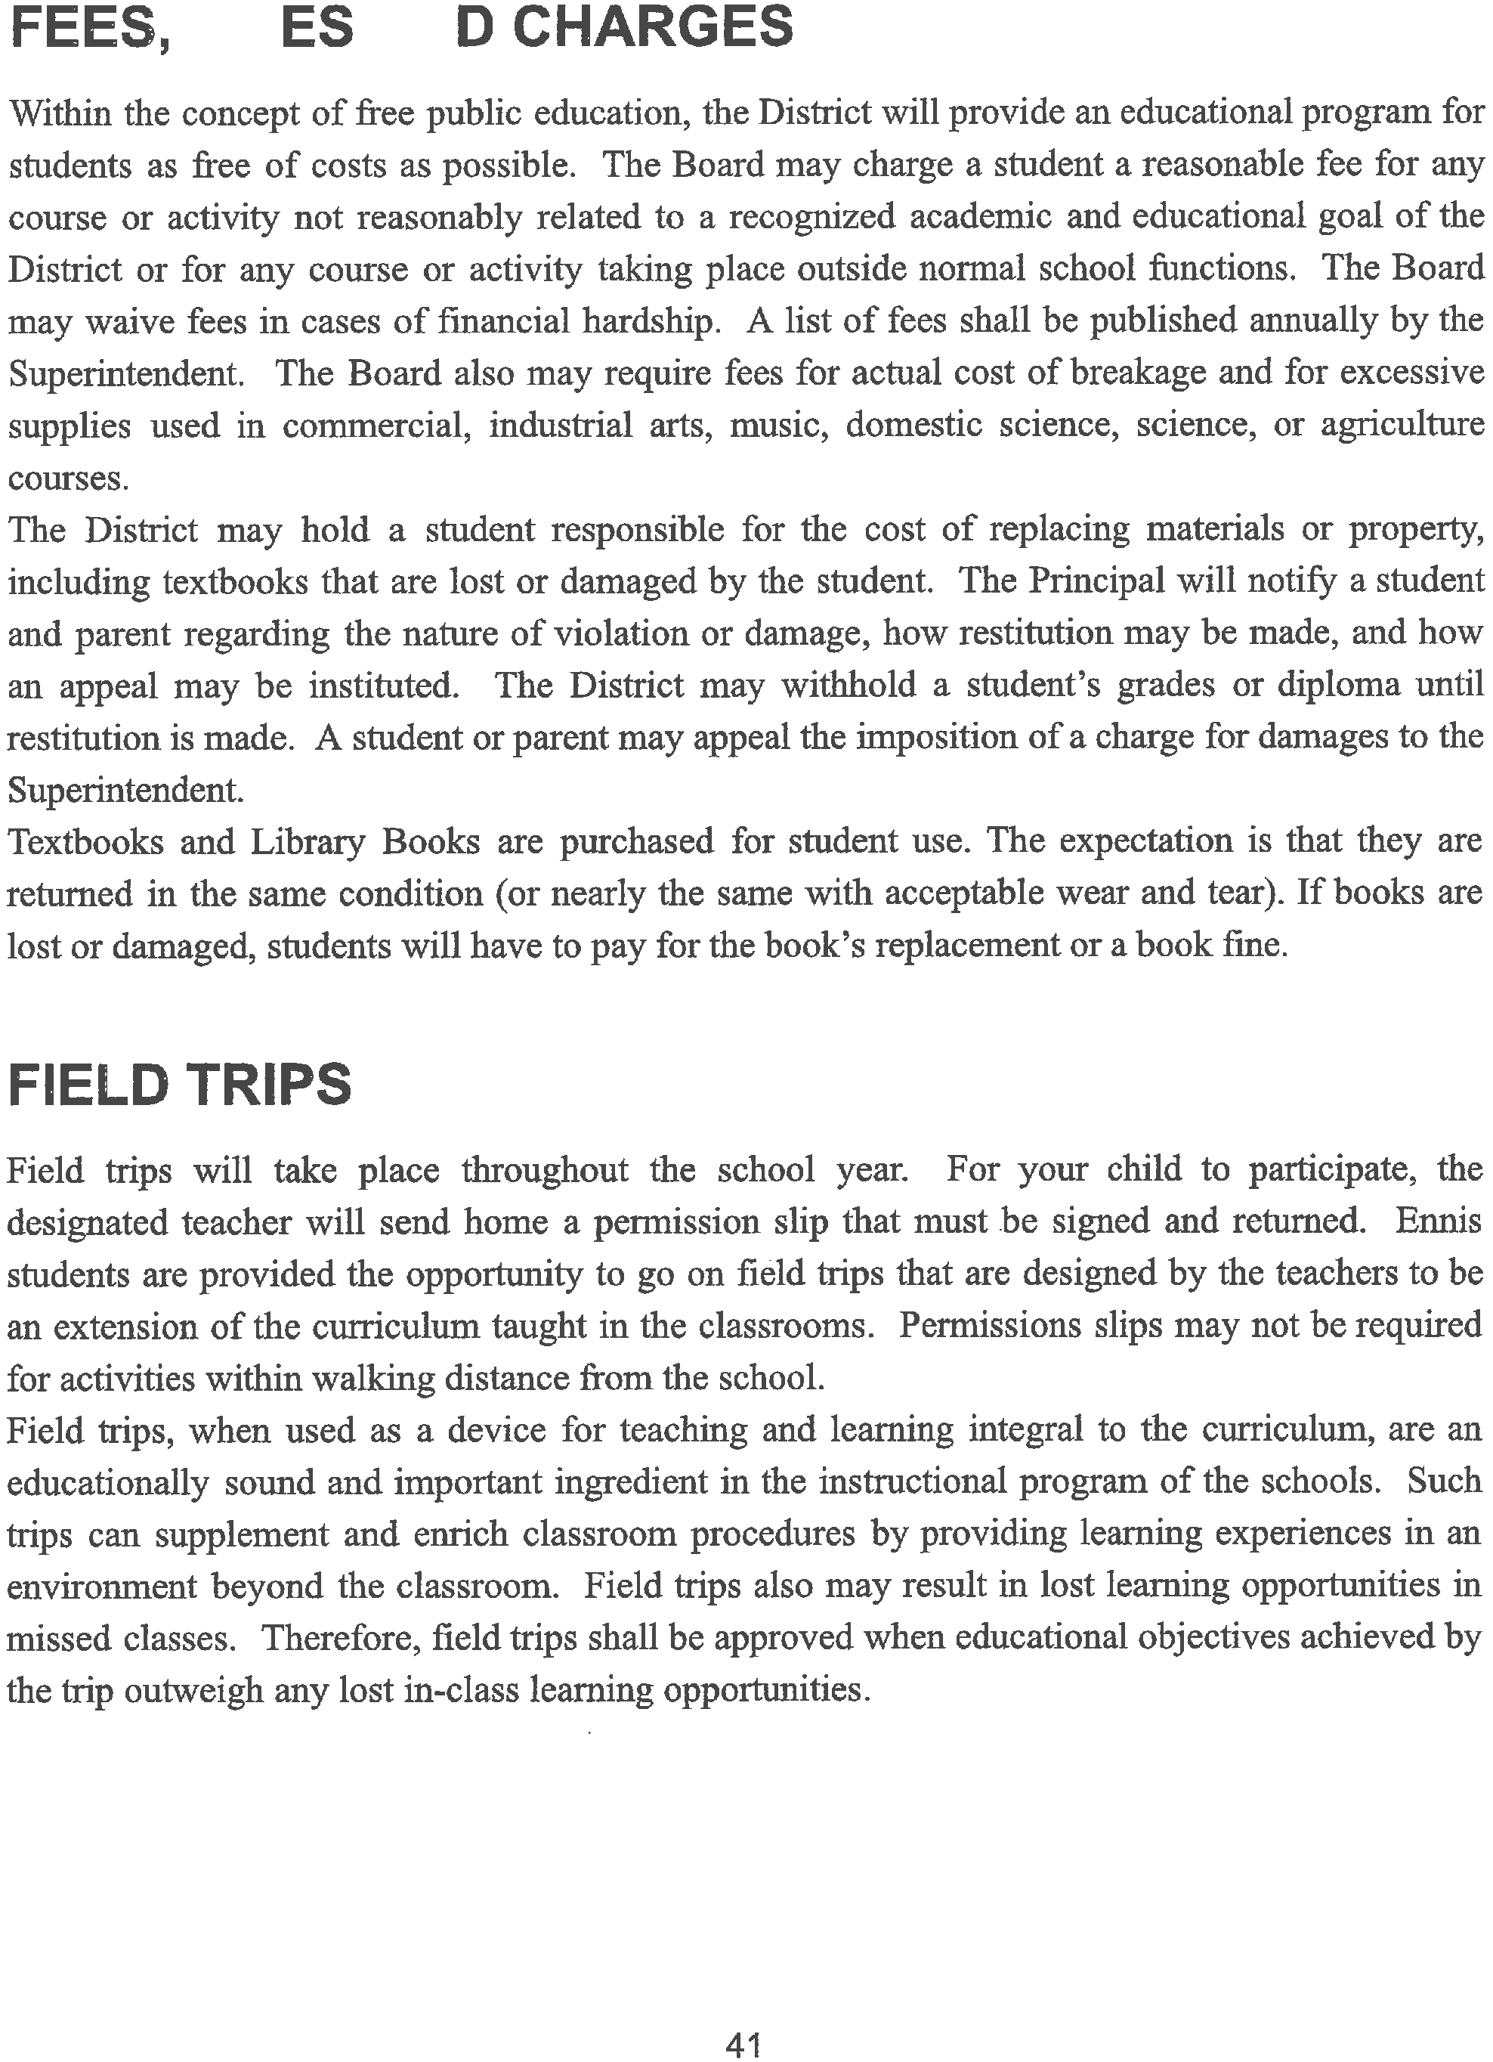

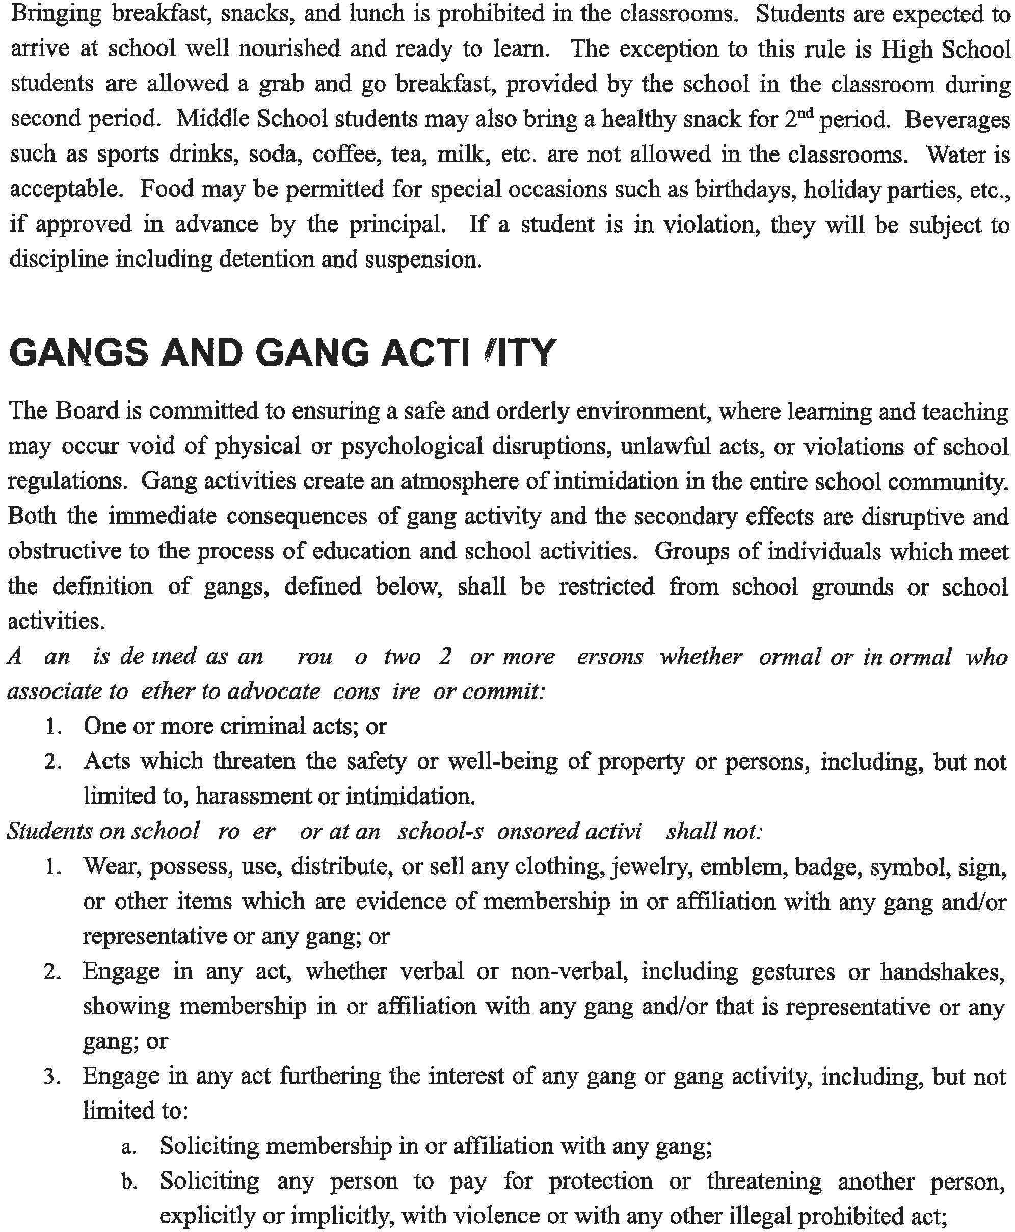

    - Painting, writing, or otherwise inscribing gang-related graffiti, messages, symbols, or signs on school property;
    - Engaging in violence, extortion, or any other illegal act or other violation of school property.
Violations of this policy shall result in disciplinary action, up to and including suspension, expulsion, and/or notification of police.
(Parent notification/conference, OSS, referral to law enforcement, expulsion)

GRADING SYSTEM
- The four-point grading system involves five basic grades (A through F) and "I". Plus and minus may also be used.

93-100...... A 4.00
90-92........ A- 3.67
87-89........ B+ 3.33
83-86........ B. 3.00
- Grade Description
80-82........ B- 2.67
77-79........ C+ 2.33
73-76........ C 2.00
70-72........ C- 1.67
67-69........ D+ 1.33
63-66........ D 1.00
60-62........ D- 0.67
59-below.. F 0.00

A Excellent
B Above Average
C Average
D Below Average
F. Failure -no credit
I* Incomplete

*Incomplete means the student has not met or finished all of the requirements for credit. An incomplete must be made up within one week after the end of the quarter or it will become an HF".
Power School offers up to date information on your student's progress. Contact the building secretary if you do not know your username and/or password.

GRADUATION REQUIREMENTS AND CEREMONIES
The responsibility of the District, upon the students' completion of the requirements for graduation, is to issue a proper diploma to each graduate. Participation in the actual graduation ceremony is not a requirement. It is a privilege extended to students and they may be denied the right to participate.
Only students who have fully completed all requirements to graduate will be allowed to participate in the graduation ceremony. [For further information, see School Board Policy/2333/241O]

43

