Please return to Mrs. Geary on or before September 4th. Payment can be made when the orders come in.

Artwork choices for shirts: Please specify which artwork you would like on the order form:

FRONT BACK
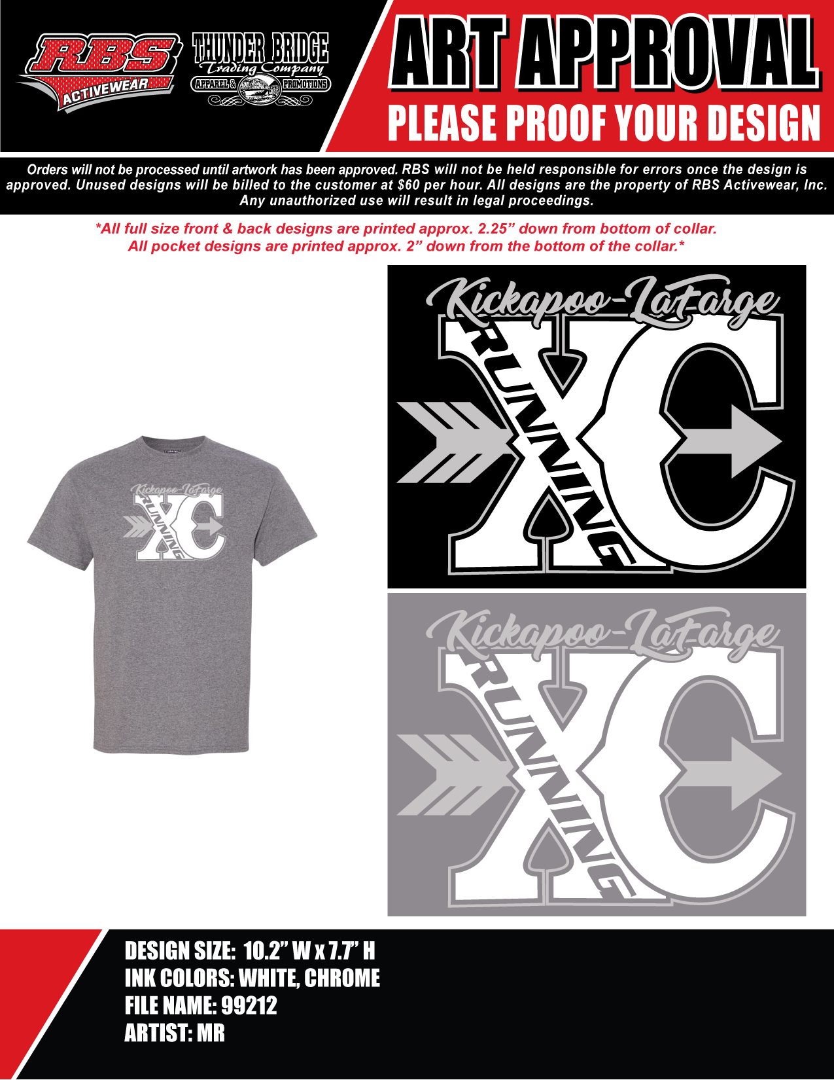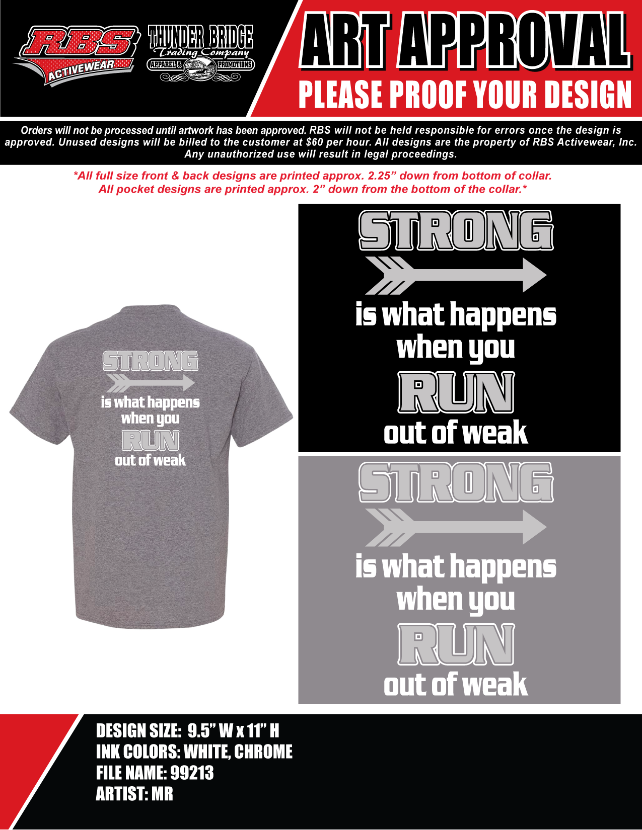

FRONT BACK

Short Sleeve T-Shirt $15.00 each up to Size XL. Add $3.00 for 2XL and $6.00 for 3XL.
Available sizes: YS, YM, YL, S, M, L, XL, 2XL, 3XL, 4XL, 5XL
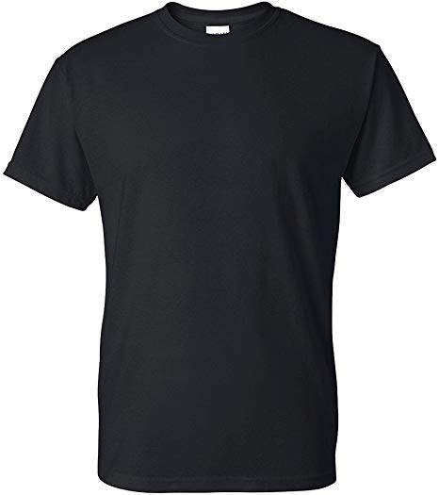 Black 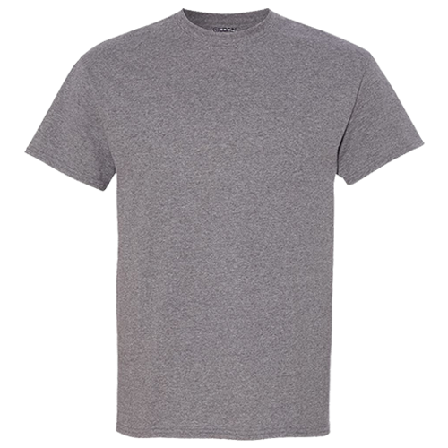Graphite Heather

Long sleeve T-Shirt $22.00 each up to Size XL. Add $3.00 for 2XL and $6.00 for 3XL.
Available sizes: YS, YM, YL, S, M, L, XL, 2XL, 3XL, 4XL, 5XL
Add $5.00 if you want last name on the sleeve
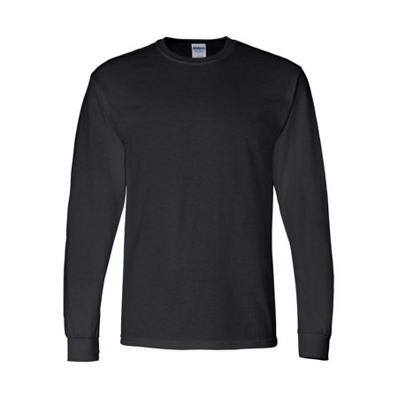 Black Graphite Heather

Sweatshirt $30.00 each up to Size XL. Add $3.00 for 2XL and $6.00 for 3XL.
Available sizes: YM, YL, S, M, L, XL, 2XL, 3XL
Add $5.00 if you want last name on the sleeve
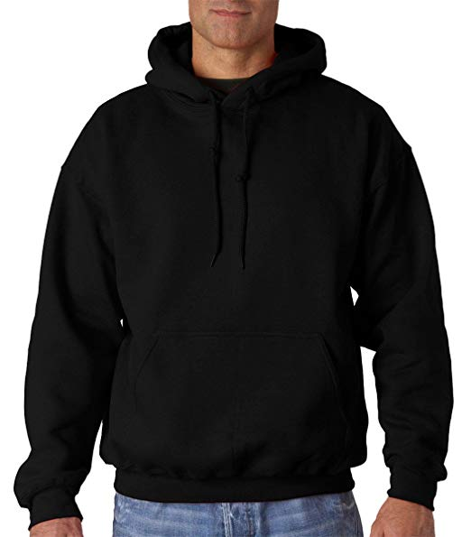 Black 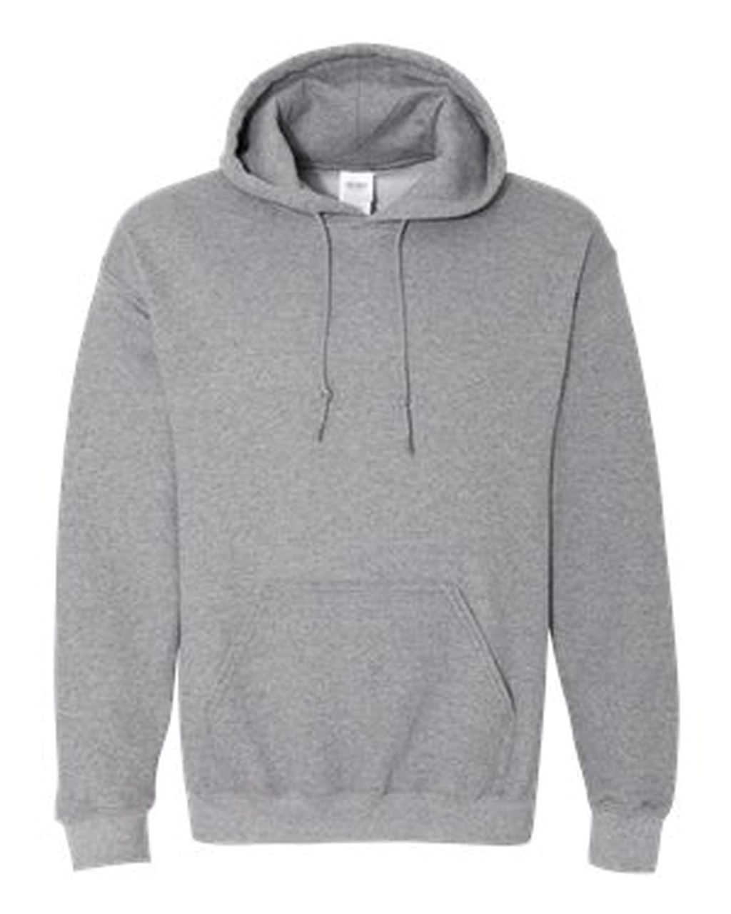 Graphite Heather

Jacket and Pants are embroidered

Jacket $54.00 each up to Size XL. Add $3.00 for 2XL and $6.00 for 3XL. (No Youth sizes)
Available sizes: YS, YM, YL, S, M, L, XL, 2XL, 3XL

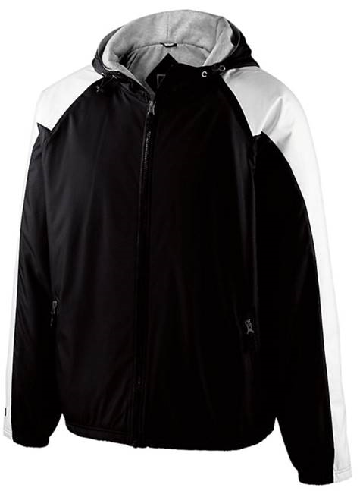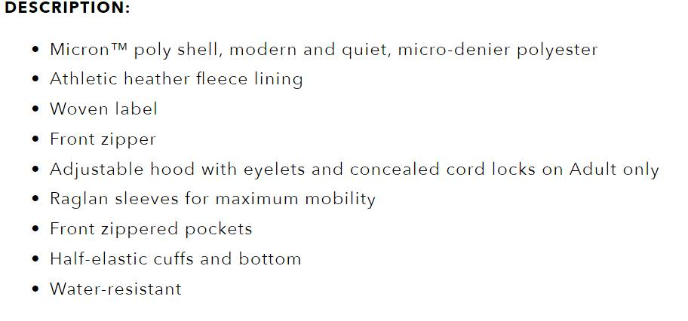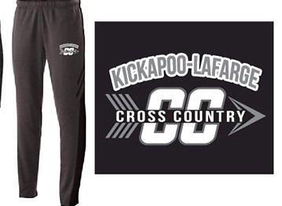

Athletic Pant $48.00 each up to Size XL. Add $3.00 for 2XL and $6.00 for 3XL.

Available sizes: YS, YM, YL, S, M, L, XL, 2XL, 3XL

NAME OF PERSON ORDERING:______________________________

ITEM: | Size | COLOR  (circle one) | ARTWORK  (circle one) | ARTWORK  (circle one)
Short Sleeve T-Shirt |  | Black  Graphite Heather
Long sleeve T-Shirt |  | Black  Graphite Heather |  |  | If wanted:  Name on sleeve for long sleeve t shirt and sweatshirt add $5.00  **Specify name you would like below:
Sweatshirt |  | Black  Graphite Heather |  |  | If wanted:  Name on sleeve for long sleeve t shirt and sweatshirt add $5.00  **Specify name you would like below:
ITEM | SIZE | If wanted:  Name embroidered on jacket add $5.00
Jacket
Sweatpants

