August/ September
2019
Breakfast / Lunch
Monday | Tuesday | Wednesday | Thursday | Friday
26 | 27 | 28 | 29 | 30
Breakfast- Biscuit w/ gravy Sausage Patty  A-Chicken Parmesan  B-Popcorn chicken | Breakfast- breakfast taco  A-Hot Ham and Cheese  B-Taco Fiestada Pizza | Breakfast- waffle w/ Syrup  A-Italian meatball sub  B-Fish Sticks | Breakfast- Sausage pancake stick  A-Tex-Mex Mac n’ Cheese  B-Pulled Pork Sandwich | Breakfast- Glazed Donut  A-Chili w/ chips and cinnamon roll  B-Crispy chicken sticks
2 | 3 | 4 | 5 | 6
No School | Breakfast- breakfast pizza  A-Chicken and noodles  B-Corn dog | Breakfast-Cheesy scrambled eggs  A-Beef soft shell tacos  B-Chicken wrap | Breakfast-French Toast  A-Goulash  B-Cheeseburger | Breakfast-Eggs and cheese biscuit  A-Walking Taco  B-Hot Dog on a bun
9 | 10 | 11 | 12 | 13
Breakfast-biscuit w/ gravy Sausage Patty  A-Sliced Turkey w/ gravy  B-Chicken Nuggets | Breakfast- breakfast taco  A-Spaghetti w/ meat Sauce  B-Pork Rib Sandwich | Breakfast- Waffle w/ Syrup  A-Beef and cheese Burrito  B-Crispy Chicken Sandwich | Breakfast- Sausage Pancake sticks  A-Italian Dunker  B- BBQ Meatball Sub | Breakfast- Glazed Donut  A-Sloppy Joe on bun  B-Pepperoni Pizza
16 | 17 | 18 | 19 | 20
Breakfast- Pancakes w/ syrup  A-BBQ Chicken sandwich  B-Country Pork Fritter | Breakfast- Sausage, Tri Tater, and Toast  A-Ham and Scalloped Potatoes  B-Cheese pizza | Breakfast- Dutch Waffle  A-Super Mexi Tots  B-Popcorn Chicken | Breakfast- Breakfast sliders  A-Chicken Alfredo w/ noodle  B-Cheeseburger | Breakfast- Cinnamon roll  A-Grilled Cheese  B-Chicken Wrap
23 | 24 | 25 | 26 | 27
Breakfast-breakfast pizza  A-Creamy Mac n’ Cheese  B-Mini Corn dogs | Breakfast- Cheesy Scrambled eggs w/ toast  A-Nachos Grande  B-Chicken Wrap | Breakfast- French Toast w/ syrup  A-Tangerine Chicken  B-Meatballs w/ gravy | Breakfast- Egg and cheese biscuit  A-Tater tot Casserole  B-Stuffed Crust Cheese Pizza | Breakfast- Long john Donut  A-Pork Rib Sandwich  B-Taco Quesadillas
30
Breakfast- Biscuit w/ gravy Sausage Patty  A-Chicken Parmesan  B-Popcorn Chicken |  | 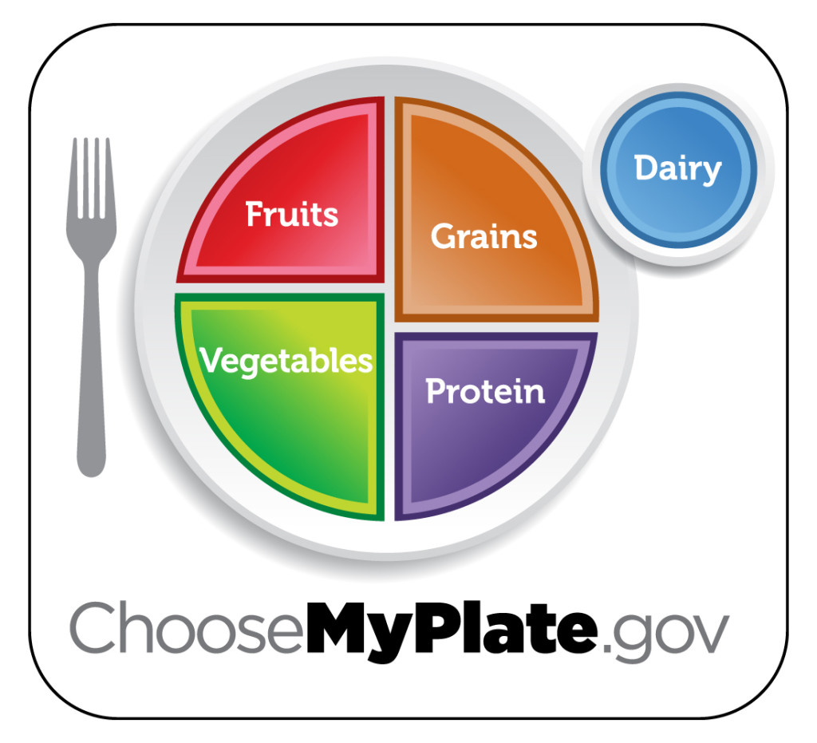 | 