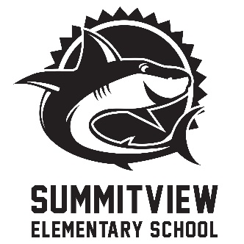
Getting to Know You
Spirit Days!

Summitview Elementary will be hosting Getting to Know You Spirit Days from Tuesday, August 27 through Friday, August 30. We encourage all students and staff to participate in order to meet new friends who share favorites!
Tuesday, August 27 | Wear Your Favorite Color
Wednesday, August 28 | Wear something related to your favorite sport or activity
Thursday, August 29 | Wear something that shows your favorite animal or favorite place
Friday, August 30 | Wear your Summitview spirit wear!

