Soulsbyville School Music Program
Music Instrument Rental Fair
Get all your music supplies for the year in one night!

Hello Parents,
The Soulsbyville Music Program is hosting an instrumental rental fair for Gottschalks Music of Modesto. Take this opportunity to stock up on music supplies and/or rent an instrument for your student!
The Fair will be hosted in the…
Soulsbyville School Band Room on Friday, August 23rd. From 4:00-6:00pm.
Gottschalks Music will be renting: flutes, clarinets, alto and tenor saxophones, trumpets, trombones, euphoniums (baritones), and bell kits for percussion students.

Additionally, students must have the following materials for band:
Flutes – Cleaning rod and cleaning cloth.
Clarinets and Saxophones – Reeds, cork grease, cleaning swab, and neck strap for saxophones.
Trumpets, Baritones, and Tubas – Valve oil.
Trombones – None
Percussion – Bell Kit and drum sticks
Additionally, all 5th grade students must have the method book Essential Elements 2000 for their instrument. All materials listed above, as well as the method book, will be sold at Rental Fair!

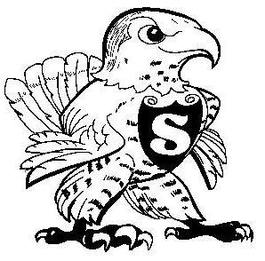
Please talk with Mr. Dooley if you are unable to provide any of the following. The school has a limited inventory that may provide you child with such supplies. Students will never be excluded from music due to financial constraints!

Thank you,

Kyle Dooley
Director of Instrumental Music
Soulsbyville School
(209) 532-1419 (ext. 3347)
kdooley@soulsbyvilleschool.com

