Belt/Centerville Cross Country

2019 Schedule

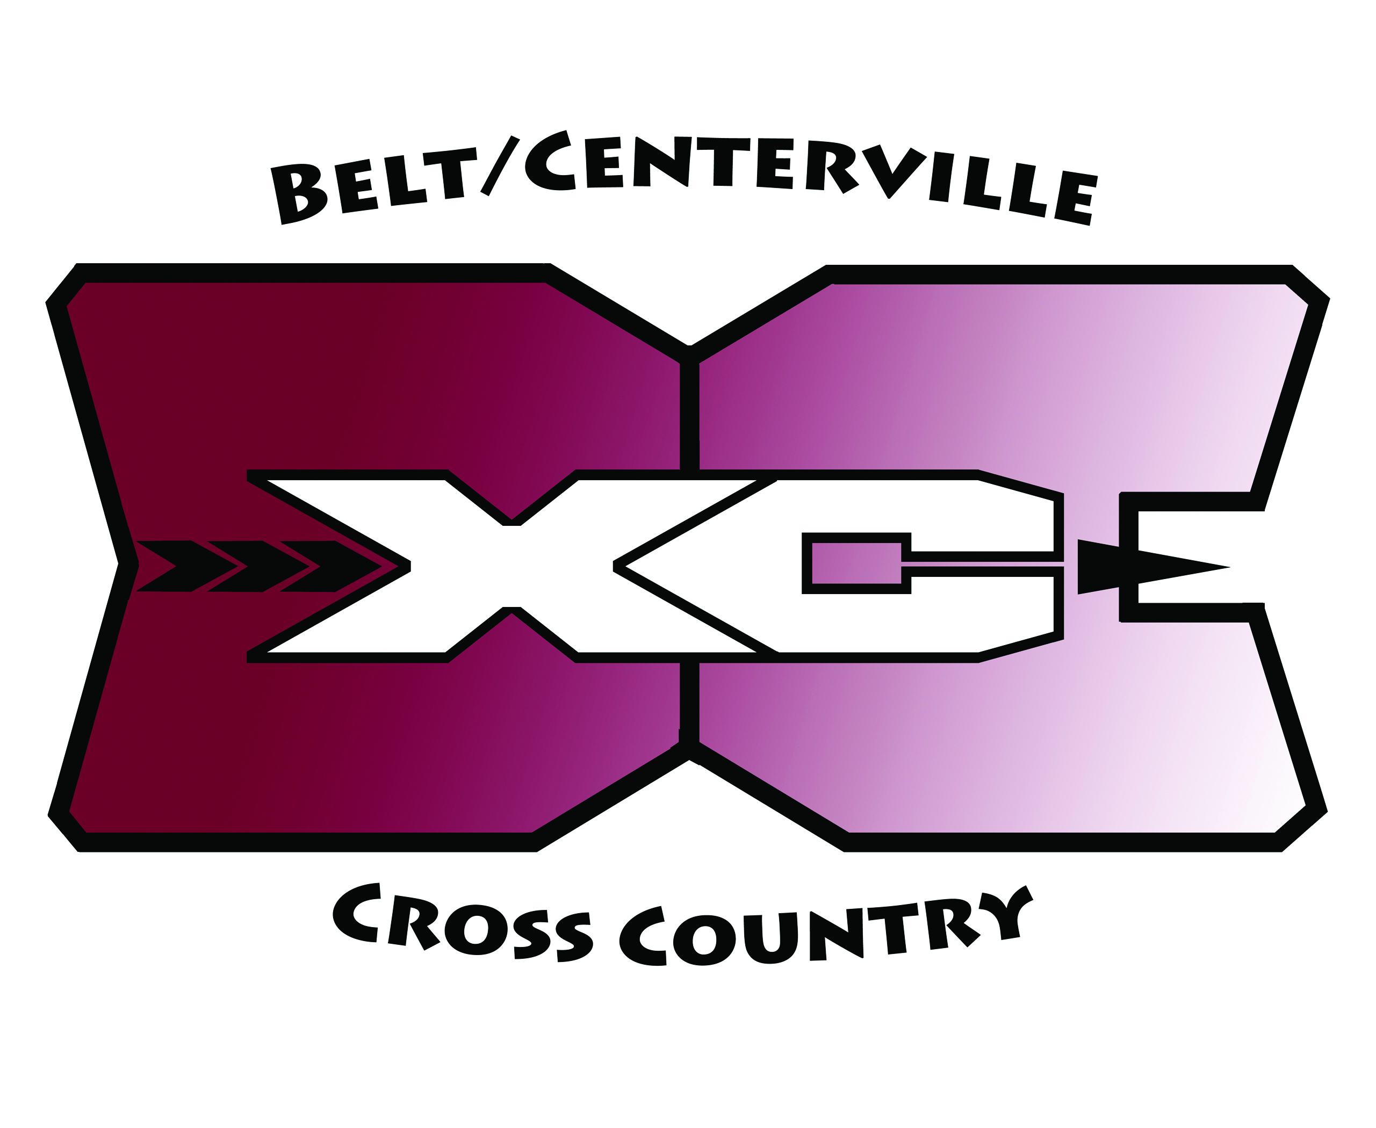

VARSITY TIME DESTINATION C-VILLE BELT
Friday, Aug. 16th TBA First Day of Practice TBA TBA
Friday, Sept. 6th 4:20 PM Cut Bank 11:30 AM 12:15 PM
Tuesday, Sept. 10th 11:00 AM Lewistown 7:00 AM 7:30 AM
Monday, Sept. 16th 4:20 PM Shelby 12:00 PM 12:45 PM
Friday, Sept. 20th 3:00 PM Great Falls 12:45 PM 1:30 PM
Saturday, Sept. 28th 9:30 AM Missoula 4:30 AM 5:15 AM
Saturday, Oct. 5th 12:00 PM Havre 6:30 AM 7:15 AM
Thursday, Oct. 10th 1:00 PM Helena 10:00 AM 10:45 AM
Saturday, Oct. 19th 11:00 AM Townsend 6:15 AM 7:00 AM
Saturday, Oct. 26th Boys Race 2 Great Falls (State)
Girls Race 4

JUNIOR HIGH
Friday, Aug. 16th TBA First Day of Practice TBA TBA
Friday, Sept. 6th 3:30 PM Cut Bank 11:30 AM 12:15 PM
Tuesday, Sept. 10th 10:00 AM Lewistown 7:00 AM 7:30 AM
Monday, Sept. 16th 3:30 PM Shelby 12:00 PM 12:45 PM
Monday, Sept. 23rd 4:15 PM Great Falls – Lyons Park 2:30 PM 3:15 PM
Monday, Sept. 30th 4:15 PM Great Falls – Lyons Park 2:30 PM 3:15 PM
Saturday, Oct. 5th 10:00 AM Havre 6:30 AM 7:15 AM
Monday, Oct. 7th 4:15 PM Great Falls – Lyons Park 2:15 PM 3:00 PM
Saturday, Oct. 19th 10:00 AM Townsend 6:15 AM 7:00 AM

Dates and times subject to change.

8/6/2019

