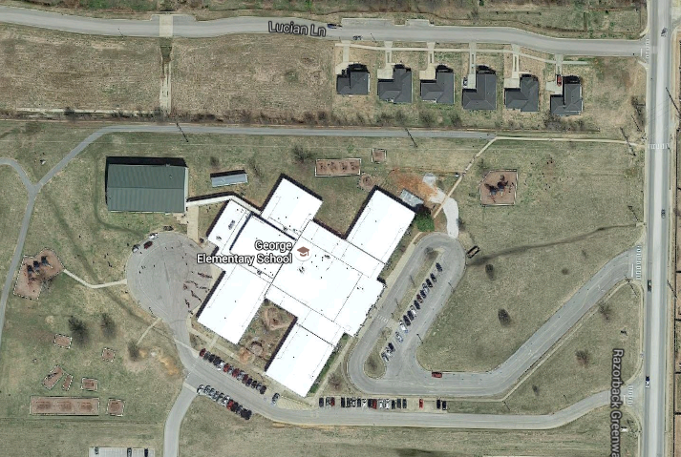

No parking and no student drop off zone from 7: 30-8:15.

Prekindergarten arrival and office visitor parking only

No Parking Zone/No student drop off zone

Doors open at 7:30 AM. Use the driveway loop to drop off students. Pull all the way to the first spot before unloading children. The spots in the front of the building are for pre-kindergarten parking and for parents who need to come into the office in the morning**. Parking for parents walking students into the building is designated below.**

**Arrival Directions**

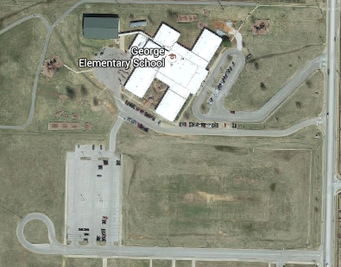

Parking for parents walking into school with children.

**If you would like to walk in to school with your child, use the parking lot pictured below. Do not park in the front or side driveways. They are for car traffic and buses. Use the parking lot pictured below.**



No Parking Zone/No student pick up zone

No parking in these spots from 3:00-3:30. These areas are for buses, prekindergarten pick up, bike riders and walkers.

**Dismissal Directions**

For your child’s safety, please keep your enrollment cards in the office current. If someone is not on the card to pick up your child, they will not be allowed to pick them up without prior approval from you.

Please do not change the way your child goes home from day to day. The most consistent way is the safest way for your child. Thank you for helping us with this!

We learn until 3:00 PM each day. Checking children out early to go home is not permitted, as it causes disruptions when we call to get the child, and it also reduces the learning time for all students. If your child has a doctor’s appointment, please check out by 2:30 PM. We will not call into classrooms after 2:30 in order to keep learning going until 3:00 PM. Thank you for helping us make the most of every teaching and learning opportunity.

All cars enter and exit through this lane. Keep your car rider tag up all the way around the loop. Take it down when leaving the school property. Any person who does not have his/her child’s tag will be sent to the office to pick up their child after 3:15 PM. Please do not park in the front of the building and take your child out of the walker line. These procedures are for the safety of all students.

3:00- Buddy walkers and bus riders are dismissed.

3:03- Regular walkers/bike riders are dismissed.

3:10- Car riders are dismissed.

* Parents may pick up children with their car tags at the back door starting at 3:10 if they have appointments etc. Park in the large parking lot between the two schools. Car tags must be shown. People without car tags or proper identification will be sent to the school office to verify identification before the child will be released.