Delwood Community School

311 Delmar Ave., P.O. Box 292
Delmar, IA 52037
(563) 674-4164

Preschool Program
and
Childcare Program

Parent Handbook
2019-2020

Delwood Mission Statement
Striving to meet the individual needs of children in a family atmosphere, promoting positive and creative learning.

Delwood Vision Statement
The Delwood School, in partnership with the community, is dedicated to providing a stimulating learning environment, which maximizes the potential of all students to be lifelong learners.

Goals Light the Way
The Delwood Community School District strives to
create a passion for learning that will sustain
students for a lifetime.

District Belief Statements
We believe that:
• Delwood Elementary will continue in our community.
• All students are capable of learning when challenged
appropriately.
• Our school, parents and community are partners in growth.
• Adequate facilities are crucial to the Delwood community.
• Our school must always plan for the future.
• Staff development must be ongoing to meet the changing needs of students.
• An education is vital in everyone’s life.
• We can always improve.
• All individuals should show respect for others and for themselves.
• Technology is an essential tool that can improve student learning and foster creativity.

School Board Goals

• Remain financially stable and an independent
school district.

• Support and enhance opportunities for middle and high school students.

• Build community support and growth in
enrollment.

• Increase achievement of all students.

• Support all Delwood families by providing a before and after school program and a quality preschool program in our district.

Preschool Teaching Staff
Preschool Teacher – Cathy Pickup
Preschool Teacher – Melissa Hawley
Preschool Associates – Cindy Marsh-Vervaecke
Ruth Fuegen
Jammie Goodenow

Delwood Preschool Program Options
All Delwood 4-year old students are welcome in our Delwood Preschool Program. The only requirement is that all children who participate in our program be toilet trained. Full or partial day programs are available, with wrap-around childcare options available each day. We will limit our preschool program to 16 or fewer students per section. The preschool program will start after Labor Day and run in conjunction with the Delwood Community School calendar. The Preschool and Childcare Programs will not be held on full staff development days. We will run both AM and PM preschool programs on scheduled Wednesday 1:30 dismissal days. Both will run in the AM. 2019-2020 school calendar will be provided to parents.

Preschool Programs

4-Year Old Options
Full week / 5-Day Preschool Program - (Monday through Friday)

If your child is at least 4-years old, by Sept. 15th, 2019, there will be no cost for the Delwood Preschool Program. Childcare and lunch costs will apply.
3-Year Old Options
If we have room available, after serving all of our resident 4-year old students, we will take 3-year old students. Programming available for 3-year old students will depend on slots available after our spring sign-up period. All 3-year old students will have to pay for the 3 year old Pre School program. $300/$240 sliding fee for all day and $200/$160 sliding fee for half day, M-F.

Childcare
Childcare services will be offered so students can take advantage of an all-day program. Students will have hot lunch, recess, and play time in the childcare session. If you would like bus transportation for your child, please contact the preschool teacher for details. All preschool students are required to wear a seat-belt/harness on the bus and parents are responsible for making sure students are secure in their harnesses. Bus drivers should remain in their driver’s seat. There will be a daily $9.00/$7.20/$0 per day charge based on socio-economic status for using the childcare program at Delwood. Childcare accounts must be kept current to continue to use the program. Bills will be sent out at the end of each month.

Before School Program
Our before school program runs from 7:00 AM until 7:45 AM each day school is in session. Cost for this program is $2.00 per day. Students meet in the gym and are involved in a variety of different activities, supervised by Delwood staff. At 7:45 AM, all before school program participants will go to the Delwood breakfast program or go to recess with their classmates.

After School Program
Preschool students will also have access to our after school program, which runs from 3:30-5:30 PM, Monday through Friday. Students pay an additional fee for this program based on the number of evenings they stay for the program. Costs are $3.50/$2.50/$0 based on Socio-Economic Status. Students can sign-up for sessions a month at a time, depending on their needs. Information about this program will be available during fall registration, or by contacting Nancy Spain, our After School Program director. When school is cancelled because of inclement winter weather, there will be no After School program.

Arrival at School
Please be on time when dropping your child off for preschool and picking them up from school. You may park anywhere except on the street west of the school building, where the buses load and unload. School starts at 8:15 AM for all students and students may arrive any time after 7:50 AM. Any student arriving after 8:15 AM will be counted as tardy for the day.

Breakfast Program
All students may eat breakfast at school, from 7:45 – 8:12 AM, Monday through Friday. Breakfast menus are published in our monthly newsletters. Student breakfast cost for the 2019-2020 school year, will be $1.10 per day.

Illness Policy
If an illness prevents your child from participating comfortably in activities or creates a greater need for care than the staff can provide without compromising the health and safety of the other children, or if a child’s condition is suspected to be contagious and requires exclusion as identified by public health authorities, then the child is made comfortable in the main office in our sick bay. If the child is suspected of having a contagious disease, then the child will remain in the office area until he or she can be picked up by a family member. The child will be located where individuals will not be exposed. Parents will be notified immediately when a child is showing any signs or symptoms that require exclusion from the preschool program. Our contracted nurse will be consulted when there are any questions as to: what level and types of illness require exclusion; how care is provided for those who are ill but who are not excluded; and when it is necessary to require consultation and documentation from a health care provider for an ill child or staff member. Delwood staff will provide information to families verbally and in writing regarding any unusual level or type of communicable disease to which their child was exposed, signs and symptoms of the disease, mode of transmission, period of communicability, and control measures that are being implemented at the program and that the families should implement at home.

Cold, Heat, Sun and Insect Protection
To protect against cold, heat, sun injury, and insect borne disease, the preschool program ensures that:
• Children wear clothing that is dry and layered for warmth in cold weather.
• Children have the opportunity to play in the shade. When in the sun, they wear
protective clothing, applied skin protection, or both. Applied skin protection will be either sunscreen or sun block with UVB and UVA protection of SPF 15 or higher that is applied to exposed skin with written parental permission to do so. (Parents are responsible for supplying sunscreen or sun block for their child.)
• When public health authorities recommend use of insect repellents due to a high risk of insect-borne disease, only repellents containing DEET will be used. Staff will apply insect repellent no more than once a day and only with written parental permission. (Parents will need to supply insect repellent for their child.)

Calendar
A preschool monthly calendar will be sent home at the beginning of each month to inform parents of what events are taking place in the Delwood Preschool Program and also include our staff development day schedules.

Absence Policy
Every absence from school by students will require a phone call to the school. You may call the school from 7:30-9:00 AM to report absences to our school secretary or feel free to call anytime to leave a message. Our phone number at school is
(563) 674-4164 or (563) 574-4164. If we do not hear from you, regarding your child’s absence, we will call you to confirm reason for absence.

Transportation
Students will be allowed to ride the Delwood Community School buses in the morning and afternoon, as long as they wear the preschool vest and school bus harness available from the school. We will work with parents, on an individual basis, for bus transportation requests. Please notify
the preschool teacher if you would like school
bus service for your child.

Picking up Children
Students will need to be picked up by their parents or by the designated caregiver listed on the Delwood Emergency Forms. A picture ID may be asked for when an unknown person is picking up the child. Please notify the school and teacher if there is someone not on your authorized list who is planning to pick-up your child. Children should be picked up at 11:30 AM or 3:30 PM unless your child is riding the bus or is staying for the childcare or after school program. After School Program students need to be picked up by 5:30 PM, at the latest, or additional costs will be charged!

Weather
If there is a school delay in the morning because of weather, we will still plan to have our preschool program. Students should report to their class at 9:00 AM for any one-hour delay and 10:00 AM on two-hour delay days. If the student is participating in the before school program, we will have staff here at 7:00 AM to accommodate parent’s work schedules. Please listen to KMAQ radio in Maquoketa or KWQC-TV or WQAD for school cancellations or delays, or sign up for our Iowa School Alerts Program which gives you information through an e-mail or cell phone text regarding any weather related school announcement. When we have late starts, we do run our morning preschool program however, we do not run our breakfast program, so please make sure your child eats breakfast at home on those mornings. If we have an early dismissal because of weather, we will not have our after school program.

Curriculum Guidelines
Your child will be exposed to many different learning skills
and learning styles through our Creative Curriculum Program :
• Pre-readiness skills (academics and social)
• Exposure to shapes, reading, numbers, alphabet and colors
• Language (communication) groups
• Social/emotional skills (follow rules, share, interact with peers and adults)
• Personal information (begin to recognize name, address, etc.)
• Fine motor skills (writing, coloring, cutting, puzzles, etc.)
• Gross motor skills (running, jumping, exercising, etc.)
• Imagination/creativity (art and cooking activities)
• Music/movement
• Hands-on learning (center based activities)

Discipline Procedures
Delwood Community School teachers and support staff will use a classroom behavior management plan based on positive reinforcement. The Delwood staff is trained to set up an environment that meets each student’s developmental needs
while creating a sense of safety and security for the entire class. We will do this
through an atmosphere of mutual respect by modeling and practicing, using problem-solving skills for a peaceful resolution of conflicts.

Pet Policies

No pets will be allowed in the preschool classroom to keep all students safe from injury or diseases. Pictures of pets however, are great for weekly “Show and Tell” If you are picking up children at the end of the day, please do not bring dogs onto school property. We want to keep all children safe from injury or disease.

Confidentiality

Parents can be assured that all information regarding students in our preschool program will be kept confidential by all staff members.

Toilet Training Issues

All students participating in our preschool program are expected to be toilet trained before attending our program. Before school starts please make sure your child can independently attend to their own needs. We do ask that you provide extra clothes for that occasional “accident” that might happen.
If your child continues to have issues with soiling or wetting, we will notify parents and work on a plan to help your child be successful. If toilet training becomes a continual issue, and disrupts the regular procedures of our preschool program, we will dismiss your child from our preschool program until they are ready to return without incidents of soiling or wetting. Please notify your teacher if your child is on any medication that might require extra trips to the restroom.
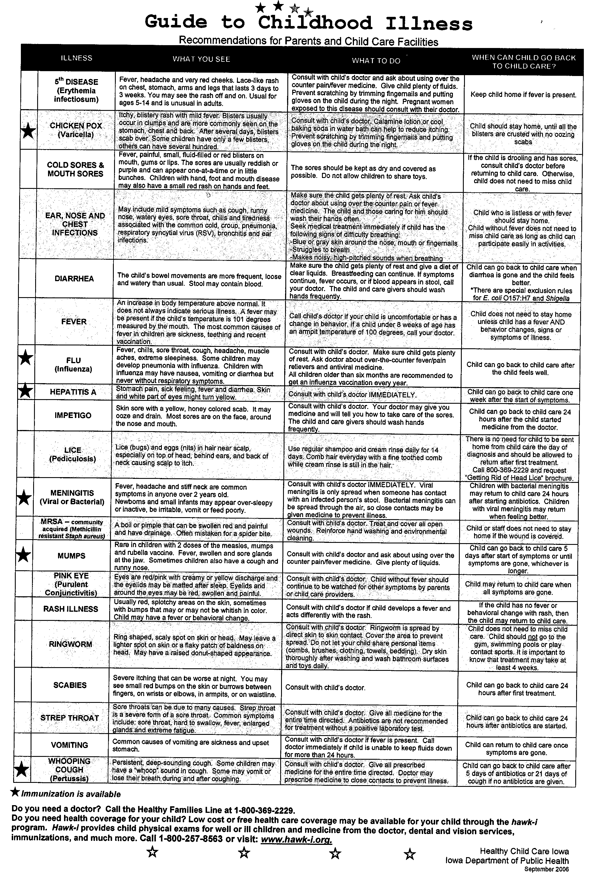

Delwood Community Preschool
Assessment Plan

Purpose

The purpose of assessment of children in the Delwood Community Preschool is to provide information to teachers and parents on children’s learning and development, and to provide a basis for making teaching, curriculum, and program decisions to meet the learning needs of children. Assessments also provide the teachers with information about children’s interests. Assessments may also lead to further referral for diagnostic testing in a variety of areas, from vision to eligibility for special services.

Procedures

Children’s progress in the Delwood Community Preschool is assessed using formal and informal methods, according to the following schedule:

• The Individual Growth and Development Indicators (IGDIS) will be used three
times/year (Fall, Winter and Spring). This formal assessment tool measures children’s growth in rhyming, alliteration (awareness of beginning sounds in words), and segment blending (ability to blend parts of words together to make whole words). Some children may also be assessed in the area of picture naming (vocabulary).

• Teaching Strategies GOLD, based on The Developmental Continuum of the Creative Curriculum is also completed by the teachers three times a year (Fall, Winter, and Spring) and is shared with parents at parent/teacher conferences. This Continuum reports on cognitive skills, language, social-emotional development, and gross and fine motor skills (including self-help skills).

• Informal assessment also occurs throughout the school year. Multiple data sources are used, including work samples, teacher and associate observation of children’s work, play, and behaviors in individual/small group/large group settings, checklists, etc.

• The children are familiar with the teachers who do the assessments, and all
assessments are done at preschool in familiar contexts. The tasks for this
assessment documentation are assessed using authentic, observation-based assessments and documented through Teaching Strategies GOLD. The objectives of Teaching Strategies GOLD are aligned with the curriculum goals and are appropriate for the children’s abilities.

• Information from parents is an integral part of the assessment process. The parents complete the Preschool Background Questionnaire at the beginning of the school year, and this information gives the teachers valuable information about each child. The teachers also meet with parents at a home visit before school starts, and the parents are given the opportunity to provide input about their goals for their children, their concerns, possible health issues, discipline practices, and any other topics the parent(s) want to discuss. Parents also have opportunities for input into the assessment process at winter and spring parent/teacher conferences, at school improvement meetings, by directly talking to the preschool teacher or by contacting the principal/superintendent.

The teachers review the assessment procedures at least three times a year (following the Creative Curriculum schedule) to be sure that the information they are obtaining, both formally and informally, is useful and valid.

Communicating with Families

The assessment plan was created with input from a committee of parents formed from the District Advisory Committee. The committee met several times with the teachers to develop the assessment plan.

The goals of the program and information about Teaching Strategies GOLD and Creative Curriculum are shared with all parents at orientation night, and also at home visits by the teachers at the beginning of the school year. The teachers share the results of assessments at the fall and winter parent/teacher conferences. Parents are given a written summary report of their child’s progress in the developmental areas of the Creative Curriculum, and also have the opportunity to discuss the information. Parents are encouraged at all parent/teacher meetings to share any information from home to contribute to the assessment process, and are also encouraged to contact the teachers at any other time to provide input. Use of the Preschool Background Questionnaire at the beginning of the year gives parents the opportunity to share information about their children with the teachers during the first few weeks of school, and also gives parents more ideas of the types of skills that will be worked on during the preschool year.

The Delwood Community School District is sensitive to family culture and home languages, and has access to an interpreter who will attend parent/teacher conferences if needed. If necessary, an interpreter could also assist the teachers with assessment of ELL children.

Confidentiality

Children’s classroom assessments are kept in locked file cabinets in the classrooms, and the classrooms are also locked overnight. Cumulative records are kept in the school office, and access to these records has the same limitations/requirements as all school records.

Referral for Diagnostic Assessment

One of the purposes of assessment in the Delwood Community Preschool is to determine if children are eligible for special education services. When indicated by formal and informal assessment results, teachers may refer children for problem solving or evaluation by other school and/or Mississippi Bend AEA staff. The procedures are the same as for school-age children and parents are involved at every level.

Uses of Assessment Information

Information gained from formal and informal assessments is used to determine the developmental progress of the children in the areas of language development, cognitive development, social-emotional development (including health), and motor development (including self-help skills). It is also used to identify the interests of the children. The teachers use the information to plan classroom and individual goals for the children, and to make any necessary changes to the curriculum, environment and/or teaching practices. For example, if the fall assessment indicates that a group of children or individual children are having difficulty with a goal of the Creative Curriculum such as number concepts, the teachers include more direct teaching of numbers into their planning. Ongoing observation and results from the winter assessments are then analyzed to monitor progress and determine if the teaching and activities have been effective to improve children’s progress in the area of numbers.

The teachers analyze data weekly and use data collected to plan upcoming activities. Our staff is highly involved in the Multi- Tiered Systems of Support (MTSS) process and teachers work diligently to match effective interventions with students that are not showing grade level skills. Teachers use this professional development time to interpret assessment information and make necessary adjustments to their activities and areas of emphasis for the coming weeks.

Access Policy

Centers are responsible for ensuring the safety of children at the center and preventing harm by being proactive and diligent in supervising not only the children, but other people present at the facility.

- Any person in the center who is not an owner, staff member, substitute, or subcontracted staff or volunteer who has had a record check and approval to be involved with child care shall not have “unrestricted access” to children for whom that person is not the parent, guardian, or custodian, nor be counted in the staff to child ratio.
*“Unrestricted access” means that a person has contact with a child alone or is directly responsible for child care.
*It is imperative that centers not allow people who have not had a record check assume child care responsibilities or be alone with children. This directly relates both to child safety and liability to the center.

- Persons who do not have unrestricted access will be under the direct “supervision” and “monitoring” of a paid staff member at all times and will not be allowed to assume any child care responsibilities. The primary responsibility of the supervision and monitoring will be assumed by the teacher unless he/she delegates it to the teacher assistant due to a conflict of interest with the person.
*“Supervision” means to be in charge of an individual engaged with children in an activity or task and ensure that they perform it correctly.
*“Monitoring” means to be in charge of ensuring proper conduct of others.

- Center staff will approach anyone who is on the property of the center without their knowledge to ask what their purpose is. If staff is unsure about the reason they will contact their Site Manager or another management staff to get approval for the person to be on site. If it becomes a dangerous situation staff will follow the “intruder in the center” procedures. Non-agency persons who are on the property for other reasons such as maintenance, repairs, etc. will be monitored by paid staff and will not be allowed to interact with the children on premise.

- A sex offender who has been convicted of a sex offense against a minor (even if the sex offender is the parent, guardian, or custodian) who is required to register with the Iowa sex offender registry (Iowa Code 692A):
  - Shall not operate, manage, be employed by, or act as a contractor or volunteer at the child care center.
  - Shall not be on the property of the child care center without the written permission of the center director, except for the time reasonably necessary to transport the offender’s own minor child or ward to and from the center.
    - The center director is not obligated to provide written permission and must consult with their DHS licensing consultant first.
    - If written permission is granted it shall include the conditions under which the sex offender may be present, including:
      - The precise location in the center where the sex offender may be present.
      - The reason for the sex offender’s presence at the facility.
      - The duration of the sex offender’s presence.
      - Description of how the center staff will supervise the sex offender to ensure that the sex offender is not left alone with a child.
      - The written permission shall be signed and dated by the director and sex offender and kept on file for review by the center licensing consultant.

Biting Policy

Even in the best child care center, periodic outbreaks of biting occur among infants, toddlers and sometimes preschoolers and occasionally older children. This is an unavoidable consequence of grouping young children together. When it happens, it can be scary and very frustrating for children, parents and teachers. Understanding the reason for biting is the first step to changing a child’s behavior. Children bite for a variety of reasons: teething, simple sensory exploration, cause and effect, imitation, crowding, seeking attention, frustration and stress. Childcare group situations are difficult: dealing with others constantly around, sharing attention and toys, and too much or too little stimulation are all very difficult for children. Biting is not something to blame on children, their parents or their teachers. When biting breaks out, a high quality childcare program immediately takes action, not to blame the biters but to change the environment and help children change their behavior.

It is important that the caregivers remain calm and in control of their emotions when biting occurs. Staff should not show anger or frustration towards the child. The caregiver should calmly respond to the child, letting them know that biting is not ok. In addition the following steps will be taken.
- The teacher will remove the child from the situation and focus caring attention on the child who was bitten.
- Encourage the biter to help take care of the child that was bitten (hold ice pack, comfort the child).
- The care giver should talk to the child who bit (if able to communicate) and talk about different strategies that the child can use next time (give them appropriate words-if able) instead of biting. This should be done is a short simple way.
It is important to explore the reasons for biting when it occurs. Staff need to work with parents to gather information about the child’s behavior and begin observations to determine the reasons for biting. Examples of some triggers would be: communication deficits, transitions, hunger, lack of sleep, need for oral stimulation or teething pain. Once triggers are identified, staff can work on prevention strategies and start teaching replacement skills. Below are some examples of how the teacher will begin this assessment.
- The teacher will examine the context in which the biting is occurring and look for patterns. The teacher will use the Center Action Plan for documentation and ask the following questions:
- Was the space too crowded
- Were there too few toys
- Was there too little to do or too much waiting
- Was the child who bit getting the attention and care he/she deserved at other times, other than when he/she was biting
- The teacher will change the environment, routines or activities if necessary
- The teacher will work with the child who is biting to resolve conflicts and frustrations in more appropriate manners, including using words, if they are capable of them.
- The teacher will observe the child, to get an idea of why and when they are likely to bite.
- The teacher will identify children likely to be bitten and make special efforts to reduce their chance of being bitten.
- The teacher, parent and administration will meet regularly to regulate an action plan and to measure the outcome of these changes.
- If biting continues the teacher will observe the group more closely and work with the parents to seek out additional resources as necessary to shadow the child who is biting.

First Aid in response to biting (both child and adult)
- Wear gloves, clean wound with soap and water. Run water over wound for 5 minutes.
- Apply ice or cool compress to help reduce the pain or swelling.
- Bandage the wound as necessary.
- Write a detailed incident report for both children involved with the incident.
First Aid if bite breaks the skin. (both child and adult)
- Wear gloves, clean wound with soap and water. Run water over the wound for 5 minutes.
- Control the bleeding.
- Cover the wound with sterile dressing and bandage.
- Contact parent of BOTH children involved and encourage them to contact their healthcare provider to determine if they need to be seen.
- Write a detailed incident report for both children involved with the incident.
*If a staff member is bitten we will use the Cedar Rapids School District Exposure Control Plan.
When children bite, their parents are informed personally and privately the same day. All information is confidential and names of the children involved in the incident are not shared between parents. In addition, biting is always documented on our standard incident form which is completed and signed by teacher, parents and an administrator is notified. One copy is give to the parent and one copy is kept a locked file cabinet in office.
When biting occurs, here’s what you can expect from us:
- We will put the child’s safety first and provide first aid as well as comfort, support and advice to any child who is bitten.
- We will provide appropriate programming for children to help prevent biting.
- We will make current information and resources on biting available to you.
- We will provide teachers with adequate knowledge and training to deal properly and effectively with biting.
- We will take your concerns seriously and treat them with understanding and respect.
- We will tell you what specific steps we are taking to address biting and explain the reasoning behind those steps.
- We will respond to your questions, concerns and suggestions—even when our response to some suggestions is no.
- We will work to schedule conferences about biting with you, at a time you can attend.
- We will keep your child’s identity confidential if he or she bites. This helps avoid labeling or confrontations that may prolong the behavior.
We wish we could guarantee that biting will never happen in our program, but we know there is no such guarantee. You can count on us to deal appropriately with biting so it will end as quickly as possible. We want the best for all the children in our program. If you want more information on biting or have questions or concerns, please let us know-we are here to help you and your child on their journey to independence

ANTI-BULLYING/HARASSMENT POLICY

Code No. 104
Page 1 of 3

ANTI-BULLYING/ANTI-HARASSMENT POLICY

The Delwood Community School District is committed to providing all students with a safe and civil school environment in which all members of the school community are treated with dignity and respect. Bullying and/or harassment of or by students, staff, and volunteers is against federal, state, and local policy and is not tolerated by the board. Bullying and/or harassing behavior can seriously disrupt the ability of school employees to maintain a safe and civil environment, and the ability of students to learn and succeed. Therefore, it is the policy of the state and the school district that school employees, volunteers, and students shall not engage in bullying or harassing behavior in school, on school property, or at any school function or school-sponsored activity.

Definitions
For the purposes of this policy, the defined words shall have the following meaning:
- “Electronic” means any communication involving the transmission of information by wire, radio, optic cable, electromagnetic, or other similar means. “Electronic” includes but is not limited to communication via electronic mail, internet-based communications, pager service, cell phones, and electronic text messaging.

- “Harassment” and “bullying” shall mean any electronic, written, verbal, or physical act or conduct toward a student based on the individual’s actual or perceived age, color, creed, national origin, race, religion, marital status, sex, sexual orientation, gender identity, physical attributes, physical or mental ability or disability, ancestry, political party preference, political belief, socioeconomic status, or familial status, and which creates an objectively hostile school environment that meets one or more of the following conditions:
- (1) Places the student in reasonable fear of harm to the student’s person or property.
- (2) Has a substantial detrimental effect on the student’s physical or mental health.
- (3) Has the effect of substantially interfering with a student’s academic performance.
- (4) Has the effect of substantially interfering with the student’s ability to participate in or benefit from the services, activities, or privileges provided by a school.

- “Trait or characteristic of the student” includes but is not limited to age, color, creed, national origin, race, religion, marital status, sex, sexual orientation, gender identity, physical attributes, physical or mental ability or disability, ancestry, political party preference, political belief, socioeconomic status, or familial status.

- “Volunteer” means an individual who has regular, significant contact with students.
Filing a Complaint
A Complainant who wishes to avail himself/herself of this procedure may do so by filing a complaint with the superintendent or superintendent’s designee. An alternate will be designated in the event it is claimed that the superintendent or superintendent’s designee committed the alleged discrimination or some other conflict of interest exists. Complaints shall be filed within 180 days of the event giving rise to the complaint or from the date the Complainant could reasonably become aware of such occurrence. The Complainant will state the nature of the complaint and the remedy requested. The Complainant shall receive assistance as needed.

School employees, volunteers, and students shall not engage in reprisal, retaliation, or false accusation against a victim, witness, or an individual who has reliable information about an act of bullying or harassment.

Code No. 104
Page 2 of 3

Investigation
The school district will promptly and reasonably investigate allegations of bullying or harassment. The superintendent or the superintendent’s designee (hereinafter “Investigator”) will be responsible for handling all complaints alleging bullying or harassment. The Investigator shall consider the totality of circumstances presented in determining whether conduct objectively constitutes bullying or harassment. The superintendent or the superintendent’s designee shall also be responsible for developing procedures regarding this policy.

Decision
If, after an investigation, a student is found to be in violation of this policy, the student shall be disciplined by appropriate measures, which may include suspension and expulsion. If after an investigation a school employee is found to be in violation of this policy, the employee shall be disciplined by appropriate measures, which may include termination. If after an investigation a school volunteer is found to be in violation of this policy, the volunteer shall be subject to appropriate measures, which may include exclusion from school grounds.

A school employee, volunteer, or student, or a student’s parent or guardian who promptly, reasonably, and in good faith reports an incident of bullying or harassment, in compliance with the procedures in the policy adopted pursuant to this section, to the appropriate school official designated by the school district, shall be immune from civil or criminal liability relating to such report and to participation in any administrative or judicial proceeding resulting from or relating to the report.

Individuals who knowingly file false bullying or harassment complaints and any person who gives false statements in an investigation may be subject to discipline by appropriate measures, as shall any person who is found to have retaliated against another in violation of this policy. Any student found to have retaliated in violation of this policy shall be subject to measures up to, and including, suspension and expulsion. Any school employee found to have retaliated in violation of this policy shall be subject to measures up to, and including, termination of employment. Any school volunteer found to have retaliated in violation of this policy shall be subject to measures up to, and including, exclusion from school grounds.

Publication of Policy
The board will annually publish this policy. The policy may be publicized by the following means:
- Inclusion in the student handbook,
- Inclusion in the employee handbook
- Inclusion in the registration materials
- Inclusion on the school or school district’s web site,
- (other) _______________________________________________________

Page 3 of 3

Code No. 104

NOTE: School districts are required to integrate the anti-bullying and anti-harassment policy into the comprehensive school improvement plan and shall collect and report data regarding instances of bullying and harassment as required by law.

NOTE: Some conduct that falls under a school’s anti-bullying/anti-harassment policy also may trigger responsibilities under one or more of the federal and state antidiscrimination laws. By limiting the response to a specific application of its anti-bullying/anti-harassment disciplinary policy and the accompanying procedures, a school may fail to properly consider whether the alleged conduct also results in discriminatory bullying and/or harassment.

Legal References: 20 U.S.C. §§ 1221-1234i.
29 U.S.C. § 794.
42 U.S.C. §§ 2000d-2000d-7.
42 U.S.C. §§ 12101 2et. seq.
Iowa Code §§ 216.9; 280.28; 280.3.
281 I.A.C. 12.3(6).
Morse v. Frederick, 551 U.S. 393 (2007)

Cross References: 102 Equal Educational Opportunity
502 Student Rights and Responsibilities
503 Student Discipline
506 Student Records

CHILDREN NEEDING SPECIAL ACCOMMODATIONS
The preschool program provides for all children, including those with disabilities and unique learning needs. Modifications are made in the environment and staffing patterns in order to meet the needs of all children. To facilitate this we follow recommended staff to child ratios based on children’s ages as well as those necessitated through individual plans. Staff members are aware of the identified needs of individual children and are trained to follow through on specific intervention plans. It is our belief that an inclusive preschool program will enrich the learning experience for teachers, students, all children and their families.
As an inclusive program, the preschool facilities meet the Americans with Disabilities Act accessibility requirements.
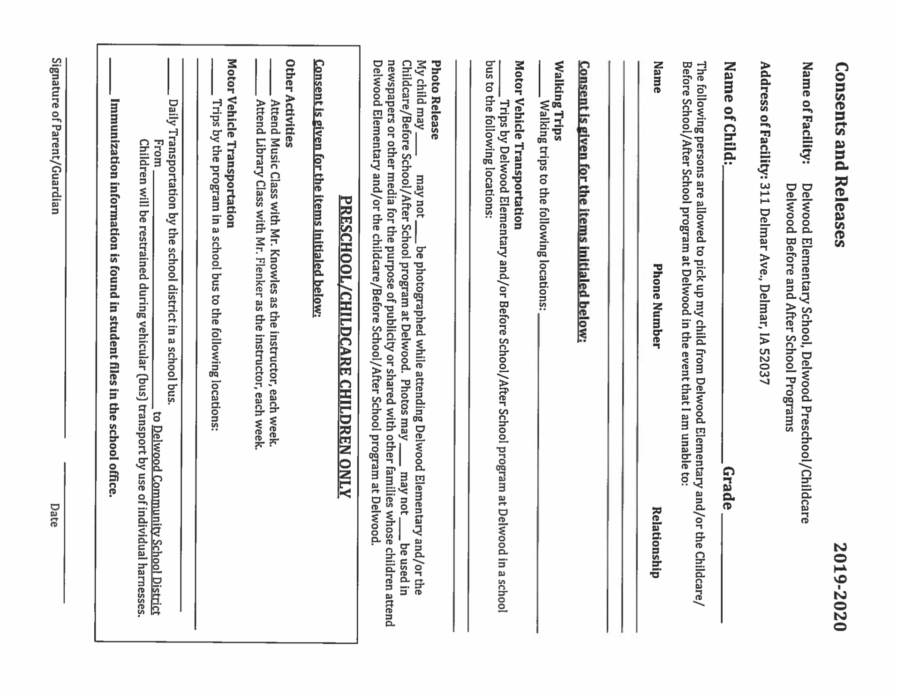

EMERGENCY DRILLS
Periodically the school holds emergency fire, intruder, bus evacuation, and tornado drills. At the beginning of each semester, teachers notify students of the procedures to follow in the event of a drill. Emergency procedures and proper exit areas are posted in all rooms. Students are expected to remain quiet and orderly during a drill or an emergency.

These drills are planned to train staff and students how to evacuate to safety areas in case of tornado, severe weather conditions, fire or a bus accident.

FIELD TRIPS
An important learning opportunity can take place in the form of a field trip that is relevant and reinforces what has been taught in the classroom. The Delwood Community School district buses or vehicles are used for these field trips. Parents will be informed of each field trip through a newsletter and calendars in advance. A parent or legal guardian must sign an informed consent form for trips for each child upon enrollment. Adult family members may be asked to volunteer to go on these trips to provide increased supervision and adult/child ratios. A first aid kit, and emergency contact information will be taken on all trips. Children will be counted periodically while on a field trip. Children may only use a public restroom if they are accompanied by a staff member. Children will never be left alone in a vehicle or unsupervised by an adult.

MEDICAL EMERGENCIES AND INCIDENT NOTIFICATION
The Delwood Preschool has in place a “Safety Procedures Booklet” that describes the following situations and procedures to follow:
Emergency phone numbers
● 911
● Poison control next to phones

Fire procedures
● Fire escapes clearly marked
● Fire drills practiced routinely

Utility Failures (electrical power failure, water line break, gas line break)
● Remain in the area or move to a safe area of the school.

In the event of evacuation, communicate to parents through Alert System

Severe weather
● Follow school procedures of early out and student dismissal
● Call parents as needed
● Communicate to families through Alert System

Bomb threats ● Call 911
● Evacuate building
● Communicate with principal and superintendent along with law enforcement
● Come back to building when all clear given

Earthquakes or disasters
● Find safety in structurally sound structure

Lost or abducted children
● Call 911
● Communicate with principal and superintendent along with law enforcement
● Contact family

Physical Threats/Armed Intruder/intoxicated parents
● Call 911
● Stay in proximity of students to keep safe
● Evacuate as needed
● Staff is ALICE trained
● Communicate with principal and superintendent along with law enforcement

Evacuations
● Students will be evacuated to a safe area including but not limited to Grossman Hall, Casey’s or fire station
● Families will be notified through Alert System
● Communicate with principal and superintendent along with law enforcement as needed

In the event that your child receives a minor, non-life threatening injury during their time at preschool, our teacher will assess the situation and apply first aid as needed. Minor cuts and scrapes will be treated with soap and water and bumps will be treated by applying ice to the injured area. Any incident or injuries will be documented on an “Injury and Illness” form and a copy will be given to the parent within 24 hours of the incident.

All staff will have immediate access to a device that allows them to summon help in a medical or dental emergency. The telephone numbers of the Fire Department, Police Department, Hospital, and Poison Control will be posted by each phone with an outside line. Emergency contact information for each child and staff member will be kept readily available. The list of emergency telephone numbers and copies of emergency contact information and authorization for emergency transport will be taken along anytime children leave the facility in the care of facility staff

FOODS BROUGHT FROM HOME
Food brought from home will be monitored and supplemented if necessary to ensure CACFP guidelines are maintained. Snacks that do not meet CACFP nutrition guidelines may be provided by parents for special occasions such as birthdays or holidays.

NUTRITION
Attitudes about food develop early in life. The food children eat affects their well-being, their physical growth, their ability to learn, and their overall behavior. We have an opportunity to help children learn about foods, to enjoy a variety of foods from their own culture and others, and to help them begin to appreciate that their bodies need to be strong, flexible, and healthy. Eating moderately, eating a variety of foods, and eating in a relaxed atmosphere are healthy habits for young children to form.

Children attending preschool may choose to have breakfast before class begins. A snack is served two hours after breakfast has ended. Two food groups will be represented at each snack time as outlined in USDA guidelines. A written snack menu is posted in the classroom and available to families. All menus are kept on file for review by a program consultant. The preschool serves a wide variety of nutritional snacks, and encourages children to expand their tastes by at least trying a portion of the food offered.

All food is prepared, served, and stored in accordance with the U.S. Department of Agriculture Child and Adult Care Food Program (CACFP) guidelines. Clean, sanitary drinking water is made available to children throughout the day. Staff discards any foods with expired dates. Foods that are hotter than 110 degrees Fahrenheit are kept out of children’s reach. Foods requiring refrigeration will be kept cold until served. All food and beverages brought from home are labeled with the child’s name and the date. Food is provided to supplement food brought from home, if necessary. Food that comes from home for sharing among the children must be either whole fruits or commercially prepared packaged foods in factory-sealed

ADMINISTRATION OF MEDICATION
Students may need to take prescription or non-prescription medication during school hours. Students may carry medication only with the permission of the parents and principal. The school must know the medications a student is taking in the event the student has a reaction or illness. Students must provide written instructions for administration of the medication as well as parental authorization to administer the medication.

Medication is stored in a locked cabinet and distributed by certified individuals. Medication must be in the original container with the following information either on the container, in the instruction sheet or in the parental authorization: name of the student; name of the medication; directions for use including dosage, times and duration; name, phone number and address of the pharmacy (if applicable); date of the prescription (if applicable); name of the physician (if applicable); potential side effects; and emergency number for parents.

Delwood Community School Assignments for 2019-2020

Level I Investigator - Principal (Marty Marshall)
311 Delmar Ave., Delmar, IA 52037
(563) 674-4164 mmarshall@delwood.k12.ia.us

Level II Investigator - Law Enforcement

|||||||||||||||||||||||||||||||||||||||||||||||||||||||||||||||||||||||||||||||||||||||||||||||||||||||||||||||||||||||||||||||||||||||||||||||||||||||||||||||||||

Equity Coordinator - Todd Hawley
thawley@delwood.k12.ia.us

|||||||||||||||||||||||||||||||||||||||||||||||||||||||||||||||||||||||||||||||||||||||||||||||||||||||||||||||||||||||||||||||||||||||||||||||||||||||||||||||||||

Homeless Coordinator – Jenny Flanigan
311 Delmar Ave., Delmar, IA 52037
(563) 674-4164
jschlueter@delwood.k12.ia.us

Equity Statement
It is the policy of the Delwood Community School District not to discriminate on the basis of race, color, gender, creed, marital status (for programs), national origin, religion, socioeconomic status (for programs), age (for employment), disability, gender identity or sexual orientation in its educational programs and employment practices. If you believe you have (or your child has) been discriminated against or treated unjustly at school, there is a grievance procedure for processing complaints of discrimination. Please contact the District’s Equity Coordinator, Superintendent Todd Hawley, 311 Delmar Ave., Delmar, IA 52037, 563-674-4164.

