Emergency Safety Intervention (ESI)
Parent Information

If an emergency safety intervention was used with a student, we invite and strongly encourage parents to schedule a meeting to discuss the incident and how to prevent future use of emergency safety interventions. A parent can request and schedule this meeting by going to the back page for the person to contact who will work to schedule this meeting with the required participants. This meeting will be scheduled no later than 10-school days from when the parent makes the request unless the parent cannot meet within that time frame.

USD 504 Oswego
http://www.usd504.org/

Doug Beisel, Superintendent
620-795-2126
dbeisel@usd504.org
Date

Dear parent or guardian of

We are writing to inform you that an emergency safety intervention has been used with your child due to behavior that presented a reasonable and immediate danger of physical harm to your child or others. An emergency safety intervention is the use of seclusion or physical restraint. Details of the incident regarding your child are included in the form attached to this letter.

If this is the first time an emergency safety intervention has been used on your child this school year, also attached are printed copies of the standards for when emergency safety intervention may be used, a flyer on your rights under emergency safety intervention law, information on your right to file a complaint with the local board of education through the local dispute resolution process, information on your right to request administrative review from the Kansas State Board of Education, and information to assist you in navigating these processes. If this is a subsequent incident this school year, then the information is not attached, and you are encouraged to access the information at the website link for local emergency safety intervention resources below.

Please use the form on the following page to provide feedback or comments to the school regarding the incident. You may submit the form to me at any time by delivering it to the school or emailing it to me. We invite and strongly encourage you to schedule a meeting to discuss the incident and how to prevent future use of emergency safety interventions. Please use my email or phone number listed below to schedule an emergency safety intervention meeting.

Local ESI Resources: http://www.usd504.org/district-information/

State ESI Resources: www.ksdetasn.org

Sincerely,

________________________________
(Signature)

(Printed Name)

(Phone Number)

(Email Address)

Please provide us with feedback or comments regarding the incident. You may attach additional pages if needed:

Emergency Safety Intervention (ESI)
Parent Information

Table of Contents

Standards of When ESI Can Be Used …………………………….………….……. Page 5
Parents’ Rights Flyer …………………………………………………….………………… Page 7
Local Dispute Resolution Process ………………………………….……………….. Page 15
Local Dispute Resolution Guide for Parents ………………..…………………. Page 16
State Board Administrative Review Process …………………………………… Page 17
State Board Administrative Review Guide for Parents …………………..… Page 18
Contact Information ………………………………………………………………………… Page 21

Standards of When ESI Can Be Used
Revised July 2016

Standards for the use of Emergency Safety Interventions
Emergency safety interventions law sets forth standards for the use of restraint and seclusion to ensure that all Kansas students and staff have a safe learning environment. The standards found in the emergency safety intervention statutes and regulations are required to be followed in all Kansas public school districts and accredited private schools.

An emergency safety intervention is the use of seclusion or physical restraint. The use of an emergency safety intervention shall cease as soon as the immediate danger of physical harm and violent action ceases to exist.

Before using an emergency safety intervention, a school employee witnessing the student’s behavior must have determined that less restrictive alternatives to emergency safety interventions, such as positive behavior interventions support, were inappropriate or ineffective under the circumstances.

An emergency safety intervention shall be used only when a student presents a reasonable and immediate danger of physical harm to such student or others with the present ability to effect such physical harm. Violent action that is destructive of property may necessitate the use of an emergency safety intervention if there is a reasonable and immediate danger of physical harm. An emergency safety intervention may not be used for purposes of discipline, punishment, or for the convenience of a school employee.

Physical restraint means bodily force used to substantially limit a student’s movement. Physical restraint is NOT:
• _Consensual, solicited or unintentional contact and contact to provide comfort, assistance or instruction;
• _physical escort;
• _prescribed treatments for a student’s medical or psychiatric condition by a person appropriately licensed to issue these treatments;
• _protective or stabilizing devices either ordered by an appropriately licensed professional or required by law;
• _any device used by a law enforcement officer in carrying out law enforcement duties; and
• _seatbelts and any other safety equipment when used to secure students during transportation.

Prohibited types of restraints:
• _Prone, or face-down, physical restraint;
• _supine, or face-up, physical restraint;
• _any physical restraint that obstructs the airway of a student;
• _any physical restraint that impacts a student’s primary mode of communication;
• _chemical restraint (‘‘chemical restraint’’ means the use of medication to control a student’s violent physical behavior or restrict a student’s freedom of movement.); and
• _mechanical restraint (‘‘mechanical restraint’’ means any device or object used to limit a student’s movement).

Seclusion means placement of a student in a location where:
• _The student is placed in an enclosed area by school personnel;
• _the student is purposefully isolated from adults and peers; and
• _the student is prevented from leaving, or the student reasonably believes that such student will be prevented from leaving, the enclosed area.

An emergency safety intervention may not be used with a student if the student is known to have a medical condition that could put the student in mental or physical danger as a result of the use of an emergency safety intervention unless not using an emergency safety intervention would result in significant physical harm to the student or others. The medical condition must be indicated in a written statement from the student’s licensed health care provider, and a copy of which shall be provided to the school and placed in the student’s file. When a student is placed in seclusion, a school employee shall be able to see and hear the student at all times.
If a seclusion room has a locking door it must be designed to ensure that the lock automatically disengages when the school employee viewing the student walks away from the seclusion room, or in cases of emergency, such as fire or severe weather.
A seclusion room must be a safe place. The room must have good ventilation and lighting, and be free of any condition that could be a danger to the student. The room must also be similar to other rooms where students frequent.
Seclusion is not time-out, which is a behavioral intervention in which a student is temporarily removed from a learning activity without being confined.

Parents’ Rights Flyer
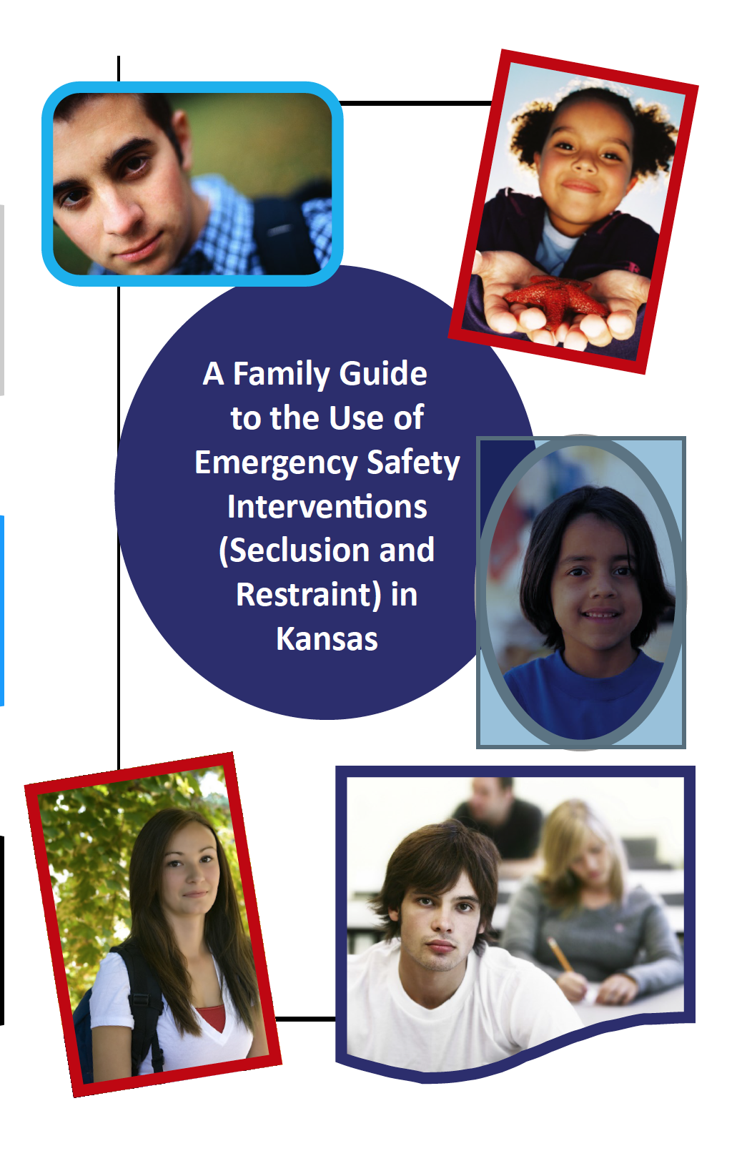

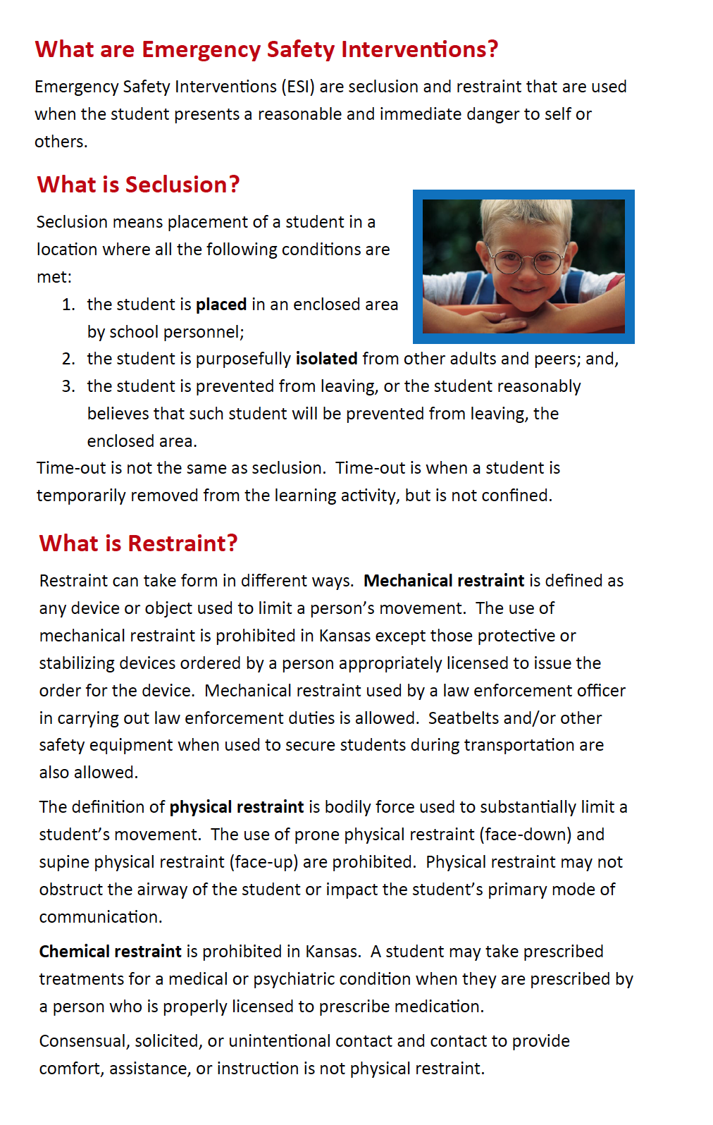
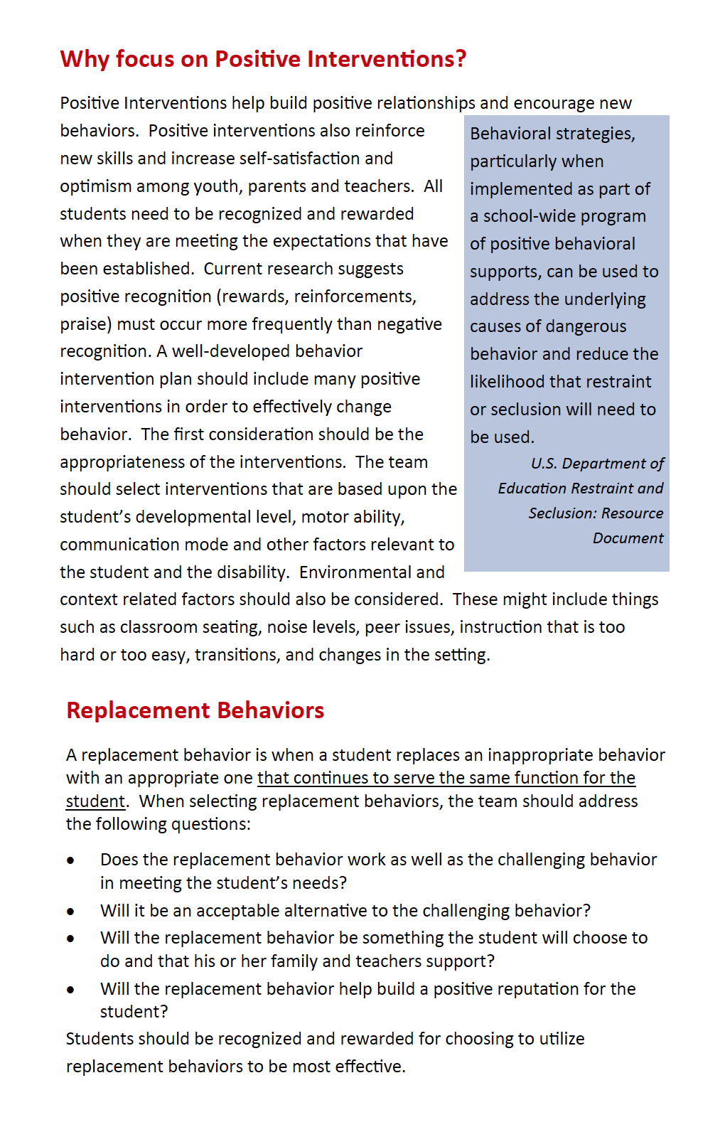
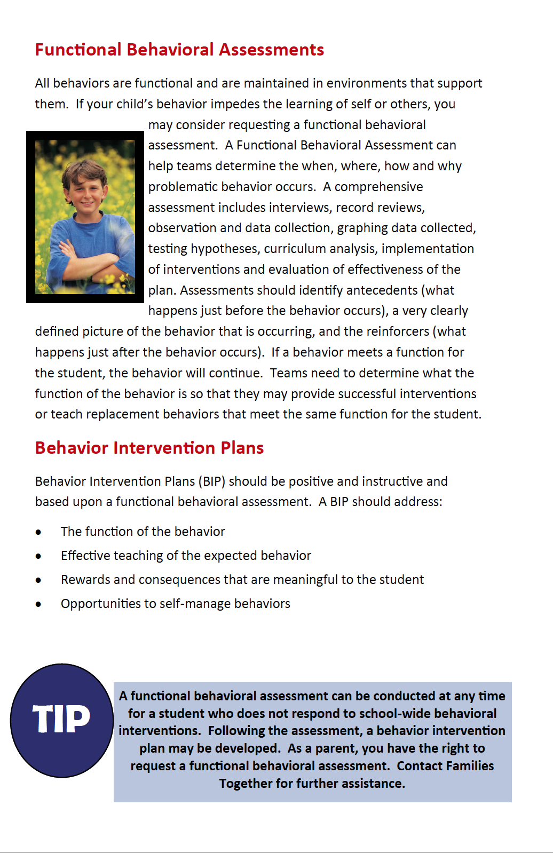
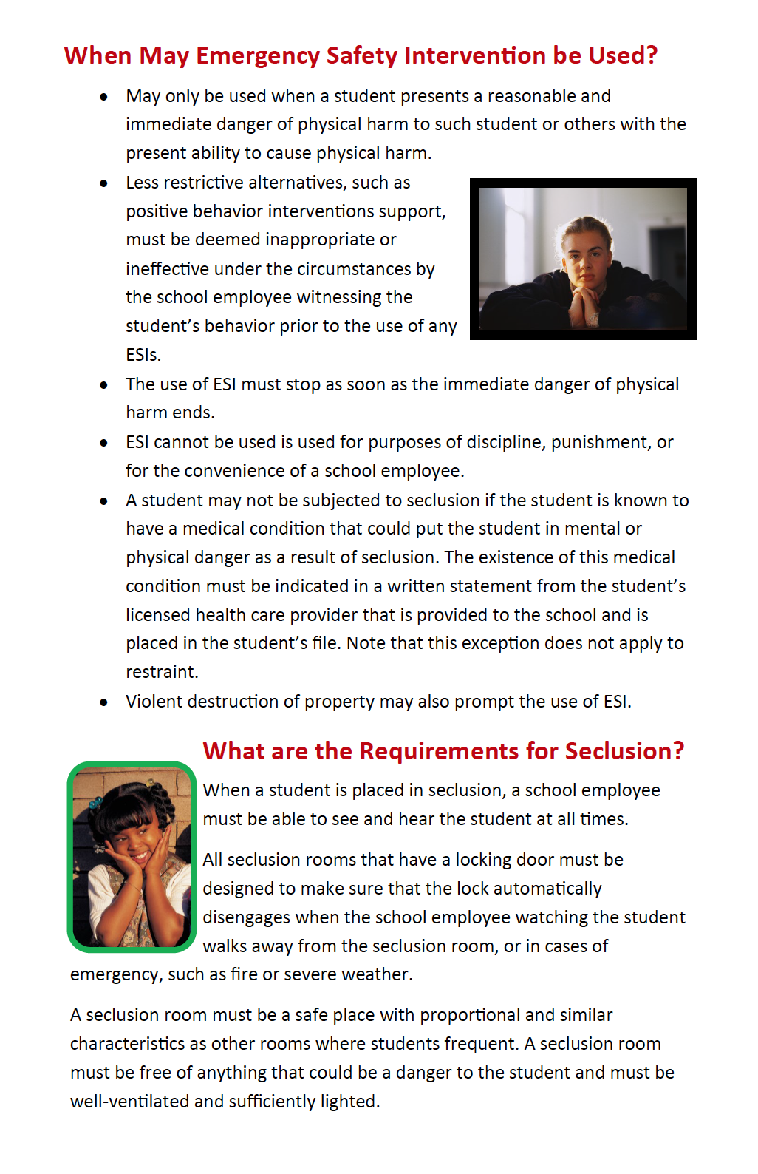
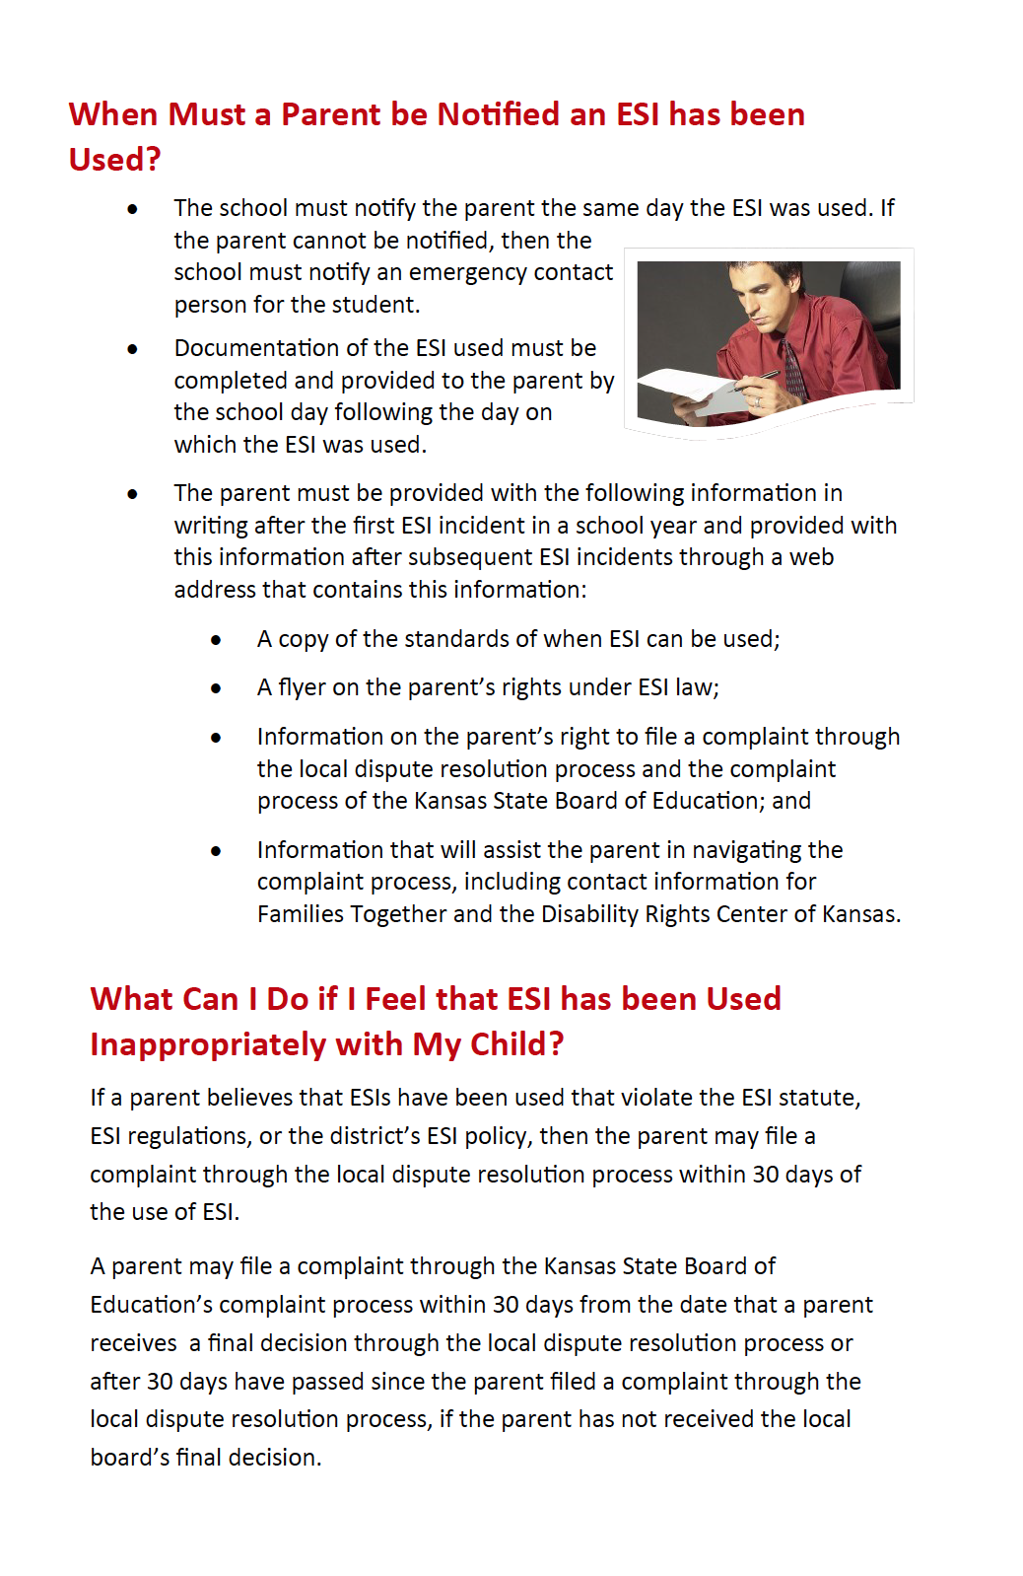
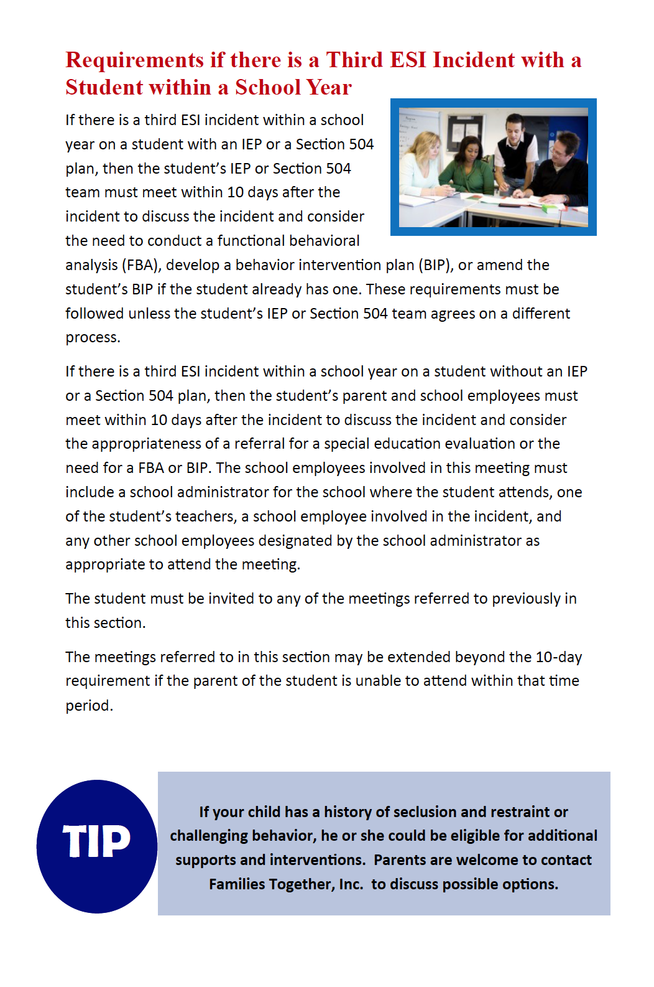
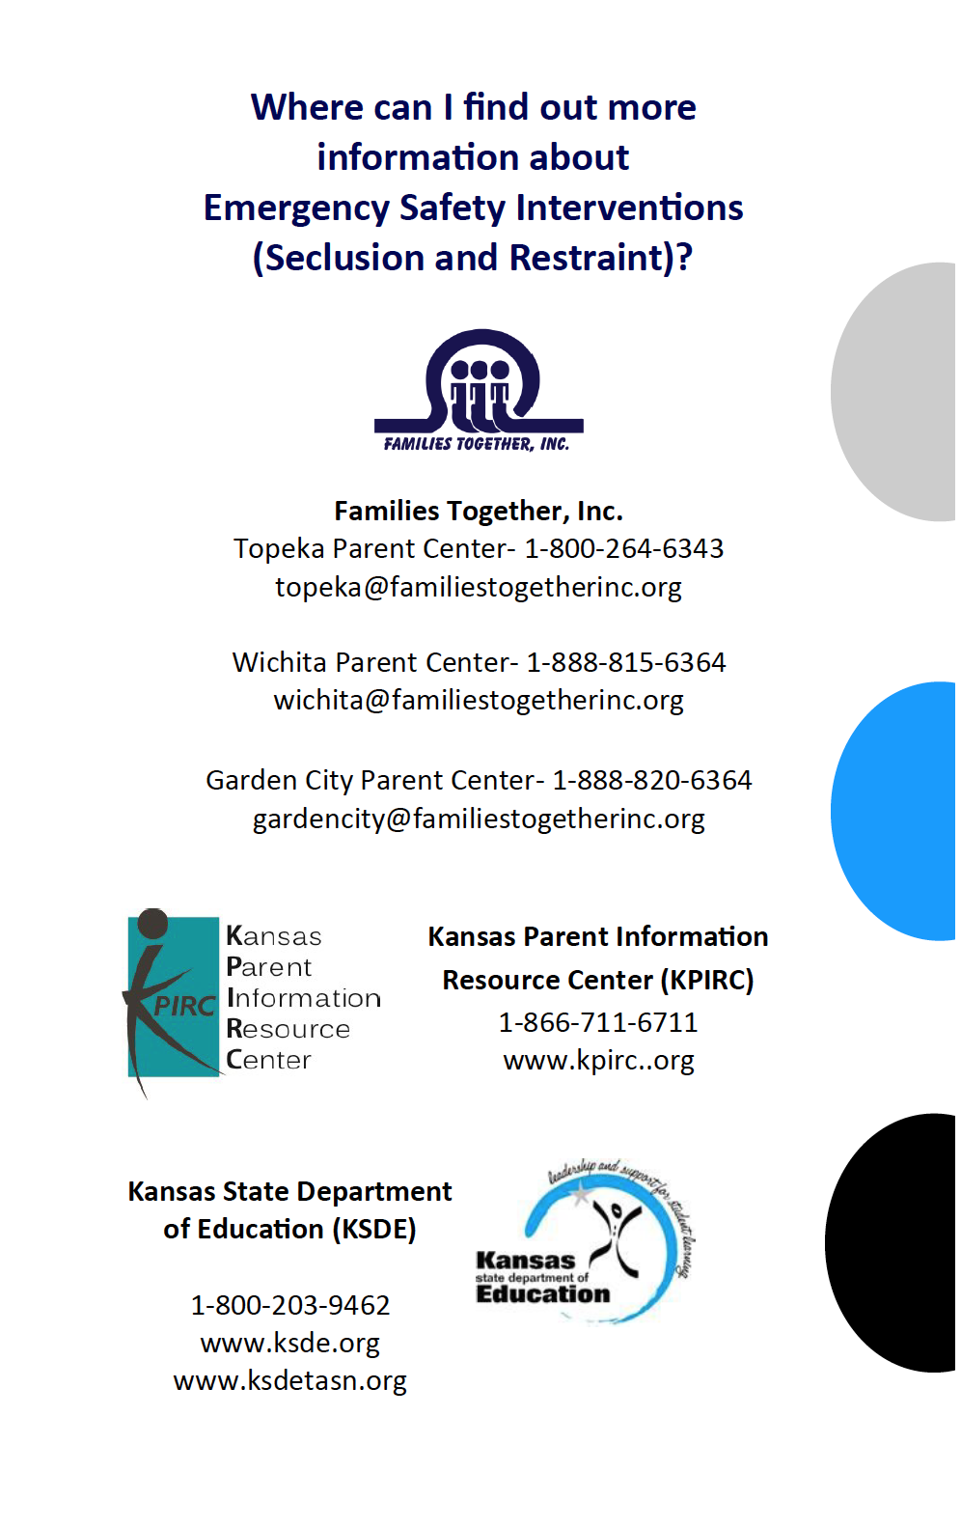
Local Dispute Resolution Process

Local Dispute Resolution Process
If a parent believes that an emergency safety intervention has been used on the parent’s child in violation of state law or board policy, the parent may file a complaint as specified below.
The board of education encourages parents to attempt to resolve issues relating to the use of ESI informally with the building principal and/or the superintendent before filing a formal complaint with the board. Once an informal complaint is received, the administrator handling such complaint shall investigate such matter, as deemed appropriate by the administrator. In the event that the complaint is resolved informally, the administrator must provide a written report of the informal resolution to the superintendent and the parents and retain a copy of the report at the school. The superintendent will share the
informal resolution with the board of education and provide a copy to the state department of education.
If the issues are not resolved informally with the building principal and/or the superintendent, the parents may submit a formal written complaint to the board of education by providing a copy of the complaint to the clerk of the board and the superintendent within thirty (30) days after the parent is informed of the incident.
Upon receipt of a formal written complaint, the board president shall assign an investigator to review the complaint and report findings to the board as a whole. Such investigator may be a board member, a school administrator selected by the board, or a board attorney. Such investigator shall be informed of the obligation to maintain confidentiality of student records and shall report
the findings of fact and recommended corrective action, if any, to the board in executive session.
Any such investigation must be completed within thirty (30) days of receipt of the formal written complaint by the board clerk and superintendent. On or before the 30th day after receipt of the written complaint, the board shall adopt written findings of fact and, if necessary, appropriate corrective action. A copy of the written findings of fact and any corrective action adopted by the board shall only be provided to the parents, the school, and the state department of education and shall be mailed to the parents and the state department within 30 days of the board’s receipt of the formal complaint.
If desired, a parent may file a complaint under the state board of education administrative review process within thirty (30) days from the date a final decision is issued pursuant to the local dispute resolution process.

Taken from KASB Policy GAAF – July 2016
Local Dispute Resolution Guide for Parents

State Board Administrative Review Process

Refer to K.A.R. 91-42-5 for complete information. The following provides a summary of the regulations regarding an administrative review initiated with the Kansas State Board of Education (KSBE).

- If a parent believes an emergency safety intervention was used in violation of K.S.A. 2016 Supp. 72‐89d01 through -89d09 or K.A.R. 91-42-1 through -7 and the parent filed a written complaint with their local board of education, then this parent may request an administrative review of the local board’s decision from KSBE.
  - The request for administrative review must include the following information:
    - Name of the student and contact information;
    - Names and contact information for all involved parties (teachers, aides, administrators, and district staff), to the extent known;
    - A detailed statement of the reason for requesting an administrative review;
    - Any supporting facts and documentation; and
    - A copy of the complaint filed with the local board, the local board’s final decision (if issued).
    - The written request for administrative review must be typed or legibly written and signed by the parent.
    - Relevant documents must be attached or, if unavailable, the documents must be referenced in the request for administrative review.
    - Written consent to disclose any personally identifiable information from the student’s education records necessary to conduct an investigation

- The request for administrative review must be filed with the Commissioner of Education within 30 days of the local board issuing its final decision OR within 60 days from the date the parent filed a complaint with the local board, if the local board did not issue a final decision. You may mail this request to the Kansas State Department of Education, Landon State Office Building, 900 SW Jackson Street, Office of General Counsel, Room 102, Topeka, Kansas 66612.

- A Hearing Officer will be designated by KSBE. The Hearing Officer must send a copy of the request for administrative review to the local board.

- The Hearing Officer will consider the local board’s final decision and may initiate an investigation that could include:
  - A discussion with the parent, during which additional information may be gathered;
  - Contact with the local board or other district staff to allow the local board to respond to the request with information supporting its final decision; and
  - An on-site investigation by Kansas State Department of Education staff.

- If new information is discovered that was not made available to both the parent and the local board during the dispute resolution process, the Hearing Officer may send the issue back to the local board.
  - If sent back to the local board, the Hearing Officer’s case will be closed and the local board has 30 days to issue a written amended final decision.
  - If the parent feels the local board’s amended final decision does not adequately address the issue, the parent may file a new request for administrative review with the commissioner by following the above process for requesting administrative review. This must be done within 30 days of the local board issuing its amended final decision. If the local board does not issue an amended final decision within 30 days, then the parent has 30 days from the date the Hearing Officer sent the issue back to the local board to file a request for administrative review with the commissioner.

- Within 60 days of receiving the request for administrative review, the Hearing Officer will, in writing, inform the parents, school administrator, district superintendent, local board clerk, and the state board of the results of the review. This time frame may be extended for good cause upon approval of the commissioner.

- The results of the administrative review will contain findings of fact, conclusions of law, and any suggested corrective actions. The Hearing Officer’s determination will include one of the following:

  - The local board appropriately resolved the complaint.
  - The local board should re-evaluate the complaint with suggested findings of fact.
  - The Hearing Officer’s suggested corrective active is necessary to ensure that local board policies meet legal requirements.

State Administrative Review Guide for Parents
Mail this request to the Commissioner of Education, Kansas State Department of Education, Landon State Office Building, 900 SW Jackson Street, Office of General Counsel, Room 102, Topeka, Kansas 66612
A request for an administrative review may include, but is not limited to, the following allegations:
- An emergency safety intervention was used with your child when your child did not present a reasonable and immediate danger of physical harm to themselves or others with the present ability to effect such physical harm.
- The district used a form of banned restraint including prone, supine, physical restraint that obstructs the airway of your child, physical restraint that impacts your child’s primary mode of communication, chemical or mechanical restraint that does not meet an exception.
- Less restrictive alternatives to emergency safety intervention were not deemed inappropriate or ineffective before emergency safety intervention was used.
- The use of emergency safety intervention with your child did not stop as soon as the immediate danger of physical harm stopped.
- emergency safety intervention was used with your child for discipline, punishment, or convenience.
- Emergency safety intervention was used with your child and you have provided school staff with documentation from your child’s licensed health care provider that seclusion could put your child in mental or physical danger.
- Seclusion was used with your child and school staff could not see and hear your child at all times.
- Your child was put in a seclusion room with a locking door that does not automatically disengage when school staff walk away or in an emergency.
- Your child was put in a seclusion room that was unsafe, not well-ventilated, or not sufficiently lighted.
The Hearing Officer may initiate a separate investigation that may include:
- A discussion with the parent;
- Contacting the local board or other staff involved; and
- An on-site investigation.

If the Hearing Officer finds new information, they may send the issue back to the local board. If you are not satisfied with the local board’s amended decision the right to request administrative review begins again.
Written request must include:
- Name and contact information of student that emergency safety intervention was used with
- Name and contact information for all people involved
- Statement describing the basis for the review with all supporting facts and documentation
- The local board’s final decision, if one was issued
- Type or legibly write the complaint and sign it
- Written consent to disclose any personally identifiable information

Contact Information

Local

USD 504 Oswego
http://www.usd504.org/

Doug Beisel, Superintendent
620-795-2126
dbeisel@usd504.org

[Insert link here to local website for emergency safety intervention information]

State

General Emergency Safety Intervention Information:
http://ksdetasn.org/tasn/emergency-safety-interventions-esi-resources

Emergency Safety Intervention Questions:
Laura Jurgensen or Julie Ehler
Kansas State Department of Education
ljurgensen@ksde.org or jehler@ksde.org
785-296-5522 or 785-296-1944

Parent Training and Information Center:
Families Together
http://familiestogetherinc.org/
888-815-6364

Protection and Advocacy System:
Disability Rights Center of Kansas
http://www.drckansas.org/
877-776-1541 or 785-273-9661

