Monday, August 26- at sites
Site evaluations, curriculum follow-up
Assessment information- Texas Gail Raymond, VTC
8:30-10:30- DLC
10:30-12:30- Holy Cross
2:30-4:30- Nikolai

Tuesday, August 27
Assessment information- Texas Gail Raymond, VTC
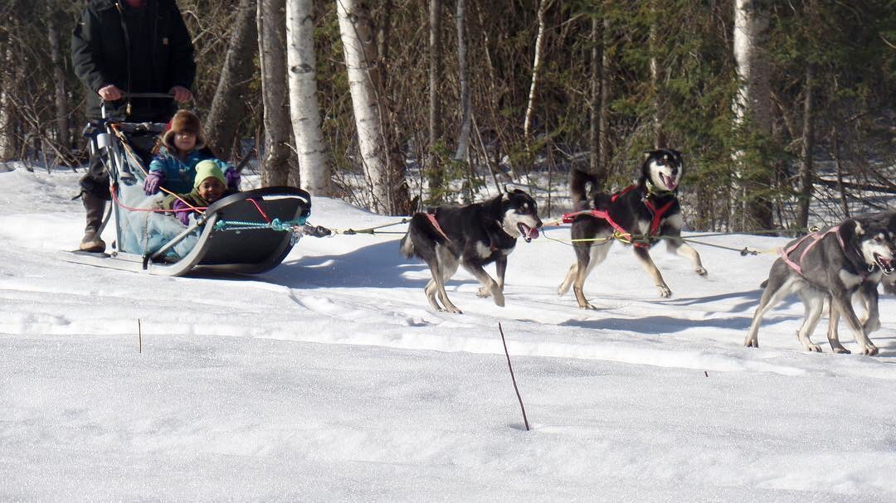
8:30-10:30- Grayling
10:30-12:30 - Shageluk

Tuesday, September 3
Assessment information- Texas Gail Raymond, VTC
8:30-10:30 Anvik
10:30-12:30 McGrath
2:30-4:30 Takotna

*Lindamood-Bell Webinar Training will take place
September 9th-12th from 1:00-4:30pm
This is MANDATORY for ALL Elementary Teachers and Aids

Iditarod Heart of Alaska: Building the Toolbox for Literacy
Fall In-Service
August 18-27, Anchorage

Literacy is the Cornerstone of Learning
Fall In-service
August 18-27, Anchorage

Saturday, August 17
8:30 Principal/Teacher Training at the
Alaska Zoo Greenhouse
12:00 Lunch- Catered by Colonial Pen
1:00 May Jo Finney, University of Michigan, Flint
2:00 Behind the Scenes Tour of the Polar Bears
4:30 Dinner- on your own

Sunday, August 18
8:30 New Teacher Meeting at Residence Inn
3:00 Meet at Residence Inn
Scavenger Hunt Van Groups chosen
5:00 Dinner at Texas Gail Raymond’s house in Chugiak

Thursday, August 22
8:30 Curriculum Training
*K-5 Teachers Wonders Training-with Lexi & Samantha
*6-12- Acellus Training- Loree & Doug
12:00 Lunch catered by NMS
1:00 Team Collaboration- sharing of Literacy Toolbox
5:00 Dinner on your own
6:00-8:00 PowerSchool Training- Britt Anderson

Friday, August 23
7:00 Breakfast at hotel
8:00 KTUU Speaker,
10:00 Evaluations/ Procedures- Matt Shelborne, Michael Willyerd
11:30 Box lunch catered by NMS
Travel to sites

Monday, August 19
8:30 BP Center
Instructional Support with Tonio Verzone
12:00 Lunch- catered by NMS
1:00 Assessments/ AKPLN- Texas Gail Raymond
3:00 Special Educaiton Overview- Casey McCarty
4:30 Dinner on your own
6:00-8:00 PowerSchool Training- Britt Anderson

Tuesday, August 20
8:30- BP Center- Introduction to Curriculum
*K-5 Teachers Wonders with Lexi
*6-12 Teachers Acellus with Loree and Doug
12:00 Lunch- Catered by NMS
Insurance shares
2:00 Curriculum Training Continues
4:30 Dinner on your own
6:00-8:00 PowerSchool Training- Britt Anderson

Wednesday, August 21
6:30 Depart for Train Depot
8:00 Train departs for Talkeetna
*Mandatory Individual Budget Meetings withTammie White
*Martha Gould-Lehe- Sharing of Culture
*Mark Nordman- Iditarod and Dog Mushing
11:20- Arrive in Talkeetna
Lunch- Box lunch handed out in Talkeetna
*Belle Michelson shares in Talkeetna
*Denali Park Ranger- at Park Station
4:40- Train departs Talkeetna
Dinner- possibly on the train- on your own
8:30pm Arrive in Anchorage

