LCSD SUPPLY LISTS (K-6)
KINDERGARTEN
REQUIRED ITEMS
- Backpack
- No. 2 pencils (2 packs)
- Colored Pencils
- Crayons
- Coloring book
- Glue sticks (NO liquid glue please.)
- 5 in. blunt tip scissors
- Erasers
- Pencil pouch
- Two-pocket plastic folders (4)
- Zip-lock bags (quart or gallon)
- Expo markers

WISH LIST
- Paper towels
- Kleenex (2 boxes)
- Hand sanitizer (12 oz. pump bottle)
- Lysol Disinfecting Wipes

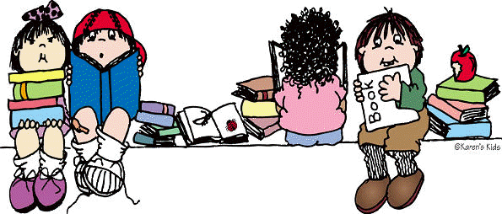
FIRST GRADE
REQUIRED ITEMS
- Backpack
- No. 2 pencils (2 packs)
- Rectangle-shaped Supply Box
- 24 Pack Crayons (2 boxes)
- Coloring book
- Glue sticks (2)
- 5 in. blunt tip scissors
- 2 Block Erasers
- Pencil pouch
- Two-pocket plastic folders (3)
- 2 Boxes Zip-lock bags (1 Quart-size and 1 Gallon-size)
- Expo markers (4 pack)

WISH LIST
- Paper towels
- Kleenex (2 boxes)
- Paper Towels (2 Rolls)
- Hand sanitizer (2-8 oz. bottles)
- Lysol Disinfecting Wipes

SECOND GRADE
REQUIRED ITEMS
- Backpack
- No. 2 pencils (2 packs)
- 2 Pairs of earbuds or 1 pair of headphones
- 1 Box Color Pencils
- 3 Packs of Notebook Paper
- Small Bottle of Elmer’s Glue
- 6 Glue Sticks
- Pencil sharpener (hand-held manual)
- 2 Packs of Erasers
- Pencil pouch
- 7 Two-pocket plastic folders with 3 prongs
- 1 Box Zip-lock bags (Gallon-size)
- 1 Two-Inch Binder
- 1 Pack of Dry Erase Markers

WISH LIST
- Paper towels
- Kleenex (2 boxes)
- Paper Towels (2 Rolls)
- Hand sanitizer (2-8 oz. bottles)
- Lysol Disinfecting Wipes

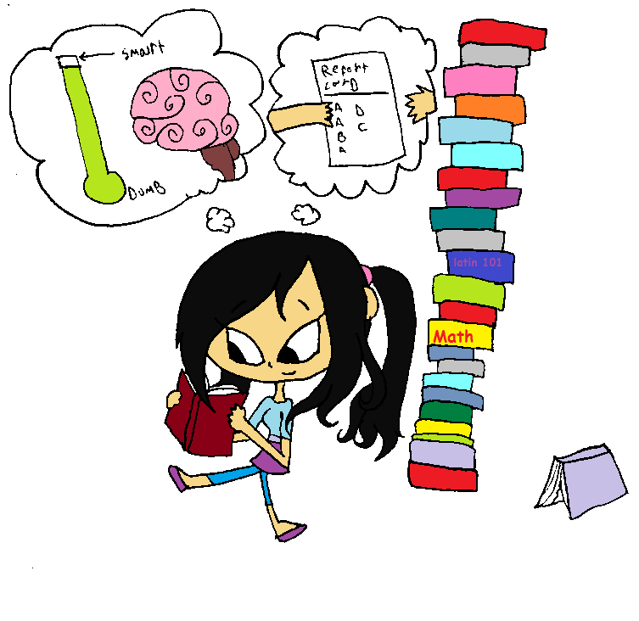
THIRD GRADE
REQUIRED ITEMS
- Backpack
- No. 2 pencils (2 packs)
- 1 Pack of Copy Paper
- 1 Box Color Pencils
- 2 Packs of Notebook Paper
- Bottle of Elmer’s Glue or Glue Sticks
- Journal
- Spiral Notebook (Blue, Red, Yellow, or Purple)
- Scissors
- 4 Two-pocket plastic folders with 3 prongs
- 1 Two-Inch Binder

WISH LIST
- Cleaning Wipes
- Kleenex (2 boxes)
- Hand sanitizer (2-8 oz. bottles)

FOURTH GRADE
REQUIRED ITEMS
- Backpack
- No. 2 pencils (2 packs)
- 1 Pack of Dry Erase Markers
- 1 Box Crayons
- 2 Packs of Notebook Paper
- Pack of Erasers
- 1 Spiral Notebook
- 1 Pack of Red Pens
- 5 Two-pocket plastic folders with 3 prongs
- 1 Two-Inch Binder

WISH LIST
- Cleaning Wipes
- Kleenex (2 boxes)
- Hand sanitizer (2-8 oz. bottles)

FIFTH and SIXTH GRADES
REQUIRED ITEMS
- Backpack
- No. 2 pencils (2 packs)
- 1 Ruler
- 2 Packs of Notebook Paper
- Glue Sticks
- 2 Composition Notebooks
- Dividers for Binder
- Blue/Black Ink Pens
- Highlighters
- 1 Two-Inch Binder

WISH LIST
- Cleaning Wipes
- Kleenex (2 boxes)
- Hand sanitizer (2-8 oz. bottles)

