**Rich Hill R-IV Current Surplus Property—July 2019**

1. **Field Paint Sprayer and Paint**

Electric Field Sprayer with charger and battery. New paint tips have recently been installed.

11 full containers of paint—2.5 gallons each. 2 partial containers.

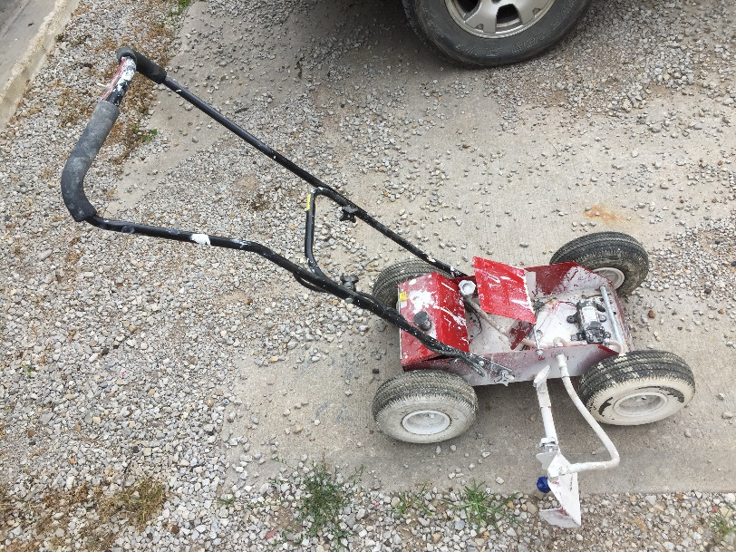

1. **Welder—Miller Thunderbolt XL Welder**

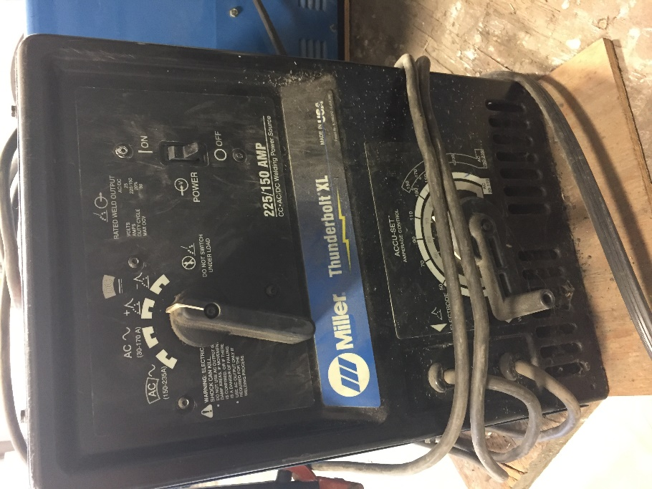 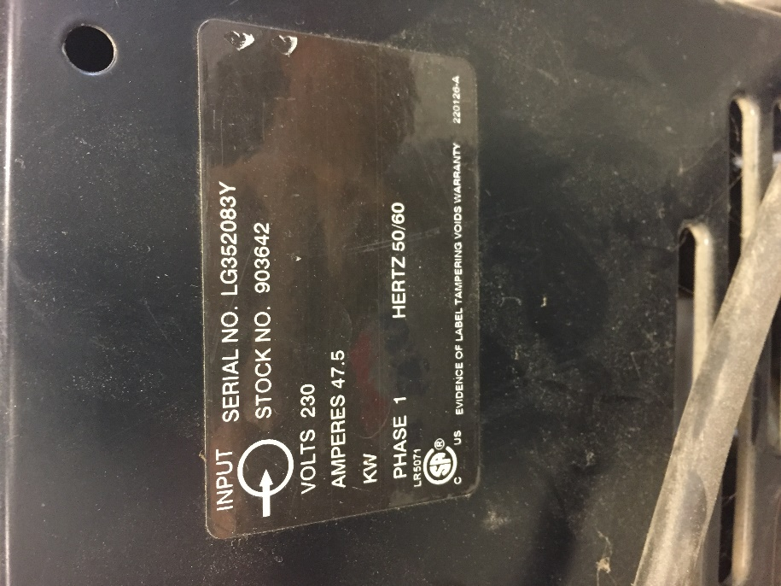

1. **Welder—Miller Thunderbolt XL Welder**

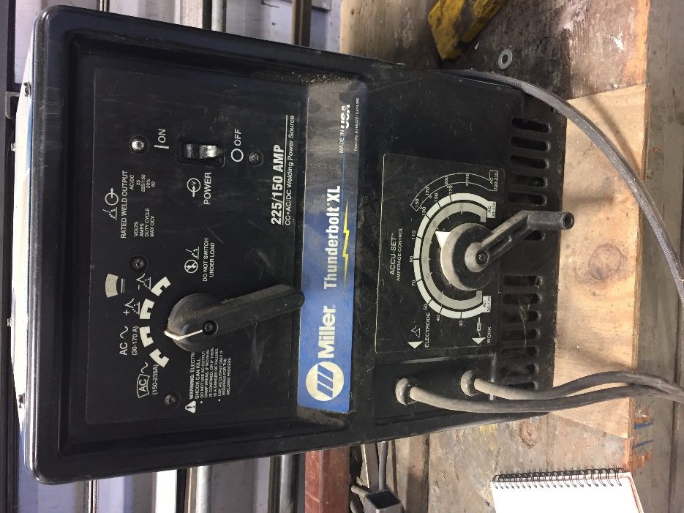 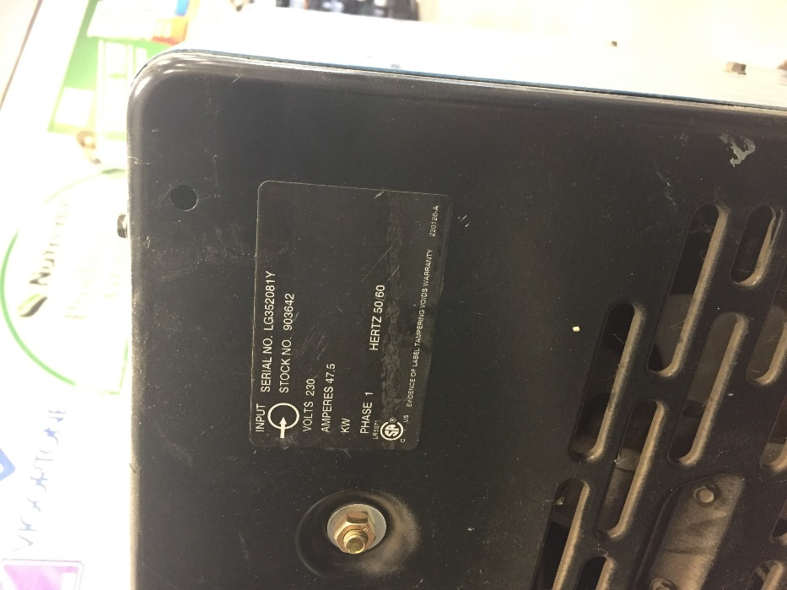

1. **Grizzly Shop Vacuum**

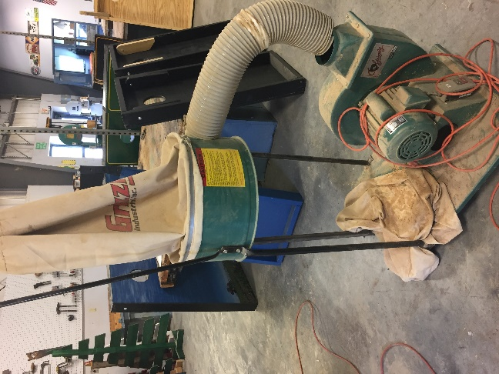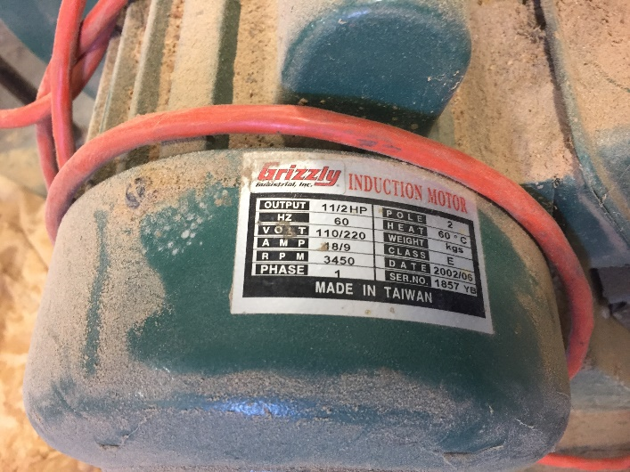 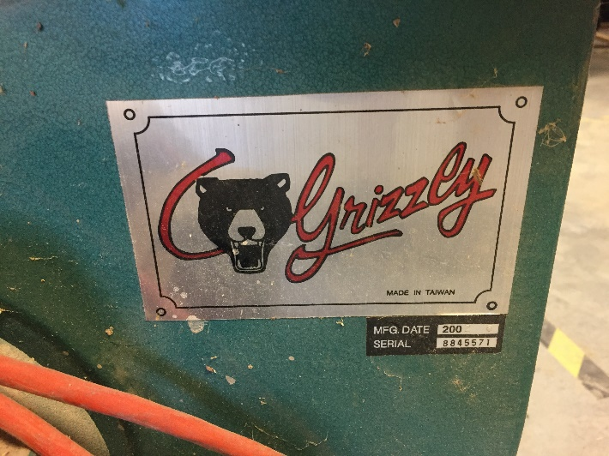

1. **Grizzly Shop Vacuum**

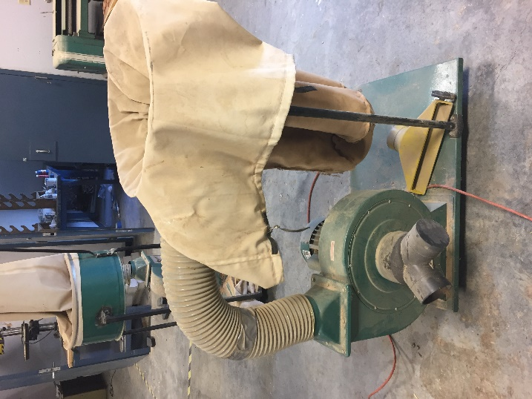 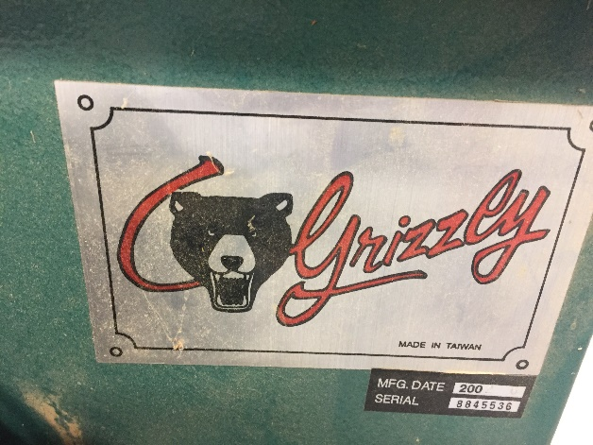

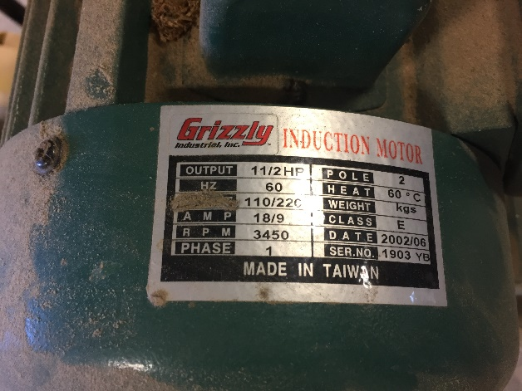

1. **Gas Steam Serving Table**

