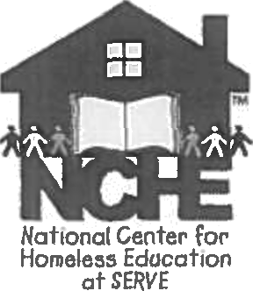 Who is Homeless?

Subtitle VII-B of the McKinney-Vento Act defines the term “homeless children and youths” as individuals who lack a fixed, regular, and adequate nighttime residence, including
children and youths who are sharing the housing of other persons
due to loss of housing, economic hardship, or a similar reason; are living in motels, hotels, trailer
parks, or camping grounds due to the lack of alternative adequate accommodations; are living in emergency or transitional shelters; or ore abandoned in hospitals;
children and youths who have a primary night1ime residence that is a public or private place not designed for or ordinarily used as a regular sleeping accommodation for human beings;
children and youths who are living in cars, parks, public spaces, abandoned buildings, substandard housing, bus or train stations, or similar settings; and

IV. migratory children who qualify as homeless for the purposes of this subtitle because the children are living in circumstances described in clauses (i) through (iii).
For more information, download Determining Eligibility for McKinney-Vento Rights and Services at https://nche.ed.gov/ briefs.php.

Educational Rights

Under the McKinney-Vento Act, homeless children and youth have the right to
receive a free, appropriate public education.
- enroll in school immediately, even if lacking documents normally required for enrollment.
- enroll in school and attend classes while the school gathers needed documents.
enroll in the local school; or continue attending the school of origin (the school they attended when permanently housed or the school in which they were last enrolled), according to each student’s best interest.
” If the school district believes that the school selected is not in the student’s best interest, the district must provide the parent, guardian, or unaccompanied youth with

a written explanation of its position and inform the parent, guardian, or youth of the right to appeal its decision.
- receive transportation to and from the
school of origin, if requested.
receive educational services comparable to those provided to other students, according to each student’s needs.

NCHE publications are supported through o contract with the U.S. Deportment of Education’s Office of Safe and Healthy Students. For more information, visit http:// ed.gov/progroms/homeless/.

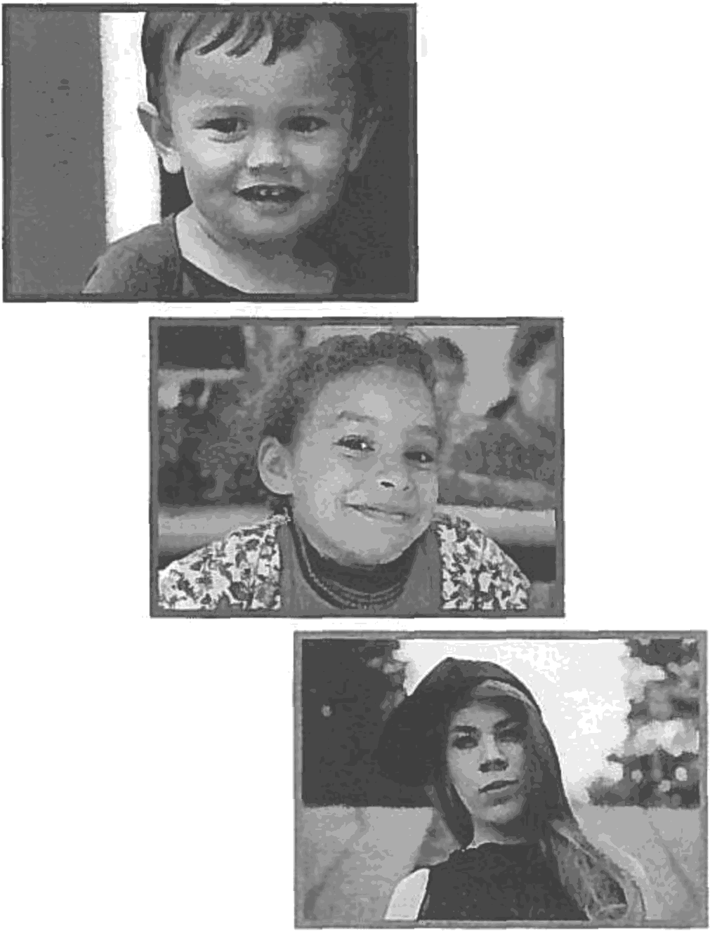
Supporting the Education of Children and Youth Experiencing Homelessness

