#### Hyde County Transformation Zone

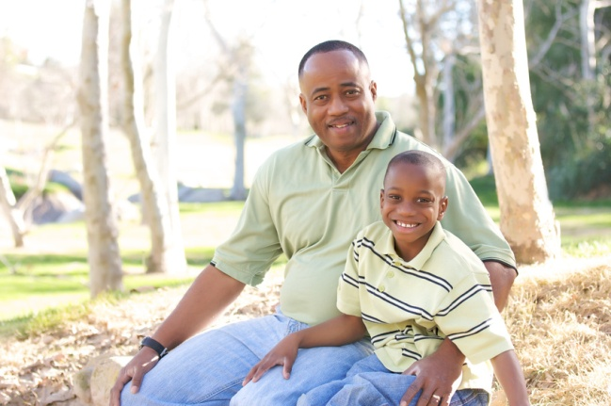

*Made possible with funding from the North Carolina Early Learning Challenge Grant*

1430 Main Street

Swan Quarter, NC 27885

Angela Lewis

Hyde Implementation Coach

Phone: 252.926.3281 ext 3501

Fax: 252.926.3083

alewis@ncsmartstart.org

Transformation Zone

The Transformation Zone

*Enhancing Quality*

*Expanding Services*

*Ensuring a Brighter Future*

# Race to the Top Early Learning Challenge Grant

**Hyde County Transformation Zone**



*Utilizing evidence-based research strategies, the mission of the Hyde County Transformation Zone is to allow families with children birth to five, regardless of income, enhanced access to high quality culturally relevant support services in the areas of family strengthening, child well-being and early literacy.*

Phone: 252.926.3281 ext 3501

# What is the Goal?

There are a number of new programs that came to Hyde County through the Transformation Zone. Some of them you will see out in the communities, while some will become part of existing systems.

Whether these programs are instituted in child care centers or on their own in churches or community centers, they all have one thing in common. Their desired outcome is to help Hyde County’s children start Kindergarten as prepared to meet the challenges of the new curriculum.



# What are the Transformation Zone strategies in Hyde County?

The following list of Transformation Zone strategies, or programs, are available in Hyde County to strengthen families and increase school readiness:

* **Child Care Health** **Consultants** work with child care centers to ensure the best practices for health and safety are being followed.
* **Healthy Social Behaviors** specialists work to promote social and emotional health of children in licensed centers.
* **Triple P** provides trained personnel to work with Hyde County families on dealing with parenting issues that range from the everyday to more severe family problems.
* **Family Connects** nurses visit all families in Hyde County with newborns to assess their needs and to connect them with resources.
* **Reach Out and Read** prepares Hyde’s youngest children to succeed in school by partnering with doctors to prescribe books and encourage families to read together.
* **Motheread/Fatheread** combines the teaching of literacy skills with child development, adult empowerment and professional skill development

# Who Are the Key Players?

The Transformation Zone is a part of the Race to the Top’s Early Learning Challenge Grant. It consists of 4 counties in Eastern North Carolina who are all dedicated to improving the school-readiness of their children aged 0 to 5. These counties are Beaufort, Bertie, Chowan and Hyde. Each of these counties has formed two teams—one of individuals who are in place to change policies (the **Leadership Team**) and one of individuals in place to make the changes happen (the **Implementation Team**). Both teams work with representatives from state agencies to ensure that the methods used to make changes are based on evidence proven strategies. This will ensure that the changes will be long-lasting and effective.



# What is the Transformation Zone?