Abingdon – Avon High School Principal’s Report
November 9, 2022 Board Meeting

The October students of the month were selected on the character trait: Work Ethic. They were: Ben Janssen, Victoria Brown, Braden Hagerty, and Mylissa Alvarado.

Currently, entity counts are:

Overall: 273 students in the high school. Plus 6 attending RAES. 1 attending Camelot. 1 attending Hope Academy, and 1 attending Arrowhead Academy.

Number of students per class in the High School.
Freshmen: 76 Sophomore: 72 Junior: 55 Senior: 71

High School Attendance Numbers:
October - 90.87%
Freshman - 94.30%
Sophomores - 90.09%
Juniors - 92.86%
Seniors - 86.24%

Basketball practice started for the girls team on Monday, October 31st. They will open the season the week of November 14th at the R.O.W.V.A./Ridgewood Thanksgiving Tournament. The boys begin practicing on Monday November 7th. They open the season the week of November 21st at the Orion Tip-Off Classic.

Congratulations to Senior Soccer player Isaac Sampson, for being named the WMOI/WRAM Athlete of the Week for the week of October 16th.

Congratulations to Junior football player Drew Sheckler, for being named the WMOI/WRAM Athlete of the Week for the week of October 23rd.

Congratulations to Talon Hunter for making the ILMEA District 2 Senior concert band and Senior Jazz I band. Talon auditioned and was hand picked to be a part of these two groups consisting of the best high school musicians in the 12 surrounding counties. Talon will be performing on November 5th and November 12th.

We held our second fire drill on Thursday, October 13th. This one was held with the Abingdon Fire Department. We have one more fire drill to hold this year.

The TWISTER Program continues to offer Homework Help, Tutoring & Student Study Hub after school Monday-Thursday from 3:15-5:00pm. All AAHS students are invited to attend (snacks & water/juice are provided). Student Study Hub is also available for students who are looking for a quiet, safe space to work on homework either on their own or in a small group in more of a 'study hall' style atmosphere.

On Monday, October 24th, 93rd District State Representative Norine Hammond was at the high school to speak to Mr. Kennedy’s Government class.

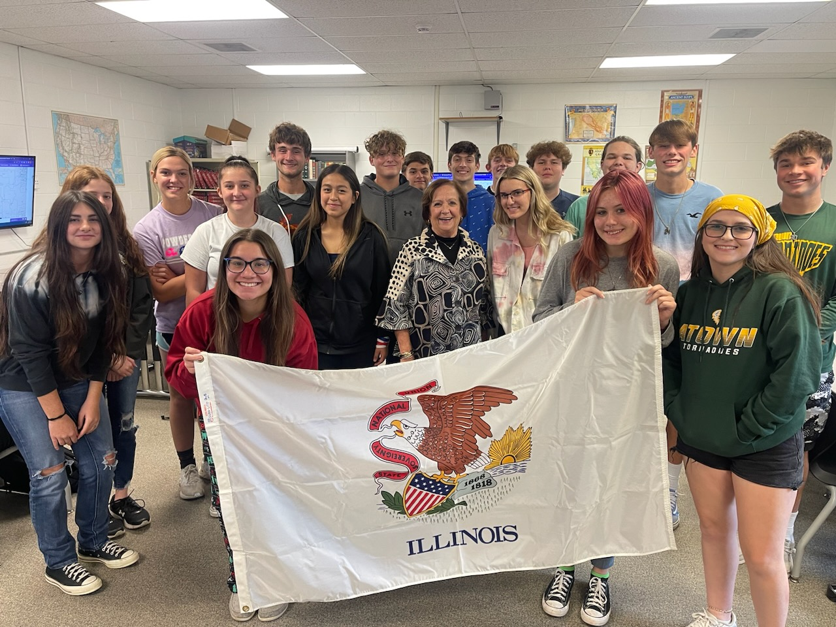

We still have one unfilled teaching position. The Science position is being filled by a full-time substitute.

First trimester at the high school ends on Thursday, November 10. The second trimester began on Monday November 14th.

Parent /Teacher Conferences are being held on November 16th and 17th from 4:30pm-7:30pm.

The FFA farm plot was harvested on October 23rd. This year's crop was soybeans. Thank you to Steve Franklin for volunteering the time and equipment for harvest.

FFA members attended the National Convention Oct. 26-29

Members of the AAHS Spanish Club showed off their artistic ability by painting pumpkins for the Day of the Dead. They also went to El Rancherito for lunch.

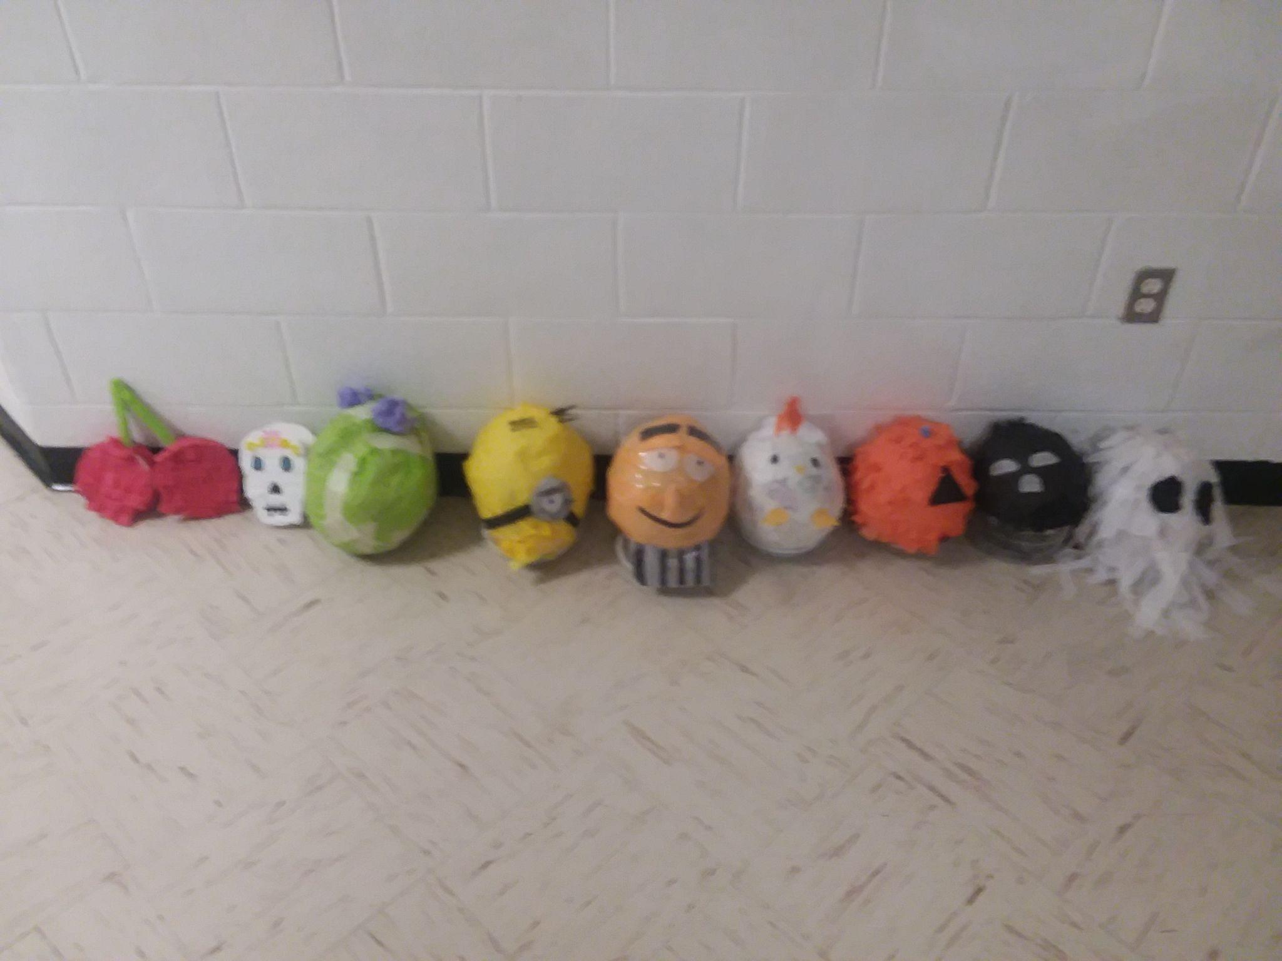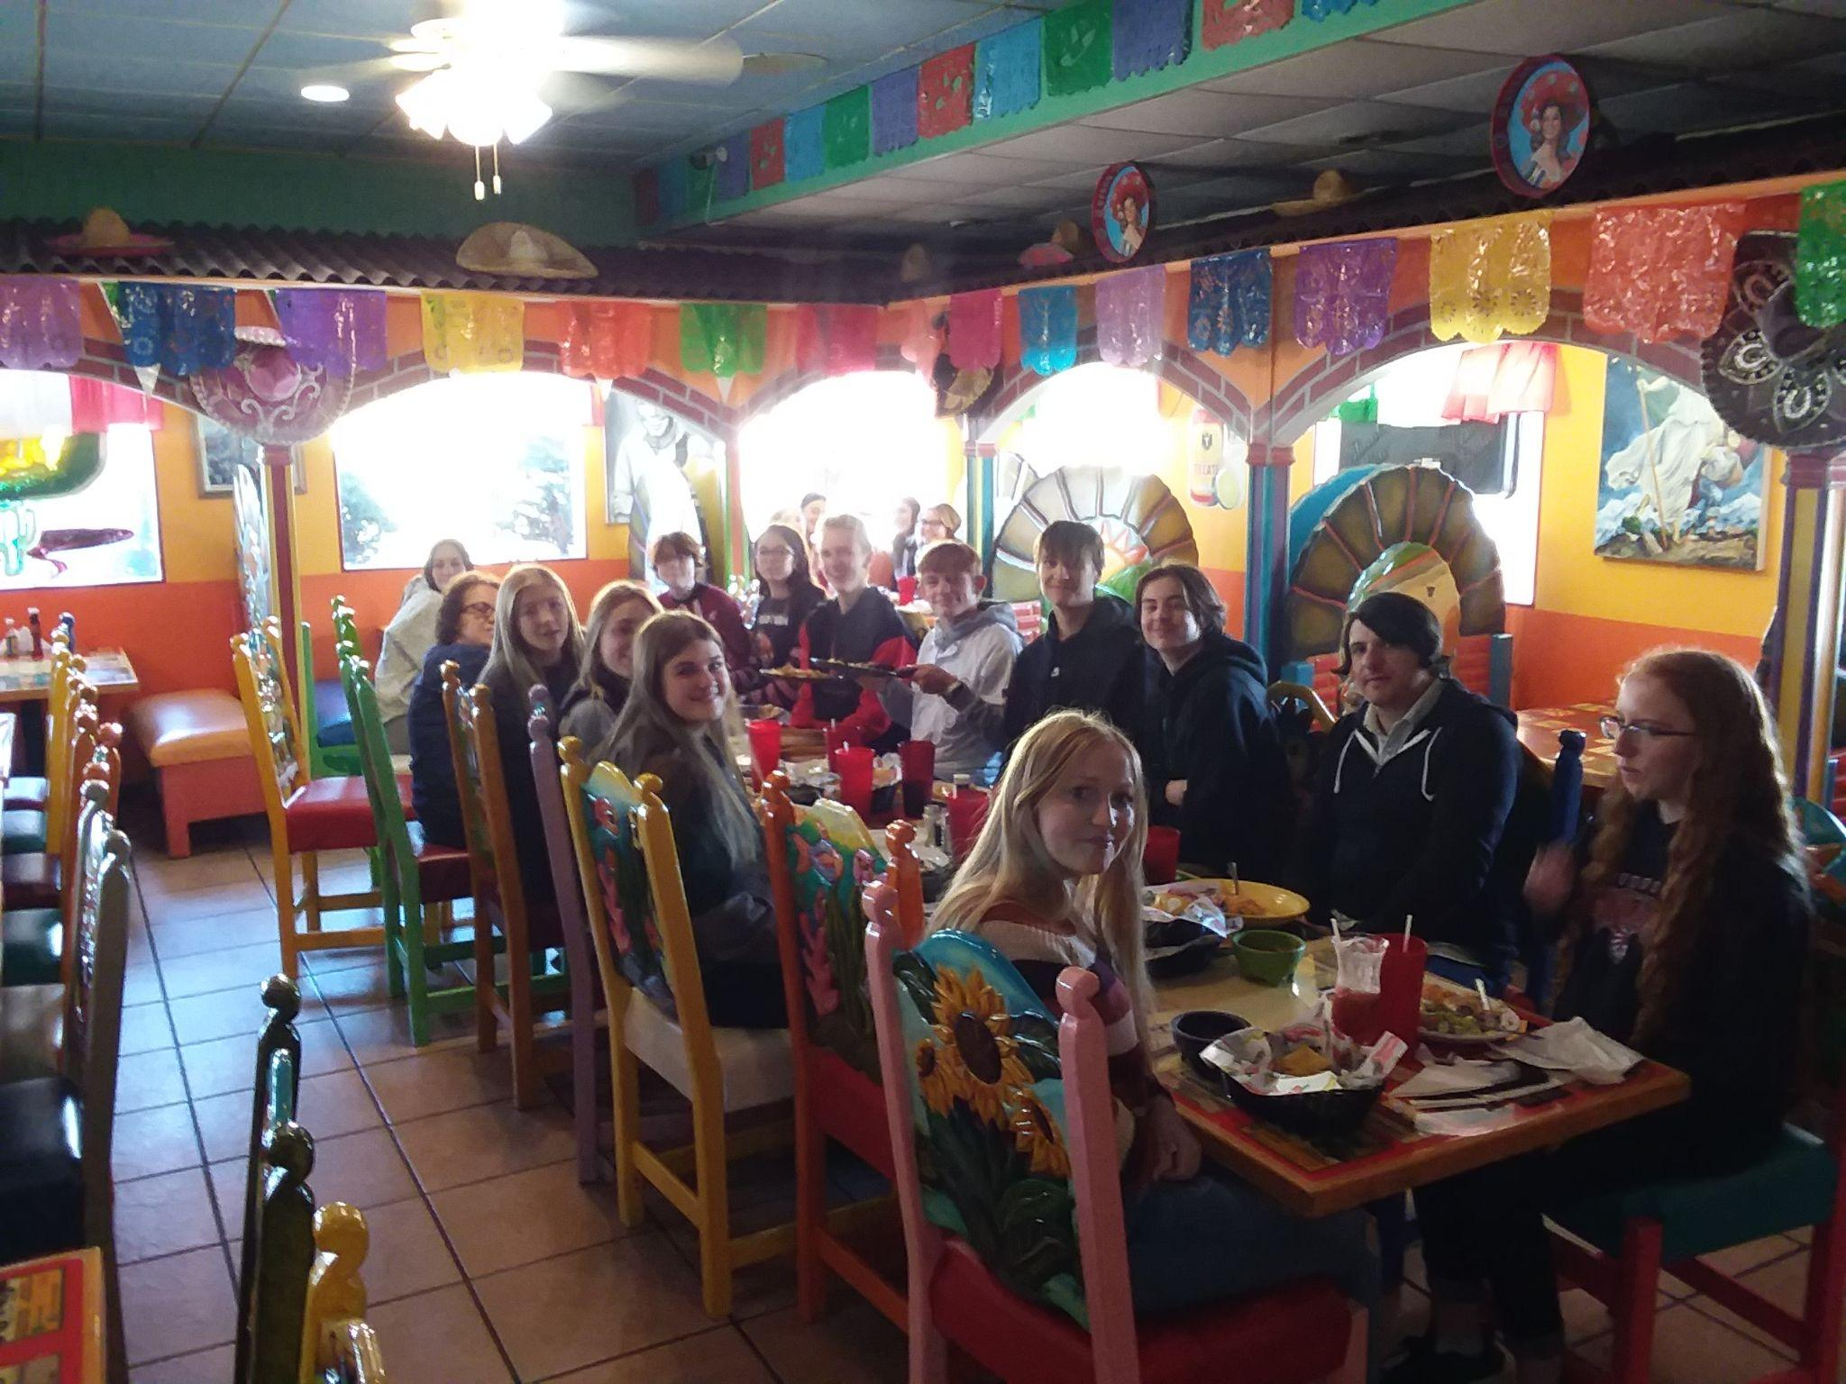

Upcoming Dates:
Election Day - November 8th- No School
End Of First Trimester - November 10th.
Veterans Day - November 11th - No School.
P/T Conferences November 16th and 17th. 4:30pm - 7:30pm
November 18th - No school
Thanksgiving Break - Nov. 23- Nov. 27th.

