May 2022 Principal's Report
Hedding Grade School

Teacher/Staff Appreciation Week
May 2-6 the Staff at Hedding was treated with something each day to show the appreciation we have for all they do. I could never thank them or do enough, but this week has become a yearly tradition that the staff looks forward to. Thank you to the Abingdon-Avon PTA/PTO for providing cinnamon rolls from Carolyn’s one day and drinks from Twisted Tea or Cool Beans on another day. Staff also received a Tornadoes t-shirt, had a day of massages from the massage therapists at Wilson Chiropractic, and a Mexican lunch for Cinco De Mayo.

Field Trips
Each grade level has been or will be taking field trips. Fifth grade attended the Peoria Chiefs D.A.R.E. day baseball game today. Fourth grade went to a Burlington Bees game at the end of April. Kindergarteners enjoyed Touch A Truck at Lake Storey and will be going to the zoo in Peoria and a trampoline park coming up. First grade will be going to Wildlife Prairie Park this Friday, and Second and Third grades will be visiting the Putnam Museum. There will also be walks to the local library to learn more about their summer reading program, field days, a talent show for 4th and 5th graders, and bowling for 1st and 2nd grades. All students will even get a chance to see a scene from Charlotte’s Web at the high school on June 1.

S.T.A.R. Assessment
Students are completing Spring assessments this week. Starting next week, the Title Math and Reading Interventionists will be meeting with each grade level to analyze the results. The reports we are able to get from the S.T.A.R. website will help teachers see which standards students are learning and understanding well, and which may need additional instruction. This information will help teachers and interventionists plan for grade level and individual student instruction going into next year.

Graduation Walk
Thank you to Mr. Weedman and the A-Town Senior Class for coming to Hedding last Friday to walk through in their caps and gowns. Students were excited to line the hallways and cheer them on. This is a real inspiration for our students who really look up to many of the high school students.
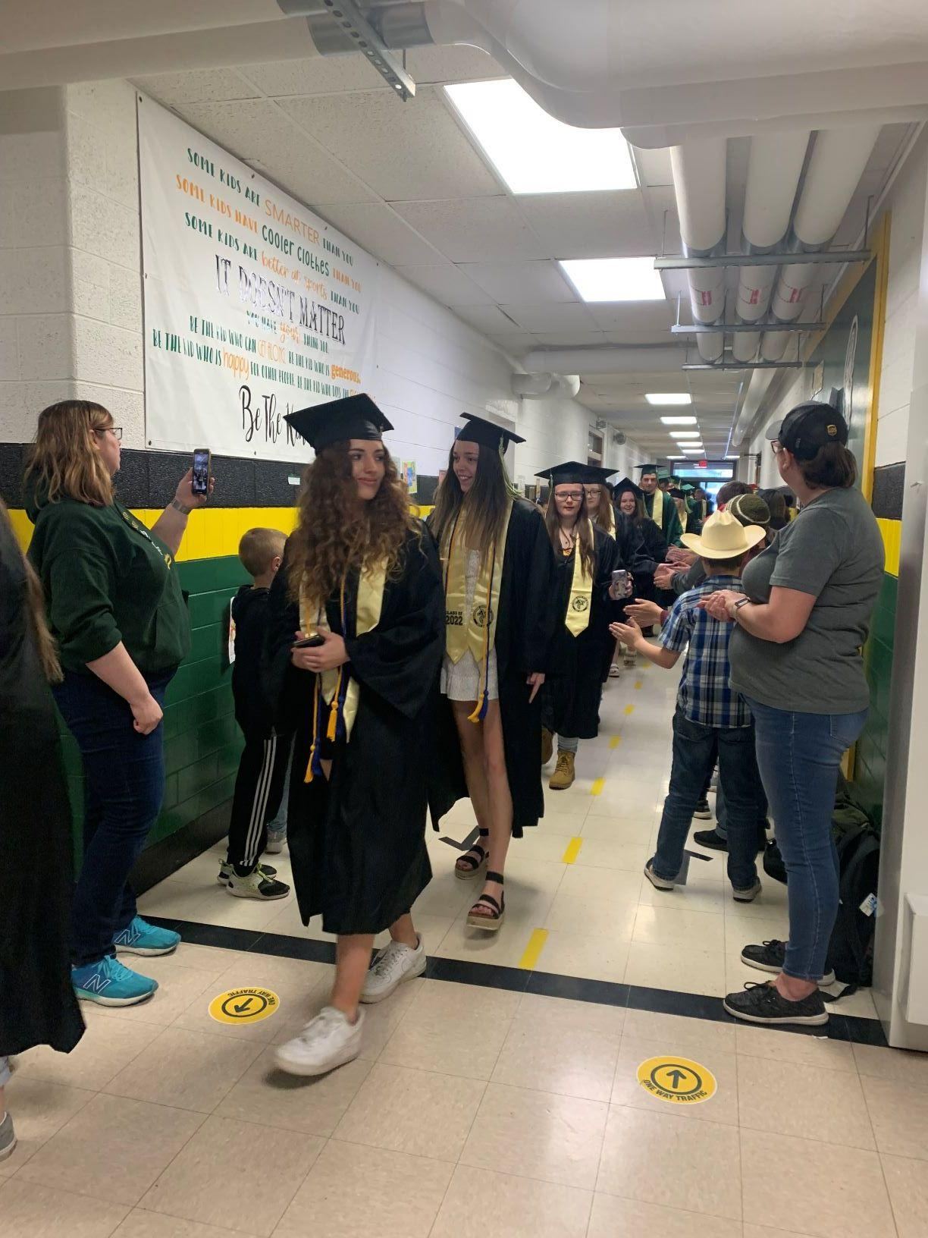

Student Recognition Breakfast
Congratulations to Kayann Andrews and Paxton Fields for being chosen to attend the Western Region Illinois Principals’ Association Student Recognition Breakfast at WIU on May 5. These two students, their parents and I enjoyed a fantastic breakfast buffet, and the students were awarded with certificates and medals.

