**Here are some things to keep in mind for the upcoming 2019-20 Sports Seasons at Sager Middle School. You can’t begin practicing until these are completed:**

1. Complete the **Online Sports Registration:** All 2019-20 Sports Registration for Sager/CPHS is now open online using Final Forms. Please visit cpps.org/o/athletics for access and instructions! You can also visit https://collegeplace-wa.finalforms.com
2. After completing your online forms, you may be required to fill out additional medical forms with the school nurse, depending on your student’s specific medical needs.
3. Get a **sports physical examination**. The doctor will complete a form at the time of your physical. Bring this form to the Sager office. Sports physicals are valid for a 24-month period.
   1. **All students will need a sports physical to participate.**
4. Verify **insurance coverage**, either by purchasing school insurance or carrying personal insurance. Parents/guardians can purchase school insurance at the Sager office.
5. Pay the **$25.00 required fees ($15 ASB Card fee & $10 Athletics Fee) at the Sager or District Front Offices.**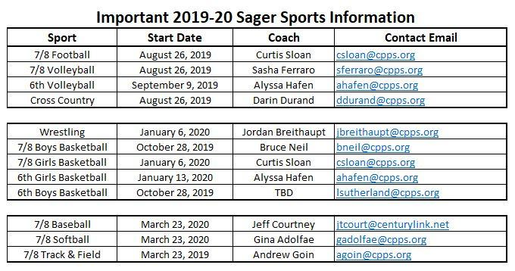

**<<<More info on the back>>>>**

**Other Important Dates:**

1. June 17-August 9; 7-8 AM and 6-7 PM Monday-Thursday--**Iron Raiders Summer Weight Training and Conditioning** at CPHS.  Register at the CPHS/Sager Main Office to attend, more info online.
2. AUGUST 15- **DISTRICT REGISTRATION FAIR**, 8am-3pm- Athletics Department will be available if you need help or support with online registration or fees.

**Athletic League Change**

Sager has moved to the Mid-Columbia Middle School Activities Association (MCMSAC), beginning in the 19-20 school year. This will impact our future schedules and sites. More information will be available in early fall.

**CPPS Athletics and Activities Website**

Check out cpps.org/o/athletics for tons of Athletics and Activities information, links, and guidance!

**Download the College Place Public Schools App**

The official app for College Place Public Schools, WA allows users direct access to the most recent news, announcements and event calendars. Customize the app to display information relevant to a specific campus and to receive important notifications from the district. Users may also access the directory of district faculty and staff, view dining menus, find the location of district events, contact campuses and departments, and follow athletic scores and updates, and much more.

*\*Be sure to select notifications for your specific needs such as Athletics!*

**Stay up to date for all Sager and CPHS Sports**

The R School Today Activity Scheduler App- you can download in the Apple or Google Play Store

**-**[**R School Today Activity Scheduler for Android**](https://play.google.com/store/apps/details?id=com.rschooltoday.activityscheduler)– Google Play Store

**-**[**R School Today Activity Scheduler for Apple**](https://itunes.apple.com/us/app/activity-scheduler/id877988259?mt=8)– Apple Store

***Directions for App***:

*Select Washington State, South Central Athletic Conference, College Place High School and you are on your way, I also recommend that you share this App with other interested parties and community members!

*You can also sign up for notifications to get score updates, and changes to the schedule!

You can also visit [**scacconference.org –**](http://www.scacconference.org/g5-bin/client.cgi?G5genie=400)this is a link to the Conference Website, which will take you to College Place.

**\*\*We encourage parents to download the App and visit the SCAC Conference website, as it will always be the most current and accurate place to find game information for Sager and CPHS Athletics.**

**For any questions, contact the Activities/Athletics Department, (509) 522-3312:**

Sager AD: Lori [Sutherland-lsutherland@cpps.org](mailto:Sutherland-lsutherland@cpps.org)

CPHS AD: Kenneth James- [kjames@cpps.org](mailto:kjames@cpps.org)

Athletic Secretary:Jaimie Derting- [jderting@cpps.org](mailto:jderting@cpps.org)