125th Lead-Deadwood All-School Reunion Celebration
June 26 and 27, 2020
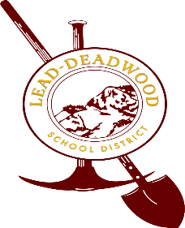
Reunion Activity Timeline:
Friday. June 26
- Golf Scramble, Lead Country Club, 8 am registration, 9 am start
- Registration, LDHS Gym 1 Foyer - 2 pm to 6 pm
  - Gym 2 Open House with hors d'oeuvres
  - HS building tour
  - Photo Opportunities
  - Music – Stacey and Orion Potter
*After 6 pm – time for individual class activities.
Saturday, June 27
- 6:30 am - $10.00 pancake breakfast – CMC Building, 7 Main Street, Lead
- 10 am parade – Lead Main Street
- 12 noon parade – Deadwood Main Street
- 2 pm – 5 pm catered picnic – Mountain Top Field
- Live Bands/Dancing
  - Mt. Top Field - Abbey Road Band – Brandon Jones Band
- Vendors, food trucks, merchandise booths, refreshments for sale

