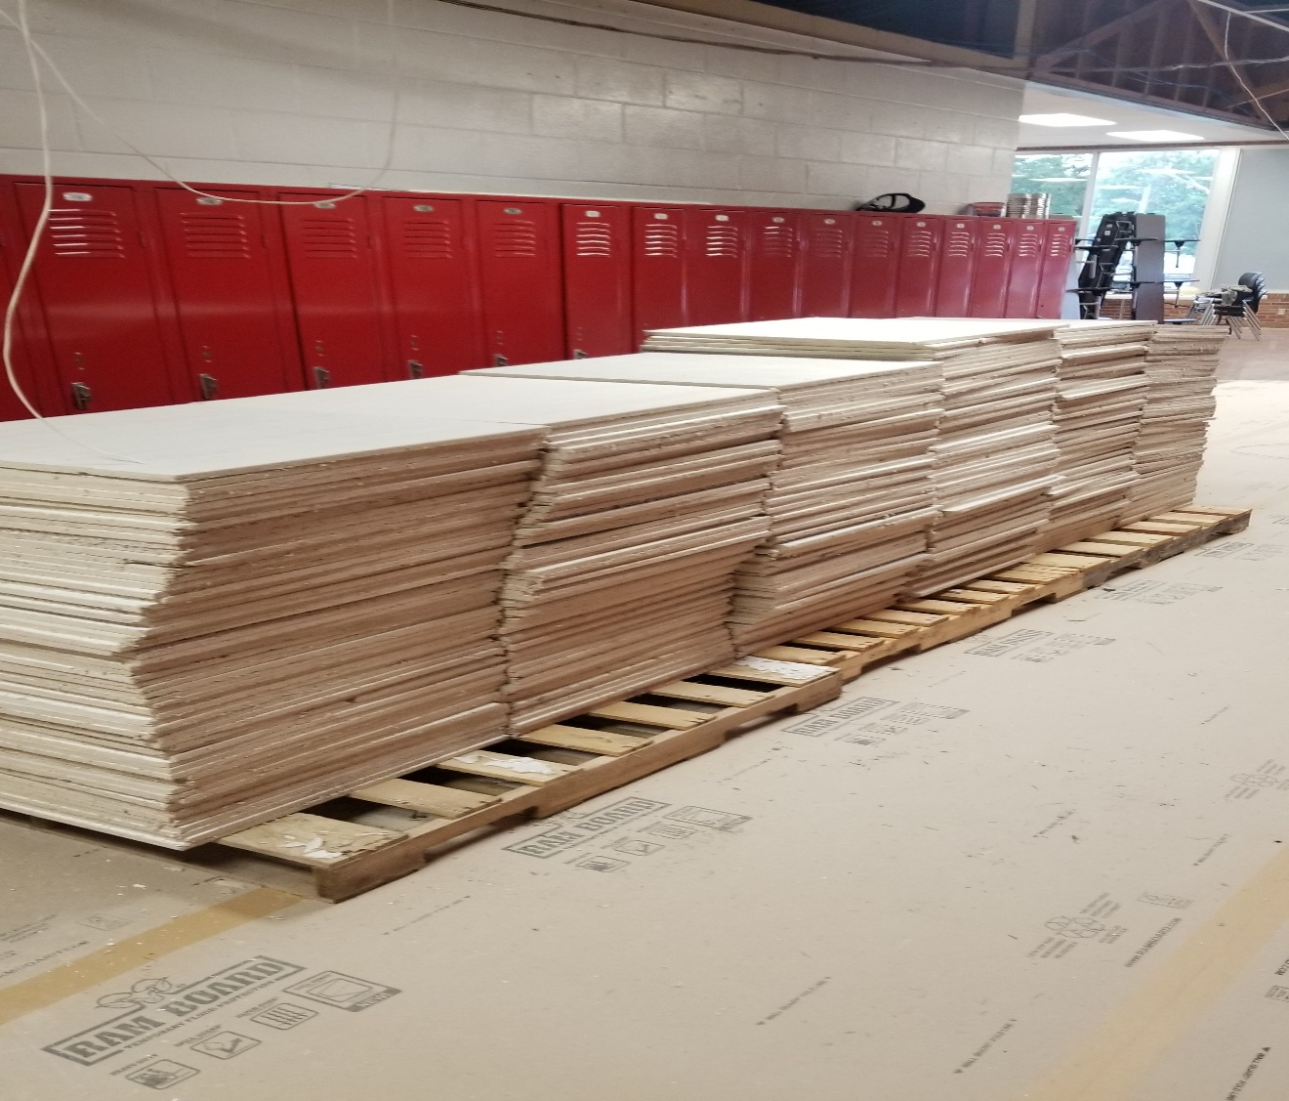

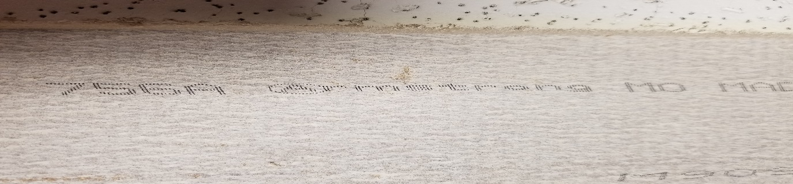

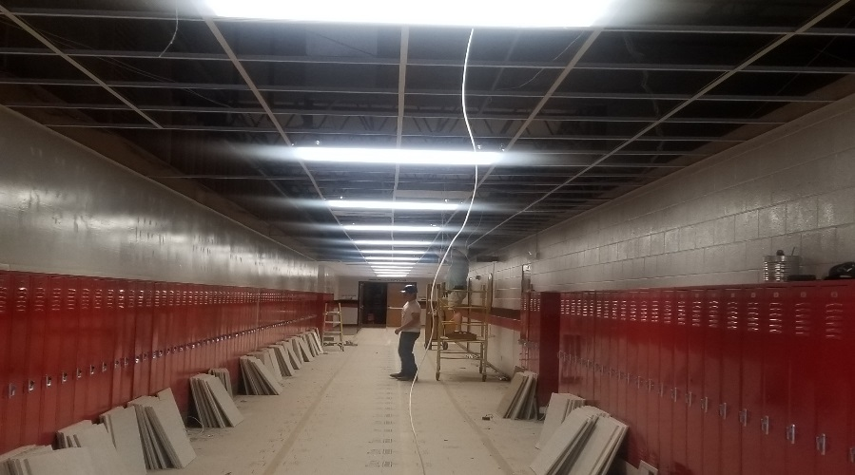
Ceiling Tiles – 2’x2’ contact
the high school for more
information 660-674-2236.
SOLD PPU
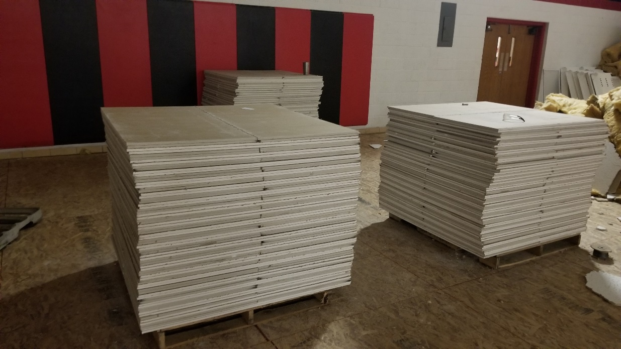

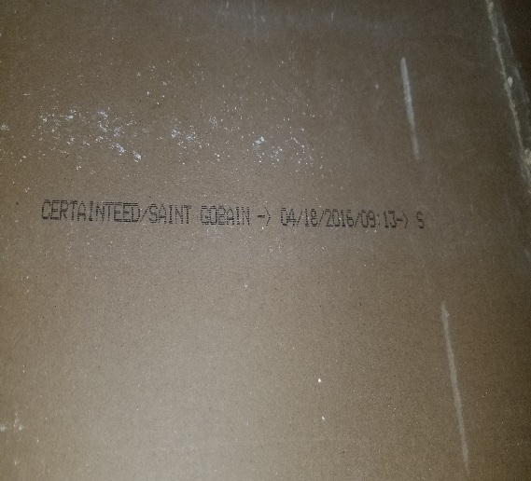
Sheetrock Ceiling Tiles 2’x4’; contact
the high school for more information
660-674-2236.
SOLD PPU

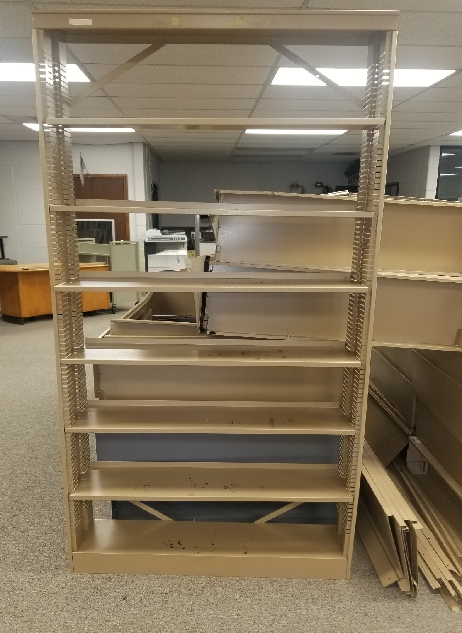
Metal Shelving for sale – SOLD OUT
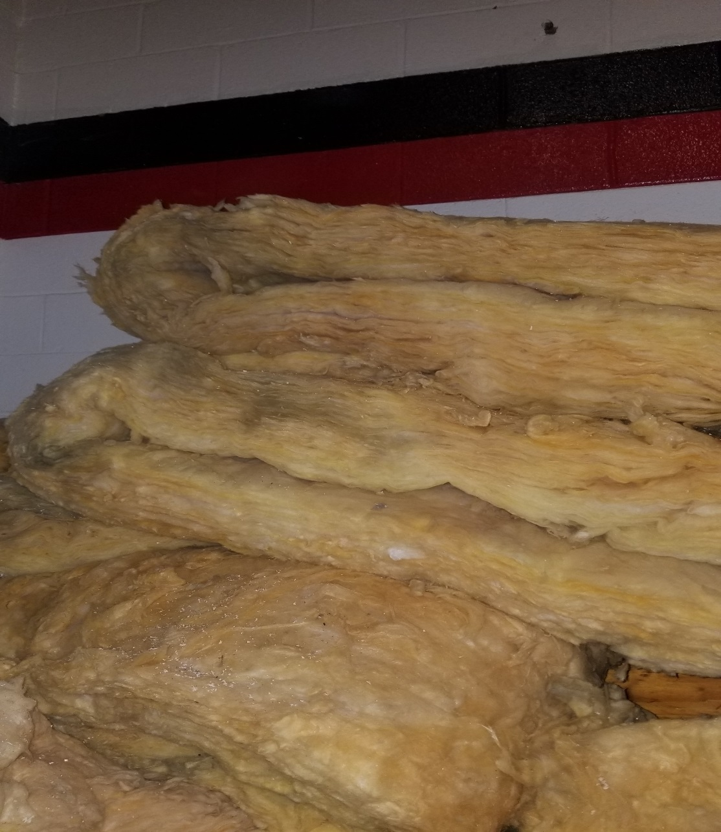

Insulation – make an offer – contact the high school 660-674-2236.
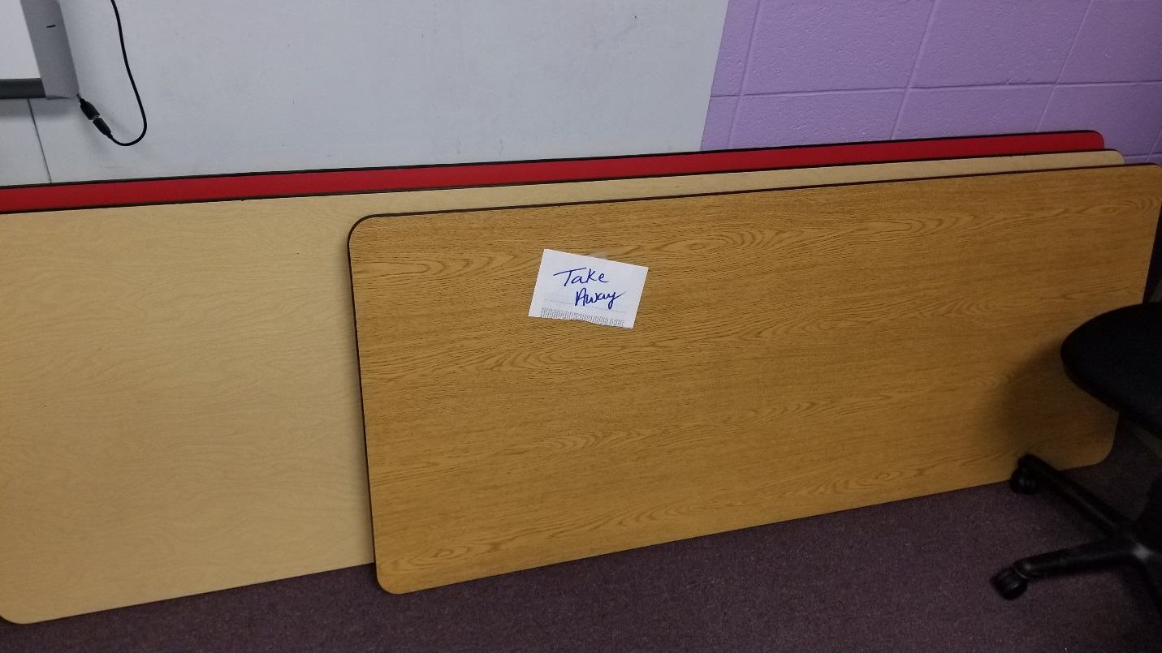
1 – 6’ & 2 - 8’ Tables SOLD – PENDING PICK-UP
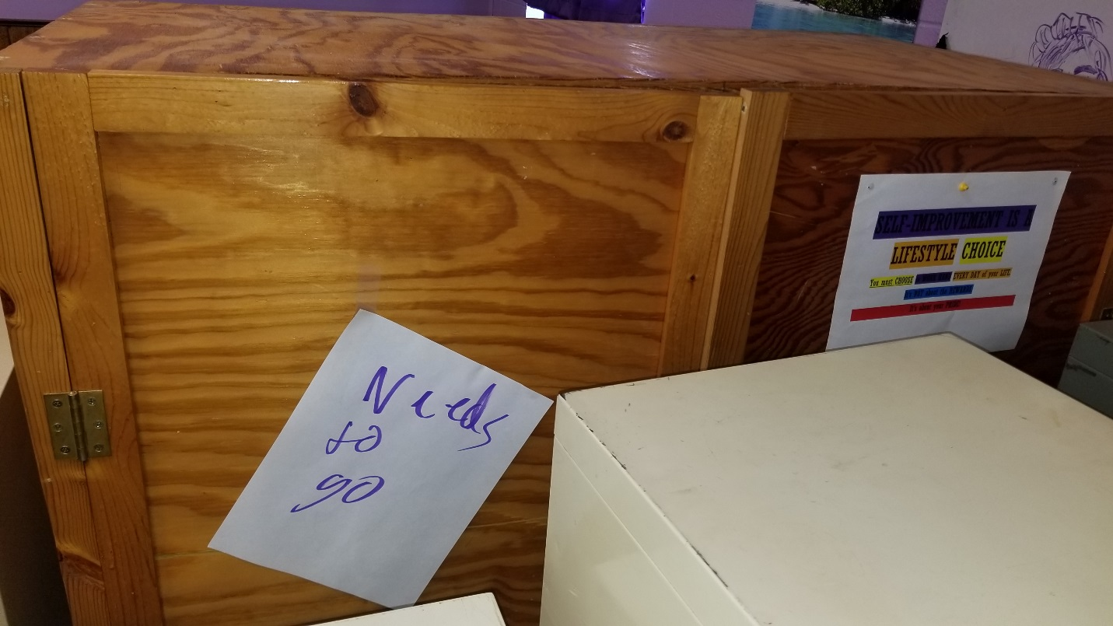
Wooden cabinet
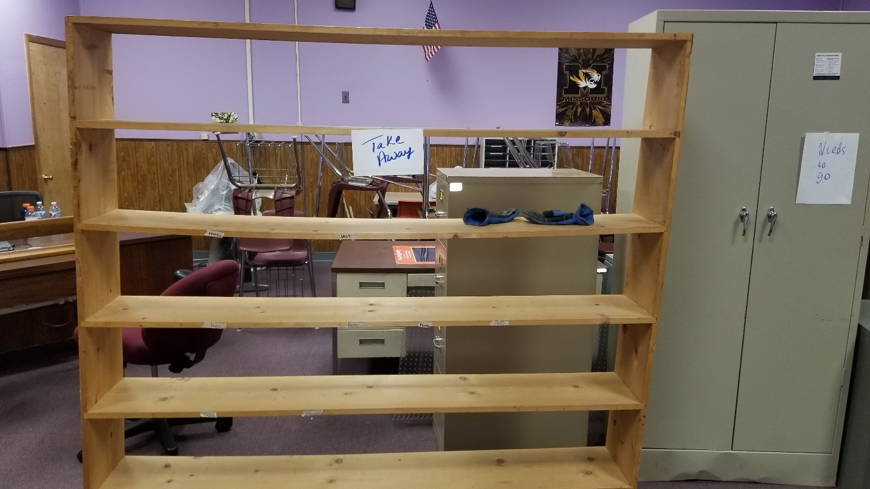
Wooden shelves - SOLD PENDING PICK-UP
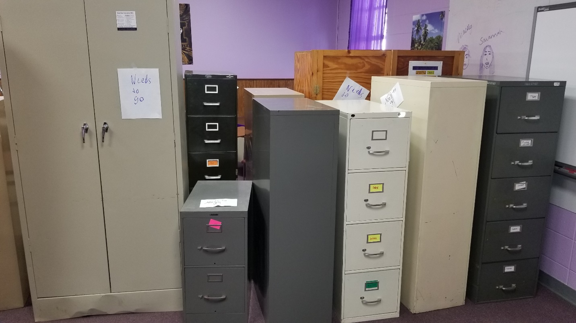
File Cabinets – 2 - 5 DRAWER FILE CABINETS SOLD PPU 1 – 2 DRAWER FILE CABINET SOLD PPU

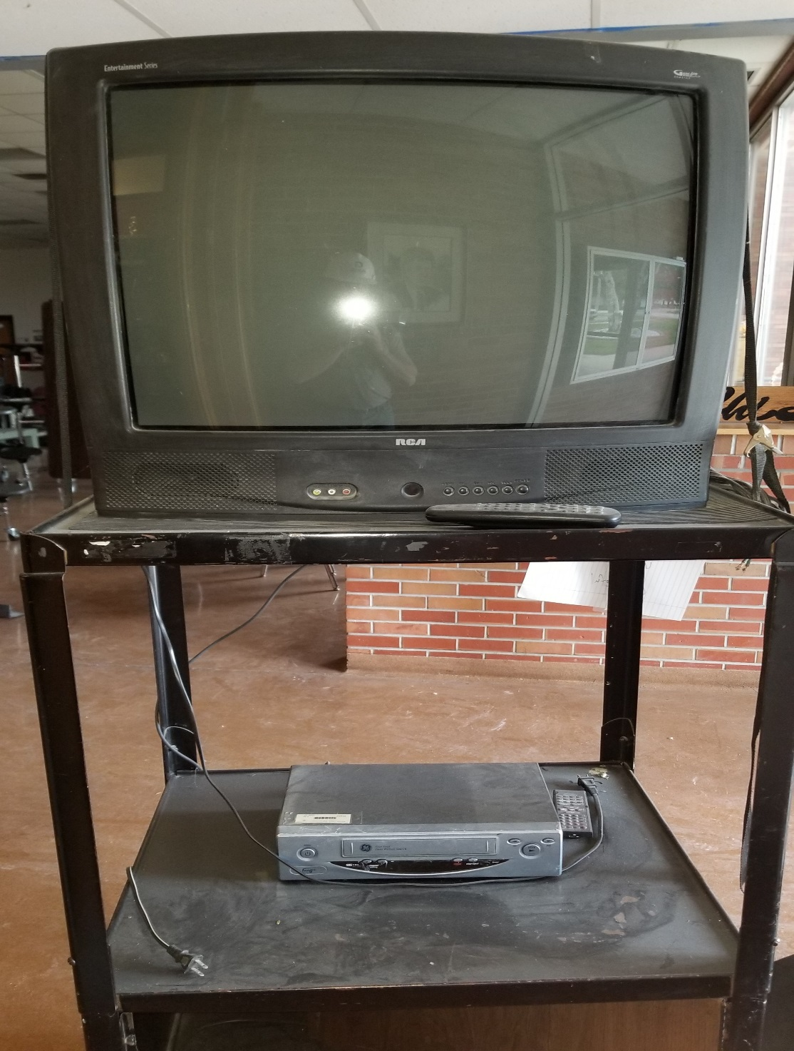
Multiple TV VCR & Stands
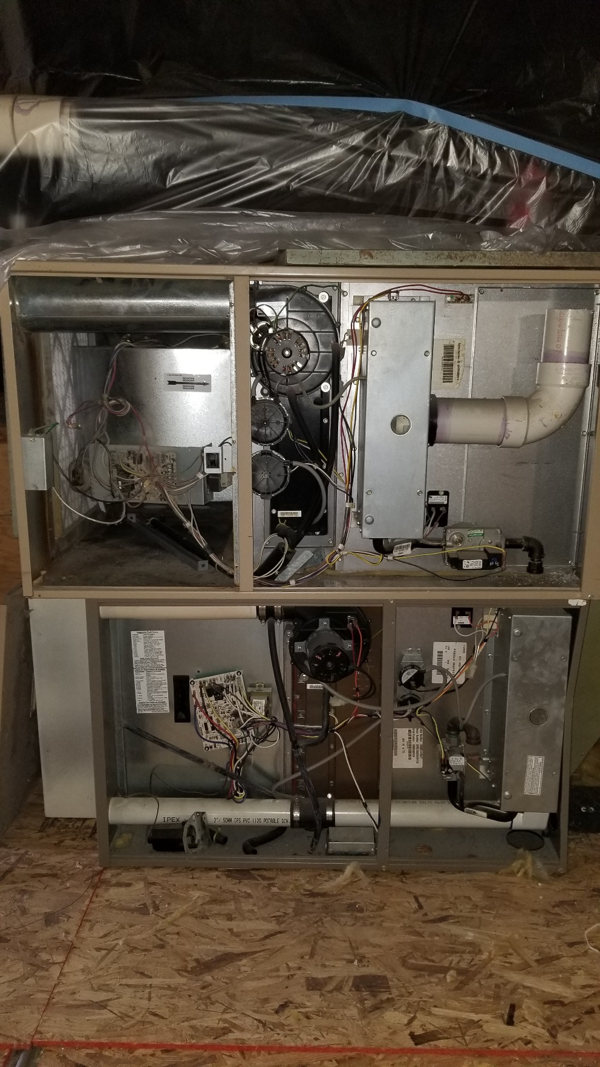

Furnace for sale

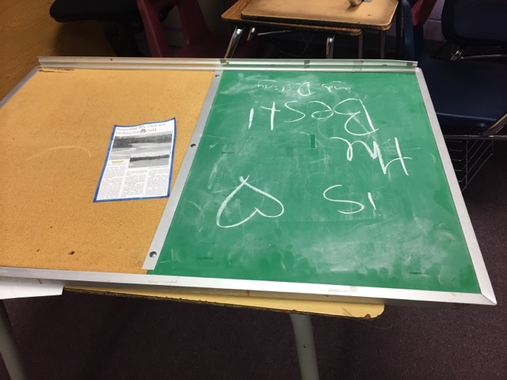

½ Cork Board/ ½ Chalk Board

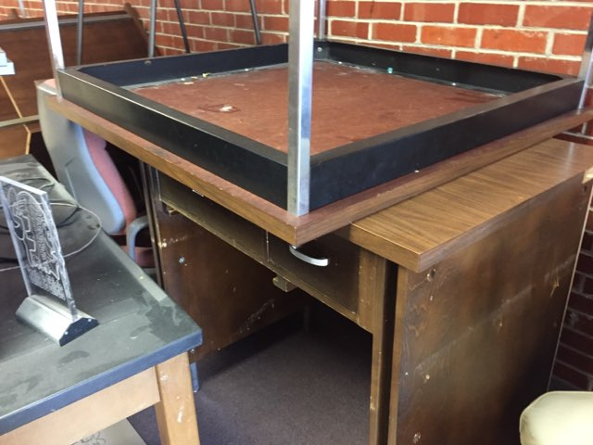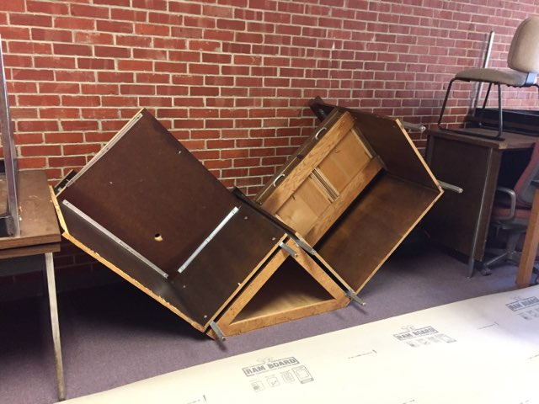

Wooden desk attaches to following to make “L” shape unit.

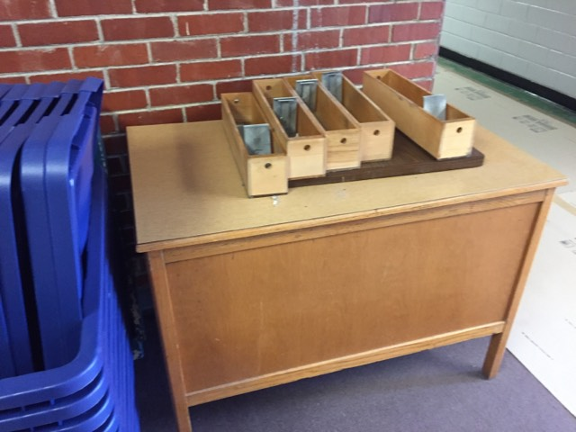
Wooden Desk

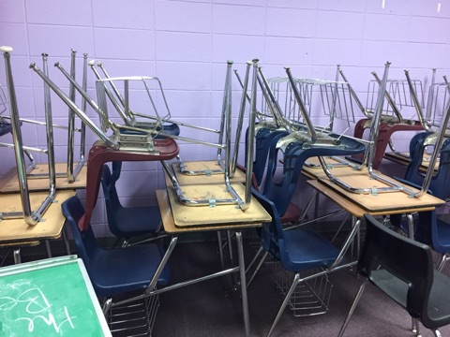
Student Desks w/chair sets
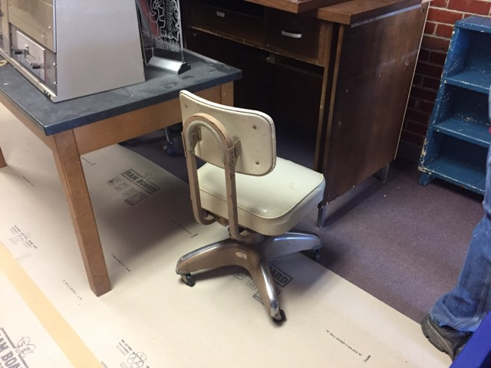
Desk Chair

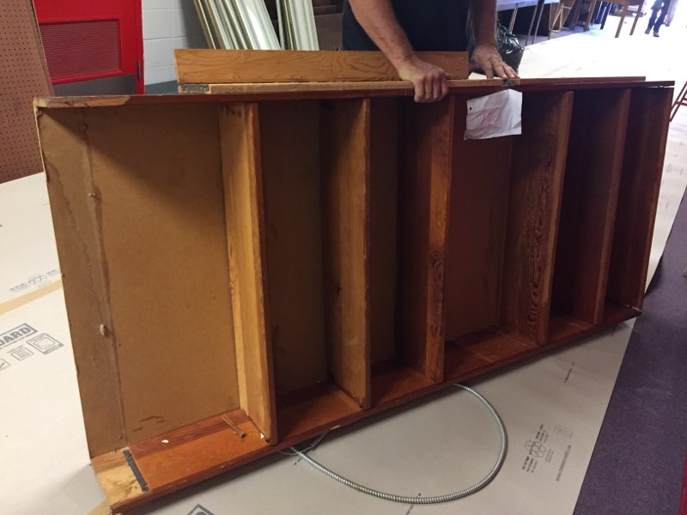
Brown wooden shelves

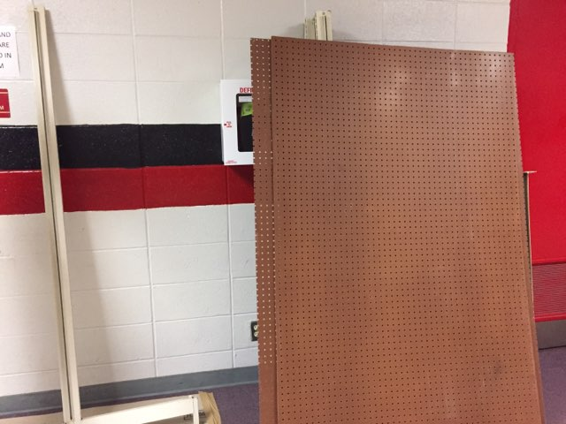
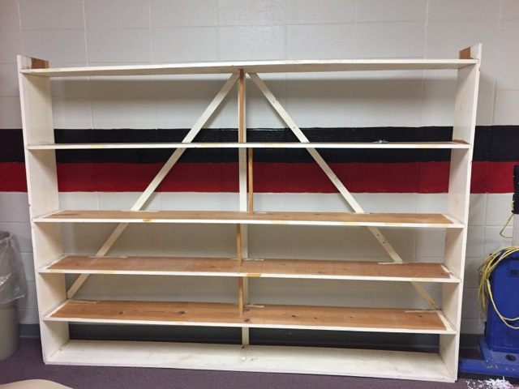
Peg Board w/frame - SOLD PPU White Shelves

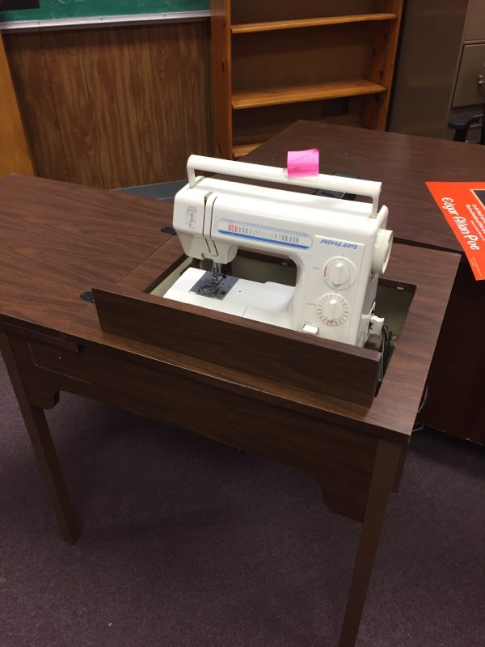
Sewing Machine w/cabinet

