For Sale
Pictures are now available for items listed below:

- 2 tall metal open shelving units SOLD OUT
- 1 wood table 60” x 30” x 26”
- 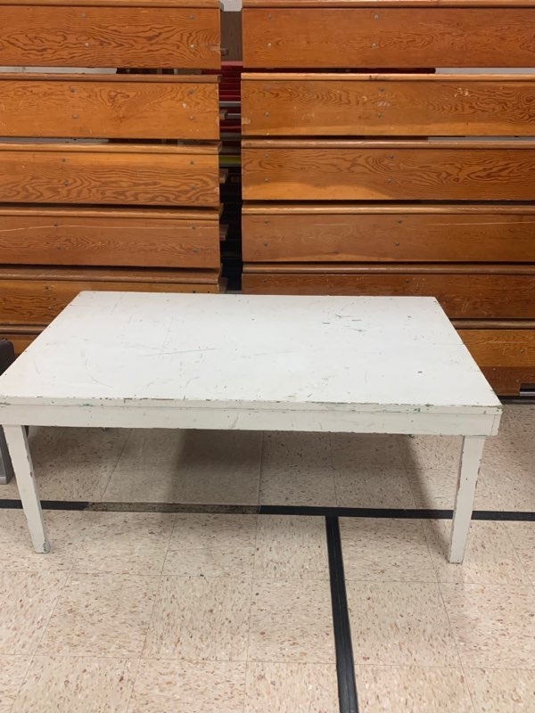

- 3 four drawer filing cabinets
- 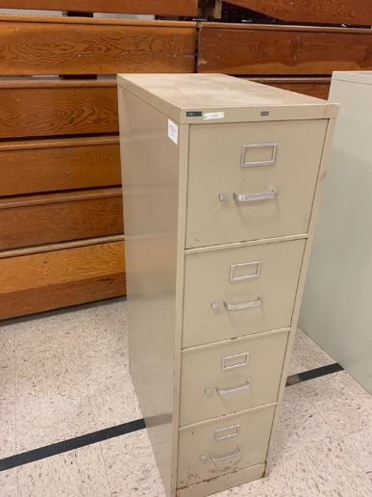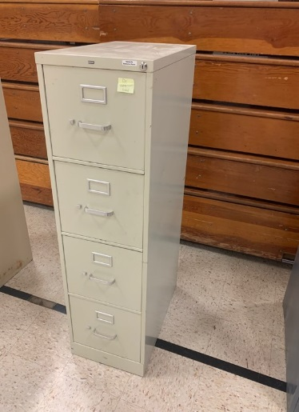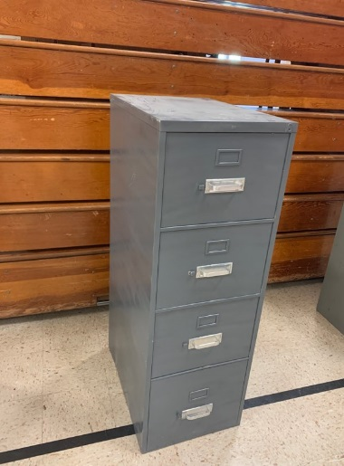

- 1 30” attic fan (no motor)
- 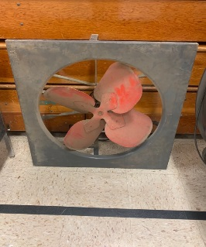

- 1 five drawer lateral file cabinet
- 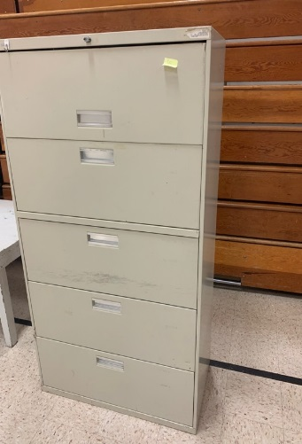

- 1 teacher’s desk 60” x 30” x 29”
- 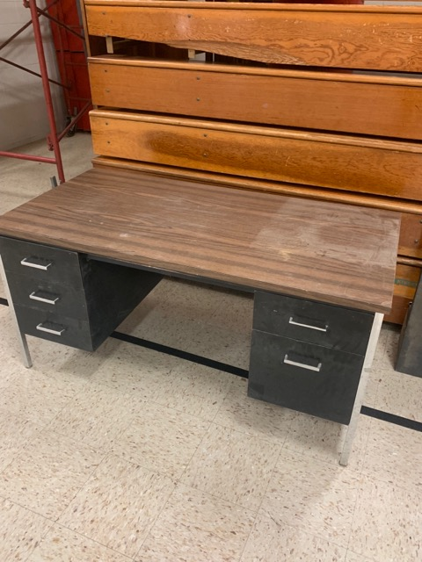

- 1 tall 2 door metal cabinet
- t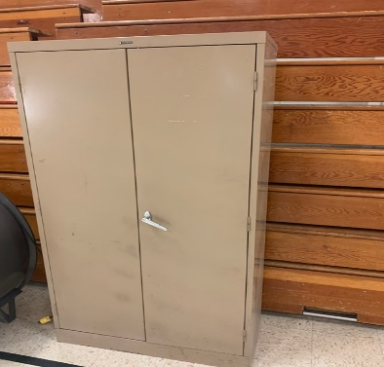

- 4 kitchen wall cabinets SOLD OUT

- 1 Magnavox 32” TV with built in DVD/VHS player SOLD OUT

