New Hope Elementary
School District
Is Seeking New Board Member

If interested, please contact New Hope Elementary School @ 209-794-2376 for an application. You can also go on our website and print out an application.

Qualifications include:
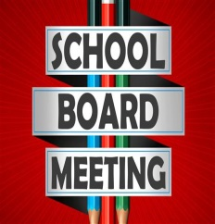
Must be 18 years of age or older
A citizen of the State
Registered Voter
Resident of the School District

New Hope School serves approximately 180 students in grades TK/K-8. We have a highly dedicated staff who work tirelessly to serve the students of Thornton. As a staff we want to provide our students with the best possible, well-rounded education.

