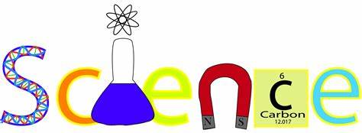

2019-2020 Syllabus for 6th Grade Science

1st Nine Weeks: Life Science
- Interactions with Ecosystems
- Biomes & Ecosystems

2nd Nine Weeks: Physical Science
- Energy & Energy Resources
- Thermal Energy

3rd Nine Weeks: Earth Science
- Earth’s Atmosphere
- Weather
- Climate
- Oceans

4th Nine Weeks: Earth & Human Activity
- Using Earth’s Resources

*There will be a minimum of 2 projects and/or labs for each grading period.
*There will be a minimum of 4 quizzes and/or tests for each grading period.

