ELA 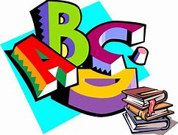
2019-2020 syllabus
1st Nine Weeks
Unit 1 and 2/ Novel
Pronouns (subjective, objective, and possessive)
Narrative Writing
2nd Nine Weeks
Unit 2 and 3/ Novel
Pronouns (intensive, number and person, antecedent agreement)
Informative Writing
3rd Nine Weeks
Unit 3 and 4/ Novel
Writing using simple, compound, complex, and compound complex sentences
Figurative Language
Argumentative Writing
4th Nine Weeks
Unit 4 and 5/ Novel
Punctuate to set of non-restrictive parenthetical elements
Review various writing types

