Wisner-Pilger Elementary School
Supply List
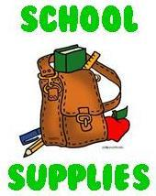

Sixth Grade
Small Elmer’s glue
12 inch ruler (metric on one side)
12 pencils (#2) (Replenish as needed)
Eraser
2 Red pens
1 Box of Colored Pencils
1 Box of Crayola or water based markers
2 One inch binders
4 Pocket folders for projects (NO large notebooks or trapper keepers)
2 Large boxes of Kleenex
1 Zippered bag or small pencil box for supplies
Scissors
1 Yellow Highlighter
Supply of loose leaf paper for daily assignments (wide or college ruled)
1 package of 4 or more of Expo Dry Erase markers (Replenish as needed)
1 pair of INEXPENSIVE Earbuds

PLEASE MARK ALL ITEMS WITH YOUR NAME!!!
Practice your cursive writing over the summer. You will need to use it in your classes. ☺

