Advanced Placement English 2018/2019
Ms. Weinstein

The purpose of the Advanced Placement English course is to examine literature the way a college course would. Therefore, it is imperative that you do the reading. The works are specifically chosen to help you prepare for A.P. free response questions. The goal is to make you accustomed to a real college course and the A.P. exam.

To this end you must read the following book over the summer: Jane Eyre by Charlotte Brontë
I use this edition in class when going over areas of the text. It is helpful if you have the same edition as you will not have to hunt to find the section of text I am discussing. Signet Classics publishes it with a new introduction by Erica Jong.
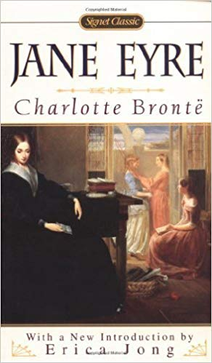

Do the reading! It is advised that you take notes on the book as you read. Read it completely and master it well. You will be required to submit one short paper, using chapter citations, along with the reading of the book. This topic was the free response essay on the 2013 AP exam. This will help you get a feel for the type of questions you will be responding to in written form.

- A bildungsroman, or coming-of-age novel, recounts the psychological or moral development of its protagonist from youth to maturity, when this character recognizes his or her place in the world. Select a single pivotal moment in the psychological or moral development of the protagonist of the bildungsroman, Jane Eyre. Then write a well-organized essay that analyzes how that single moment shapes the meaning of the work as a whole. Be sure to mention the literary devices, such as theme, tone, syntax, diction, mood, characterization, etc. that Brontë uses to portray the psychological development.

The paper should be approximately 3-4 pages in length and address all parts of the topic. DO NOT MERELY SUMMARIZE THE NOVEL. If you don’t address all parts of the topic you will not do well on this paper. If you have any questions, see me before the end of the school year. The paper will be due on Tuesday, September 10, 2019 submitted to turnitin.com. You will be given the turnitin class ID number and password on the first day of school.

Good Luck!

