Cove High School
Senior Project Guide
2018-2019

Senior Project Standard
The successful completion of the Cove Senior Project will provide a collection of evidence that demonstrates the students extended application of learning.

Updated 8/19/2018
Student Name: __________________________

Table of Contents

Page(s) |  | Title
2 |  | Timeline
3 |  | Senior Project Overview
4 |  | Outline of Sr. Project Requirements
5 |  | Senior Project Proposal Information
6 |  | Senior Project Mentor
7-8 |  | Collection of Evidence--Sr. Project Portfolio
9-10 |  | Oregon Dept. of Education Collection of Evidence Scoring Rubrics
11-12 |  | Sr. Project Presentation and Scoring Rubric
13-14 |  | Sr. Project Reflection and Scoring Rubric
15 |  | Thank You letter (example)
16 |  | Addendums
17 |  | Addendum A—Personal Statements
18-21 |  | Addendum B—Title Page Template, Written Sections definitions, Planning Chart, Signature/Approvals
22-23 |  | Addendum C—Mentor Proposal Conference Form
24-25 |  | Addendum D—Monthly Progress Logs
26 |  | Addendum E—Cumulative Progress Log
27 |  | Addendum F—Mentor Evaluation

2018-2019 Senior Project Timeline

Assignments to support successful completion of the Senior Project
Use the due dates listed below to manage your time and plan ahead.
*note: some dates are approximations and may be subject to change at Designated Staff’s discretion

JUNIORS DUE DATE
Personal Statements-Draft (support for Sr. Project) TBD

Project Topics of Interest TBD

Mentor Identified & Mentor Conference Form Completed October 16, 2018

Topic Proposal Submitted March 19, 2019

Senior Project Proposal Approved April 16, 2019

SENIORS DUE DATE
Personal Statement-Final (support for Senior Project) September 25, 2018

Monthly Reflection Logs - Due at monthly Advisory Meeting.
Reflection Log #1 (may be an accumulation of summer work) September 25

Reflection Log #2 October 23

Reflection Log #3 November 27

Reflection Log #4 January 29

Reflection Log #5 February 26

Reflection Log #6 March 18

Complete Physical Project February 26, 2019

Compose Oral Boards Presentation TBD

Present Oral Boards for Advisory April 10, 2019

Formal Senior Project Presentation April 23, 2019

Reflection Paper May 13, 2019

Senior Project Portfolio of Evidence May 20, 2019
(all the above assignments and related documentation that demonstrates successful completion of the Extended Application graduation requirement)
Cove High School Senior Project 2018-2019

An Overview
Senior Project is designed to meet the Extended Application portion of Diploma requirements for graduation in the State of Oregon. It gives students the opportunity to create a relevant project connected to their future goals. Through the Senior Project, students apply academic standards, essential skills, technical knowledge, and other skills appropriate to their personal and/or career interests and post-high school goals. Students are asked to reflect on their future aspirations, to design and implement a project that allows them to develop new skills, to present their learning in front of an audience and to reflect upon their learning.

Students who successfully complete a Senior Project will meet the following state graduation requirements:
- Demonstrate extended application through a collection of evidence.
- Demonstrate career related knowledge and skills, personal management, team work, communication, problem solving, employment foundations and career development.
- Participate in career related learning experiences.
Your project will have the following components:

Rigor: Is the project challenging? Are you applying your knowledge and skills in a new and/or complex way? Do you have to learn something in order to complete it?
Relevance: How does your project relate to your Personal Education Plan, including your post high school goals and aspirations?
Reflection: You will reflect on your learning and experiences and make clear and meaningful connections with your Personal Education Plan.

Your project will allow you to demonstrate:

Personal Management: Manage your time, resources and responsibilities. Exhibit appropriate work ethic, and behaviors.
Problem Solving: Use decision-making problem solving techniques effectively.

Communication: Demonstrate effective communication skills to give and receive information.

Teamwork/Collaboration: Demonstrate teamwork and ability to effectively work with others.

Employment Foundations: Demonstrate academic, technical and organizational knowledge and skills required for successful employment.
Career Development: Demonstrate career development skills in planning for post-high school experiences.

OUTLINE OF COVE SENIOR PROJECT REQUIREMENTS
(further details are contained in this Sr. Project Guide)

Junior Year

Junior Year (Fall)
- Topics of Interest Generated--Advisory
- Topic Selected--Advisory
- Mentor Identified--Advisory
- Mentor Conference (form to be completed)—Advisory (*must be approved prior to beginning research)
Junior Year (Winter/Spring)
- Topic Research (based on project goals)--Advisory
- Topic Proposal—English
- Proposal Approvals—Advisory (*must be approved prior to moving forward)

Senior Year

Senior Year (Summer/Fall)
- Complete Physical Project—Advisory
- Organize Evidence for Presentation—Advisory
Senior Year (Winter)
- Compose Oral Boards Presentation Speech w/Visuals—English/Speech
- Rehearse Oral Boards—English/Speech
Senior Year (Spring)
- Present at Oral Boards for Evaluation--Advisory
- Reflection Paper—English
- Senior Project Portfolio--English

Senior Project Proposal

Refer to Addendum B

English III—Dr. Farrell

Junior Year (Fall)
- Topics of Interest Generated--Advisory
- Topic Selected--Advisory
- Mentor Identified--Advisory
- Mentor Conference (form to be completed)—Advisory
Junior Year (Winter/Spring)
- Topic Research (based on project goals)--Advisory
- Topic Proposal—English
- Proposal Approvals--Advisory
Senior Project Proposals should be composed after meeting with your mentor and discussing the items on the Mentor Proposal Conference form. To complete the proposal, you must submit a typed document that follows the provided components structure, and it must contain all required signatures to verify that all involved parties agree to its contents.

Senior Project Proposal Components:
I. Title Page (use template - Addendum B)
II. Proposal Written Sections (five sections following the guidelines provided - Addendum B)
III. Planning Chart, Mentor Information, and Signatures (filled in with required information and signed - Addendum B)
IV. Mentor Proposal Conference Form (this form outlines what you and your mentor discuss and agree on in terms of planning for your project - Addendum C)

Senior Project Mentor

Mentor Proposal Form--Refer to Addendum C

What is a mentor?
Someone who has knowledge and experience in your topic and can provide support and guidance in completing your project

What can a mentor do for me?
- Answer questions
- Provide guidance, encouragement, and motivation
- Give you information on how to access resources
- Help you develop relevant research topics and research questions
- Provide a lot of “how to” information for your project

How do I find a mentor?
Ask people! Ask friends, family, teachers, etc. if they know anybody in your topic area who would be willing to mentor you. Consider the person with whom you Job Shadowed and/or have interned. Search in the community for someone working in the field. If you have been involved with an organization related to your topic, they may be of help to you. Speak with your teachers to learn of potential community members who you may contact.

How involved does the mentor need to be? VERY!!!
Student and mentor are encouraged to meet on a regular basis. Your mentor must be aware of each step you are accomplishing. This person will be responsible for signing your time log sheets and for completing a Mentor Evaluation form for you at the completion of your project.

Who can be a mentor?
- Has related expertise and a minimum of 4 years experience in your topic area.
- Has the knowledge base that will help your specific project.
- Is available to meet with you on a regular basis.

Who can NOT be a mentor?
Parent/Guardian, relative, an individual that the student lives with or a Cove School staff member can NOT be mentors.

Can I have more than one mentor?
Yes. If you are doing a multi-faceted project, it may be to your benefit to have more than one mentor.

Does my mentor have to live in the community?
It makes it a lot easier if the mentor works or lives close by. Your mentor needs to see your product at its various stages and this would be difficult with a distant relationship. The mentor also has to evaluate your final product.
Senior Project Portfolio--Collection of evidence
to support the graduation requirement

Evidence of your project and learning from your project is to be compiled in a portfolio folder. Use the following checklist to guide the progress of your portfolio development.
The listed items are required. You may add anything to your portfolio that you are proud of, so don’t let this list limit you.

Use the following to help you complete and organize your Senior Project portfolio.
- Portfolio Evaluation form (may be included by advisor)
- Table of Contents
- Approved Project Proposal
- Mentor Proposal Conference Form
- Documentation of Senior Project to show SUFFICIENT EVIDENCE of Career Related Learning Standards.
  - Monthly reflection logs & cumulative log
  - Evidence of hours spent on project - Include evidence that you listed in your proposal, calendars, time log sheets, etc. to show the total time you spent on your project.
  - Copy of Thank You letter(s)
  - Mentor Evaluation
Evidence of Project (evidence will vary depending on nature of your Senior Project)
Presentation outline | Photographs | Journal entries
Handouts | Copy of Power Point | Created documents
Other ________________________________________________________

    - Advisory Presentation - evidence of participation (Designated Staff /administrator signature of participation)
    - Senior Project Presentation & Showcase of Learning Rubrics- (evaluator’s scoring of formal presentation)
    - Reflection Paper-Final Draft

Required Portfolio Organization
- Separate sections with dividers.
- Organize information chronologically or in a way that best represents your project.
- LABEL EVERYTHING. Remember, the portfolio tells the story of your project.
- Make portfolio look professional. Free of errors, typos, etc. Don’t just spell check but proofread!

Guidelines for a Sufficient Collection of Evidence

The guidelines show each of the three Extended Application (Senior Project) traits (Relevance, Rigor, Reflection), followed by clarifying questions, a space to check progress, and an area for listing the specific location of the evidence. Students should routinely use the clarifying questions and check-off space provided to track their progress and to ensure their collections show enough evidence of all three Extended Application traits. Using these guidelines will help students to be sure their collections are complete and ready to be scored.

Extended Application (Senior Project) Standard
Students will be able to apply and extend academic and career-related knowledge and skills in new and complex situations appropriate to the students personal, academic, and/or career interests and post high school goals.

Does the work sufficiently represent the Extended Application standard?

The collection must include:
- Relevance
  - Evidence of personal relevance. Students show clear connection between their work and their post-high school goals and plans as they have developed or evolved. They show evidence of new learning, ideas, results or conclusions.

- Rigor
  - Description of academic and specialized knowledge and skills appropriate to context. Students explicitly describe the academic and specialized knowledge and skills they used. They demonstrate an understanding of how these knowledge and skills are appropriate to their education plans and post-high school goals.
  - Application of learning to new contexts. Students apply and extend academic and specialized knowledge and skills in complex or non-routine situations, where the student uses some individual responsibility and autonomy.

- Reflection
  - Reflection on applied learning and connection to goals. Students reflect on how they applied academic and specialized knowledge and skills in complex or non-routine situations. They also describe how their work relates to their post-high school goals.

Is there sufficient documentation of the students’ work?

The collection must include:
- Documentation of process. Students explain the steps involved and types of activities, communications, or research used when putting together their collection of evidence.

- Tangible documentation of products. Students provide tangible evidence of their work through photos, video, written pieces, etc.

- Record of reflection. The collection of evidence must include some form of written and/or verbal record of reflection.

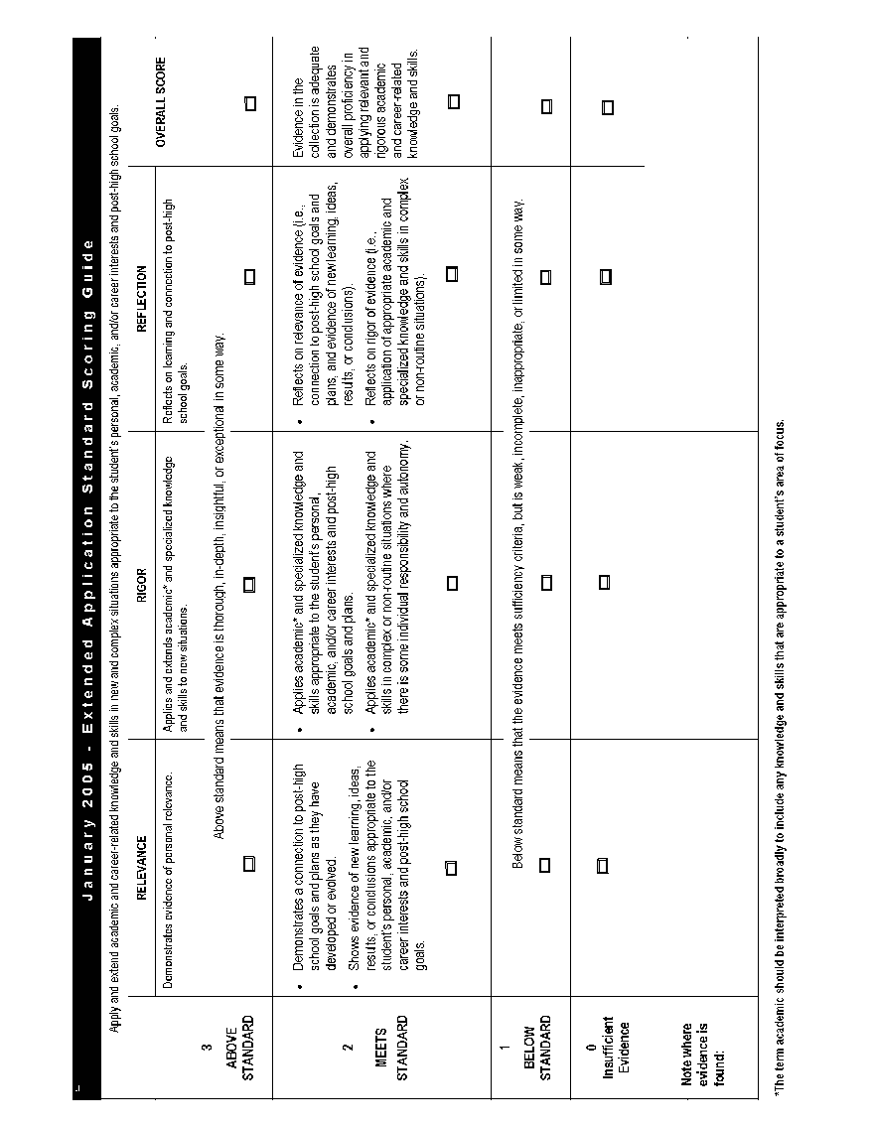

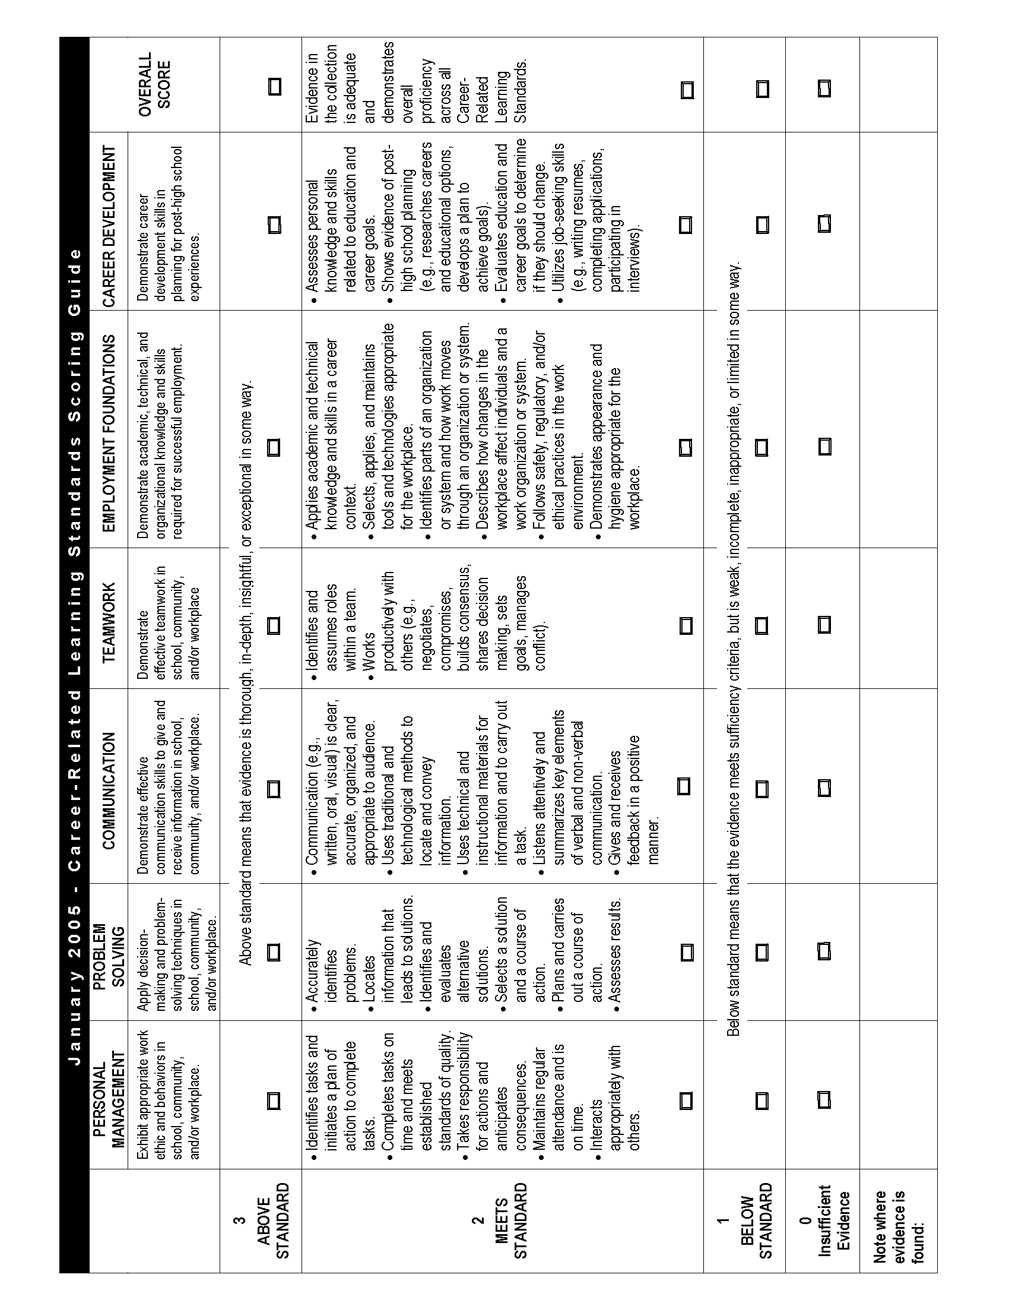

Present to an Audience and Showcase Experience

The next step of your Senior Project is to publicly present your learning, which may include your peers, parents, staff and community members. Your formal presentation should be a minimum of 15 minutes in length and include a visual aide that enhances your presentation. (Refer to Presentation Scoring Rubric)

FORMAL PRESENTATION
- Introduce yourself (first and last name) and your project. Include an insight regarding your project that draws in the audience, and helps them listen closely to your presentation.
- Describe how or why did you choose your project, and how it’s relevant to you.
- Discuss the process you went through to complete the final product, along with evidence for each of the following Career-Related Learning Standards:
Personal Management | Problem Solving | Communication
Teamwork | Employment Foundations | Career Development
- Show your final product to the audience in a way that helps them experience it as much as possible: demonstrating how to use it in front of your audience, presenting a video of people exploring it, or showing a series of photos that document how it all came together.
- Share your thoughts on what you’ve learned from the Senior Project process.
- Conclude your presentation by giving thanks to people who have supported you through your Senior Project, and give your audience of students and parents a takeaway lesson: something they can learn from your experience about themselves, their community, or their future.
Additional expectations to support a successful presentation:
- Show up at least 10 minutes before your scheduled presentation
- Dress professionally
- Presentations must be a minimum of 15 minutes long.
- Days prior to presentation, check in with your hosting teacher regarding room preparation and technology needs.
- PRACTICE! PRACTICE! PRACTICE!
- Be prepared to answer a variety of questions like the following:
What did you expect to learn in the process? What did you learn through the work you did? What insights did you gain? What is your analysis of the project’s benefits? If you had it to do over, what would you do differently? What advice would you give to next year’s seniors about their projects?
The Visual Aid
Your presentation must be supported by a visual aid to assist with the demonstration, explanation, and presentation of your project for your audience. Your goal is to ENHANCE your presentation with the use of a visual aide.
Some suggestions for visual aids include:
- Objects: tools or materials that show or demonstrate your senior project.
- Display boards: diagrams, drawings, illustrations, maps, pictures, or brochures, etc., thoughtfully displayed on a presentation board or projected from a document camera.
- Document camera: Pictures, writing, maps, diagrams, etc. can all be projected using a document camera.
- I-movie/Videotapes: Segments of an event, rehearsals, practice, final video, highlights, (3 minutes or less)
- Electronic Presentations (i.e. PowerPoint): Presentations can be made using PowerPoint, Google Presentation, etc... It is your responsibility to know how to operate the equipment.
Showcase of Learning
Students will showcase their learning to the community after the formal Senior Project presentations. Students are encouraged to create a tri-fold visual that captures the main elements of their project. Additionally, students should prepare an “elevator” speech that includes the essential question and key learning from the senior project experience.

Senior Project Presentation Scoring Rubric

Students will present their learning in a 15 minute presentation to an audience. The presentation will have a clear opening and closing, convey their learning and application of the Career Related Learning Standards.
The student is expected to use a visual aide that enhances his/her project.

Student Name Date

Evaluator Presentation time
Start time End time

Presentation Topic

Circle the bullets in each box that best describes the student’s presentation.
 | Ideas/Content | Visual Aide | Organization | Language | Delivery
6 | - Purpose of the presentation is driven home  - Main idea is focused  - Specific details are strategically placed for effect | - Visual enhances the presentation and changes the way viewers looked at the project | - The intro is strong and creative  - Conclusion is accurate and imaginative  - Speaker’s thoughts make the presentation interesting | - Language is expressive and captivating  - Grammar shows deep knowledge of the English language  - Vocabulary is complex and varied | - Use of voice & tone changed the way people listened  - Constant eye contact  - Proper pronunciation
5 | - Purpose is creative and inviting  - Main idea is focused  - Specific details are relevant and original | - Visual enhances the presentation and the viewers knowledge of the project | - The intro is well developed  - Conclusion is accurate and impacting  - Speaker’s thoughts are easily followed | - Language is expressive and well developed  - Grammar is flawless  - Vocabulary is complex and varied | - Outstanding use of voice & tone  - Constant eye contact  - Proper pronunciation
4 | - Purpose is engaging to listeners  - Main idea is focused and clear to the listener  - Specific details support the main idea | - Visual is completed and adds to the understanding of the project | - The intro is developed  - Conclusion is accurate and developed  - Sequencing is logical w/appropriate transitions | - Language is used well  - Grammar is used well  - Vocabulary is appropriate to grade level | - Effective use of voice & tone  - Effective eye contact  - Proper pronunciation
3 | - Purpose is emerging  - Main idea is discernable but needs help  - Specific details may not support the main idea | - Visual is used but seems incomplete and/or does not enhance the presentation. | - Evidence of an intro exists but hard to identify  - Evidence of a conclusion exists but hard to identify  - Speakers thoughts are not easily followed | - Language is appropriate but not complex  - Grammar is appropriate  - Vocabulary shows lack of complete understanding | - Effective use of voice & tone  - Inconsistent eye contact  - Some words mispronounced
2 | - Purpose is hard to define  - Main idea is not focused  - Specific details are insufficient to support the main idea | - Visual is missing major parts to support the presentation  - Visual does not enhance the presentation | - Evidence of an intro is lacking  - Evidence of a conclusion lacking  - Speaker’s thoughts are hard to follow | - Language complexity is below grade level  - Grammar shows lack of understanding of the language  - Vocabulary shows lack of understanding | - Little change in voice & tone  - Rarely made eye contact  - Mispronounced words
1 | - Purpose is not discernable  - Main idea is not apparent, wanders  - Specific details are not included | - Visual is not available/not done | - No Evidence of an intro  - No evidence of a conclusion  - No line of thought is found/discerned | - Language is too simple for grade level  - Grammar inappropriate for grade level  - Vocabulary is detrimental | - Hard to hear the speaker  - Never made eye contact  - Mispronounced many words.

Rate student’s overall presentation (circle one) 5/6: Exceeds 4: Meets 1-3: Needs Further Work

Pass (4-6):______ Redo (1-3):________
Notes:

Reflect on Your Learning

Format: Follow MLA Essay Writing Guidelines

Length: 2-3 pages (12pt. typed, double-spaced)

Reflection Content:
How did you apply each of the following career learning standards during your work on your project? What were your challenges and successes? What new learning will you take with you in your post–high school endeavors? What specific skills did you apply in each of the following areas?

Problem Solving, Communication, Teamwork & Collaboration, Employment Foundation, Career Development, Presentation

Use the following to guide your writing. Discuss your learning experiences, not a description or whether you enjoyed the project. This is a reflection on your learning. If any part of the project was not a success, learning still occurred. Include your challenges as well as your successes. These will help you think critically about your experience.
- What did you learn about yourself through this project? (strengths, weaknesses, talents, traits)
- What specific skills did you apply during your project? (see chart below)
- What new skills, knowledge or habits will you be able to apply to personal or career pursuits in the future?
- Looking back would you have chosen the same topic knowing what you know now?
- What did you learn about preparing and presenting to a panel?
- What part of this project or process are you particularly proud of?
- Looking back on the entire project what would you do differently next time?

Reflective Paper Rubric

Students will write a 1-2 page reflective paper after the presentation is complete.
Follow MLA Essay Writing Guidelines and address the following:
How did you apply each of the following career learning standards during your work on your project? What were your challenges and successes? What new learning will you take with you in your post–high school endeavors? What specific skills did you apply in each of the following areas?

Problem Solving, Communication, Teamwork & Collaboration, Employment Foundation, Career Development, Presentation

Student Name Evaluator

Circle the bullets in each box that best describes the student’s paper.
 | Ideas/Content | Organization | Sentence Fluency | Conventions
6 | - Purpose is clear.  - Main idea is focused  - Specific details support the main idea | - The intro is strong and creative  - Conclusion is accurate and imaginative  - Writers thoughts make the piece engaging to read | - There is natural flow of the language used.  - Writing is easy to read aloud  - Sentence length, structure and complexity is varied | - Sentence ending punctuation is correct.  - Spelling is correct  - Grammar usage is correct
5 | - Purpose is clear.  - Main idea is focused  - Specific details support the main idea | - The intro is well developed  - Conclusion is accurate and impacting  - Writers thoughts are followed easily | - There is natural flow of the language used.  - Writing is easy to read aloud  - Sentence length, structure and complexity is varied | - Sentence ending punctuation is correct.  - Spelling is correct  - Grammar usage is correct
4 | - Purpose is clear.  - Main idea is focused  - Specific details support the main idea | - The intro is developed  - Conclusion is accurate and developed  - Sequencing is logical w/appropriate transitions | - There is natural flow of the language used.  - Writing is easy to read aloud  - Sentence length, structure and complexity is varied | - Sentence ending punctuation is correct.  - Spelling is correct  - Grammar usage is correct
3 | - Purpose is emerging  - Main idea is discernible but needs help  - Specific details may not support the main idea | - Evidence of an intro exists but hard to find  - Evidence of a conclusion exists but hard to find  - Writers thoughts are not followed easily | - The essay is written in short, simple sentences.  - Writing is disjointed and hard to read aloud  - Sentence length, structure and complexity is not visible | - Sentence ending punctuation is sporadic  - Spelling is sporadic  - Proper grammar usage is found sporadically
2 | - Purpose is hard to define  - Main idea is focused  - Specific details are insufficient to support the main idea | - Evidence of an intro lacking  - Evidence of a conclusion lacking  - Writer’s thoughts are hard to follow | - There is sporadic flow of the language used.  - Writing is easy to read aloud  - Sentence length, structure and complexity is varied | - Sentence ending punctuation is correct.  - Spelling is a challenge in the essay  - Proper grammar usage has major gaps
1 | - Purpose is not discernible  - Main idea is not apparent, wanders  - Specific details are not included | - No Evidence of an intro  - No evidence of a conclusion  - No line of thought is found/discerned | - There is no natural flow of the language used.  - Writing should not be read loud  - Sentence structure is not found | - Sentence ending punctuation isn’t used.  - Spelling makes ideas hard to follow  - Grammar usage makes ideas hard to follow

Rate student’s overall paper (circle one) 5/6: Exceeds 4: Meets 1-3: Needs Further Work

Pass (4-6):______ Redo (1-3):__________ Advisor:

Notes:

Senior Project Mentor Thank You Letter Guidelines

- 1” margins all around
- Single space
- Double space between paragraphs
- Do not indent paragraphs
- Follow the format below

Your street address
City, State, Zip Code
Date (hit enter 4x)

Mentor’s name
Business Name (if applicable)
Street address
City, State, Zip Code (hit enter 2x)

Dear (Mentor’s name): (hit enter 2x)

Paragraph One
- “Thank you for …” Be specific for what you are grateful for i.e. volunteering time; sharing expertise; support with the product, etc.

Paragraph Two
- Explain how you have benefited and/or grown from your mentorship by identifying specific skills and knowledge you have gained through the experience.
- Describe your most memorable session and explain how it was significant or rewarding.
- Make reference to the product by explaining how the product demonstrates learning gained through the mentorship. Thank them for the help and guidance provided in creating the product.

Paragraph Three
- Thank your mentor again for the rewarding experience and learning opportunities provided.
- INVITE YOUR MENTOR to be in the audience of your Senior Project Presentation
- Provide contact information should they wish to contact you in the future (optional).

Sincerely, (hit enter 4x)

Sign here (be sure to sign before mailing the letter)

(Typed Name here)

Addendums to Senior Project

Page(s) | Addendum | Description
17 | A | Personal Statements
18-21 | B | Title Page Template, Summary of Written Sections, Planning and Signature Forms
22-23 | C | Mentor Proposal / Conference Form
24-25 | D | Monthly Progress Logs
26 | E | Cumulative Progress Logs
27 | F | Mentor Evaluation

Sr. Project Support--Choosing a project that is a good fit

Addendum A
Personal Statements

To support the selection of a meaningful and relevant senior project, students are strongly encouraged to complete the following Personal Statements as a means of reflecting on one’s goals and aspirations.
Note: The Personal Statements are not a requirement for the Senior Project, but are helpful for preparing to apply for scholarships.

The four Personal Statements are aligned to the OSAC Scholarship application.
For each personal statement, the length is "no more than 150 words”.

Personal Statement #1:

Explain your career aspirations and your educational plan to meet these goals.

Personal Statement #2:

Explain how you have helped your family or made your community a better place to live. Please provide specific examples.

Personal Statement #3:

Describe a personal accomplishment and the strengths and skills you used to achieve it.

Personal Statement #4:

Describe a challenge or obstacle you faced in the last ten years. What did you learn about yourself from this experience?

General Tips for OSAC Scholarship Application:
Let your Personal Statements tell your story. Donors are looking for reasons why they should choose you for their scholarship award. Show the “unique you” in your Personal Statements and use correct grammar, punctuation, and spelling. Do not repeat information already included in your application, such as that your greatest accomplishment is your GPA. Focus on something unique about yourself! For all Personal Statements, pay attention to the topic and any length requirements.
You can also link all the specifics here:
http://www.oregonstudentaid.gov/eapp_essays.html

For the OSAC scholarship in general:
http://oregonstudentaid.gov/

Senior Project Proposal

Addendum B

TITLE OF PROJECT
by
Student Name

In partial fulfillment of the graduation requirements for
Cove High School
Cove, Oregon
Semester 2, 20__

Written Sections

Written Sections
The written sections of the proposal are detailed paragraphs using headings (as provided below) and subheadings (as appropriate) to provide the reader with a clear overview of what you have planned, researched, discussed with your mentor, and how you will complete your project. Please include the following sections covering all pertinent details:
Introduction
Provide a paragraph that introduces the topic. Begin in broad terms and then narrow to more specifics of what you plan to explore. Explain why you have chosen this topic as your area of exploration. (How does it tie to an area of interest or your career path?) End this paragraph with a purpose statement that includes your essential question(s).

Literature Review
Begin by stating what you already knew about this topic prior to researching it, and then describe what you needed to find out. Provide information that you have gathered about your topic. This information should inform how you plan to carry out the physical project. It should support answering the essential question(s), but the physical project will directly answer the question(s). Use in-text (parenthetical) citations following the format for your subject area (i.e., APA, MLA, Chicago/Turabian) and provide a properly formatted reference list. A minimum of eight resources is required.

Project Description
Provide a detailed description of the project. Define if it is career-related, community service oriented, or a personal exploration. Explain what you intend to learn (refer back to your essential and supporting questions). How will this learning be new as well as a challenge to you? Who is your mentor/outside expert? What skills or expertise does he/she have? How did you find your mentor? If you knew your mentor prior to beginning your senior project, explain your relationship with this person. How do you anticipate your mentor and/or other experts in the field will help you explore your essential and supporting questions? Share your projected timeline.

Proposed Evidence
What will you do or create as clear evidence of the research you have done and the knowledge you have gained, and how will this demonstrate that you have achieved your learning goal? What visual evidence will you provide to document the process of your project (photos and/or other types of images, video, etc.)? You must include visuals in your presentation.

Academic Integrity Discussion/Statement
Discuss your understanding of the need to fulfill all the requirements of your Senior Project with academic integrity. Include the following statement at the end of this section:

I understand that if I commit plagiarism in any written component or falsify the project in any way, I will appear before the Advisory Board and, in addition to academic and disciplinary consequences, my graduation status may be in jeopardy.

Addendum B continued

Planning Chart

Estimated Cost: ____________
If cost is over $50, please describe below how you will be able to meet this expense.

Estimated Hours to Complete: ________________
Must be 15 hours at minimum.

Estimated Start Date: ____________ Estimated Date of Completion: _____________

On a scale from 1-10 (1 being low challenge), please rate this project in terms of its personal challenge to you:
1 2 3 4 5 6 7 8 9 10

Please explain why you gave it this rating:

Mentor Information (please have mentor complete the following)

Mentor’s Name: _________________________________________________________

Job Title: _______________________________________________________________

Company/Organization: ___________________________________________________

Work Phone: _____________________________ Best Time to Call: __________________

Home Phone: _____________________________ Best Time to Call: __________________

Fax Number: _____________________________ Email: ____________________________

Home Address: _____________________________ City ______________ Zip ______________

Work Address: _____________________________ City _______________ Zip ______________

My background/experience/career which will enable me to help my senior with the project:
Addendum B continued

Signatures

Mentor:
As a mentor, I agree that the student can complete the project as described in the above proposal. I have read the list of duties for a mentor and agree to perform those duties. I will only advise and aid the student in completing the project. I will not complete the project for the student. I will accurately assess the student’s completion of the project when filling out and signing the progress report and final evaluation forms. I am at least 21 years of age and not related to the student.

____________________________________________________ _______________________
Mentor Signature Date

Parent:
As a parent/guardian, I support my student’s choice of a Senior Project as described in the above proposal. I understand that any costs, injury, etc. accrued through my student’s completion of the project are totally my and/or my student’s responsibility.
__________________________________________________
Parent/Guardian Name (Please Print)

____________________________________________________ ________________________
Parent/Guardian Signature Date

Student:

As a Cove High School student, I agree to complete all of the work on the physical project as described in the above proposal. I will do so in a respectful manner that brings pride to Cove High School, including its staff, and that follows the rules and behavioral expectations of the school. I realize that if I do not do all of the above, my physical project will receive an automatic failing grade, therefore preventing me from passing the Senior Project. I also understand that hours toward the Senior Project may not start until the physical project is approved.

____________________________________________________ ________________________
Student Signature Date

Mentor Proposal Conference Form

Addendum C

Student Name: ________________________________ Mentor Name: ____________________________

Date of Conference: ______________________ Location of Conference: ___________________________

The student should fill out the following three prompts prior to meeting with the mentor.

- Describe your ideas for a physical project:

- Describe why you are interested in each of the above ideas:

- Describe how each of the ideas will provide you with a challenge:

With your mentor, discuss the ideas and come to a decision about which one you will use for your Senior Project. Highlight that idea (or circle it). Then, complete the following items with your mentor.

- List 2-4 goals that you plan to achieve by doing this project. These should relate to career, service, or personal exploration.

- Describe what you already know about in terms of this project.

- Describe information that you will need to acquire to complete this project.

- List out suggested resources to explore to acquire the above information. (These will be used in your proposal section on research.)

- List out any steps that have already been completed that will not count as a part of this project.

- List out all tasks that must be completed in order to finalize this project. (Your mentor will help you to define these and to plan the time appropriately.) Add more pages as needed.

Task Number & Description |  | Approx. Time to Complete | Complete by this Date
1.

2.

3.

4.

5.

6.

7.

10. List out all materials you will need to complete the project.

11. List out any other people you need to contact as resources.

12. List out what you will use as a collection of evidence for the process to prove that you have completed your project (e.g., journal, receipts, emails, samples of work, photos/video, etc.

Student:

I have worked through this form with the input of my mentor, ____________________________________.

____________________________________________ _______________________
Student’s Signature Date

Mentor:
I have worked through this form with my student for his/her Senior Project in order for the physical project portion to run smoothly and for the senior to understand how to successfully complete the physical project. I know that this project will take at least 15 hours to complete and will be quite challenging for the student. I am at least 21 years of age and not related to the student. I understand there will be a mentor’s meeting that I will be required to attend.

_______________________________________________ ___________________________
Mentor’s Signature Date
This proposal format has been adapted from multiple sources, including Portsmouth High School, Portsmouth, RI; Mazama High School, Klamath Falls, OR; and Monument High School, Monument, OR.
Senior Project Progress Log

Addendum D

Progress Log 1 Due Oct 23
Progress Log 2 Due Nov 27
Progress Log 3 Due Jan 29
Progress Log 4 Due Mar 18

Use this log to track your progress, reflect on learning, and plan next steps. Describe or attach evidence of your progress. Turn in your progress logs to your advisor on or before the due dates listed above.

Student  Name |  |  | Date  recorded
Designated Staff |  |  | Total hours this log
Mentor  Signature |  |  | Cumulative hours logged

Exactly what I accomplished, including tasks, resources, and costs:

Challenges/solutions, feelings/thoughts:

When, where, what I will do next on my project:

Describe and/or attach your evidence for this log:

Cove Senior Project CUMMULATIVE PROGRESS Log

Addendum E

Student Name: _____________________________ Designated Staff’s Initials____________

Mentor Signature: ___________________________________

Date Action/Result Time Start Time End CRLS

Cove Senior Project
Mentor EVALUATION

Addendum F

We appreciate you taking time to mentor a Cove High School student and support them in completing their senior project. We would appreciate you taking a few minutes to share your assessment. Please feel free to add anything else that you believe would help us.
Mentor Name Title:
Company/Address/Phone
Student Name Date
Using the following scale of 1-4 please rate the student in the following areas:

4-Exceeds Expectation | 3-Meets Expectation | 2-Below Expectation |  | 1-Needs Improvement
1. The student initiated and maintained meaningful collaboration with a community member on his/her Senior Project design, development and assessment. |  |  | 4 | 3 | 2 | 1
2. Student Appearance:  -Dressed appropriately.  -Groomed appropriately. |  |  | 4  4 | 3  3 | 2  2 | 1  1
3. Student Conduct:  -Scheduled appointments in professional manner.  -Punctual for meetings  -Behaved in a professional/appropriate manner.  -Maintained a positive and appropriate attitude |  |  | 4  4  4  4 | 3  3  3  3 | 2  2  2  2 | 1  1  1  1
4. Communications:  -Related well to mentor and others.  -Asked appropriate questions.  -Can understand and take directions  -Demonstrated interest in the experience.  -Was receptive to new ideas |  |  | 4  4  4  4  4 | 3  3  3  3  3 | 2  2  2  2  2 | 1  1  1  1  1
5. Overall Evaluation:  -Student seemed to benefit from the experience |  |  | 4 | 3 | 2 | 1
What suggestions do you have for improving our senior project program? (Use space on back as needed, including general comments)

Would you be willing to mentor another student in the future? (yes) (no)

May this information be shared with your mentee? (yes) (no)

Please return ASAP Mail to: Cove High School
Email: Lisa.Murchison@covesd.org PO Box 68
Phone: 541-568-4424 Cove, OR 97824

