Bureau Valley South (Wyanet and Buda) News
Issue 17 Volume 7 May 17, 2019
Unity, Excellence and Pride!
We are what we believe. What we believe unifies us.
We promise to our students and communities to provide a positive learning environment which promotes both academic and social success

Website-- www.bv340.org

Rotary Birthday Books for May

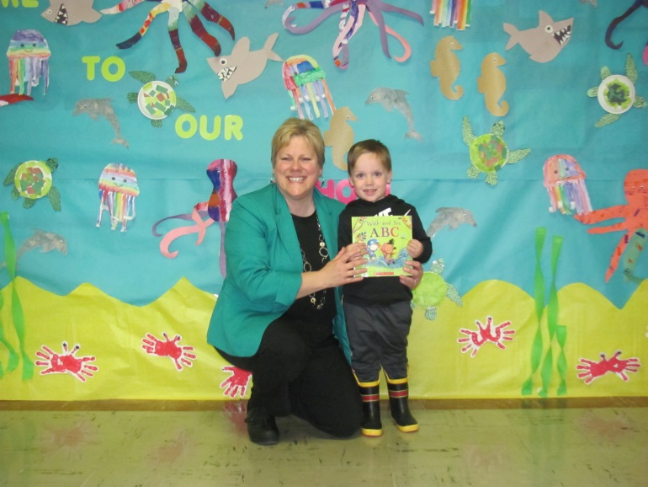

Thank you to the Walnut Rotary for purchasing Birthday Books for all of our students!

Bureau Valley (Pre-K – 8) Yearbooks

Yearbooks cost $15.00. If you have any questions, please contact the school office in Wyanet at 815-699-2251 or Buda at 309/895-2037. Flyers to order were sent home! If you need another flyer, please call the office. You can also order on-line at book.hrimaging.com.

Bureau Valley Athletic Summer Camps

Boys' Basketball Camp – June 18 - June 21

Girls' Basketball Camp - June 10 – June 13

Football Camp (High School) - July 22- August 1

Football Camp (grades 6-8) - June 10-13

Football Camp (grades 3-5) –June 10-13

Volleyball Camp – (Jr High & High School) June 24-28
(grades 3-5) –June 25-28
(grades Pre-K -2)-July 8

Golf Camp – (grades 3-12) - July 12, July 19, and July 26

The flyers have been sent out through Teacherease and information is available in the school offices.

BOOK SALE!! BOOK SALE!! BOOK SALE!!

The library is having a book sale! I am selling used books from our library. Both non-fiction and fiction titles will be available! Some books are in brand new

condition, others are in well-loved condition. All items will be sold for $.25 each or 5 for $1.00.

Students will be able to purchase items during library time throughout the rest of the year until I run out of books to sell.

This is a great opportunity to build your child’s book collection for a low price. As always, thank you for your support of our library program.

Happy reading!!
Mrs. Dana Wagner

D.A.R.E. Graduation

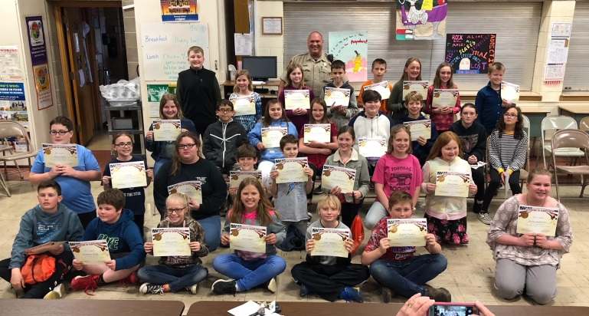

During the second semester of school this year, Mrs. Salisbury's and Mrs. Kuelper's 5th grade classes participated in the DARE program. DARE.’s curriculum, as well as its enhancement lessons, focus on bullying, internet safety, and over-the-counter prescription drug and opiates abuse. DARE is made possible for our students due to the support of the Bureau County Sheriff's Department, Officer Cliff Morse, and the Bureau Valley South PTO. Congratulations to all of our DARE students, their teachers, and their parents. It is our hope that you will always be drug-free and violence-free role models for others.

BV Legacy Bricks

The Bureau Valley legacy brick program will be a special recognition and reflection area between the HS and 2019 addition for JH/Elem. This project is to fund a flagpole outside of the new JH. Examples of bricks could be: Memorials for family/friends, BV Class bricks, Sports teams, Staff Members, Businesses, or families. If you would like to purchase a brick, please contact the any school office for a form. The form was also emailed to parents.

The BV App

We are loving our new app! Stay updated with access to
real-time sports scores, the daily cafeteria menu, news
from administrators, student stories, and even emergency notifications.
You can download the app for free on both Google Play or the Apple App Store.
Download for Android: http://bit.ly/2F7S7FR
Download for iPhone: https://apple.co/2FeqR7H

Bureau Valley Promotions and Graduation

Friday, May 17 at 7:0pm -BV North 8th Grade Promotions at North

Saturday, May 18 at 7:00pm BV South 8th Grade Promotions at Manlius

Sunday, May 19 at 1:30pm –BV High School Graduation

Free Children’s Orthopedic Clinic
Provided by the
Illinois Elks Children’s Care Corporation,
The Galesburg Elks Lodge #894, and
The Kewanee Elks Lodge #724
with Dr. Steven Potaczek
Tuesday, May 21, 2019
8:00 am – 9:30 am
(By Appointment Only)
OSF Galesburg Clinic
3315 N. Seminary
Galesburg IL
For Appointments
Please Contact the Elks Children’s Care Program
1-800-272-0074 Weekdays from 9 a.m. to 4 p.m.

Registration for 2019-20 School Year

Registration (In Person) is Thursday, August 1, 2019 from 10:00am to 6:00pm at Bureau Valley High School in Manlius.
Registration Options for 2019-20:

Online: Beginning July 22, 2019 through August 1, 2019, parents may log into their student's Teacherease account and register their student(s) for the 2019-20 school year. Online registration allows parents to pay for fees with a debit or credit card. Some paper forms may be required, depending on the age of the student. Any required paper forms may be dropped off at the registration day on August 1st. Parents can also pay by check or cash on August 1st.

Print Forms from www.bv340.org:
Another option is to print the forms, found online at www.bv340.org, and bring the completed forms to the High School during registration times on August 1st.

Attend District Registration: If parents choose not to use the online registration tool at home, parents must attend the registration day held at the high school on August 1, 2019. Computers will be available on August 1st for parents that wish to use the online registration tool. Parents may also choose to complete paper forms, which will be available on August 1st.

Please visit our website, www.bv340.org and click on the Parents tab at the top of the web page. Then select Student Registration. Here you will find the Registration Fees for the 2019-20 school year. There is information on immunization and health requirements, forms for school physicals and class supply lists.

Please check our website throughout the summer for more registration information. Also follow us on Twitter and Facebook at BV340.

Summer School

Don’t forget the summer school sessions you signed up for in June.

June 10, 11, & 12 Eat ‘n Play 9-11am at Wyanet

June 10, 11, & 12 The Flower Shop1-3pm at Walnut

June 11-14 Preschool Pop Up 8:30-10:30 Walnut

June 17-20 Preschool Pop Up 8:30-10:30am Wyanet

June 17, 18, & 19 Eat ‘N Play 9-11am Walnut

June 17, 18, & 19 The Flower Shop 1-3pm Wyanet

June 18, 19, & 20 Mary Poppins 8-11am Walnut

June 18, 19, & 20 Mary Poppins 12:30-3:30pm Wyanet

June 24 & 28 Pinkalicious Meets Pete the Cat 8:30-10am at Walnut

June 25 & 27 Pinkalicious Meets Pete the Cat 8:30-10am at Wyanet

June 24 & 28 Patricia Polacco 10:30-12:00pm Walnut

June 25 & 27 Patricia Polacco 10:30-12:00pm Wyanet

Bureau Valley Pre-School Screening

Bureau Valley (Walnut and Wyanet) Pre-School Screening, for the upcoming 2019-2020 school year, will be held on Monday, May 20 and Tuesday, May 21 at the Trinity Evangelical Lutheran Church 202 S. Fourth St. Manlius, IL 61338.

The screening is from 8:10 am – 2:30 pm by appointment only. Each appointment lasts 45 minutes to an hour and includes vision, hearing, speech, language, motor and academic skills. The screening is open to all children who are 3 by July 18, 2019.
Children currently in the Bureau Valley preschool program do not need to be screened.

Families who are wanting their child in the preschool program MUST provide proof of income at screening time (please provide 1 of the following-preferably the first page of tax return or you may provide pay stubs, most recent W-2, or letter from employer). If you receive program assistance from any of the following, you will also need to provide proof (WIC, SNAP, TANF, SSI, CCAP, or Medicaid).

If you are interested in the screening, please call Tracy Shepard at Bureau Valley (Wyanet) at 815-699-2251 for an appointment.

College for Kids

Join the Fun!
Summer 2019
At Sauk Valley Community College

June 24-27
Make Your First Fortnite
Style Video Game

July 8-11
Virtual reality: The Future is Now

July 15-18
Make Your First 3D Video Game!

July 22-25
ROBLOX Makers

College for Kids provides fun, informative classes to students entering 3rd through 8th grade.

For more information call 815.835.6212, online registration available at svcc.edu/cfk

Dates to Remember

  - Monday, May 20-No Pre-K classes/Pre-K screening by appointment only
  - Tuesday, May 21- No Pre-K classes/Pre-K screening by appointment only
  - Tuesday, May 21-2nd grade to Zearing Park
  - Wednesday, May 22-Ag in the Classroom at Buda/ No Pre-K classes
  - Thursday, May 23-Pre-K attends regular schedule AM 8:00-10:40am and PM 12:00-2:40pm
  - Friday, May 24- Pre-K attends regular schedule AM 8:00-10:40am and PM 12:00-2:40pm
  - Monday, May 27-No School –Memorial Day
  - Tuesday, May 28 No Pre-K classes/7pm Board of Education Meeting at District Office
  - Wednesday, May 29-No Pre-K Classes
  - Thursday, May 30-No Pre-K classes
  - Friday, May 31-Pre-K attends 12:0-1:30pm for Pre-K Celebration/2pm Dismissal/Report Cards sent home/ K-2nd grade sack lunch

^{Have a Wonderful Summer!}

