For Parents & Guardians:
Following the Pre-Registration
AND
Enrollment Forms process at

Welcome to Carson City-Crystal Area Schools!
We are pleased to offer a paperless enrollment process that will allow you to compete forms electronically and upload required documents directly to your student’s PowerSchool Profile. Below are instructions for the two steps of our enrollment process. Please feel free to reach out should you need assistance.
1. Pre-Registration:
Parents/Guardians of all NEW or RETURNING (to the district from being unenrolled) will need to follow this link to complete the single page Application for Enrollment: https://ps.cccschools.org/public/formbuilder/form.html?formid=96585
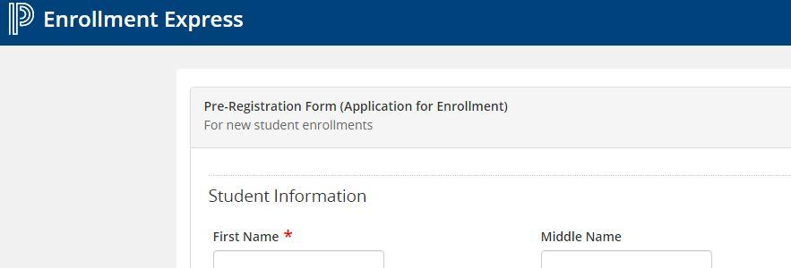

2. Enrollment Forms:
- Once your Application for Enrollment is submitted, it will be processed by the school to which you are applying. Once the application is approved, a letter will be sent to you with step by step instructions to set up a PowerSchool Parent Account. After you complete the set-up of your account, log in and select “Forms” from the left hand navigation menu.

- You will then be taken to the Forms page where you will select “Enrollment” from the list of forms available to complete one at time. If you need to save a form and come back to it, just click “Save” to return to complete and then “Submit” when finished.
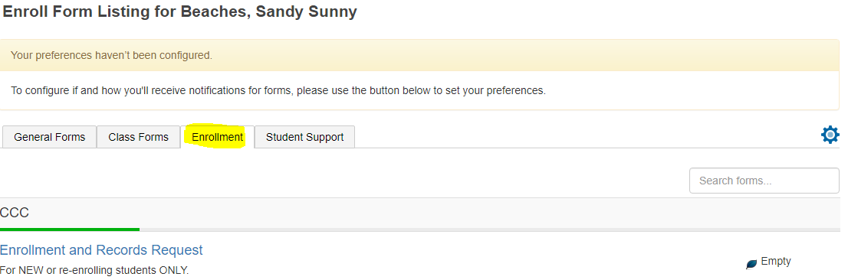

- The list of forms you need to complete are:

Form Name and Description | Elementary | Upper Elementary/  Middle School | High School | Alternative Education
Enrollment and Request for Records (All New & Returning Students must upload birth certificate and immunization record)
Residency Affidavit (All New & Returning Students must upload 2 residency verification documents)
Student Contacts & Custody
Student Demographics
Health Information
Home Language Survey
Homeless Survey
Online Approval
Permissions/Agreements
Transportation (ONLY if accessing bussing)
Kindergarten Questionnaire (Kindergarten ONLY)
Medication Administration (Only if medication needs to be administered at school. Parent provided only)
Student Driving Permission/Agreement
Age of Majority (18 Years or older if necessary)
- Don’t hesitate to reach out for assistance should you need it:
School | Administrative Assistant | Phone Number | Email Address
Carson City Elementary | Cindy Turner | 989-584-3138, opt. 1 | cturner@cccschools.org
Upper Elementary/  Middle School | Jackie Teegardin | 989-584-3138, opt. 2 | jteegardin@cccschools.org
High School & Alternative Education | Robin Tyler | 989-584-3138, opt. 3 | rtyler@cccschools.org

