CAMPUS INFORMATION FOR SUBSTITUTES

CAMPUS
PT PRIMARY (PK -K)
Ruthie Walker-Principal rwalker@ptisd.org
1808 Silver Falls Rd.
SECRETARY

Evelyn Nowlin enowlin@ptisd.org (903) 295-5095
HOURS

7:15 am-3:20pm

BIRCH ELEMENTARY(1ST-4TH)
Daniel Stuard-Principal Katie Montgomery 7:15 am-3:20 pm dstuard@ptisd.org kmontgomery@ptisd.org
815 Birch Dr. (903) 295-5120
PARKWAY ELEMENTARY(1st-4th)
Melanie Keoun-Principal Stephanie Ziegelbauer 7:15 am-3:20 pm
mkeoun@ptisd.org sgraham@ptisd.org
601 PT Parkway (903) 295-5151

PT MIDDLE SCHOOL(5th-6th)
Mickey White-Principal mwhite@ptisd.org

600 PT Parkway

(903) 295-5160

8:00 am-4pm
JoJean Arnett jarnett@ptisd.org

CAMPUS

PT JUNIOR HIGH(7th-8th)

Lisa Sawyer-Principal lsawyer@ptisd.org

2100 NW Loop 281

(903) 295-5081

PT HIGH SCHOOL(9th-12th)

Cleo Wadley-Principal cwadley@ptisd.org 900 Northwest Dr. (903) 295-5031

SECRETARY

Sheri Kirchhoff skirchhoff@ptisd.org

Karen Wall kwall1@ptisd.org

HOURS

8am-4pm

8 am-4 pm

PT EXCEL HS- Excellence Compelling Extraordinary Learners (9th-12th)

Caci Brinkley-Principal LaTosha Anaya 8 am - 4 pm

cbrinkley@ptisd.org lanaya@ptisd.org

900 Northwest Dr.

(903) 295-6753

PAC.E. Campus-Pirate Alternative to Continuing Education (Alternative Education)

Shalonda Adams sadams@ptisd.org 1701 Pine Tree Rd (903) 295-5130

Jazmin Merriman

jmerriman@ptisd.org

7th-12th

7:15 am-3 pm 6th & below

Primary &

PINE TREE ISD SCHOOL LOCATOR

Reel Ro
r

Gilmer Road
903-295-5000
PTISD.org

Birch Elementary

A /
B··D
C E

A ..
Birch Drive
>
Junior High

H 0
w
I Ill

Pine Tree

WLoop
281

Silver Falls Road
Road

W Fairmont Street
--- -

Highway2S9

W Loop
281
Northwest
Drive HG Mosley Parkway
7_flrr====:::::::::::!-l
Enterprise
Street
1I

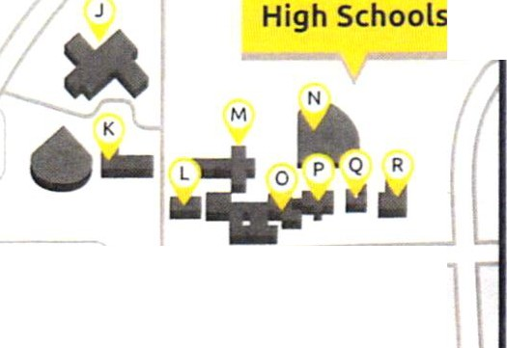
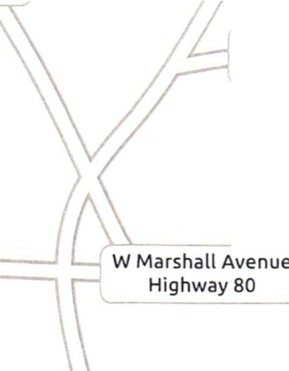
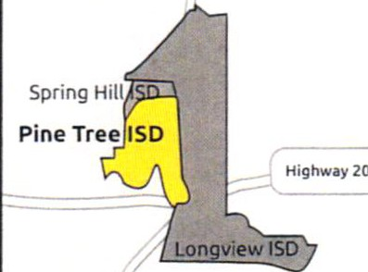
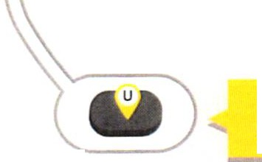
Parkway Elementary
& Middle School
Public Schools in the City of Longview
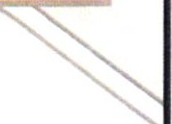
s [ T
- Tennis/ Softball
- ExCEL High School
- PT High School (9 -12)
- Baseball Field
0 . High School Theater
- Pirate Center
- Swim Center
- Fieldhouse
- Parkway Eleme nta ry (1-4)
- Middle School (5 • 6)
- Pirate Stadium
- Primary (PK· K)
- Birch Eleme nta ry (1 - 4)
- Auditorium
0. Auxiliary Stadium
- PACE
- Community Center
- Administrat ion / Tax Office
- Facility Ser vices
I. Transportation Center
J. Junior High (7 • 8)
I I

Pirate Stadium

