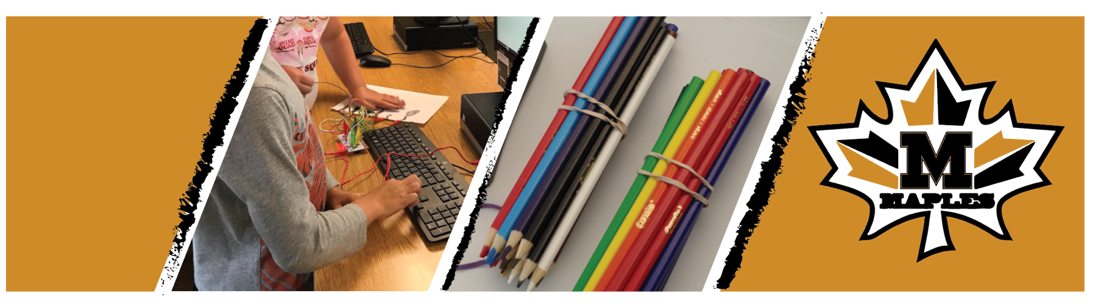

MAPLES CAMP INNOVATION
Join us for some innovative summer fun!
June 10-14 First Come Basis (48 spots available)

The Maples Camp Innovation is a summer camp for students entering grades 3-8 in the fall of 2019. Students will explore science, technology, engineering, math, making and more with new and innovative technology! Students will rotate through sessions each day, beginning at 8:30 am and ending at 3:30 pm. Sessions ﬁll quickly and space is limited, make sure to register early! Students must attend all day. Registration fee is covered due to grant funding from Chevron Corporation (registration fee prior to grant funding was $75.00), which includes all sessions, materials, daily snacks, and prizes. Students are asked to bring a bagged lunch. Only register if you plan on attending the entire week. Do not register if you can’t attend!

Online Registration will open April 23, 2019
https://sites.google.com/iu1.org/innovationanddesign/student-programs?authuser=0
Camp is located at the Bobtown Elementary School.
Sessions include:
Coding Exploration: Using various coding tools (dependent on grade level) students will design, program, and create custom code using tools such as robots, sensors, and more. Students will build on programming and computer science skills to create unique programs that will in the end complete a custom task.

Circuitry & Electronics: Students will explore the science behind circuitry and electronics using various hands-on tools and materials (dependent on grade level). This session will allow students to expand their skills and test out new projects each day! Students will be faced with new challenges every day.

Tinker, Make, Create: Students will use a variety of digital fabrication tools and other maker materials to create unique and custom projects. Students will dive into new tasks each day using a range of tools to invent, create, and produce personalized projects.

Rocketry & Engineering: Students will take technology to the next level! This hands-on session infuses innovative technologies, teamwork, and hands-on learning. Students will explore the science of our atmosphere, altitudes, all while exploring the engineering and design behind NASA Rockets that have been launched into space!

