Social Emotional Learning
What is Social Emotional Learning (SEL)?
SEL is the process through which children and adults acquire and effectively apply the knowledge, attitudes, and skills necessary to understand and manage emotions, set and achieve positive goals, feel and show empathy for others, establish and maintain positive relationships, and make responsible decisions (Collaborative for Academic, Social, and Emotional Learning 2020).
SEL In Mississippi
Mississippi identifies five social and emotional domains aligned to CASEL’s five core competences, each of which is composed of multiple skills and abilities (CASEL, 2013).
Domain 1: Self-Awareness
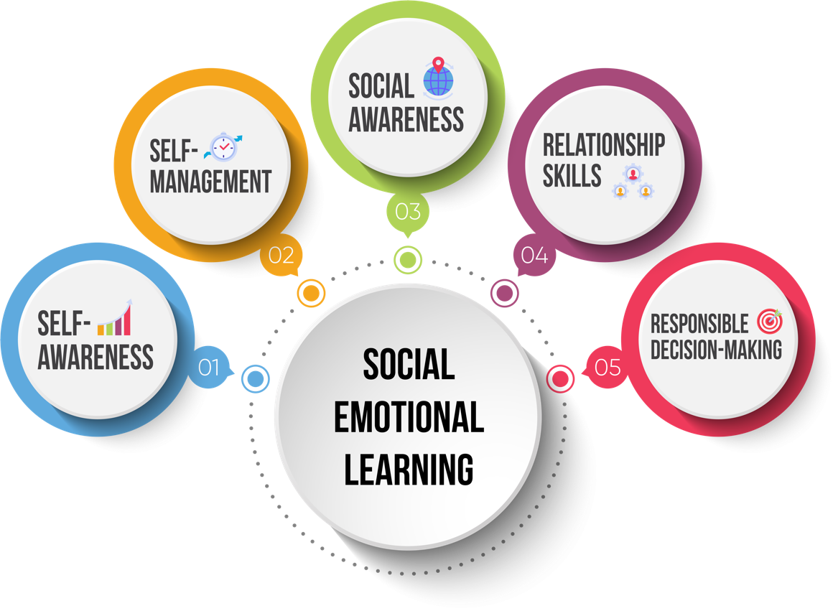
Domain 2: Self-Management
Domain 3: Social Awareness
Domain 4: Relationship Skills
Domain 5: Decision-Making

SEL in Marshall County School District (MCSD)
Research has found that, on average, students receiving social emotional interventions improved significantly compared to those not receiving an intervention. The results indicated that social emotional skills, social behaviors, and academic performance increased, attitudes towards self and others were more positive, conduct problems were reduced, and emotional distress lessened (Durlak et al., 2011).
MCSD Social Emotional Learning Vision
MCSD will create positive learning environments where students, families, and staff feel respected and supported and our students are prepared to meet college and career readiness standards (CCRS).
MCSD Social Emotional Learning Goals
- Create a positive culture and climate focused on empathy, respect and equity
- Implement direct SEL instruction integrated in academic lessons and extracurricular activities (K-12 MS Social Emotional Learning Competences)
- Foster a supportive environment for all MCSD staff
- Implement Multi-Tiered System of Supports (MTSS) to provide academic and behavior interventions
- Implement monthly district-wide character education focus

