Drive One for Your School
M.C.S. at Mertz Ford
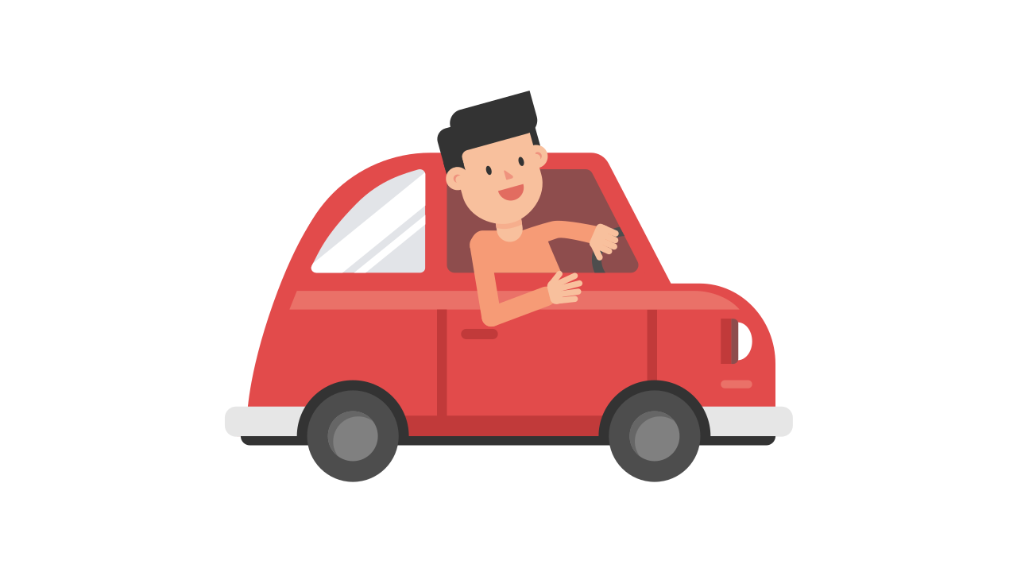
April 13th
10 a.m. - 3 p.m.
M.C.S. can earn up to $6,000!!!!
No pressure to buy
* Free pizza day in May for your child
* Homeroom with the most parents that attend will earn an ice cream party

