South Dakota Creation Care Network
Lesson Plan and Resources

Lent Focus: Palm Sunday with EcoPalms

New Year’s Creation Care Resolutions. ____ Completed? ____ Progress? ____ Whoops!

In Lent we spend 40 days in preparation and reflection. The Diocesan CC Network has not had much activity during Lent. Perhaps this is an area for growth; perhaps develop for your church, one of the “Other Lenten Creation Care Activities” described below.

However, we have always suggested an unusual Creation Care activity for Lent – using EcoPalms for Palm Sunday. What are EcoPalms? EcoPalms are a multi-leaf frond, not the single-strip palm. They are “eco” because they are grown and harvested using sustainable forestry practices in Central America.

EcoPalms are a great “attention getter” for a Creation Care message about social justice and environmental sustainability – here’s the deal.

www.ecopalms.org.

Eco-palms are a fair-trade product, so their purchase improves income and living conditions for the communities gathering the palms. EcoPalms provide fair wages and development assistance for impoverished harvesting communities. Profits are returned to the local villages. Half of the farmers in the palm-growing area of Guatemala earn additional income from harvesting fronds and, some households support themselves exclusively by collecting fronds.

EcoPalms have conservation benefits. Sustainable palm harvest leaves the palm forest healthy so that the forest can provide shade, reduce soil erosion, provide wildlife habitat, and remain an economic benefit year after year.

The program was founded by the University of Minnesota, which has partnerships with faith-based organizations such as Lutheran World Relief , United Methodist Committee on Relief, the Presbyterian Church of the United States and others. A bundle of 20 palms cost about $8 in 2022.

The South Dakota churches who purchase EcoPalms educate congregants by printing a bulletin insert from the EcoPalm web site; by placing the EcoPalm information brochure (fee download) on coffee tables, or by placing an article about EcoPalms in the church newsletter or website. The experience of waving the EcoPalm on Palm Sunday has several benefits:

1) Education about sustainability,
2) Reflect on sustainable practices in your community,
3) Action as our purchasing choices contribute to earth stewardship and eco-justice.

Other Lenten Creation Care Activities

During Lent, we may seek to deepen our prayer and worship practices. It seems that every year there is a fresh offering of Lenten resources that focus on Creation Care. First, let’s look at the TEC suggestions and then list a few other ideas from the past.

- TEC suggestions for Lent: Episcopalians are requested to reflect on the Way of Love Program.
https://www.episcopalchurch.org/lent-resources/.

- The TEC website says that the Way of Love is “More than a program or curriculum, it is an intentional commitment to a set of practices. It's a commitment to follow Jesus: Turn, Learn, Pray, Worship, Bless, Go, Rest.” Download bulletin inserts for each week of Lent.

- Follow Presiding Bishop Curry on a 4-minute walk through the streets of New York as he introduces The Jesus Movement, which is the ongoing community of people who center their lives on Jesus and following him into loving, liberating and life-giving relationship with God, each other and creation. Yes, Creation Care is one of the three pillars of The Jesus Movement (Creation Care, Reconciliation, Evangelism).

https://www.episcopalchurch.org/jesus-movement/.

- United Thank Offering: The 40 Days of Gratitude Lenten Journal is designed for at-home use for adults to deepen their spiritual practice of gratitude during Lent. Each week in Lent, they will focus on practicing gratitude for a specific topic based on scripture. The Journal can be downloaded (print out double-sided and stapling it on the long edge, so that it functions as a book). There is also a children’s version. About half of the topics remind you to think about gratitude for Nature or for the products from Nature.

https://unitedthankoffering.com/wp-content/uploads/2021/10/40-Days-of-Gratitude-4.pdf.

- EcoSpirituality Resources (Catholic) is written by Sister Terri who really has some great ideas. She has suggested Lenten resources for 2020-23. She focuses on soil, water and air during Lent. One of her resources has a compelling title “Spirituality of Soil: A Lenten Journey from Cosmic dust to Easter Garden.” It seems that these topics should be good themes in South Dakota. We could adapt the free downloadable EcoSpirituality Lenten booklets for South Dakota and present information on sustainable farming practices for soil conservation and protecting water quality. The goals of sustainable agriculture are environmental health, economic profitability, and social and economic equity (sometimes referred to as the “three legs” of the sustainability stool).

https://ecospiritualityresources.com/lent-2020/

  - Sister Terri writes: “The rich assortment is there for Catholics and Christians to better understand the evolving worldview coming from the new science and new theology so that they can better integrate their beliefs into that worldview.”

- Creation Care Alliance is an interfaith Creation Care group in North Carolina. They have a robust Creation Care Program. They have recommend reading one of two books for lent.
  - Wild Hope walks its reader through the Lenten season by examining the stories of endangered species the world over. Father Richard Rohr comments thusly: “wild, imperiled creatures as expressions of God’s own self—and of God’s own suffering. What better subject for Lent?”

https://creationcarealliance.org/resource-highlight-lenten-studies/.

- The second book is titled For the Beauty of the Earth: A Lenten Devotional by Rev. Dr. Leah Schade. Recall the hymn “For the Beauty of the Earth?” The focus is on nature’s splendor, how God nurtures our spirit through creation, and how we must protect our precious home.

- Other groups that have offered Lenten resources in the past are

  - Creation Justice Ministries: https://www.creationjustice.org/educational-resources.html.

  - Earth Ministry: a project of Washington Interfaith Power and Light that represents the Native Nations in the Northwest. https://earthministry.org/wp-content/uploads/2015/02/KentShifferd.pdf

  - Lutherans Restoring Creation is a grassroots movement promoting care for creation in the Evangelical Lutheran Church in America.
https://lutheransrestoringcreation.org/ways-to-integrate-creation-care-to-your-lenten-practices/

What can one person do?

The Creation Care message sometimes seems overwhelming. Often, the question is “What can one person do?”

The first Christian response would be “Love thy neighbor,” but connecting neighbor-ly-ness and use of plastic bottles and plates (for example) might be hard.

More specific guidance might be to do things that lessen your personal impact. There are many published lists of things you can do – just pick one or two or three to activate your personal stewardship. Doing small things is good because 1) little acts do add up, 2) little acts educate people about an issue, and 3) little acts are how we can show our personal interrelationship with God and our stewardship of His Garden.
However, there is debate about the value of small changes in personal behavior compared to big changes in government policy. Yes, changes in the actions of individuals can be positive, but they are perhaps insufficient to solve the larger pollution problems. Shifting responsibility away from the polluters and onto individuals does little to reduce pollution, and the profits continue unabated. Beware if you are asked to change your behavior but the polluter is not!

The justification for doing small things is to become educated about an issue. The deeper understanding of an issue might be the motivation needed to undertake actions to change policy (e.g., congressional correspondence, signing petitions). Another action that one person can do is “don’t be one person.” Join the Creation Care group at your church, or join a secular advocacy group.

From the Catechism of Creation

Question: What can we do to preserve the land upon which we dwell and raise crops?

Answer: In the spirit of the Old Testament instruction to give the land a Sabbath year’s rest from planting crops, we can promote wise farming techniques that preserve the land and avoid poisoning the soil, air and waters with excessive use of chemical fertilizers. We can seek to maintain or restore a wider diversity to the variety of plants and animals used for food. We also can find ways to preserve valuable farmland from thoughtless conversion to housing and commercial uses, and to create community gardens in city neighborhoods and small towns.

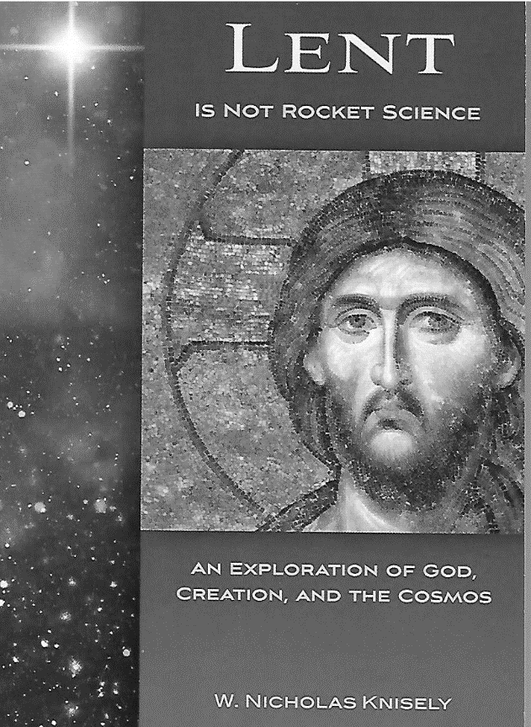
The author is the Bishop of the Episcopal Diocese of Rhode Island and former professor of astronomy and physics.

These 40 meditations journey from the largest scale of the created order to the very smallest scale.

2013, 4 x 6-inch, soft cover, 160 pp.

Forward Movement www.forwardmovement.org.

Also available on the Amazon, and Barnes & Noble.

