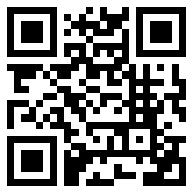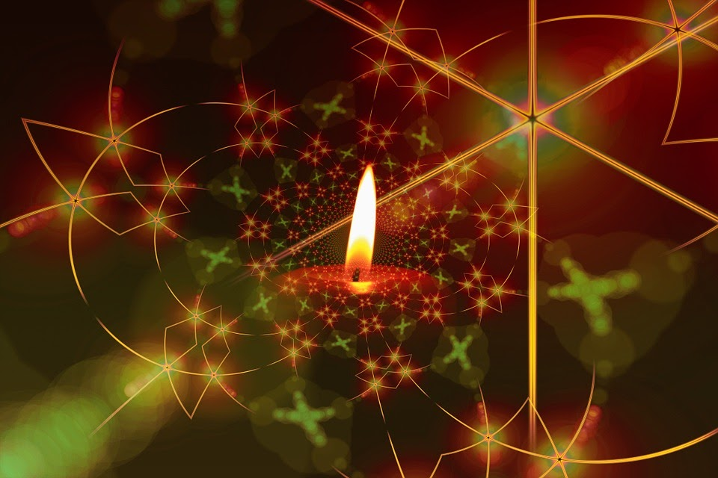oik

**Advent Festival of Lessons and Carols**

***Presented by the North Eastern Deanery of the Episcopal Diocese of South Dakota***

**Time:** 4 – 5 p.m.

Followed by Refreshments

**Cost:** Freewill Offering

**ALL ARE WELCOME!**

The Abbey Gift Shop

will be open

For more information, contact

[events@abbeyofthehills.com](mailto:events@abbeyofthehills.com) or   
call (605)398-9200.

*The Abbey of the Hills fosters the*

***rediscovery of peace.***

For more information about upcoming events:

**www.AbbeyOfTheHills.org**

**December 17, 2022**

46561 147th Street, PO Box 38, Marvin SD 57251

605-398-9200 | abbey@abbeyofthehills.org