Banana Plant Extract May Be The Key To Slower Melting Ice Cream
By Sowmya Kolluru on May 27, 2018

Few people can resist the lure of a delicious ice cream scoop or two, especially on a hot day. The only thing that spoils the fun is that the treat is hard to savor slowly, like one would a piece of candy, without ending up with a sticky, melted mess. Now, researchers from Colombia's Universidad Pontificia Bolivariana may have found an unlikely ally to help solve this age-old problem — cellulose fiber extracted from banana plant waste.

Bananas, as you probably know, grow in bunches on a tree-like perennial herb. Each cluster is attached to a central stalk, called a rachis, which is discarded once the fruit has been harvested. The team, led by Dr. Robin Zuluaga Gallego, began by extracting cellulose nanofibrils (CNFs) from powdered rachis. The tasteless, odorless macro fibers, thousands of times smaller than the width of a human hair, were then added in various concentrations to 100 grams of ice cream mix.

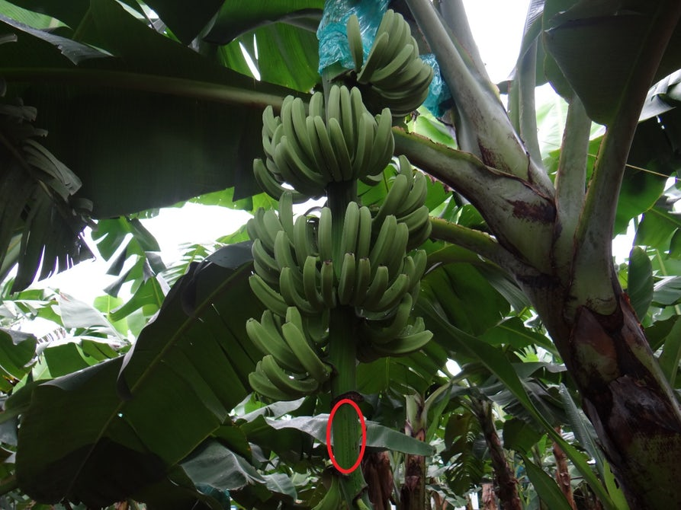

With the right amount of CNFs mixed in, the dessert lasted longer in its frozen state than conventional ice cream, extending both its shelf life and the amount of time the treat can be enjoyed. Even more exciting was that the fibers increased the viscosity of low-fat ice cream to levels higher then its full-fat counterpart. Since this is what determines the frozen treat’s creaminess and texture, CNFs could help create healthier ice cream without compromising on taste.

The researchers, who presented their findings at the American Chemical Society (ACS) meeting in New Orleans on March 21, 2018, next plan to investigate how different types of fat, such as coconut oil, affect the behavior of CNFs in other frozen treats.

The Colombian researchers are not the only one working on creating a slower-melting ice cream. In 2015, scientists at the University of Dundee in Scotland found that a naturally occurring protein called BSIA (Bacterial Surface Layer A) was remarkably effective in keeping the treat frozen for longer periods of time. With both teams scrambling to be the first to get to market, the future of everyone’s favorite dessert certainly looks promising.

STUDENT QUESTIONS

1)Please read the title….what will this article be about?

2)How is eating an ice cream cone different than eating a piece of candy?

3)Where does cellulose fiber come from?

4)Will cellulose fiber help ice cream melt slower?

5)Specifically, what is the substance called that makes up the macro fibers?

6)When you add the right amount of CNFs – what happens to ice cream?

7)There is another benefit from using CNFs – what is that?

8)The researchers who presented their findings at the American Chemical Society (ACS) meeting in New Orleans on 3/21/18 next plan to investigate what aspect of ice cream?

9)What did the scientists at the University of Dundee in Scotland discover about BSIA?

10)What is your favorite flavor ice cream?

