/# Name:______________________________

Chula School
5/6th Grade AMI Work (Days 1-5)
Directions:
For each AMI day, pick ONE activity from the Reading, Writing, Math, and Science subject/columns to complete. Label the paper with your number, name, subject, and letter of assignment choice for each assignment. (#, Joe, Science, B)
If you have completed an activity in a subject area, it cannot be repeated on additional AMI days.

PARENTS: Please initial as your child completes the activity. Your child should return this page along with the written work to his/her teacher upon returning to school.

Reading  PICK ONE | Writing  PICK ONE | Math  PICK ONE | Science/SS  PICK ONE | Art/PE  OPTIONAL
A.. Create your own reading log for the reading you do during AMI days. Make sure your log includes the title, author, and pages you have read. | A. One of the best days of your teacher’s life will be when he/she can see you again!  Write a short journal response to this prompt:  Describe the best day you have ever had. Why was it the best day?  The best day that I ever had was ____ because ____. | A. 1. John bought fruit at the grocery store. He bought 1 ½ pounds of apples, 3 ¼ pounds of oranges. He got a total then went back to get a 3 $\frac{2}{8}$ pounds of pineapple. How many pounds of fruit did he buy?  2. If the fruit is $1.50 a pound, how much did he spend?  Explain your answers and show all your work! | A. Interview a famous person in history. Create 10 interview questions. Then, write answers as if you were that person. | Art  Using objects and items from in and around your house, create a work of art of your choice. Examples: aluminum foil, paper, sticks, toys, tape, rubber bands…  Daily Workout  30 jumping jacks  10 squats
●Read for 30 minutes.
Add to your log.
●Choose and complete one activity from the reading menu. (Bottom)
B.  ●Read for 30 minutes.  Add to your log.  ●Choose and complete one activity from the reading menu. | B. Your teacher thinks you have a great imagination! Write a short journal response to the following prompt:  If you could have any superpower, what would it be? Why? What would you do?  If I could have any superpower, it would be ___, because…. (5th-3 sent., 6th-5 sent. minimum.) | B. 1. Joe is building a garden. How much area is his garden below?  5 ft.  15 ft.  What size would the new garden be if he wanted it to be ½ the area? Explain your thinking. | B. Create a new country. Draw a map filled with geographical features. Name the country. Design a flag. Describe the culture and government. | Daily Workout and Music  Listen to music, move your body to the rhythm while transferring your weight from foot to foot.  Identify any musical instruments used in the song you listened to. (ex. Brass, string, woodwind, percussion, electronic)
C.  ●Read for 30 minutes.  Add to your log.  ●Choose and complete one activity from the reading menu. | C. Ask a family member what scares them. Tell them about what scares you.  Write a short journal response to this prompt:  Describe something that scares you. Why?  Something that scares me is _____, because ____. | C. 1. Complete the equations:  (13 x 10) + 5 = 100 + ____  245 + 325 = 225 + ______  (12 x 10) = (__ x 10) + 20  477 - 248 = 510 - _____  2. Count by ¼s from  2 ½ to 6 ½. | 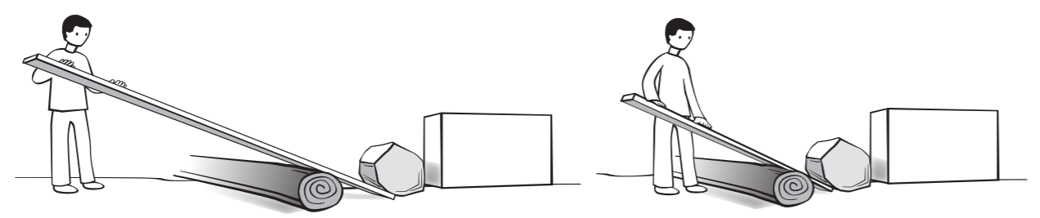  C. What best describes the energy it takes to lift the rock on top of the box?  A It will take more energy to lift the long board.  B It will take more energy to lift the short board.  C It is the same for both boards.  Explain.I think____ because _____. | Art  Create artwork of your choosing.  Daily Workout  Find a ball (or paper ball). Using your best skills while dribbling, kicking, and controlling the ball. Repeat 15-20 times.
D.●Read for 30 minutes.  Add to your log.  ●Choose and complete one activity from the reading menu. | D. Watch your favorite show or movie. Write to tell me your opinion on why it is your favorite. Include reasons to support your opinion, linking words, and a concluding statement. | D. 1. Joe is adding to his garden. How much area is his new garden below?  5 ft.  15 ft.  6 ft  2 ft  What size would the new garden be if he wanted it to be ½ the area? Explain your thinking. | D. What do you know about the moon? What is it made of? Does the moon help us?  Write a 5-8 sentence paragraph about what you know. Include 3-5 provable facts. | D.  Play your favorite sport for 30 minutes. If you don’t have a favorite, make one up using cotton balls or something you find around the house.
E.  ●Read for 30 minutes.  Add to your log.  ●Choose and complete one activity from the reading menu. | E. Your teacher wonders what you are doing!  Write a response to this prompt:  List things you do most days and the times you do them.  My daily schedule is ____. Some things I do are ______. | E. 1.Graph the following points. What would the next two points on the graph be?  (2, 4) (3, 6) (4, 8) (5, 10)  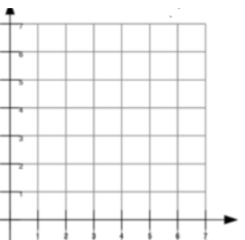  2. Count by ½s from ¼ to 5½ | E. What do you know about soil? What is it made of? Is it living or nonliving? What can be found in soil? Does soil help us? Write a 5-8 sentence paragraph about what you know. | Art & Health  Draw a person that is stretching. Label the muscle group it is stretching.  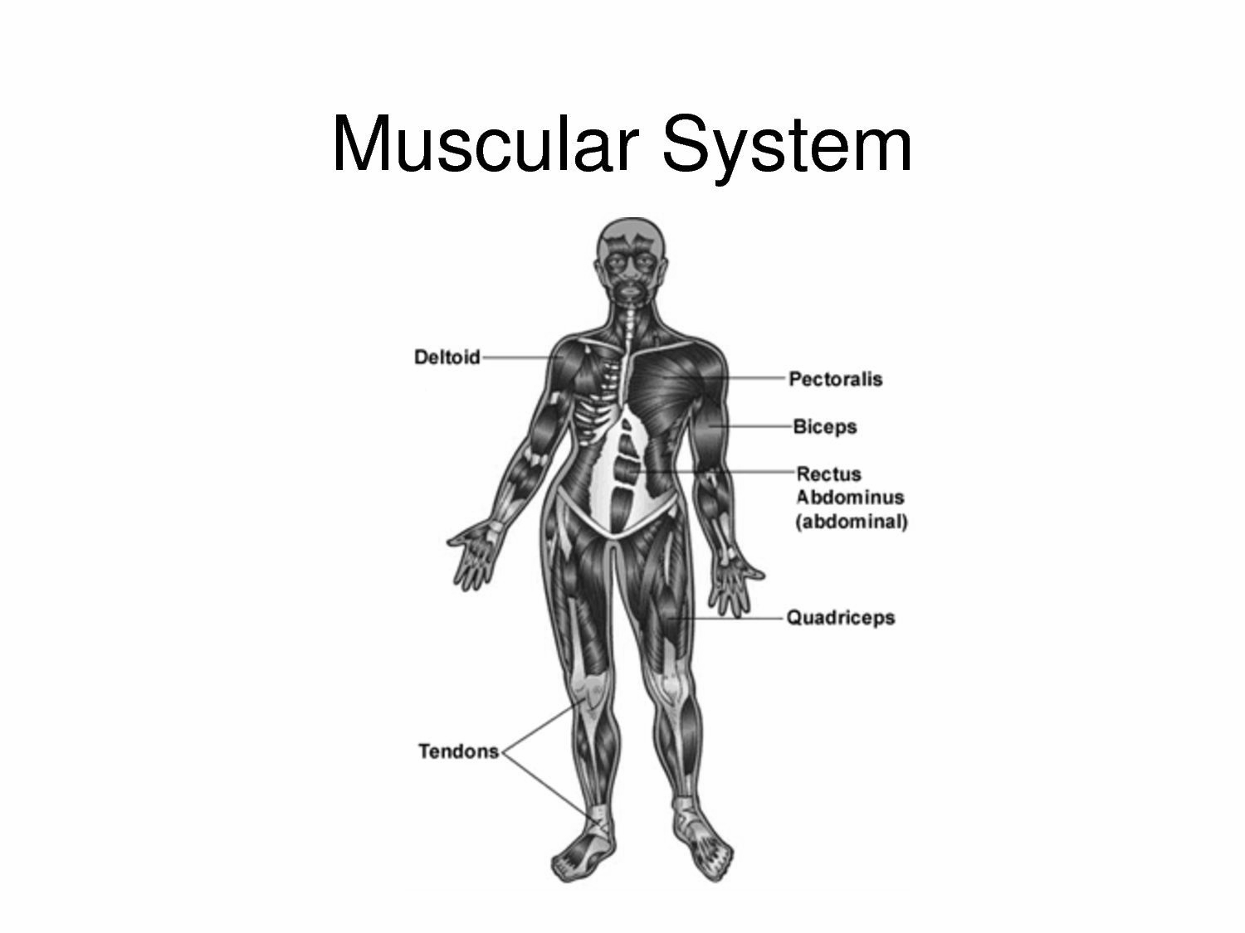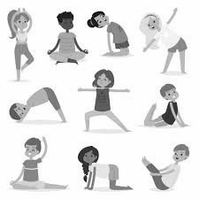

Reading Menu - Choose ONE to complete each day.
What lesson did the character learn in this story?  One lesson is _____. I know this because ____.  Another lesson is ____ because ______ . A third lesson is _____ because ______ . | Explain the problem in your story. Predict how you think this problem is going to be solved.  The problem in this story is ____.  My prediction is __. I think this because __ | Your choice. Respond to your text in any way you want. Have fun!  The text makes me think about ____.  In my opinion, _______.  I noticed that _____. | Create a diary or journal entry in the voice of a character in your story. What kinds of thoughts and feelings might this character write about? What events?  Today I felt___. | Explain how the main character helped or did not help solve the problem in the story.  __ helped solve the problem by __  __ did not help solve the problem because ___
Draw a picture of an event or character in your story. Why did you choose this event or character?  I chose to draw __ because __ | Write a letter to the author of your book. Tell the author what you like and dislike about the book and suggest some things you would change in the story.  I liked ___. I did not like ____. | Describe the setting of your story. If the setting was different, how would the story change?  The story takes place in ___. If the story took place in the past/future, ____would be different. | Provide text evidence and explain how the author connects to the intended audience.  The author connects to the audience when ____. | What is the main idea of the book or passage? Tell two details that support this main idea.  The main idea of __ is blank.  One detail is __. Another is ___.

