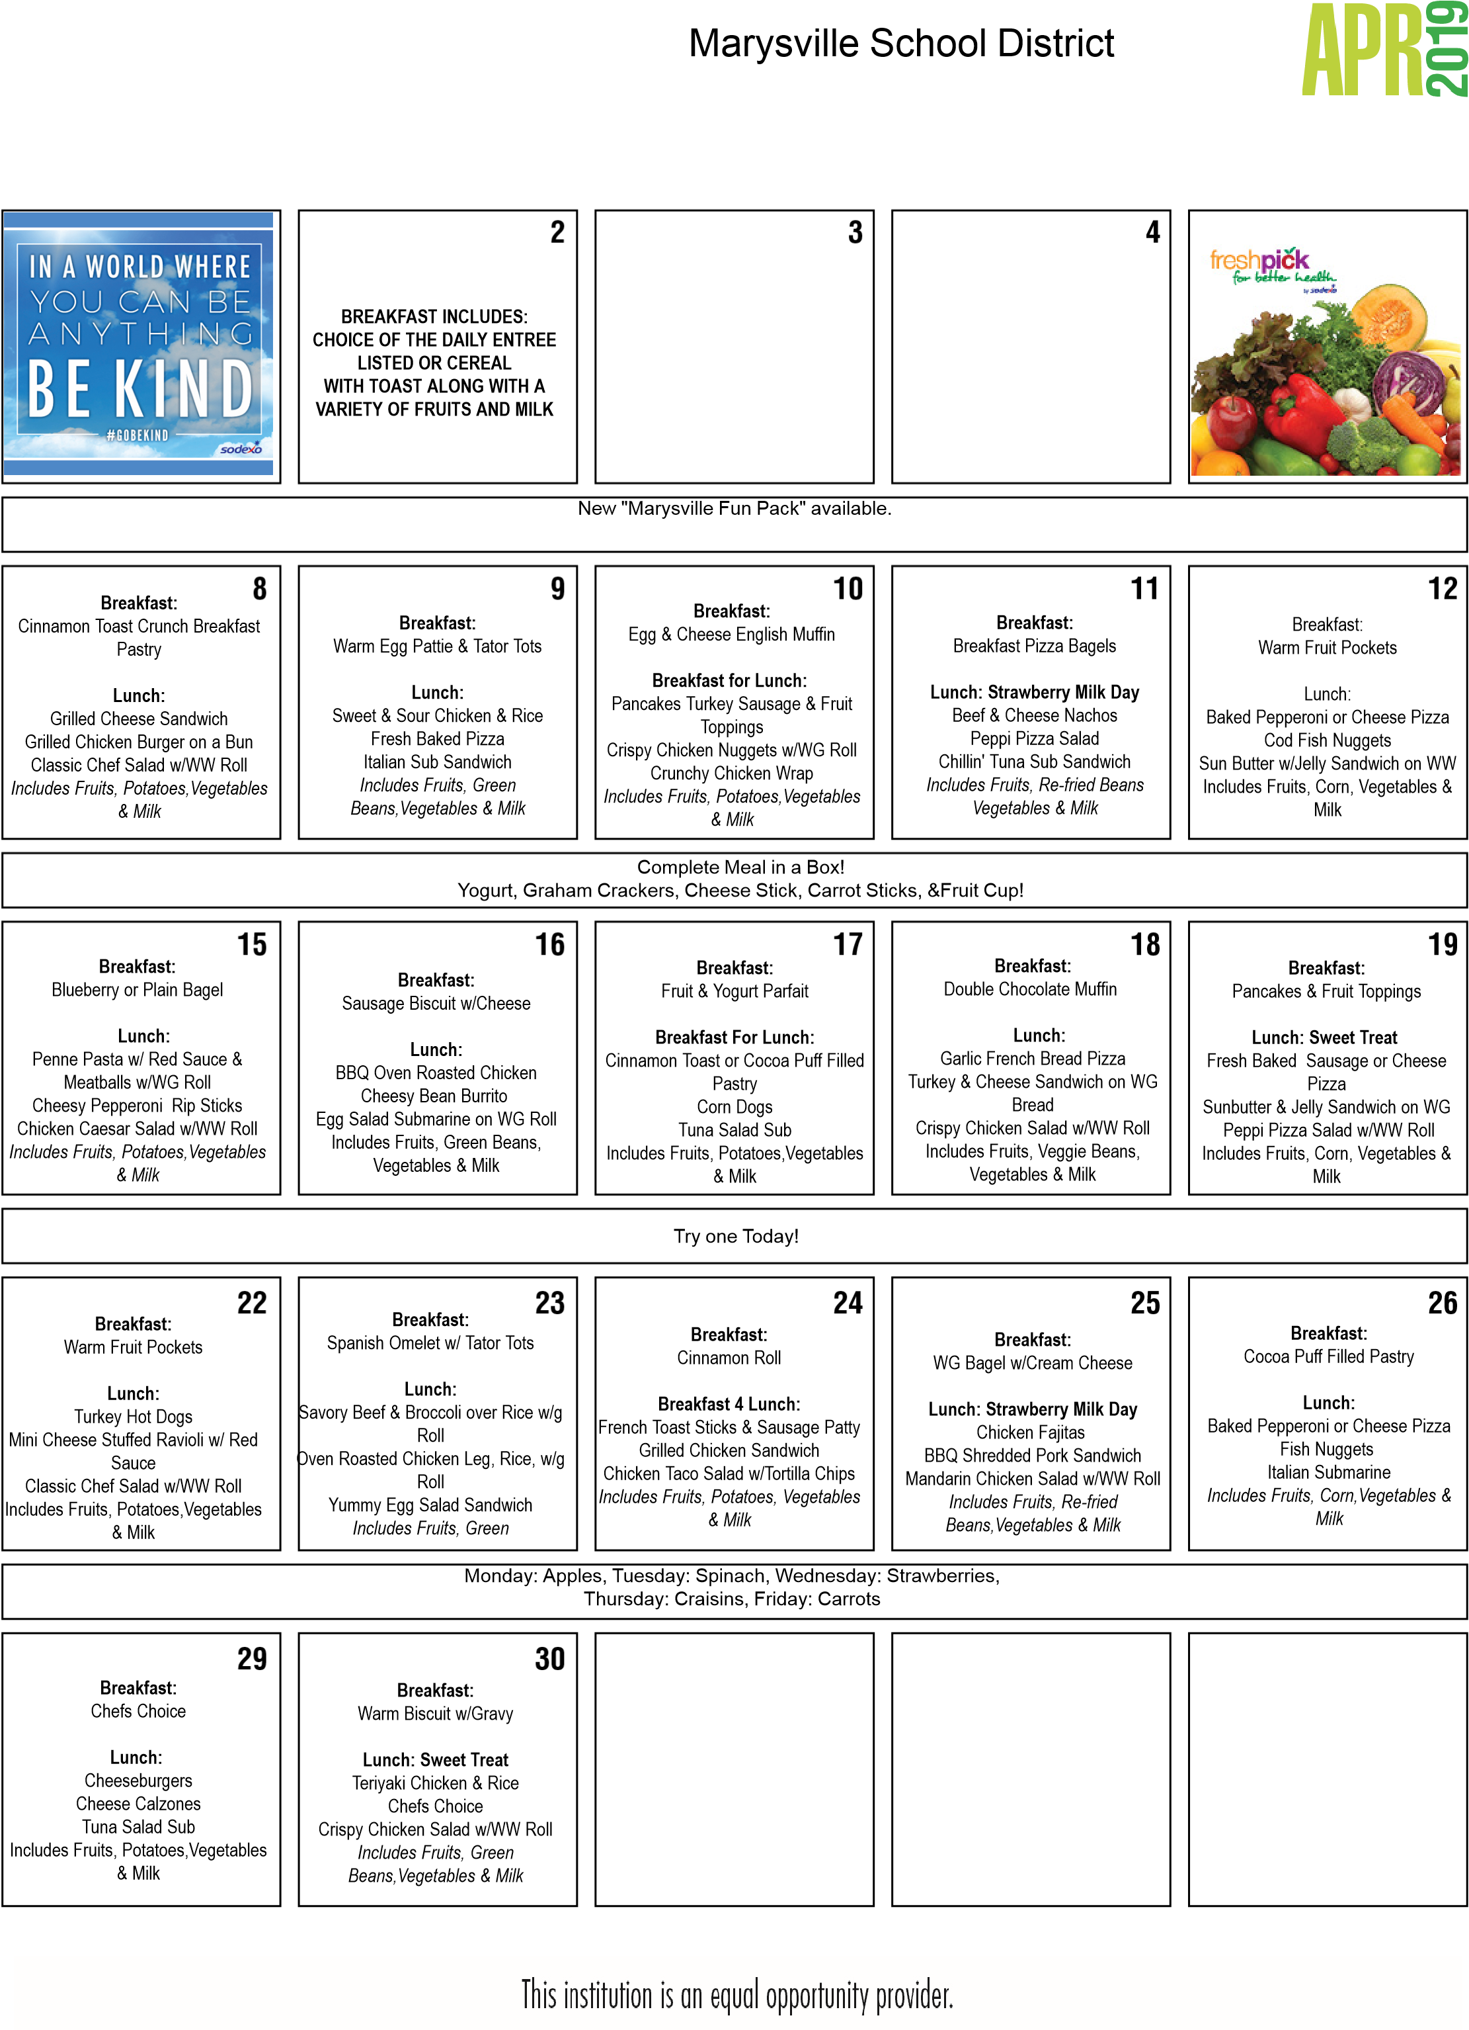
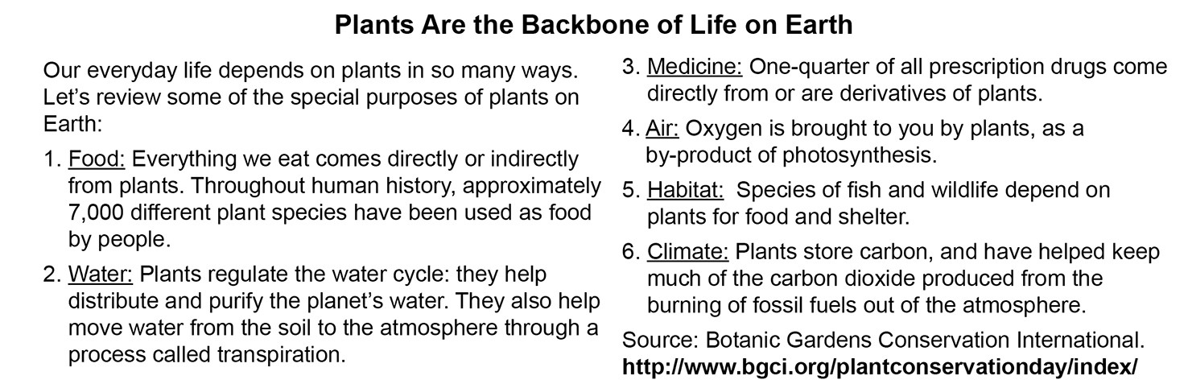
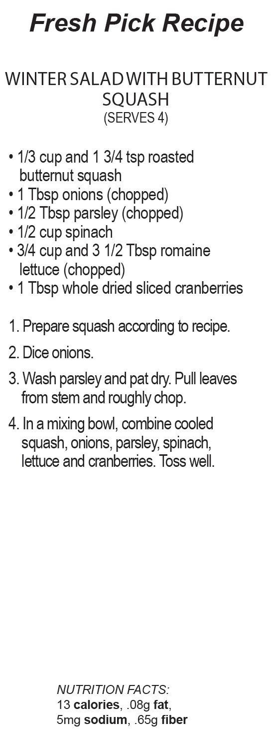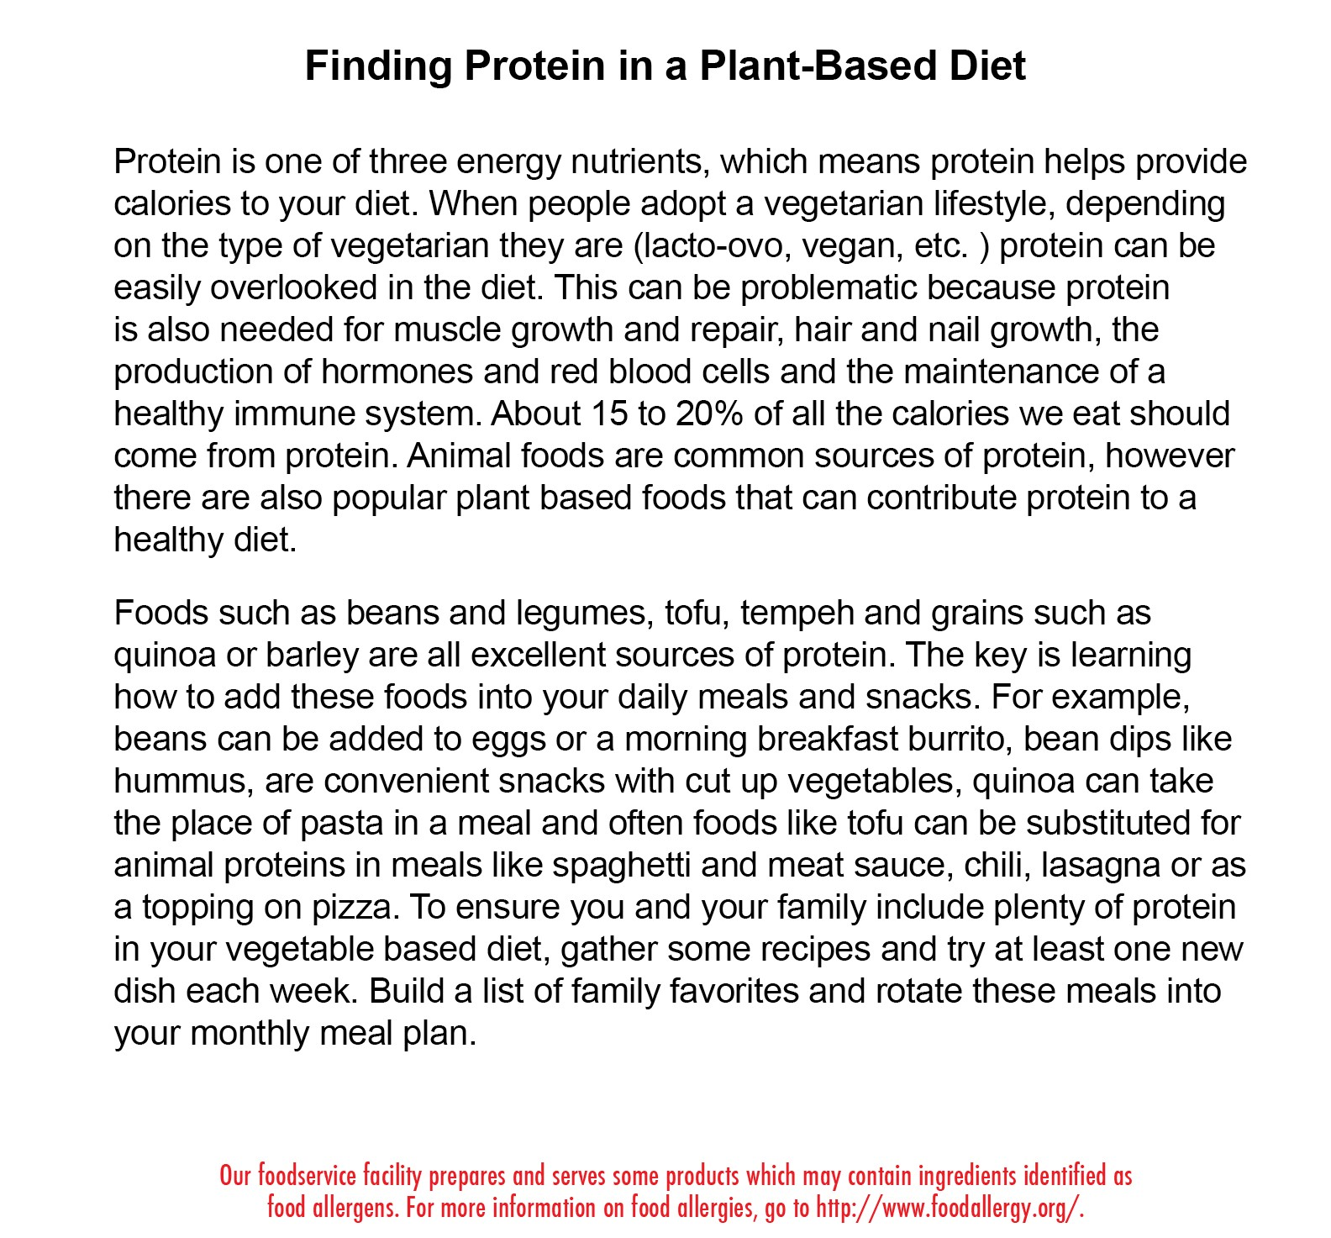
SCHOOL MEAL PRICES: BREAKFAST: REDUCED MEALS AT NO COST. PAID: ELEMENTARY $2.00LUNCH: PAID: ELEMENTARY $3.00 REDUCED: $.40 ADULTS $4.50 INVEST IN YOUR STUDENT'S LONG TERM HEALTH PURCHASE SCHOOL MEALS! Non-Discrimination Marysville School District does not discriminate in any programs or activities on the basis of sex, race, creed, religion, color, national origin, age, veteran or military status, sexual orientation, gender expression or identity, disability, or the use of a trained dog guide or service animal and provides equal access to the Boy Scouts and other designated youth groups. The following employees have been designated to handle questions and complaints of alleged discrimination: Civil Rights Coordinator - Gregg Kuehn, Risk Management Supervisor, gregg_kuehn@msd25.org, 360-965-0110; Title IX Officer - Jason Thompson, Deputy Superintendent, Jason_thompson@msd25.org , 360-965-0004; Section 504 Coordinator, Nancy Smith, Director of Categorical Programs, nancy_smith@msd25.org, 360-965-0051; ADA Coordinator – Ginger Merkel, Executive Director of Special Education, ginger_merkel@msd25.org, 360-965-0174. Address: 4220 80th Street NE, Marysville, WA 98270. Website: www.msd25.org Marysville School District is a drug- and tobacco-free workplace. You can report discrimination and discriminatory harassment to any school staff member or to the district’s Civil Rights Coordinator, listed above. You also have the right to file a complaint. Please Note: Policies that address this issue are Policy 3210 “Non Discrimination” & 5010 – “Non Discrimination and Affirmative Action.” These Policies are available online at www.md25.org, at your school, or at the District Office: 4220 80th Street NE, Marysville, WA, 360-965-0000.

