Mustang Messenger
January 10, 2023

Hello ACEC Community!

Happy New Year! I would like to extend best wishes to all for a happy and healthy new year. It’s a pleasure to see all of the children, teachers and staff back at school after a long, well-deserved break and getting back into our routines.

Basketball is back up and running. I would like to introduce Michael Wright who will be coaching the boy’s 5th and 6th grade team and Kristy Bohannon who will be coaching the 7th and 8th grade boys’ team. A special thanks to prior graduates of ACEC, Keegan O’Bryan, Ta’Rell Latique and Mathew Colby who have been supporting the 5th and 6th grade boys. Keegan O’Brian will be coaching the 3rd and 4th grade girls and boys on Saturdays starting on January 14th. Mrs. Newhard sent home paperwork last week with 3rd and 4th grade students.

You may be hearing students talk about the new doors to the library. The library now has secure doors like the hallway doors. This was discussed during our school safety audit that was conducted earlier this school year. We hope to have our intercom system fixed or replaced soon.

We will be having the lights in our school replaced with more energy efficient models. This project will be starting the week of January 16th. Classrooms may be moved for a day when the lights are being replaced. A plan will be discussed with faculty and staff this week.

The ACEC Leadership Team met in December and will be meeting again this week. The team meets the 2nd Wednesday of each month. Our parent representatives are Jessica Honsinger and Nicole Latimer. Our student representative is Makayla Murray. The team’s focus is reviewing our school’s current continuous improvement goals and drafting new goals. Attendance data will be reviewed this month.

Ms. Barbie is working on the talent show with our students. Illness had postponed this school day event. We hope to have this the last week of January or the first week of February.

8th grade students should be working with Mrs. Cramer regarding school choice for 9th grade and the paperwork that each school requires of students to enroll. Please email Mrs. Cramer with any questions or concerns at kcramer@gisu.org.

Teachers and students are working on academic assessments over the next couple of weeks. If you have any questions please contact the homeroom teacher via Class Dojo, email, or phone call.

Please make sure students have the proper clothing for outside recess. We live in Vermont and the weather can change quickly. If you are in need of winter clothing, please contact Wendy at wsavage@gisu.org.

Please remember my door is always open if you ever need to talk.
Take care and be well!
Ms. Beth

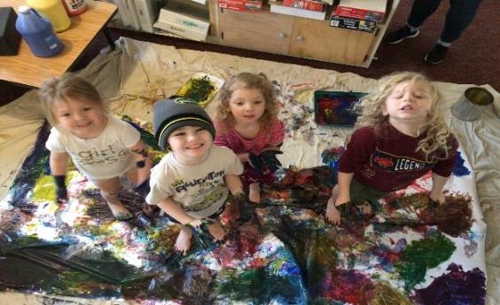
Pre-k has adjusted back to school well this month. We have welcomed Felix a new student into our pre-k family. Friends have enjoyed exploring the story "The mitten" by Jan Brett, adjusting back to classroom expectations, body painting and exploring water in the sensory table.

Kindergarten Happenings…

Happy New Year Kindergarten Families. This month we welcomed back our reading interventions Mrs. Chadwick, we are so happy to have her back in our classroom supporting students!

This month we started our universal assessment in literacy and math. We are using a program called i-Ready as a tool to help assess our students. Once students take the diagnostic test, they can then work on different games and activities to strengthen their skills.

In literacy, we continue to work on phonological awareness, focusing our attention on beginning and end sounds. We also started our Geodes reading program. Students spent all last week looking at a wordless book called Pele. Through images and their background knowledge they were able to bring the story to life! It has been a lot of fun and I cannot wait to see what happened as we progress in the program.

In science and writing we have started our unit on Arctic Animals, starting with penguins. The last couple weeks we have watched videos, read books and discussed all things penguins. I challenge you to ask your child one new thing they learned about penguins this week!

Hi Primary Families!

We have been working hard and having lots of fun together in Primary this past month!
After the new year, we began a new way to celebrate all of the respectful, responsible, safe choices that the students are making. The Apricots, Blueberries, and Tangerines are all working towards filling their pom-pom jugs. When they are full, we stop everything and celebrate! Ask your child how they earned pom-poms this week!

Please help your children remember all of their outerwear each day- we are going out to recess as often as we can to enjoy the fresh air.

Intermediate Mustang Messenger

Reading & Writing ~ Ms. Dobson
The students returned to school excited, full of energy and ready to learn! I’ve always found the weeks & months after the holidays some of the most productive time in the classroom and that was evident this week as we began our 2nd round of mandatory testing for the year. The assessments provide valuable information regarding their reading comprehension, fluency, phonological awareness, phonics, vocabulary and sight words. The assessments completed so far are indicating significant growth in many areas! Please know I am available to meet with you anytime should you have any questions or concerns. You don’t need to wait for a formal parent/teacher conference, and I am always by phone or email: edobson@gisu.org.

Science/Social Studies/Word Work - Mr. Herz

This week all three grades did a review of the Scientific Method in preparation for investigations coming up. We continued to keep an eye on the weather/natural disasters that has affected various areas of the world (floods, ice, storms, volcanoes, etc). In social studies, we are finishing up our state GOOGLE SLIDES in 4th and 5th grades, covering population, square area, geographic features, and sites of interest. All grades are working on the differences between a town, city, state, country, and continent. Word work has been Fundations in 3rd grade, and multiple meaning words and spelling in all three grades. 5th Grade will have a field trip to Missisquoi Wildlife Center on February 7th, 2023, with The Science Guy, Kurt Valenta.

Math- Ms. Mello
The students are back in the routine of school after a restful and exciting winter break. This week, third grade students have been working on number and shape patterns and identifying the sequence of the pattern and what the next part of the pattern looks like. Fourth grade students have been working on multi-digit division strategies using partial quotients to solve division problems. Fifth grade students have been working on adding and subtracting fractions by finding the common denominator in order to solve. Starting next Tuesday, all students will be doing the winter i-Ready assessment.

Literacy Intervention - Ms. Ehle

We are currently undergoing winter assessments in intervention. We use the results of the assessments to create the intervention groups, so some groups will change.
Some students in the 3rd grade who receive reading/writing intervention have received a homework pack. Included in the packs are sight words, one or two “just right” books, and a notebook. Students may use the notebook to log when they read the book, and to write about it.
It would be extremely helpful if students could read their book(s) with someone at home! Once students can read the books fluently (smoothly) and correctly, they will receive another book. Sight words should also be practiced with an adult (or other proficient reader), until they can be read without pause. When students have mastered their given sight words, I will replace them with the next set.
Students in intervention need extra practice and experiences with words and books. This extra practice will help students catch up more quickly and is vital to reading success! Please let me know if you have any questions or concerns about the homework packs. You may contact me via email at mehle@gisu.org. Happy reading!

Middle School Science

The 6th grade has been working on a unit about matter and atoms. We have been learning what the parts of the atom are and how the periodic table is structured. Students are drawing a typical atom of an element that they picked, as well as making an informational slideshow that they will present next week.

The 7th grade is working on the human body. We are learning about the function of the immune system and how the body’s defenses, particularly white blood cells, protect us from pathogens like viruses and bacteria.

The 8th grade has been focusing on how the surface of the Earth changes over time. This week we are learning about physical and chemical weathering, erosion, and deposition of sediments.

Middle School Math Happenings

The math team and I are very pleased with the results and growth ACEC middle school students have shown since the last i-Ready assessment in September. Keep up the great work!
In class, the 6th graders are reviewing decimals and fractions and what to do when you add, subtract, multiply, or divide them. Our 7th graders are working with Percents and how to convert Fractions to Decimals to Percents in no direct order. We are also using equations to find parts of the whole. Finally, in 8th grade, students are working with proportional and non-proportional linear equations in "slope intercept" form or y = mx + b form.

Middle School ELA
6th graders are focusing on writing paragraphs and analyzing character development in the book Bud, Not Buddy. They are actively participating in small group and class discussions!

7th and 8th graders are analyzing poems and creating their own poems using different formats found in the verse-novel The Crossover. Toward the end of the unit they will use their knowledge of figurative language and poem formation to create their own poetry portfolio.

Middle School Social Studies
In 6th grade, we finished reading Blood on the River, a historical fiction novel about the Jamestown colony. Now we're learning about how American colonies grew and became successful. This week we're talking about how the slave trade began, and how slavery in America differed from slavery in the ancient world.

In 7th and 8th grade, we've begun studying World War I. This week and next we're reading about the events leading up to WWI and considering the question, "could WWI have been avoided?" Next, we'll learn about how the industrial revolution (our previous unit) changed warfare and made it even more deadly.

Music

I want to take the time to thank everyone who participated in and attended the 2022 Winter Concert. The students and I got such great feedback from the community that we can’t wait to implement into our next concert.

Speaking of which, don’t let the snowfall fool you - we’re already gearing up for the Spring Concert here at ACEC! Our students can’t wait to share more songs, dances and more with you.

In the meantime, students are working on identifying musical instruments, exploring their singing voices, manipulating vocal samples, songwriting, beatboxing and more! Ask your child about “Rumble Ball”, and they will tell you this is a musical response game that all of our students have been working on and enjoying in different variations!

Some last bit of housekeeping; our 5th grade families in Ms. Mello’s class will be receiving information to bring home for any students interested in band and selecting an instrument. We encourage all students who want to practice at home to rent an instrument from our friends at Ellis Music! They’re an amazing Vermont-owned family business that will work closely with you to get your child the gift of music making.

Mr. C

Art

Primary students have begun exploring concepts around snowflakes. This week we’ve been creating using “cool colors.” We will start learning about symmetry in the coming weeks. Intermediate has been wrapping up projects from before break and will begin new ones. Third and fourth are creating posters for the annual Vermont Green Up Day Poster Contest. If you do not want your child’s work to be entered into the contest, please email me to let me know by January 27. Otherwise, all works will be sent. The students who have started have seemed very excited for this opportunity. Fifth and sixth, as well as Mr. Dabney’s seventh grade homeroom, have begun artist research projects. They selected an artist that seemed appealing to them and will discover more about them through some internet research. They are also learning about finding information and citing where they got their it from, how to use iPads and other digital citizenship skills. They will create works of art to represent their artists later on. Ms. May’s seventh grade has begun a winter landscape painting unit and eighth grade is doing a digital art unit. Everyone has seemed excited for their new projects, and it’s been great coming back from break.

Physical Education

We are working on basketball skills in physical education. Students are making improvements in dribbling, working to keep the ball low and look up. We are also emphasizing using both dominant and nondominant hands. There has been a lot of excitement around shooting. Students are really pumped about practicing shooting and playing shooting games! We are starting to work on what it looks like to play as a team and how to make good passes to get the ball down the court.

From the ACEC Library:

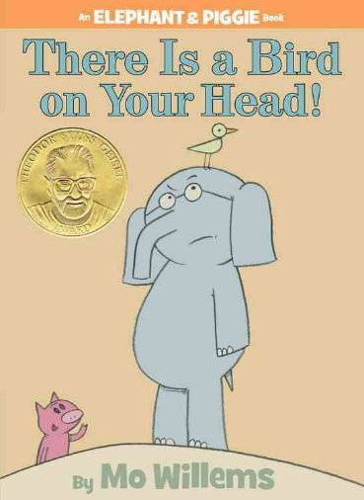
Author Highlight - Mo Willems. Willems got his start working on Sesame Street — where he won multiple Emmys as a writer and animator on the show. The Elephant & Piggie books continue to be very popular. They are delightful stories that follow the best friend duo of Gerald (the Elephant) and Piggie (the pig). If you haven't read one yet, check them out. My favorite one is There is a Bird on Your Head!

On a more serious note, as we are getting back to normal, this year students will be accountable for any lost books that they have checked out from the library. Make sure you get those books back in on time! There is a 2-week check out period. I will send out reminders and notices. Remember that one of the school tenets is to Be Responsible, and borrowing books is a great way to practice.

