2019 KICKAPOO TRACK AND FIELD CLOTHING ORDER FORM
Name:____________________________ Phone:_________________________
Total: $_______________ Please make checks out to KAS.
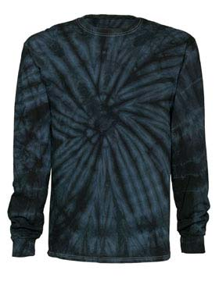
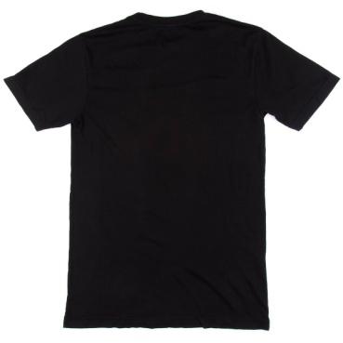
Due Date: Friday, March 29, 2019 with cash or check to Ms. Schullo

Adult Short Sleeve T-shirt
Adult Size | Price | Black
SM | $10.00
MD | $10.00
LG | $10.00
XL | $10.00
XXL | $12.00
XXXL | $12.00
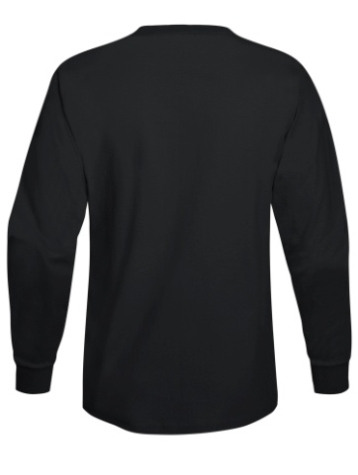

Adult Long Sleeve T-shirt
Adult Size | Price | Black
SM | $15.00
MD | $15.00
LG | $15.00
XL | $15.00
XXL | $17.00
XXXL | $17.00

Name Down the Sleeve ___________________________ (add $6.25)
Adult Long Sleeve Tie Dye T-shirt
Adult Size | Price | Black Tie Dye
SM | $20.00
MD | $20.00
LG | $20.00
XL | $20.00
XXL | $22.00
XXXL | $22.00

Name Down the Sleeve ___________________________ (add $6.25)
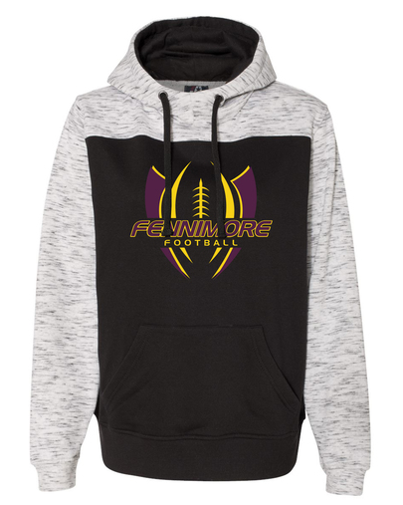

Adult Hooded Sweatshirt
Adult Size | Price | Black/White
SM | $35.00
MD | $35.00
LG | $35.00
XL | $35.00
XXL | $40.00
XXXL | $40.00

