BEARKATS ELEMENTARY SUPPORT SHIRTS
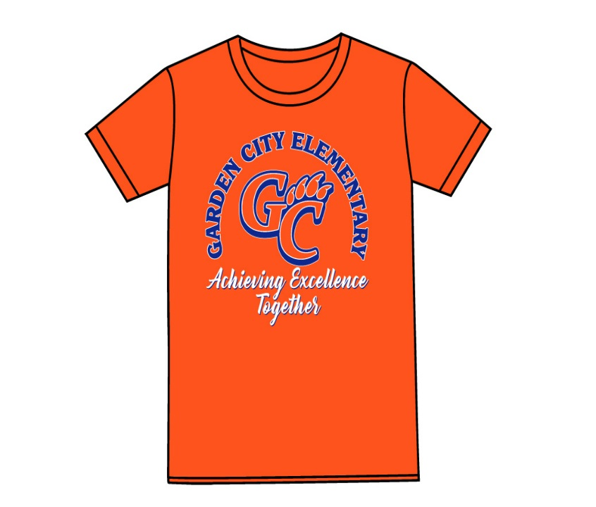
It’s time to order shirts for field day,
field trips, and our
STAAR TESTING DAYS.

The shirts are orange with
royal blue lettering.

.
PTO has graciously agreed to pay for the Elementary Students. All other shirts are $ 8.00 each for family and friends.
Student’s size:
YXS | YS | YM | YL | AS | AM | AL | A1X | A2X | A3X

FAMILY SIZE:
PLEASE RETURN ORDER FORM WITH MONEY BY WEDNESDAY, MARCH 27. ****PLEASE MAKE CHECKS PAYABLE TO GARDEN CITY ELEMENTARY. THERE WILL NOT BE ANY LATE ORDERS.

_________ #SHIRTS X $8.00 = __________________
NAME: _______________________________ CASH_____
TEACHER: ____________________________ CHECK #____
$____________

