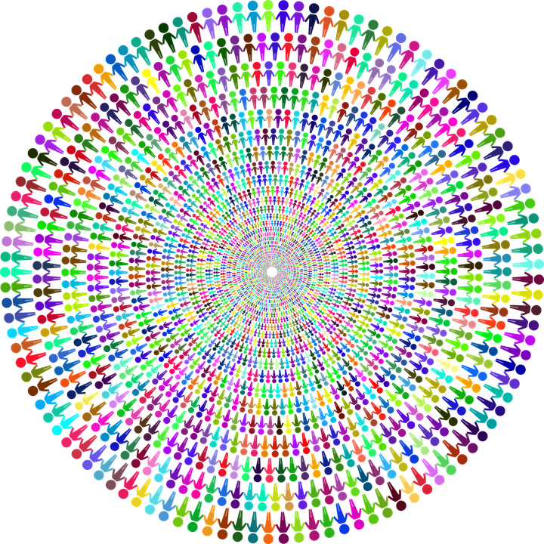
MULTI-CULTURAL WEEK
CELEBRATION

Monday, April 1, 2019 - World Map in Main Hallway

Tuesday, April 2, 2019 - World Cup Soccer Tournament –3:00 PM - 5:00 PM

Wednesday, April 3, 2019 - Selling of Food from AROUND THE WORLD
after school

Thursday, April 4, 2019 - Dress Up Day – Dress in your cultural garb

Photo booth
Culturefest – 5:00 pm – 7:00 pm
Friday, April 5, 2019 - Multicultural Assembly- 9 th – 11th graders Periods 2 and 3

