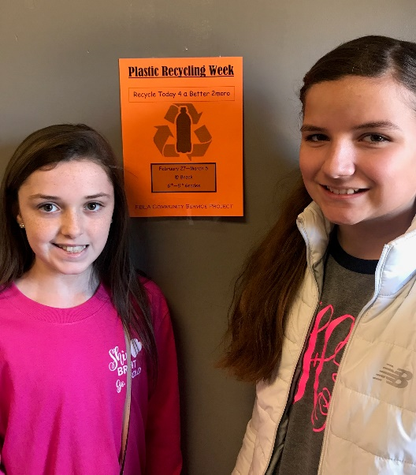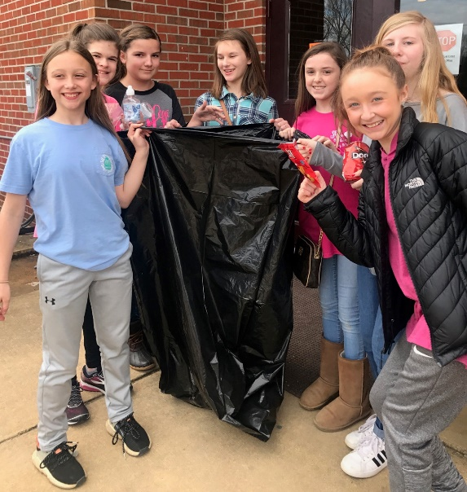
Kossuth Middle School Students and KMS FBLA members, Meredith Gillmore and Claire Hopper, directed the KMS FBLA Community Service Project of recycling plastic. They, along with the KMS FBLA members and the KMS student body, collected plastic bottles for a week during their breaks. Meredith and Claire were responsible for transporting all the plastic bottles to the recycling center. The recycling project was a huge success for KMS FBLA.

