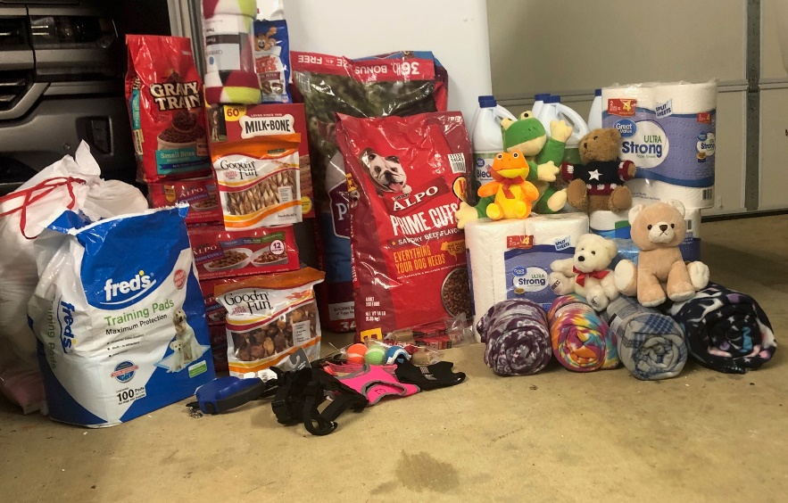
KMS FBLA sponsored a community service project. Lanie Moore and Ella Trimble supervised this from start to finish. They, along with KMS FBLA members and the KMS student body, donated items needed by the Lead Me Home non-profit organization. Items donated were dog food, blankets, toys, collars, leashes, and some actually donated money. Ms. Amber Austin is the director of Lead Me Home. Lead Me Home rescues and rehabilitates stray dogs in Alcorn County. Mr. Jeff Wall is a tremendous help to Ms. Austin. He assists her in many ways including flying his own plane to transport the dogs to where they need to go for veterinary services and re-homing. The Lead Me Home Community Service Project was definitely a big success.

