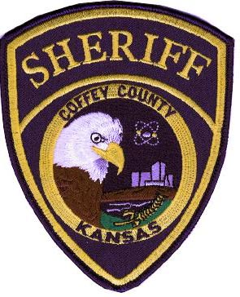
Undersheriff Ken Roney Memorial
Coffey County Sheriff’s Office
605 Neosho St. – Burlington, KS 66839
Scholarship Application
DUE BY: April 15, 2019

Date: ________________________
Name: _________________________________________________________ Age: ________________
Address: _____________________________________________________________________________
Cell Phone: __________________________________ Home Phone: ____________________________
Email: _______________________________________________________________________________

Applicant Signature: _______________________________________
Printed Name: ____________________________________________

Education
High School: _____________________________________ City: __________________________________
High School GPA: _________________________________
College Attended: _________________________________ City: _________________________________
College GPA: _____________________________________
Other Schools Attended: __________________________________________________________________

Major planning to pursue in college/university/technical school: __________________________________
_______________________________________________________________________________________

List any special abilities, interests, volunteer jobs and hobbies: ____________________________________
________________________________________________________________________________________
________________________________________________________________________________________

List awards, honors, positions held in school organizations, activities and/or athletic endeavors. List any special recognition awards received: ________________________________________________________________
_________________________________________________________________________________________

List chronologically your three most recent jobs, including summer and part-time jobs:
- ___________________________________________ From: _____________ To: _____________
- ___________________________________________ From: _____________ To: _____________
- ___________________________________________ From: _____________ To: _____________

Have you ever participated in Boy/Girl Scouts of America? Yes______ No ________
If you answered yes and are an active member;
Please provide: Troop # _________________ City: ______________________________________
Also, list scouting achievements and awards:

_________________________________________________________________________________________

_________________________________________________________________________________________

_________________________________________________________________________________________

Organizational Memberships

List any clubs, societies or organizations in which you are or have been a member (not previously listed)
_________________________________________________________________________________________
_________________________________________________________________________________________

Please submit the following with your completed application:
- A recent photograph
- A 250 word essay answering the following question: Explain why it is important to be involved in your community’s activities.

Mail to:
The Coffey County Sheriff’s Office, 605 Neosho St., Burlington, KS 66839

OR

Deliver to:
605 West Neosho, Burlington, KS

