Parent tips for raising strong mathematicians
Growing Thinkers!
_____________________________________________________________________________________

Math in Literature
When children are exposed to diverse literature, they are provided with opportunities to develop an understanding and build ideas on a topic. While we often focus on reading for fluency and understanding with children, it is also important to share literature that focuses on mathematical thinking. Math literature can include counting or shapes that teach math concepts explicitly, or stories that have embedded math ideas, such as Goldilocks and The Three Bears (size, order, sequences). When we read with (not just to) children, we can learn about how they may interpret ideas and use questions or a discussion to nurture their thinking. Be sure to check out Finding the Math in Storybooks for Young Children to help guide these discussions here: http://tinyurl.com/jo8ulkr

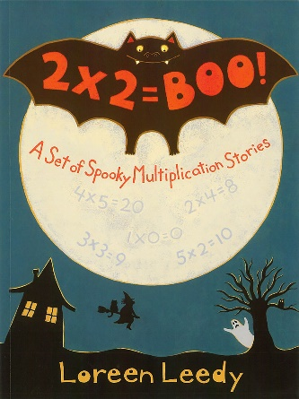
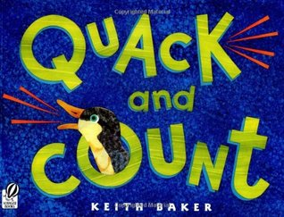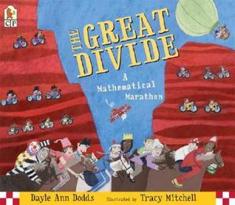

Do you Sudoku?
Solving these puzzles helps us to develop problem-solving strategies and utilize mathematical thinking in the form of logical deduction. Check out the following: http://www.wintersudoku.com/

Math Card and Dice Games
Using a deck of cards and dice to support your child’s math skills is fun and an effective math tool. Below is a link to multiple card and dice games for children in grades kindergarten through eighth grade. Skills such as sorting; greater than and less than; and adding, subtracting, and multiplying are reinforced through these exciting card games.
You can visit: https://www.granby.k12.ct.us/uploaded/faculty/wyzika/Dice_and_Card_Games_to_Practice_Math_Facts.pdf

Math Questions
Even if you don’t feel comfortable with math, try to show enthusiasm for what your child is doing in math at school. You might ask them each day at dinner or homework time what they studied in math that day. Let them explain the concepts they are working on and then follow-up with questions. When your child finishes their homework, ask them to show you how they solved a few problems. As they explain their methods to you, they’ll be reinforcing their own skills. They will also be proud to be teaching you something!

Thinking or Memorizing?
Learning math facts can be more about thinking than memorizing. Learning strategies can build math competency. Encourage your child to “use what they know.” For example, if a math problem wants to know how many legs 3 horses have all together. They could say, “I know a horse has 4 legs. If there are 3 horses, I need to add 4 three times. 4+4+4=12.” Younger child would use addition to solve. An older child might use multiplication. “I know a horse has 4 legs. If there are 3 horses, I need to multiply 4 times 3. 4x3=12.” Again, explaining their thinking will reinforce their own skills.

