Parent tips for raising strong readers and writers

Growing Readers!
_____________________________________________________________________________________

Read Regularly
Have your child read every day ~ or read to your child every day. Aim for 20 minutes per day. Bed-time reading is a peaceful way to end the day. Bring along a book to read during a sibling’s sports practice. Curl up together with a book when you get home from work.

Spot the Details
Reading carefully can help your child find details that will boost his comprehension. Don’t forget to read those headings, captions, and other extras. Ask your child if (s)he has any questions about the book and then help him/her find the answers. Ask him/her who the story is about, where the story takes places, what happened, and if there was a problem in the story.

Vocabulary
A large vocabulary can help your child become a better reader and writer. When you go places together, talk about words that adults may use. If you are at the dentist, you may talk about the word molar. If you are at a restaurant, you may talk about the word entrée. Don’t stop with nouns—using descriptive words improves vocabulary as well. At a ballgame, talk about the player sprinting or the ball soaring. Having conversations improve vocabulary while helping the relationship you have with your child.

Writing
Writing not only helps your child become a better reader, it helps your child work through emotions. Writing in a journal can store your child’s memories. Sharing those writings can also serve as bonding time with your child.
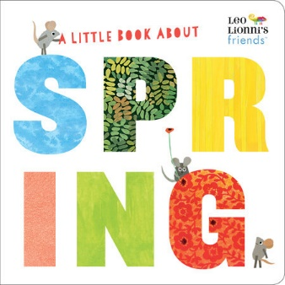
A Little Book About Spring
It’s hard to imagine the beauty of spring in the dead of winter, but Leo Lionni and Julie Hamilton’s cheery illustrations will remind you that flowers and sunshine are just around the corner.

