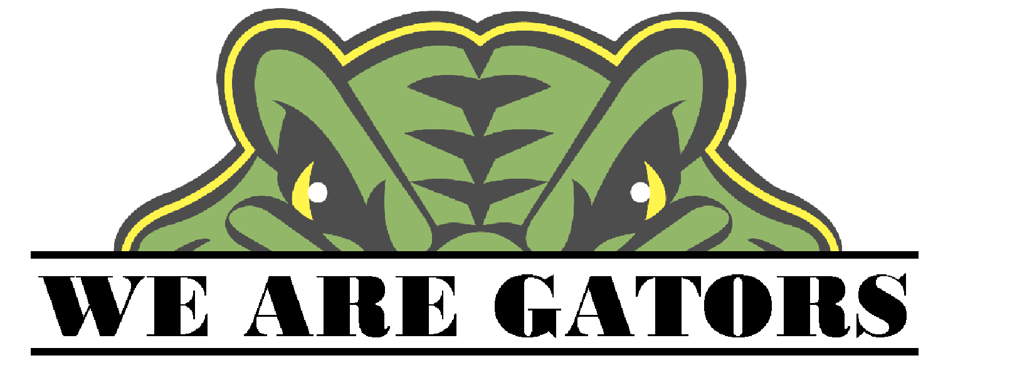
Two Rivers School District
Student Services Plan
2018-2019

Two Rivers Personnel Implementing Plan:

Michael Dean, Superintendent/ Equity & Race/Homeless Liaison
Barry Fisher, 7-12 Principal
Becky Fowler, Food Services/Wellness Committee
Josh Harrison, K-12 Assistant Principal
Jennifer Holt, Counselor/DTC/504/Parental Involvement Facilitator/Foster Care
Ricky Kimzey, ESL/Teacher
Mary Lawrence, Federal Programs Coordinator/ K-12 Curriculum Coordinator
Marci McVey, Gifted and Talented/High School Parental Involvement Facilitator
David Minnie, K-6 Principal/ALE Director
Lindy Minnie, Physical Education/Wellness Committee
Jeremy Rainey, ALE Teacher
Tammy Rainey, LEA Supervisor (Arch Ford Cooperative)
Todd Spencer, Resource Officer/Director of Transportation
Rebecca Treadwell, ESL/Migrant
Debra Whisenhunt, Counselor/STC/504
Judy Whitlow, Middle School Parental Involvement Facilitator
Toby Yeager, Technology Coordinator
Pat Briley, Nurse/Wellness Committee
Betty Ennis, Anita Geiger, and Tosha Palmer-Elementary Special Education Teachers
Janet Ball, Darla Keim, and Capella Neely-Middle and High School Special Education Teachers
Lyon's Rehabilitation-Speech, Occupational Therapy, and Physical Therapy
Community Services, Counseling Associates and Day Springs Inc.-Outside agencies who use our facilities to see students

Delivery of Services

The Two Rivers School District provides two fully certified and licensed school counselors to spend at least seventy-five percent of their time during the school year to provide direct counseling to students. This complies with the student/guidance counselor ratio of no more than 450 students per counselor.

The following are incorporated into the Two Rivers School District Direct Counseling Delivery of services for students:

Developmentally Appropriate Classroom Guidance is provided for K-12 students in either individual, large group or small group sessions. Students are provided guidance in the following areas: Social/Emotional (Personal Competency) development, resolving student conflicts and/or differences, and providing intergroup skills. School counselors strive to assist students in understanding the relationship between academic performance and success in school and how this relationship follows them for later success with college and career programs after graduation.

Orientation: Students entering kindergarten, from our preschool, are brought to our campus to start becoming familiar with our school. Those entering 5th grade and transitioning to the middle/high school building, attend orientation night with their parents, prior to the beginning of the school year.

Academic Advising and Planning: Academic advising and planning is initiated through classroom guidance, small group, and individual counseling. Students are informed of the importance of taking rigorous courses (including AP and Concurrent Credit), that best meet foundational, prerequisite knowledge for their future college/career aspiration. Students receive advisement on national college assessments, assistance with registering for college assessments, workforce opportunity information, Career and Technical Education opportunities, and alternative educational programs that may be needed to assist students toward obtaining graduation and post-secondary options. Parents are welcomed and encouraged (open door policy) to meet with the counselor and student to discuss course selection and advising on an individual basis.

Students are provided information on career pathways, career and technical courses, and certifications they can obtain while in high school. Students are transported to Arkansas Tech Career Center to explore career and technical training opportunities/coursework, prior to course selection.

Parental consent is required for students enrolling in ACE coursework at Arkansas Tech Career Center and any concurrent credit coursework. Representatives, from post-secondary institutions, also visit with students, in high school, to discuss the opportunities various technical and certificate programs offered throughout the state after graduation.

College Night is hosted by Two Rivers School District for students and parents, to offer an overview of the college admissions process, financial aid application process, and learn more about the various programs, majors and scholarship opportunities provided at surrounding colleges and universities.

Students and parents may also receive assistance with making application for financial aid, by contacting the school counselors. Parents are welcomed to complete the FAFSA and/or other forms in the school counseling office, if assistance is needed.
Scholarship information is posted in announcements, placed outside the counseling office for “anytime” availability, and posted to the school website.

Preventative Interventions (anti-bullying, suicide prevention, etc.) are provided directly to students or through educational programs. Outside resources are used to further educate students.

Responsive Services are provided as needed, through individual or small group counseling. These include potential academic obstacles, obstacles to learning, individual family/peer concerns, conflict resolution and social/emotional concerns. This may involve the use of school personnel, student peer helpers, or outside agencies.

Preventive measures and response services include, but are not limited to, the careful attention and assistance of school personnel and swift referrals for students needing immediate assistance with crisis counseling.

Individual Planning includes interpretation of student needs and assessments. as well as, an ongoing, grade-level appropriate career exploration process. This serves as the foundation to “Student Success Plans” introduced in grade 8. Students begin making their four and six-year plans by completing interest inventories and exploring career development through age-appropriate activities.

Additional Components of Student Services Plans

Psychological Services are provided to students referred for possible learning/ behavioral issues, as well as, those exhibiting exceptional qualities. These referrals are made to the appropriate personnel or outside agencies.

Health Services are provided by the district’s full time, licensed nurse, who coordinates with area agencies. The school nurse serves all students, as needed, on a daily basis, and provides the necessary services to those with individualized healthcare plans.

