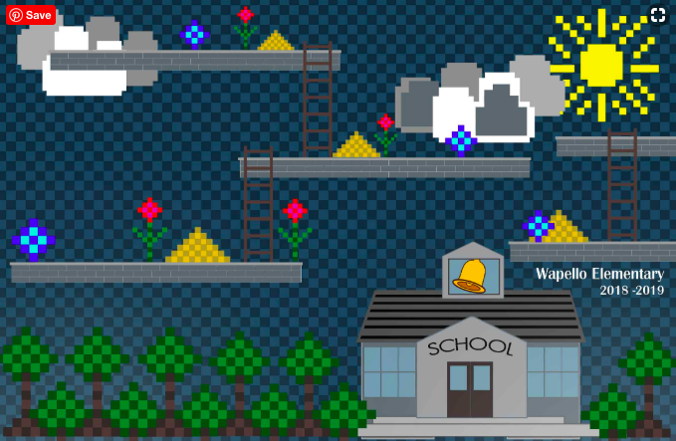
Now is the time to order
your copy of the
2018-2019
Wapello Elementary Yearbook!

At Wapello Elementary we know that a yearbook shows “a treasured record of a happy school year to have forever.” With that said, the yearbook for 2018-2019 will once again feature 24 glossy pages of crisp, color photos that will give your child a memory of their year at Wapello Elementary.

We are excited to be able to once again offer the opportunity for the 2018-2019 yearbooks to be produced in March and yearbooks will be ready for delivery in May.

We hope you are equally as excited to receive this treasured memory of your student’s year at Wapello Elementary and will choose to place your order today! This will be the only opportunity to order a yearbook. There will be very few extras if any, so please get your order in today! The cost is $15.00. Please make checks payable to Wapello Elementary School.

Please detach and return the bottom with payment to the office.
Due: March 15th with correct payment
____________________________________________________________________________

Student Name: ________________________________________________

Grade: __________ Teacher’s Name: _______________________________

# of Books: ___________________ Amount Enclosed: ________________

