SCHOOL YEAR 20______- 20______ ASTHMA ACTION PLAN Date: __________________
Name: __________________________________DOB:_______________ School:_________________________________ Health Care Provider #:____________________Fax:________________ Emergency #:911 OR______________________
DIAGNOSIS: Asthma Severity (Select one): □Intermittent:□Exercise Induced Asthma/Bronchoconstriction
□Persistent: □Mild; □Moderate; □Severe
RESCUE MEDICATION: □Proventil HFA; □Ventolin HFA; □Xopenex HFA; □ProAir HFA; □ProAir RespiClick; □Nebulizer
PREVENTATIVE MEDICATION (taken at home): □Inhaler □Diskus
#______Inhalations/Puffs _____times a day; Other:______________________________
What triggers my asthma: □Smoke □Mold □Tree/Grass/Weed Pollen □Cold/Virus □Exercise □Seasons Other:_______________
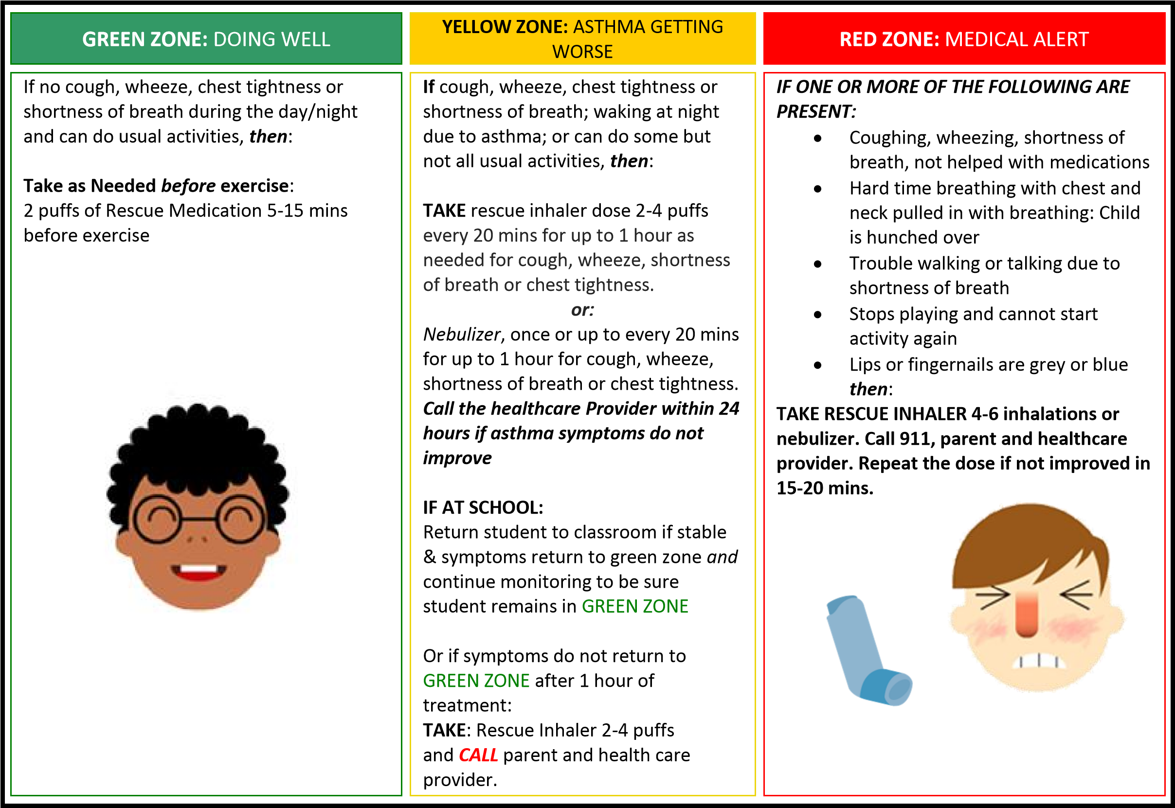

(Circle one) Patient MAY / MAY NOT be allowed to carry and self-administer rescue inhaler.

□I authorize health information sharing on my child with relevant school officials and healthcare providers.
□Autorizo a la información de salud compartiendo en mi hijo/hija con las autoridades escolares competentes y profesionales de la salud.

Parent/Guardian Signature Provider Signature
x x
It is the policy of La Joya ISD not to discriminate on the basis of sex, age, handicap, religion, race, color, or national origin in its educational programs. Es póliza del Distrito Escolar de La Joya el no discriminar por razones con base en sexo, edad, religión, raza, color, origen nacional, ni por discapacidad dentro de sus programas educacionales.

